

VIETNAM NATIONAL UNIVERSITY - HO CHI MINH CITY

UNIVERSITY OF INFORMATION TECHNOLOGY

**FACULTY OF INFORMATION SYSTEMS**

**-----**











**-----**

**FINAL REPORT**

**SUBJECTS: INFORMATION SYSTEM ANALYSIS AND DESIGN**

**TOPIC:**

**Building Electronic Store Website**

**Class: IS201.O11.HTCL**

**Instructors: PhD. Cao Thi Nhan, M.S. Duong Phi Long**

**Group 4:**

|  |  |
| --- | --- |
| Bui Canh Long | 18521018 |
| Vo Lam Truong | 20522093 |
| Nguyen Trung Nguyen | 20521678 |
| Chu Ngoc Thang | 20521891 |

*TP. Hồ Chí Minh, tháng 12 năm 2023*

# TABLE OF CONTENTS

TABLE OF CONTENTS 1

TABLE OF CONTENTS IMAGES 4

COMMENTS FROM LECTURES 6

THANK YOU 7

CHAPTER 1: INTRODUCTION 8

1.1. Introduction 8

1.2. Research problems / Problems of the project 8

1.3. Objectives of the project 9

1.4. Scope of project 9

1.5. Report outline 9

CHAPTER 2: REQUIREMENT SPECIFICATION 11

2.1. Situation survey/ Survey of the current situation 11

2.1.1. Interview 11

2.1.2. Survey of the organization/ Current organizational situation 16

2.1.3. Survey of business processes, major activities 16

2.2. Software requirements 16

2.2.1. Functional requirements 16

2.2.2. Non-functional requirements 18

CHAPTER 3: ANALYSIS AND DESIGN 19

3.1. Use-case Diagram 19

3.1.1. Administrator / Employee 19

3.1.2. Customer 22

3.2. List of actors 22

3.3. List of use-case 23

3.4. Use-case Specification and Activity Diagram 24

3.4.1. Use-case Sign Up 25

3.4.2. Use-case Sign in 26

3.4.3. Use-case Search product 28

3.4.4. Use-case Explore product 29

3.4.5. Use-case Manage profile 30

3.4.6. Use-case Recreate Password 32

3.4.7. Use-case Product reviews 35

3.4.8. Use-case Choose to buy the product 36

3.4.9. Use-case Sign-in for Administrator 42

3.4.10. Use-case Analysis revenue 43

3.4.11. Use-case User management 44

3.4.12. Use-case Product management 51

3.4.13. Use-case Order management 58

3.4.14. Use-case Article management 63

3.4.15. Use-case Manage feedback 74

3.4.16. Interface management 79

3.5 Sequence diagram vs Class diagram 109

3.5.1. Sign Up 109

3.5.2. Sign In 110

3.5.3. Search Product 111

3.5.4. Explore Product 112

3.5.5. Manage profile 113

3.5.6. Recreate Password 115

3.5.7. Product reviews 116

3.5.8. Choose to buy the product 118

3.5.9. Sign-in for Administrator 121

3.5.10. Analysis revenue 122

3.5.11. User management 123

3.5.12. Product management 127

3.5.13. Order management 132

3.5.14. Article management 135

3.5.15. Manage feedback 142

3.5.16. Interface management 145

3.6 Class diagram and entity class diagram 163

3.6.1 Customer overview class diagram 163

3.6.2 Administrator overview class diagram 164

3.6.3 Entity class diagram 164

3.6.4. Class specification 164

3.7 State Diagram 193

3.7.1. Customer account 193

3.7.2. Shopping cart 193

3.7.3. Product 193

3.8. Mapping to Relational Model diagram from Entity class diagram 194

CHAPTER 4: IMPLEMENTATION AND TESTING 195

4.1 Introduction to the implementation environment 195

4.2 User Interface 195

4.2.1. Customer interface 195

4.2.2. Admin interface 209

CHAPTER 5: CONCLUSION 213

5.1 Project achievement 213

5.2 Limitations 213

5.3 Development direction 213

CHAPTER 6: SELF ASSESSMENT 214

# TABLE OF CONTENTS IMAGES

Picture 1: Login interface for users 194

Picture 2: Banner interface 195

Picture 3: List of products 195

Picture 4: The interface displays brands and product categories 196

Picture 5: Display new products 196

Picture 6: Display products on sale 196

Picture 7: Displays product review articles 197

Picture 8: Display reviews from customers 197

Picture 9: Website footer interface 197

Picture 10: The interface displays detailed product information 198

Picture 11: Display product information and recommend similar products 198

Picture 12: Product review form 199

Picture 13: Product search function 199

Picture 14: Filter function to sort found products 200

Picture 15: Displays recently viewed products at the bottom of the page 200

Picture 16: Page interface of product advice articles 201

Picture 17: Product review page interface 201

Picture 18: A product review article 202

Picture 19: Suggest other articles 202

Picture 20: Phone product catalog 203

Picture 21: Laptop product catalog 203

Picture 22: Tablet product catalog 204

Picture 23: Screen product catalog 204

Picture 24: Desktop product catalog 205

Picture 25: Phone accessories product catalog 205

Picture 26: Laptop accessories product catalog 206

Picture 27: Smart watch product catalog 206

Picture 28: Shopping cart details page interface 207

Picture 29: Payment page interface 207

Picture 30: Login interface for admin 208

Picture 31: Interface to view revenue statistics 208

Picture 32: User management interface 209

Picture 33: Article management interface 209

Picture 34: Product management interface 210

Picture 35: Order management interface 210

Picture 36: Feedback management interface 211

Picture 37: Manage interface components (slides,..) 211

# COMMENTS FROM LECTURES

……………………………………………………………………………………………………………………………………………………………………………………………………………………………………………………………………………………………………………………………………………………………………………………………………………………………………………………………………………………………………………………………………………………………………………………………………………………………………………………………………………………………………………………………………………………………………………………………………………………………………………………………………………………………………………………………………………………………………………………………………………………………………………………………………………………………………………………………………………………………………………………………………………………………………………………………………………………………………………………………………………………………………………………………………………………………………………………………………………………………………………………………………………………………………………………………………………………………………………………………………………………………………………………………………………………………………………………………………………………………………………………………………………………………………………………………………………………………………………………………………………………………………………………………………………………………………………………………………………………………………………………………………………………………………………………………………………………………………………………………………………………………………………………………………………………………………………………………………………………………………………………………………………………………………………………………………………………………………………………………………………………………………………………………………………………………………………………………………………………………………………………………………………………………………………………………………………………………………………………………………………………………………………………………………………………………………………………………………………………………………………………………………………………………………………………………………………………

# THANK YOU

First, the group would like to express special thanks to Ms. Cao Thi Nhan (Theoretical lecturer of Information Systems Analysis and Design Teacher) and Mr. Duong Phi Long (Lecturer of Practical Analysis and System Design information) provided knowledge, advice and contributed valuable ideas to help the group complete their course projects.

Starting from the purpose of learning how to analyze, design systems, as well as learn about business processes of cafes, our team has implemented the project “Building Electronic Store Website”.

During the project's implementation, the team attempted to implement the project in the best way possible, based on the knowledge provided by the school's teachers and self-learning of additional tools and new knowledge. However, the project is not finished and still contains many errors, but it is the result of team members' efforts, as well as the assistance of all friends and teachers.

The team is looking forward to receiving suggestions from lecturers to draw valuable experiences and improve their knowledge so that the group can continue to complete other projects in the future.

Sincerely thank lecturers!

*TP. Hồ Chí Minh, tháng 12 năm 2023*

# CHAPTER 1: INTRODUCTION

## 1.1. Introduction

Today's society is facing the trend of strong economic development and the application of information technology to business processes and commercial fields. Data storage, data management and processing in commercial business is becoming increasingly important and urgent for businesses, especially those with large volumes of business data. Tools for effective management, bringing high business performance.

With the development of science and technology, especially information technology, computer components are increasing, and their prices are getting cheaper. On the other hand, thanks to modern technology, people's lives are becoming more and more interesting. Most of us always want to have modern appliances in our homes: computers, TVs, laptops, etc. Businessmen always want to meet customers' needs (fast, convenient, and accurate). and reduce the cost of hiring human resources.

Realizing the importance of optimizing data storage methods to easily manage and process information, our team decided to build an "Electronic Store Website", with the desire will save time, store a lot of data and process information simply, quickly and effectively.

## 1.2. Research problems / Problems of the project

Nowadays, we are facing the trend of strong economic development and application of information technology to business processes and commercial fields. Data storage, data management and processing in commercial business is becoming increasingly important and urgent for businesses, especially those with large volumes of business data. Tools for effective management, bringing high business performance.

Optimizing data management using information technology tools is of particular interest to businessmen and managers. This is also one of the top issues because it is the basis for evaluating whether a business is developing sustainably and effectively. Because a business that wants to operate and develop effectively in the long term must ensure the tight management of its data and resources, meeting optimal operational requirements, preventing loss or incidents. data incidents, causing the risk of serious consequences and risks in the business process, affecting the corporate brand. To ensure that nature, nothing is more optimal than modernizing the resource and data management stages of businesses and companies in the process of operation and development, especially businesses in the field of data management. business and trade field.

## 1.3. Objectives of the project

Building a website to manage activities, events, job recruiting that satisfies the following critical requirements:

* Fully manage information about all types of products and products.
* Manage the process of importing and exporting invoice and order information quickly and easily.
* Manage customer information.
* Manage invoice payments.
* Information is stored in the database for synchronous retrieval.

## 1.4. Scope of project

Due to the limited time available to implement the project, many other parts must be completed, so the group will concentrate on performing some of the primary functions required of website selling, such as..

## 1.5. Report outline

The group will present detailed content in this report through the following chapters.

* **CHAPTER 1:** INTRODUCTION

Briefly introduce the topic content, the reasons for selecting the topic, pose the problem, provide the solution, and state the objectives and scope of the research.

* **CHAPTER 2:** REQUIREMENT SPECIFICATION
* **CHAPTER 3:** ANALYSIS AND DESIGN

Describe in detail the process of system analysis and design based on object-oriented methods. Draw Use-case diagram, Use-case specification, and present diagrams: Activity Diagram, Sequence Diagram, Class Diagram, Entity class, State Diagram and map the Relational Model from Entity class diagram.

* **CHAPTER 4:** IMPLEMENTATION AND TESTING

The installation environment is introduced and presented, as well as the design results of the system's interactive screen interfaces.

* **CHAPTER 5:** CONCLUSION

Summarize the topic's content, including the results obtained and the limitations encountered after implementing the topic. At the same time, the group will provide recommendations for the topic's future development.

# CHAPTER 2: REQUIREMENT SPECIFICATION

## 2.1. Situation survey/ Survey of the current situation

### 2.1.1. Interview

|  |  |  |  |  |
| --- | --- | --- | --- | --- |
| General Survey  System: TechShop  Creator : Bùi Cảnh Long Created Date : 28/09/2023 | | | | |
| Ord | Topic | Requirement | Start | End |
| 1 | Software systems, machines | Learn carefully about the system's resources, such as machines, equipment, software, and operating systems. | 28/09/2023 | 28/09/2023 |
| 2 | Statistical and reporting process | Requirements for statistical and reporting processes on e-commerce websites include data collection, sales and product analysis, user behavior tracking, marketing campaign evaluation, report creation and visualize data, along with performing A/B tests for website optimization. | 28/09/2023 | 28/09/2023 |
| 3 | Customer service | Customer service requirements for sales websites include 24/7 online support, live chat feature, quick order processing, and providing detailed product information. This requires the website to have a friendly interface, a secure payment system, and the ability to interact quickly with customers. | 28/09/2023 | 28/09/2023 |
| 4 | Products and quality | Products and quality requirements for sales websites include providing detailed product information, high-quality images, user reviews, flexible return policies, and high-quality products. This requires accurate product descriptions, clear images, and guaranteed product quality. | 28/09/2023 | 28/09/2023 |
| 5 | Customers  management | Requirements of Customers management for sales websites include customer information management system, easy registration and login features, order management and purchase history, as well as promotions and membership cards. This requires the website to have an effective customer information management system and provide a personalized shopping experience. | 28/09/2023 | 28/09/2023 |
| 6 | Product Management | Product Management requirements include product information management, periodic inventory updates, effective warehouse management, and ordering process optimization. This requires the system to have an accurate product database, flexible information updating process, and effective warehouse management. | 28/09/2023 | 28/09/2023 |

**Table 1. Survey Strategy**

|  |  |
| --- | --- |
| Survey Form  System : TechShop | |
| Internviewee : Nguyễn Trung Nguyên | Interviewer: Chu Ngọc Thắng |
| Form : Online interview  Location : Zoom | Time : 9:00-13:00 30/9/2023 |
| Target: Collect and understand working process of website. | |
| Details of the internview:   * Introduction * Overview about current system * Overview of the internview * Survey plan: * Topic 1: Product Management * Topic 2: Statistical and reporting process * Topic 3: Customers management * Topic 4: Software and hardware | Estimated time:  Total : 4 hours |
| General Observe |  |
| Unexpected occurrence |  |

**Table 2. Survey Form**

|  |  |  |
| --- | --- | --- |
| Internviewee : Nguyễn Trung Nguyên | | 30/9/2023 |
| Questions | | Records |
| Topic 1 | What product management features do you want on your website? | Product automation and product data analysis |
| When the price of the product be updated? | Prices will be updated when the market and manufacturer's policies change |
| Topic 2 | What statistics does the system need? | The system includes the following statistics:   * Statistics of product sales and inventory * System user statistics |
| How long does it take to figure out how many products are sold on a regular basis? | The statistics of products sales will be collected on a weekly basis and for a term specified by the management if data reporting is required. |
| Topic 3 | Is all basic customer information saved? | All basic customer information is stored in the system to serve the purchasing process and customer information will be kept confidential. |
| When a customer does not use the website for too long, will the customer's information still be stored? | Customers are the main deciding factor for the survival of the website, so storing customer information is necessary regardless of whether they do not use the website often. |
| Topic 4 | What kind of hardware does a computer system have? | Currently, the Website is equipped with a server and a computer system for the admin. |
| How often is the system maintained? | The system should be periodically maintained once a month |

### 2.1.2. Survey of the organization/ Current organizational situation

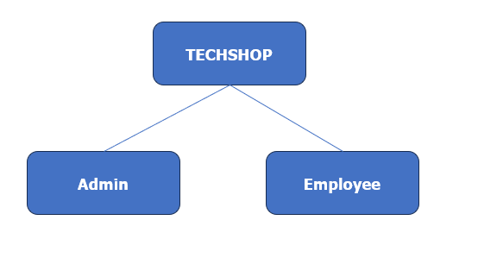

### 2.1.3. Survey of business processes, major activities

Product listing: List all the electronic devices you want to sell on your website. Ensure that each product has a clear description, images, and pricing.

Sales: Implement a secure payment system to handle transactions. You can use popular payment gateways like Momo, Zalo, or credit card processing, cash.

Customer service: Provide excellent customer service through various channels like live chat, email, and phone support. This will help build trust and loyalty among your customers.

Marketing: Promote your website through various marketing channels like social media, email marketing, and paid advertising to attract potential customers.

Inventory management: Keep track of your inventory and update your website accordingly. Use tools like inventory management software to streamline this process.

Analytics and reporting: Monitor your website's performance using analytics tools like Google Analytics. This will help you understand your customers' behavior and make data-driven decisions to improve your website and business.

Other processes.

## 2.2. Software requirements

### 2.2.1. Functional requirements

1. **Storage function**

Product information: Store detailed information about each electronic device, such as product name, description, price, and specifications.

Product images: Store high-quality images of each electronic device to showcase them on your website.

Order and customer data information about customer orders, including product details, shipping addresses, and payment information.

Inventory management: Keep track of your inventory and update your website when products are added or removed.

Security: Implement security measures to protect your website and customer data from unauthorized access and cyber threats.

1. **Feature function**

Search functionality: Allow users to search for products using keywords or specific filters.

Product filtering: Offer options for users to filter products based on categories, price, or other attributes.

User account management: Allow users to create accounts and manage their personal information, order history, and wish lists.

Shopping cart and checkout: Implement a shopping cart that allows users to add products to their cart and proceed through the checkout process.

Responsive design: Ensure that your website is responsive and compatible with various devices and browsers for a seamless user experience.

Security features: Implement security features like SSL certificates and secure payment gateways to protect your website and customer data.

### 2.2.2. Non-functional requirements

Performance: Ensure that your website loads quickly and is responsive, even during peak traffic times.

Scalability: Design your website to scale with your business, so you can handle an increasing number of customers and products.

Security: Implement security measures to protect your website and customer data from unauthorized access and cyber threats.

Accessibility: Make your website accessible to all users, including those with disabilities, by following accessibility guidelines like WCAG.

Compliance: Ensure that your website complies with relevant laws and regulations, such as data protection and privacy laws.

Maintenance and support: Plan for regular maintenance and support to keep your website running smoothly and resolve any issues that may arise.

# CHAPTER 3: ANALYSIS AND DESIGN

## 3.1. Use-case Diagram

### 3.1.1. Administrator / Employee

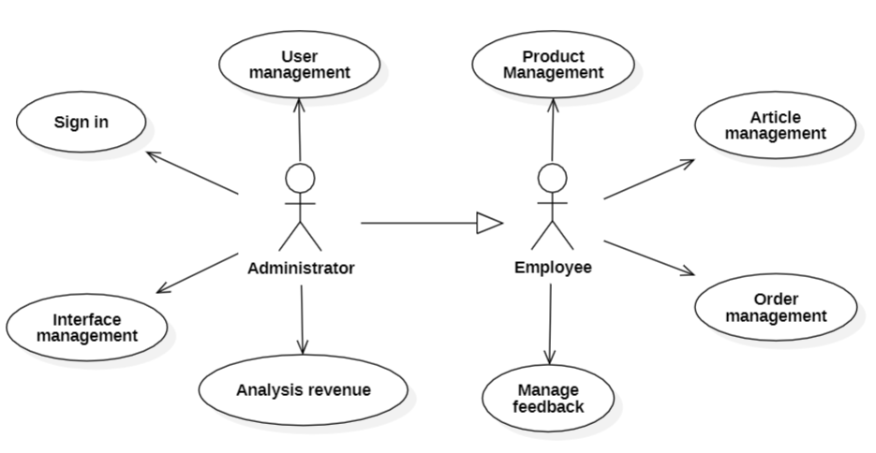

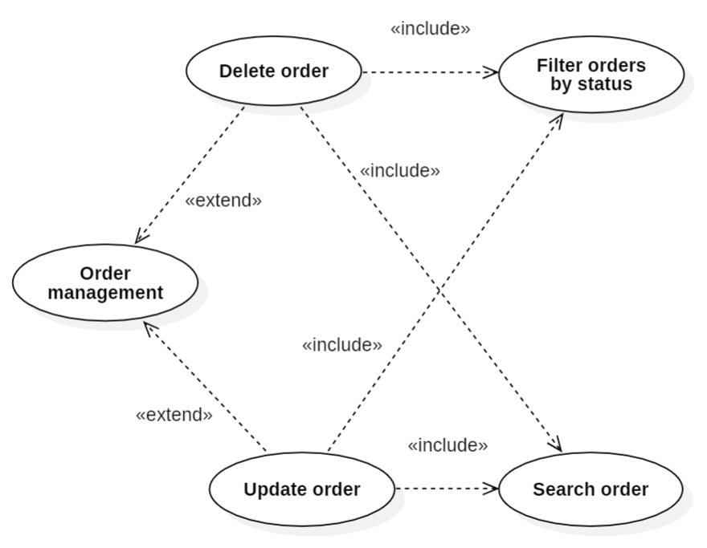

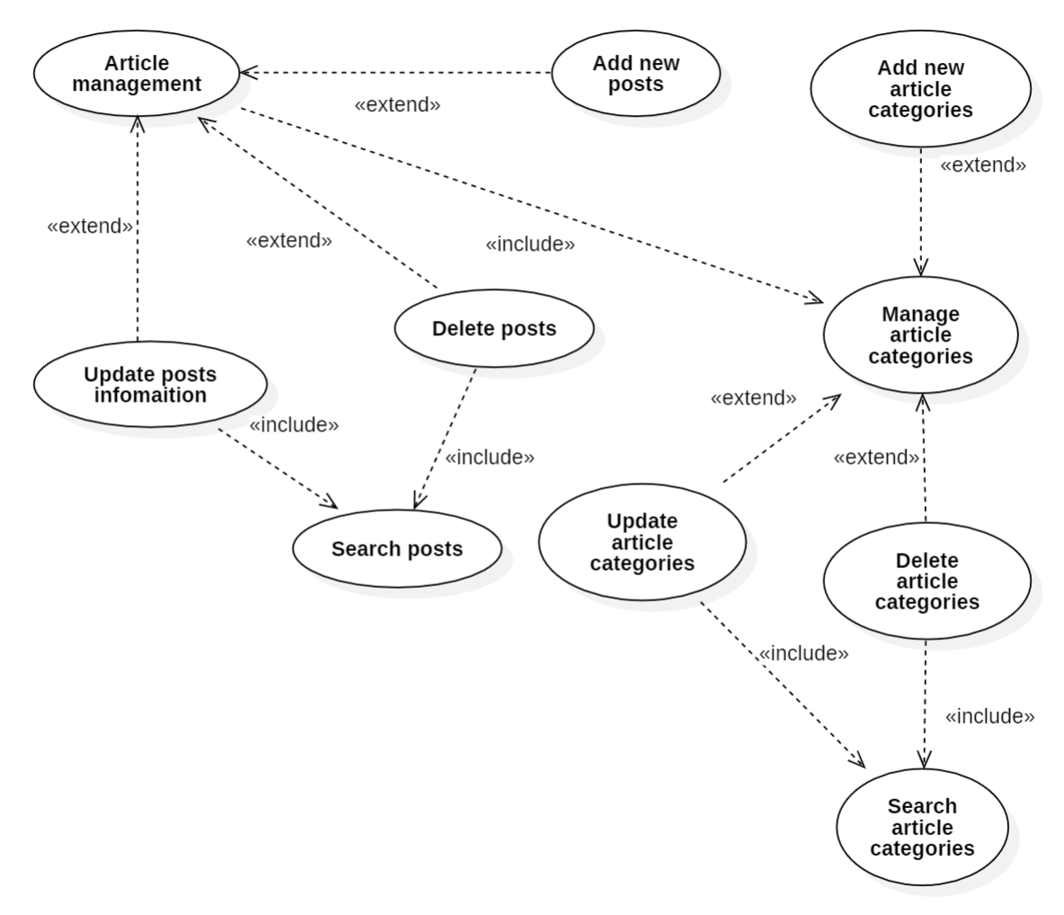

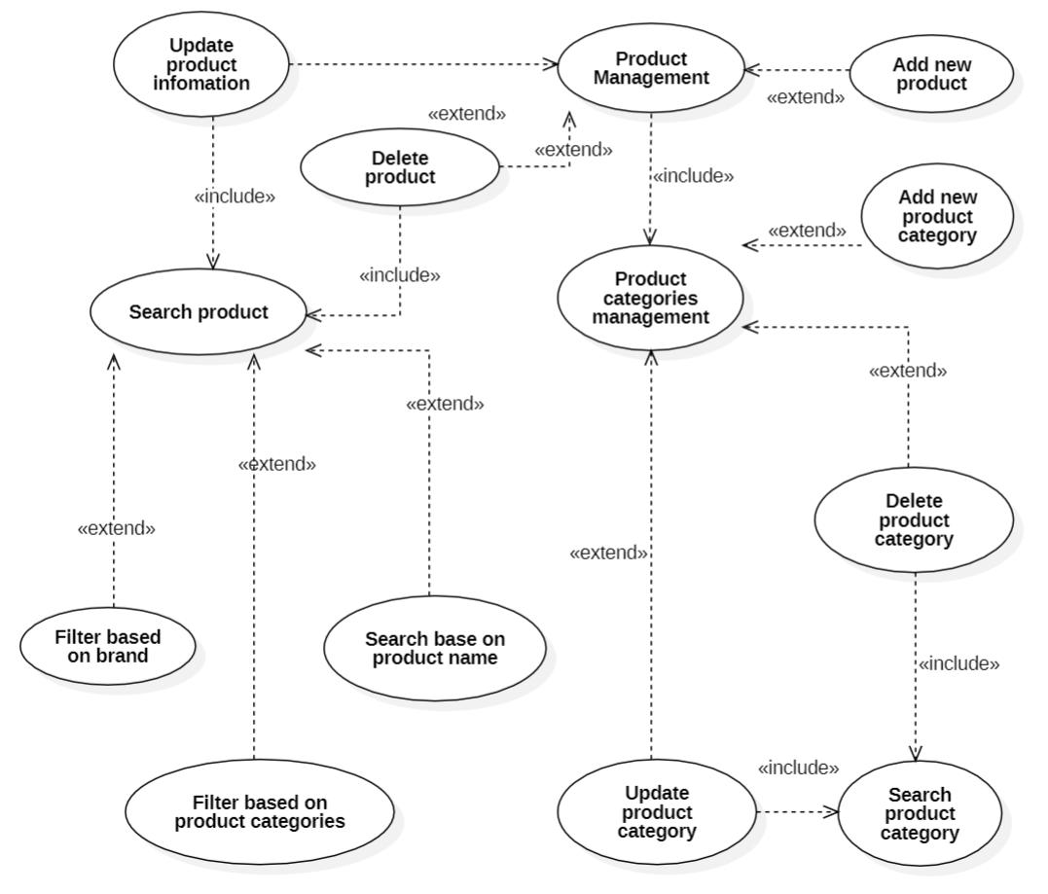

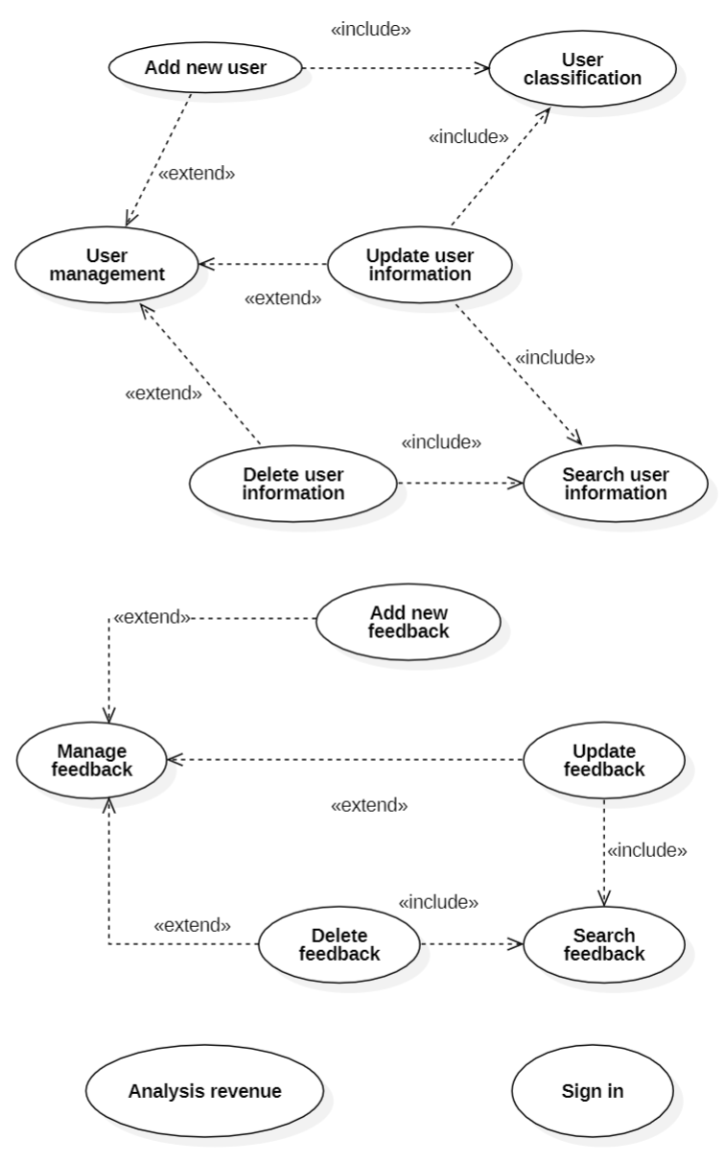

### 3.1.2. Customer

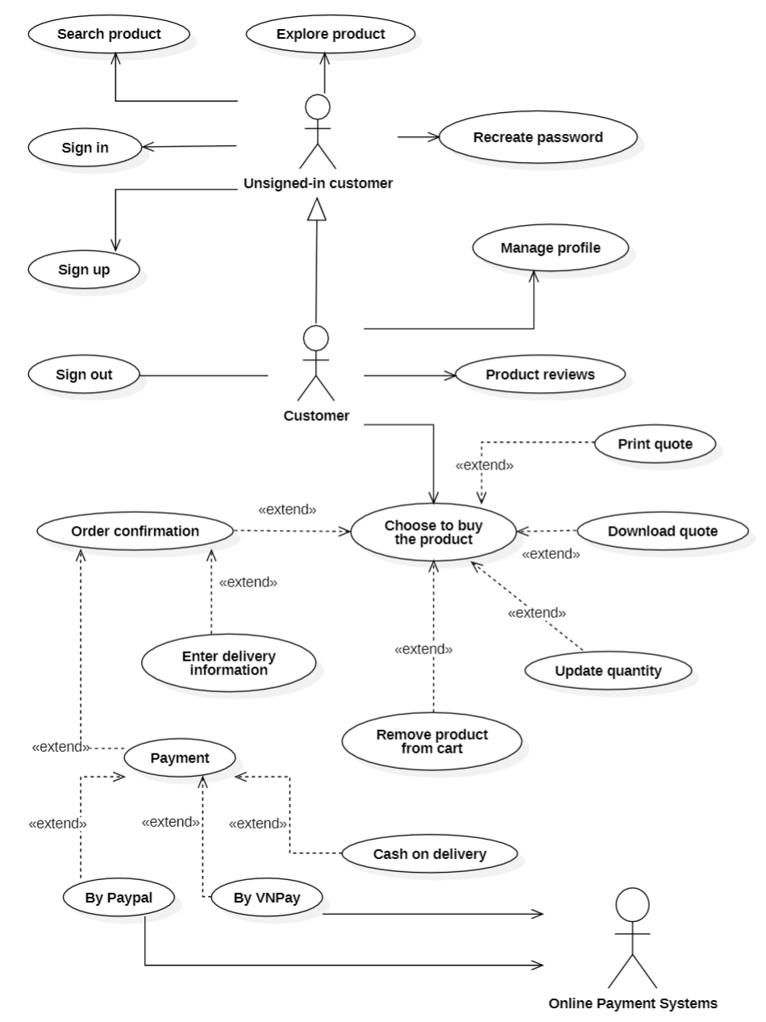

## 3.2. List of actors

|  |  |  |
| --- | --- | --- |
| Index | Actor | Meaning |
| 1 | Admin | System Administrator, the system's highest user |
| 2 | Customer | People is signed-in to system and available to use all the system’s services. |
| 3 | Unsigned-in customer | People can sign in / sign up to use all the system’s services and can view and explore products. |
| 4 | Online payment system | The system processes payments via payment methods from third parties. |
| 5 | Employee |  |

## 3.3. List of use-case

|  |  |  |
| --- | --- | --- |
| Role | Use case | Meaning |
| Customer’s Role | Sign up | Sign up for membership. |
| Sign in | Sign in for using services. |
| Sign out | Exit permission to use all services. |
| Search product | Search information such as product name, brand, category, and so on. |
| Explore product | See the now showing product and related information. |
| Manage profile | Customers can change private information. |
| Product reviews | Once signed in, purchased and experienced the product, customers can write feedback and reviews about the product. |
| Choose to buy the product | Customers choose to buy products from the website. |
| Admin’s Role | Sign in | Sign in to play the role. |
| Analysis revenue | Admin has the functions of calculating monthly revenue, daily revenue, number of products and number of members. |
| User management | Manage user information and classify users. |
| Product management | Information about the product will be managed by the admin such as adding, deleting, editing and sort products by category. |
| Order management | Order information will be managed by the admin such as adding, deleting, and editing orders. |
| Article management | Information about the article will be managed by the admin such as adding, deleting, and editing articles. |
| Manage feedback | Information about the feedback will be managed by the admin such as adding, deleting, and editing feedback. |
| Interface management | The website interface will be managed by the admin such as adding, deleting and adjusting sections on the website interface. |
| Employee’s Role |  |  |

## 3.4. Use-case Specification and Activity Diagram

### 3.4.1. Use-case Sign Up

|  |  |
| --- | --- |
| **Use-case name** | **Sign Up** |
| Description | Users create an account for all system services. |
| Trigger | Users click to button “Sign Up”. |
| Pre-condition | User’s devices must connect to Internet. |
| Post-condition | User gets a notification about sign up successfully.  User account is created and can be used to sign in for a next time. |
| Basic flow | 0. Users click on sign up button.  1. The system display sign up the page.  2. The user enter information such as email, password, name, … and click confirm.  3. System validates user entered information in correct format.  4. System validates user information unique in database.  5. System store user information in the database.  6. System notify user that account created, user can sign-in by using this account. |
| Alternative flow | System displays invalid information due to wrong format.  Use-case continue at step 2.  The system displays invalid information due to maybe have an existed account with user entered information.  Use-case continue at step 2. |
| Exception flow |  |

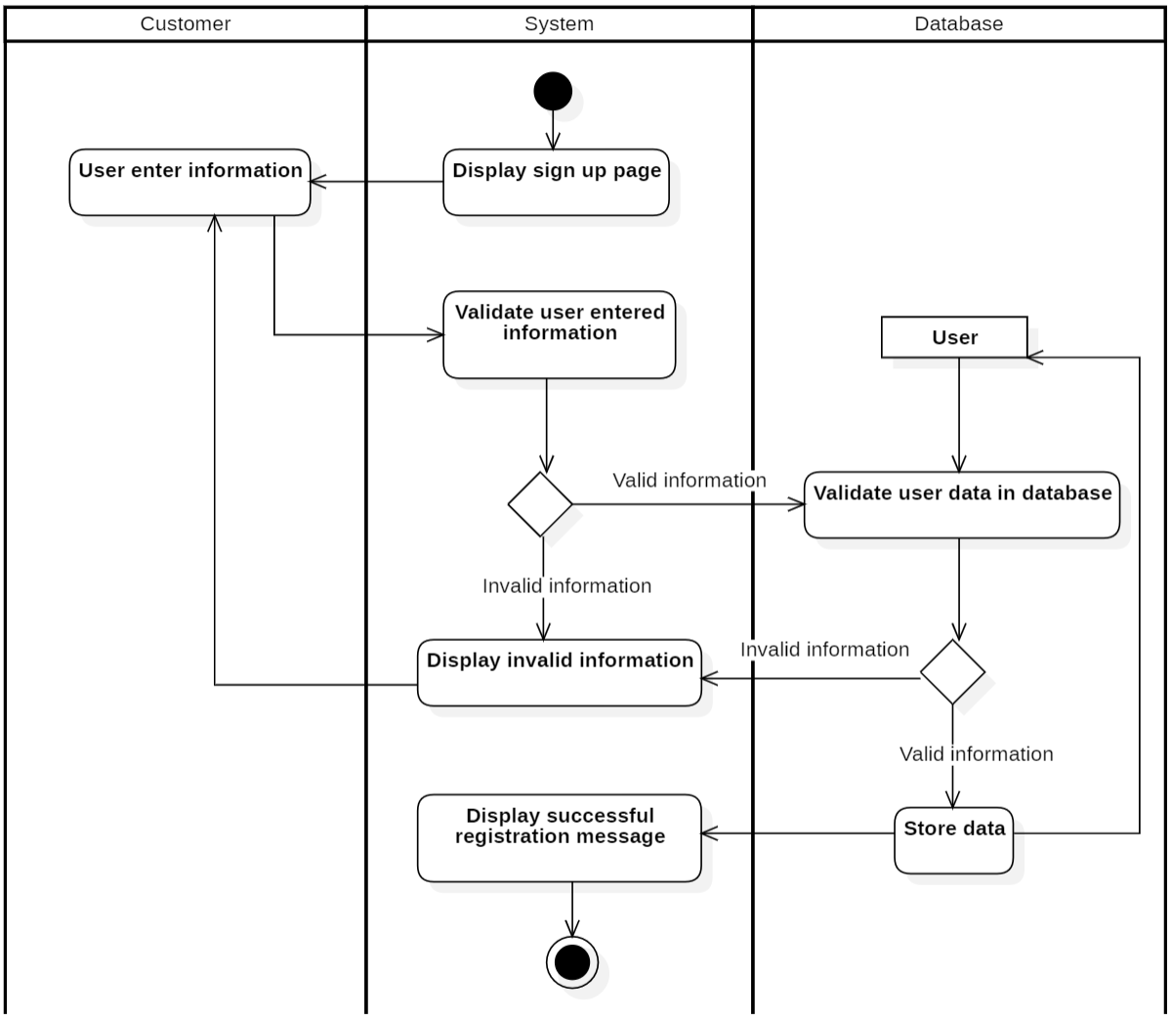

### 3.4.2. Use-case Sign in

|  |  |
| --- | --- |
| **Use-case name** | **Sign In** |
| Description | Users use exist account to sign-in to system for all services. |
| Trigger | Users click to button “Sign In”. |
| Pre-condition | User’s devices must connect to the Internet.  User’s account existed. |
| Post-condition | Users get a notification about sign in successful.  Users redirected to home page and users can use services. |
| Basic flow | 0. Users click on the sign in button.  1. The system displays a sign in the page.  2. The user enters email & password and click confirm.  3. System validates user entered information in correct format.  4. System validates user’s input data with existed account data in database.  5. System store sign-in status using sessions.  6. System displays successful signed-in and redirect to home page.  7. System saves users sign-in status. |
| Alternative flow | System displays invalid information due to wrong format.  Use-case continue at step 2.  The system displays invalid information due to user’s account information does not match with existed account information in database.  Use-case continue at step 2. |
| Exception flow |  |

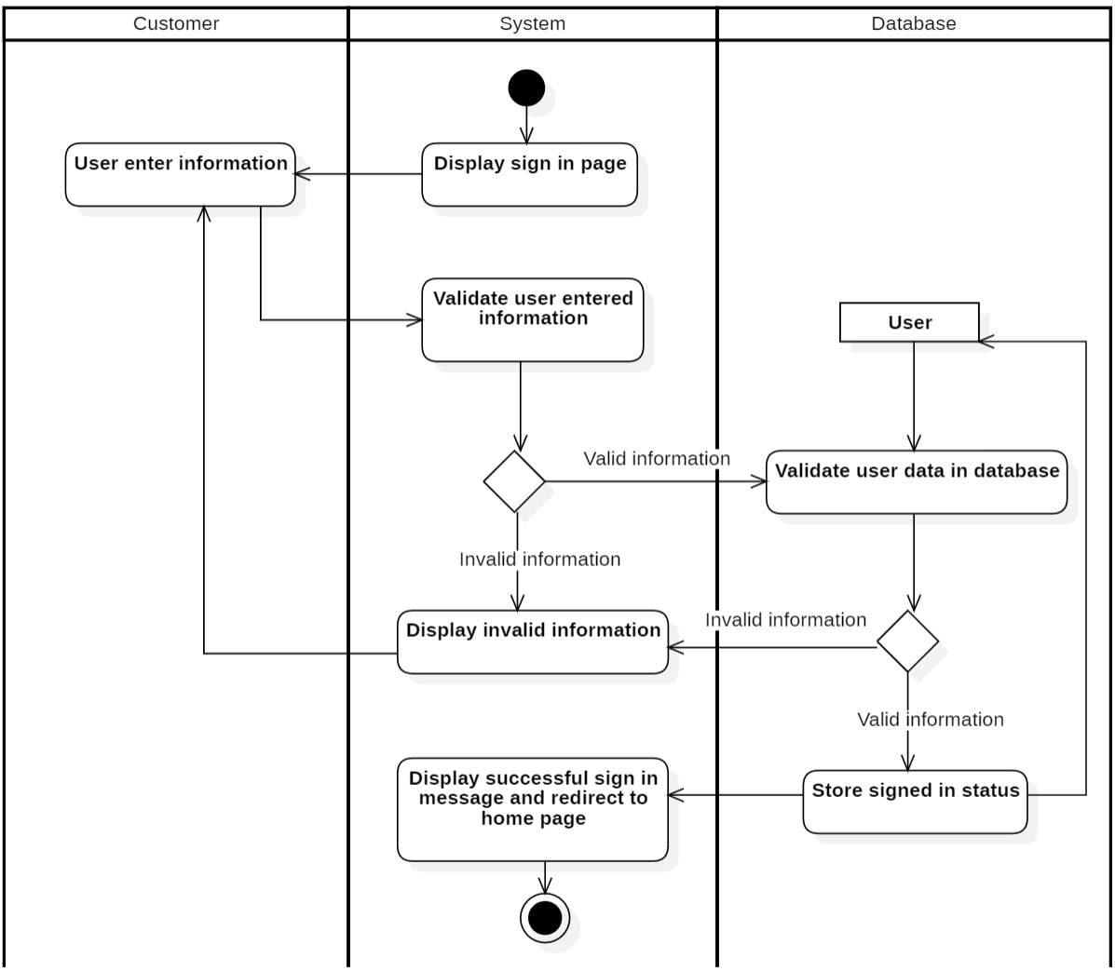

### 3.4.3. Use-case Search product

|  |  |
| --- | --- |
| **Use-case name** | **Explore product** |
| Description | Search information such as product name, brand, category, and so on. |
| Trigger | Customers click on the "Search" button. |
| Pre-condition | Customer’s devices must connect to the Internet. |
| Post-condition | The customer's order is confirmed successfully.  Customer’s payment information is stored into the database. |
| Basic flow | 1. Customers enter keywords on textfield and then click “Search” button. (with magnifying glass icon) 2. The system processing request. 3. The system queries a list of products related to keywords. 4. The system redirects customers to the result page. 5. The system displays the results page with related products briefly described. |
| Alternative flow |  |
| Exception flow | 3a. The system displays an empty result message in case the product is not found.  Use-case continues at step 1. |

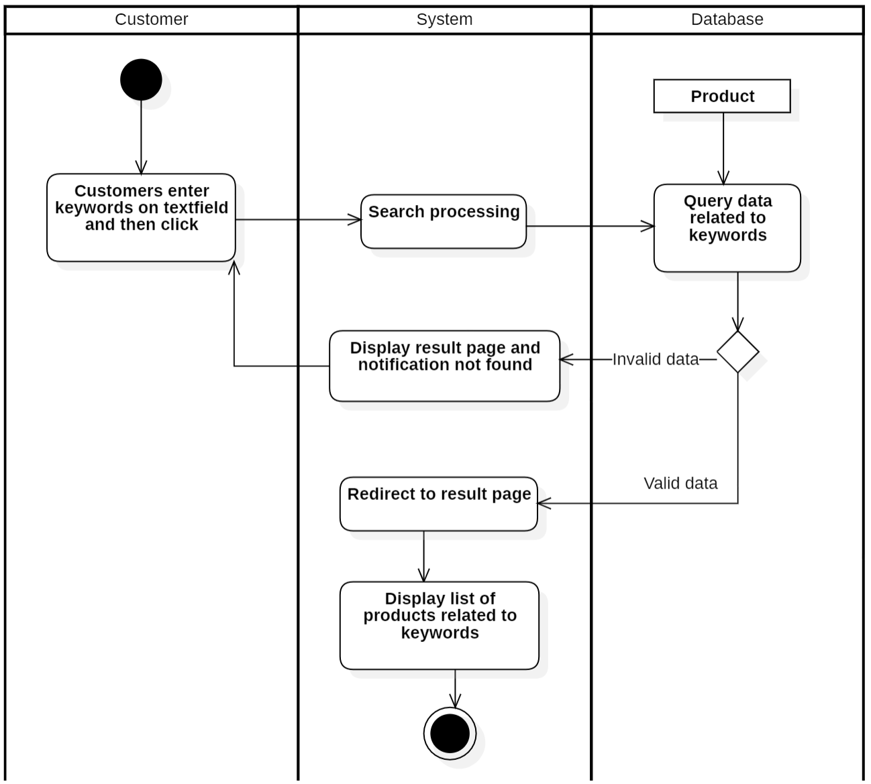

### 3.4.4. Use-case Explore product

|  |  |
| --- | --- |
| **Use-case name** | **Explore product** |
| Description | Customers want to explore products |
| Trigger | Customers click to button “Product” |
| Pre-condition | Customer’s devices must connect to Internet |
| Post-condition | Customer gets a list of products with detail information |
| Basic flow | 1. Customers select a product need to explore. 2. The system sends process display product request. 3. The system displays detailed product information. |
| Alternative flow |  |
| Exception flow |  |

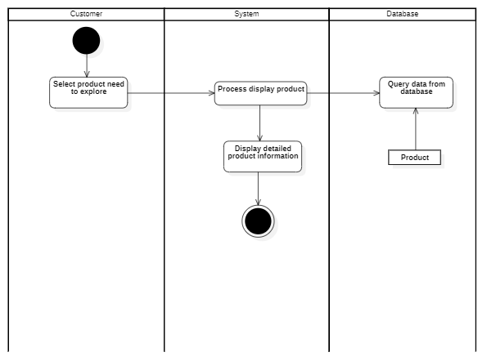

### 3.4.5. Use-case Manage profile

|  |  |
| --- | --- |
| **Use-case name** | **Manage Profile** |
| Description | Customer change private information. |
| Trigger | Customers click on the "Profile" button. |
| Pre-condition | Customer’s devices must connect to the Internet.  Customer’s account existed.  Customer’s status is signed in. |
| Post-condition | Customers get payment history with detailed information. |
| Basic flow | 1. Customers click on button “Profile” 2. The system queries the customer’s information and customers payment history based on signed-in status. 3. The system displays payment history on the page with detailed information. 4. Customers enter new information such as name, date of birth, email and number phone,.. 5. The system validates customers’ information in a correct format. 6. System stores new data in a database. 7. The system displays a successful message. |
| Alternative flow | 5a. The system displays invalid information due to wrong format. Use-case continue at step 4. |
| Exception flow |  |

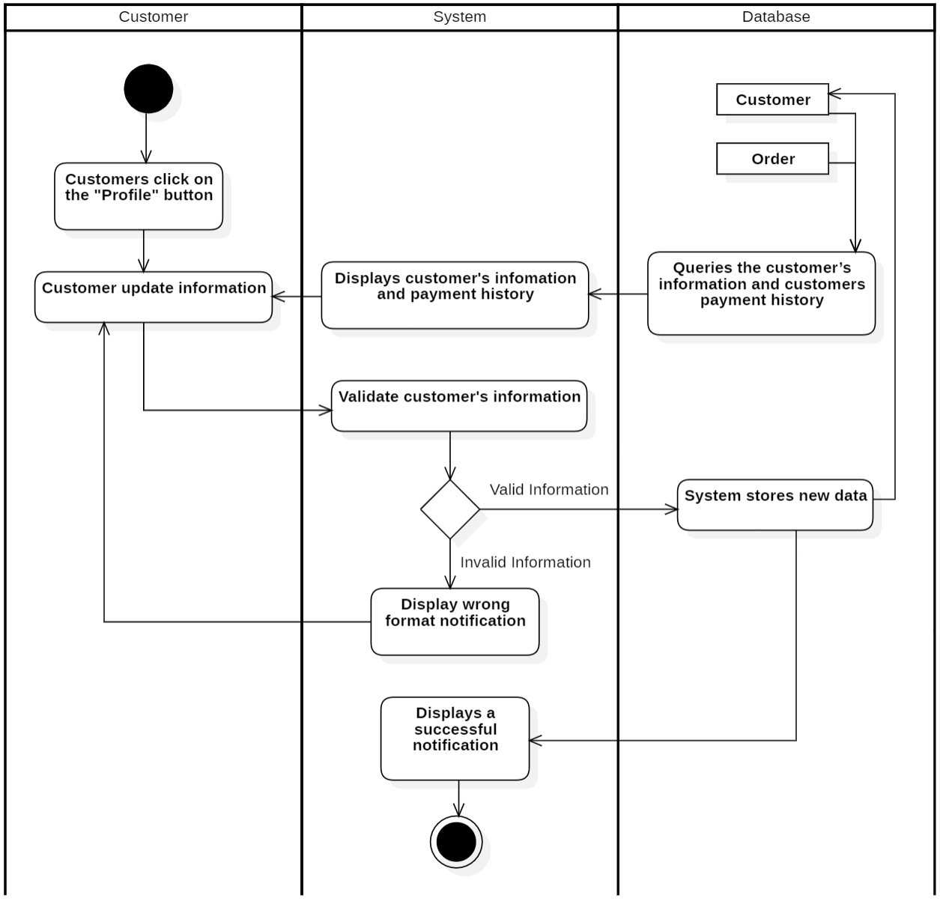

### 3.4.6. Use-case Recreate Password

|  |  |
| --- | --- |
| **Use-case name** | **Recreate Password** |
| Description | Customers forgot account password so cannot sign-in to system for all services. |
| Trigger | Customers click on the "Forgot password" button. |
| Pre-condition | Customer’s devices must connect to the Internet.  Customer’s account existed.  Customers forgot password and cannot sign-in.  Customers must remember sign-up email. |
| Post-condition | Customers get an email containing a new password notification about sign in successfully.  Customer’s password will be updated in the database. |
| Basic flow | 1. Customers click on “Forgot password” button. 2. System displays forgot password page. 3. Customers enter signed-up email. 4. The system validates customers’ email in a correct format. 5. The system validates the email of the customer in the database. 6. The system sends an email with a code to verify. 7. The system displays a popup enter the code. 8. Customer enter code taken from the email. 9. The system validates the code. 10. The system displays a popup for the customer to enter a new password. 11. The customer enters the new password and clicks confirm. 12. The system update data in the database. 13. The system displays successful message and redirected to login page. |
| Alternative flow |  |
| Exception flow | 4a. The system display invalid information due to wrong format  Use-case continue at step 3.  5a. The system display invalid information due to no existed account been signed with customers’ entered email.  Use-case continue at step 3.  9a. In case the customer enters the wrong code, the system displays incorrect code.  Use-case continue at step 8. |

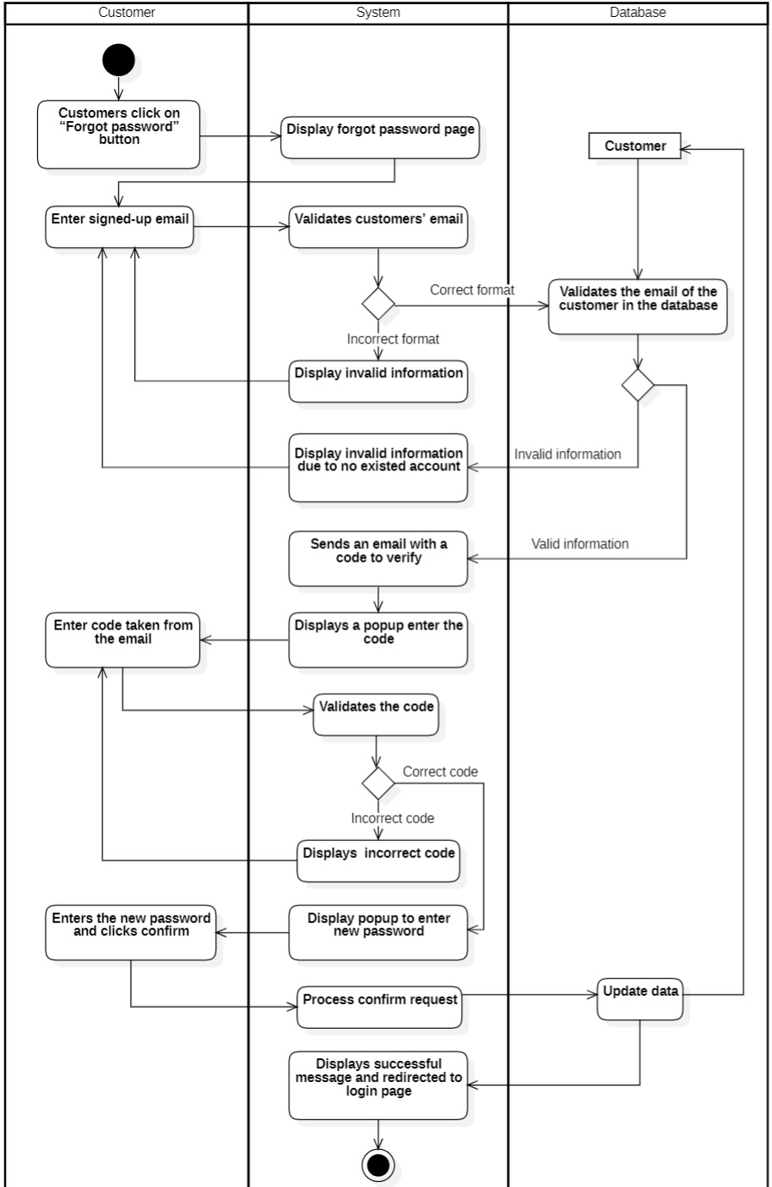

### 3.4.7. Use-case Product reviews

|  |  |
| --- | --- |
| **Use-case name** | **Product review** |
| Description | Once signed in, purchased and experienced the product, customers can write feedback and reviews about the product. |
| Trigger | Customers click to view the product information detail page. |
| Pre-condition | User’s devices must connect to the Internet.  Customer’s account existed.  Customer’s status is signed-in. |
| Post-condition | Customers conduct reviews and submit review information. |
| Basic flow | 1. Customer click to select the product. 2. The system displays the product detail information page. 3. Customers click on the write review button. 4. Customers rate the product by number of stars, write a review. 5. Customer click to button “Send”. 6. The system store rate information in the database. 7. The system sends a success notification and thanks. |
| Alternative flow |  |
| Exception flow |  |

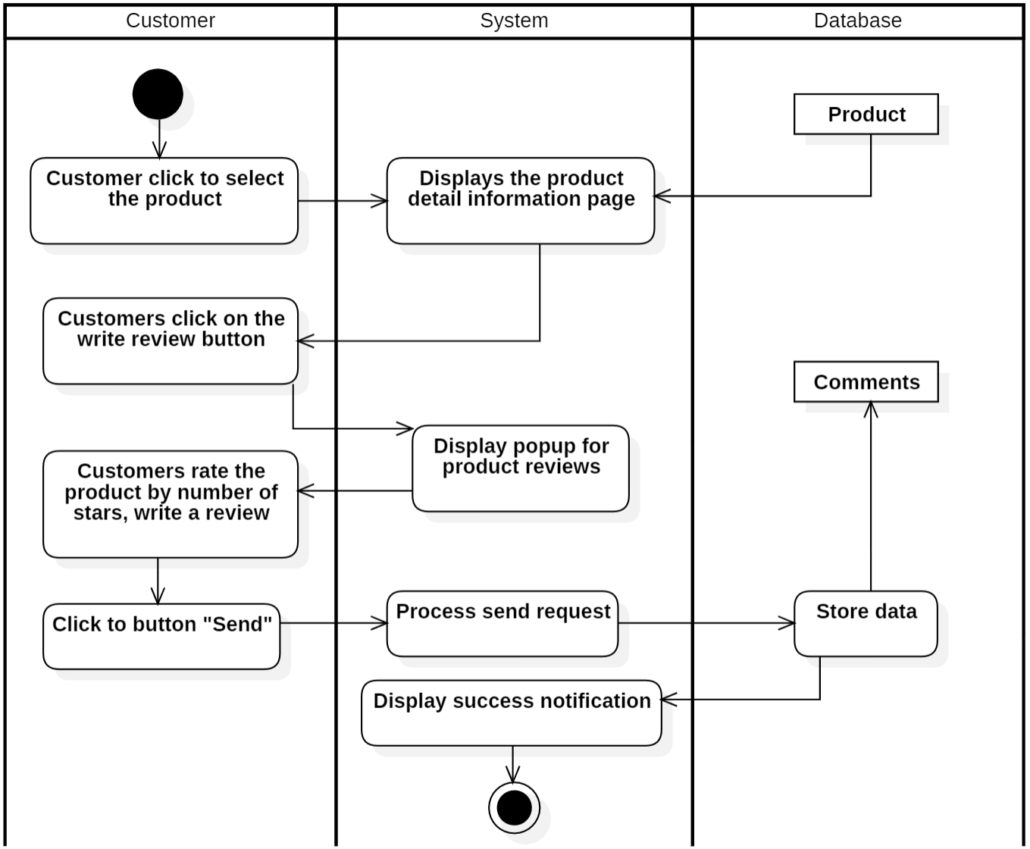

### 3.4.8. Use-case Choose to buy the product

|  |  |
| --- | --- |
| **Use-case name** | **Choose to buy the product** |
| Description | The customer choose to buy products from the website. |
| Trigger | The customer click on the "buy now" button. |
| Pre-condition | Customer’s devices must connect to the Internet.  Customer’s account existed.  Customer’s status is signed-in. |
| Post-condition | Customers check and store order information. |
| Basic flow | 1. The system displays a list of products. 2. The customer chooses to buy products from the list of available displayed products. 3. The system processes adding products to the customer's shopping cart and displays the message "product has been added to cart". 4. The customer click on the shopping cart. 5. The system displays product information including a list of products, information, quantity and price on each product as well as the total price. 6. The customer chooses one of the following functions: 7. If the customer chooses the function update quantity:   The S1 – Update quantity sub-flows is executed:   1. If the customer chooses the function print quote:   The S2 – Print quote sub-flows is executed:   1. If the customer chooses the function download quote:   The S3 – Download quote sub-flows is executed:   1. If the customer chooses the function remove a product from cart:   The S4 – Remove a product sub-flows is executed   1. If the customer chooses the function remove all product from cart:   The S5 – Remove all product from cart sub-flows is executed: |
| Alternative flow | **S1 - Update quantity:**  S1.1: The customer clicks "+" to add or "-" to reduce the number of product.  S1.2: The system process update.  S1.3: The system updates the quantity into the database.  S1.4: The system displays a successful notification.  **S2 - Print quote:**  S2.1: The customer clicks “Print quote”.  S2.2: The system displays a popup to print and a preview of the quote.  S2.3: The customer clicks on the “Print” button.  S2.4: The system displays a successful notification.  **S3 - Download quote:**  S3.1: The customer clicks “Download quote”.  S3.2: The system displays a popup to download and a preview of the quote.  S3.3: The customer clicks on the “Download” button.  S3.4: The system displays a successful notification.  **S4: Remove a product from cart:**  S4.1: The customer clicks on the remove button.  S4.2: Process deletion request.  S4.3: The system update invoice in the database.  S4.4: The system displays a successful notification.  **S5 – Remove all product from cart:**  S5.1: The customer clicks on the “Remove product from cart” button.  S5.2: The system deletes all products in the shopping cart, displays the message "cart is empty" and returns to the home page. |
| Exception flow |  |

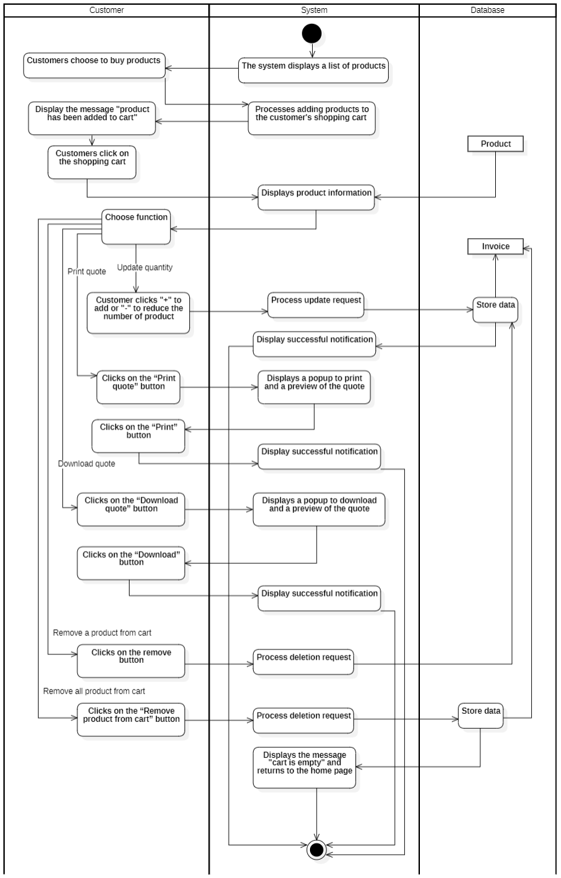

* **Use-case Order confirmation**

|  |  |
| --- | --- |
| **Use-case name** | **Order confirmation** |
| Description | Customers proceed to provide payment information and confirm order. |
| Trigger | Customers click on the "order confirmation" button. |
| Pre-condition | Customer’s devices must connect to the Internet.  Customer’s account existed.  Customer’s status is signed-in. |
| Post-condition | The customer's order is confirmed successfully.  Customer’s payment information is stored into the database. |
| Basic flow | 1. The system displays the shopping cart details page. 2. The customer clicks the "order confirmation" button. 3. The system redirects customers to the checkout page. 4. The customer enters a promotion voucher (if any). 5. The customer enters purchase information including full name, email, phone number, address and note. 6. The customer selects an appropriate payment method. 7. The system waits for payment from customers. Customers continue to enter payment information (Mastercard, Visa,…) at the payment provide pop-up. 8. The system stores payment information, update bonus points for users in the database. 9. The system displays successful message to customers, send invoices email and redirects customers to homepage. |
| Alternative flow |  |
| Exception flow | 7a. In case the customer enters invalid payment information, the customer cannot confirm a transaction from payment provided due to any reason – payment failure.  Use-case continues at step 10.  8a. In case of an error from the payment method provider, the system displays the payment failure reason from payment provider.  Use-case continue at step 10. |

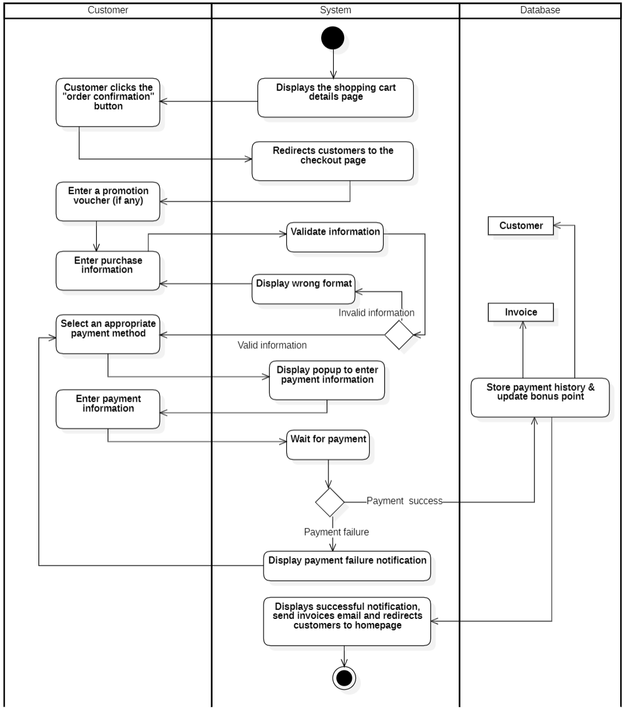

### 3.4.9. Use-case Sign-in for Administrator

|  |  |
| --- | --- |
| **Use-case name** | **Sign in (for administrator)** |
| Description | Administrator use exist management account to sign-in to system for all monitoring. |
| Trigger | Administrators clicks to button “Sign in” at management page. |
| Pre-condition | Administrators’ device must connect to Internet.  Administrators’ account existed. |
| Post-condition | Administrators get a notification about signed-in successful.  Administrators is redirected to management page. |
| Basic flow | 0. Administrators clicks “Sign in” button at management page.  1. System display management sign-in page.  2. Administrators enter email & password.  3. System validate administrators entered email & password in correct format.  4. System validates administrators’ data with existed administrator  account in database.  5. System store signed-in status of administrators using sessions.  6. System displays successful signed-in and redirect to management   1. page. |
| Alternative flow | 3a. System display invalid information due to wrong format.  Use-case continue at step 2.  4a. System display invalid information due to administrators’ account information does not match with existed account information in database.  Use-case continue at step 2. |
| Exception flow |  |

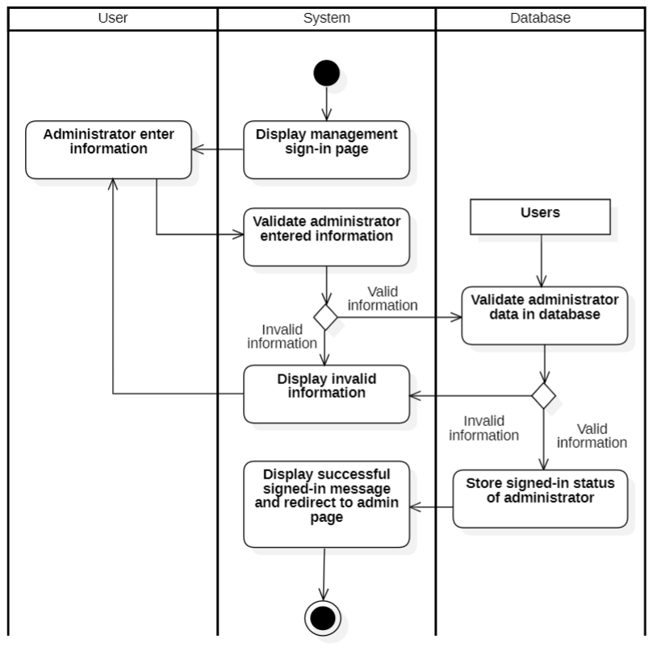

### 3.4.10. Use-case Analysis revenue

|  |  |
| --- | --- |
| **Use-case name** | **View revenue (for administrator)** |
| Description | Administrator can view the revenue in the database. |
| Trigger | Administrators click on the "Revenue (month) or Revenue (year)" button on the admin page to view details or do not need to click (only basic view). |
| Pre-condition | Administrators’ device must connect to Internet.  Administrators’ account existed.  Administrator’s status is signed in. |
| Post-condition | The order is stored in the database.  The admin management page is reloaded with the data queried from the database. |
| Basic flow | 1. System display admin page with data loaded from database.  2. Administrators select revenue view function to view details or do not need to click (only basic view).  3. System processes viewing data.  4. System display detail and redirect to revenue detail management page. |
| Alternative flow |  |
| Exception flow |  |

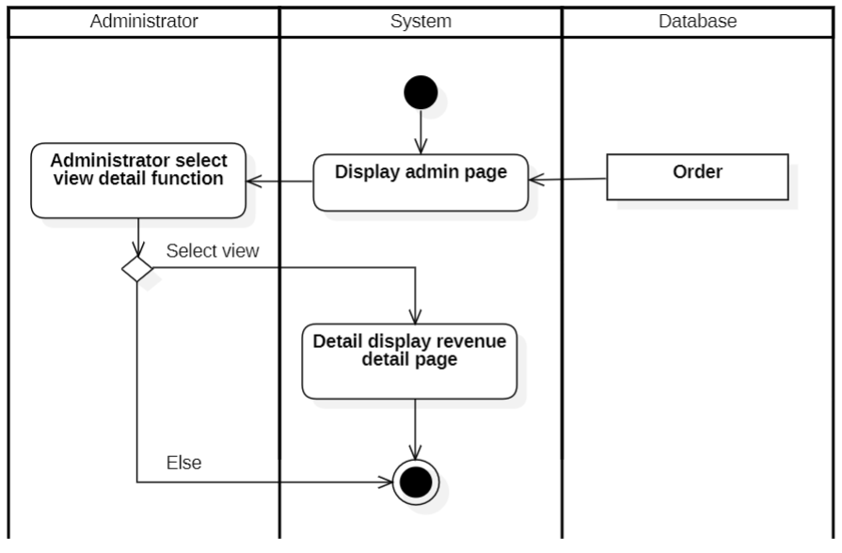

### 3.4.11. Use-case User management

|  |  |
| --- | --- |
| **Use-case name** | **Manage user (for administrator)** |
| Description | This use case describes how administrator make, update, delete, and search a user. |
| Trigger | The administrator chooses the user management function to create, update, delete, and search for the user. |
| Pre-condition | Administrators’ device must connect to Internet.  Administrators’ account existed.  Administrator’s status is signed in.  User information must be existed in database.  No external data involved. |
| Post-condition | The user is stored in the database.  The user management page is reloaded with the data queried from the database. |
| Normal flows | 1. The system displays the user management page with the data queried from the database. 2. The administrator chooses one of the following functions: 3. If the administrator chooses the function to create a new user:   The S1 – Create user sub-flows is executed.   1. If the administrator chooses the function to update user:   The S2 – Update user sub-flows is executed.   1. If the administrator chooses the function to search user:   The S3 – Search user sub-flows is executed.   1. If the administrator chooses the function to delete user:   The S4 – Delete user sub-flows is executed. |
|  | **S1 – Create user.**  S1.1. System display user management page with data loaded from database.  S1.2. Administrators select create function.  S1.3. System display user information form.  S1.4. Administrators enter user information.  S1.5. System validate user information in correct format.  S1.6. System validates user information with existed data in database.  S1.7. System stores user information in database.  S1.8. System updates data at user management page with inserted data (new data).  **S2 – Update user.**  S2.1. System display user management page with data loaded from database.  S2.2. Administrators select update function and item to be updated.  S2.3. System display user information form with existed data.  S2.4. Administrators modify user information.  S2.5. System validate user information in correct format.  S2.6. System validates user information with existed data in database.  S2.7. System updates user information in the database.  S2.8. System updates data at user management page with updated data at selected item.  **S3 – Search user.**  S3.1. System display user management page with data loaded from database.  S3.2. Administrators select search function and enter keywords.  S3.3. System processes searching data.  S3.4. System queries data based on keywords.  S3.5. System updates data at user management page (data related to keyword is retained).  **S4 – Delete user.**  S4.1. System display user management page with data loaded from database.  S4.2. Administrators select delete function and item to be deleted.  S4.3. System processes delete request.  S4.4. System validates no external data required user information and selected account existed in database.  S4.5. System deletes user information in the database.  S4.6. System updates data at user management page with selected account deleted. |
| Alternative flow or Exception | **S1 – Create user.**  S1.5a. System display invalid information due to wrong format.  Use-case continue at step S1.4.  S1.6b. System display invalid information because data had been existed in the database.  Use-case continue at step S1.4.  **S2 – Update user.**  S2.5a. System display invalid information due to wrong format.  Use-case continue at step S2.4.  S2.6b. System display invalid information because selected data hadn’t been existed in the database.  Use-case continue at step S2.4.  **S3 – Search user.**  S3.4a. System displays empty result notification.  Use-case continue at step S3.5 (no data is retained)  **S4 – Delete user.**  S4.5a. System display error notification because external data had required that user information or no data existed.  Use-case stop. |

Create User:

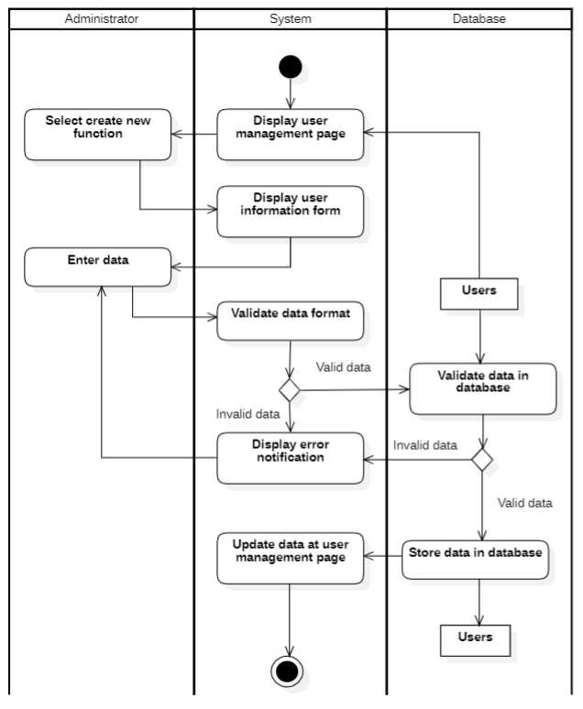

Update User:

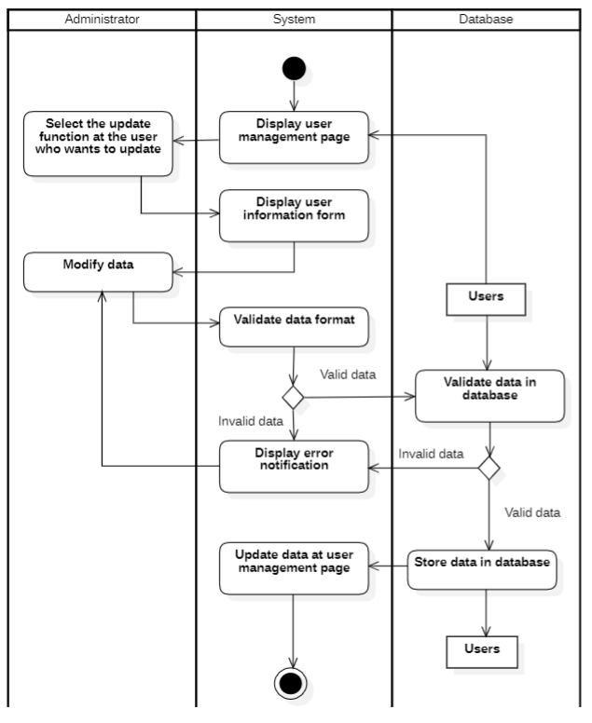

Search User:

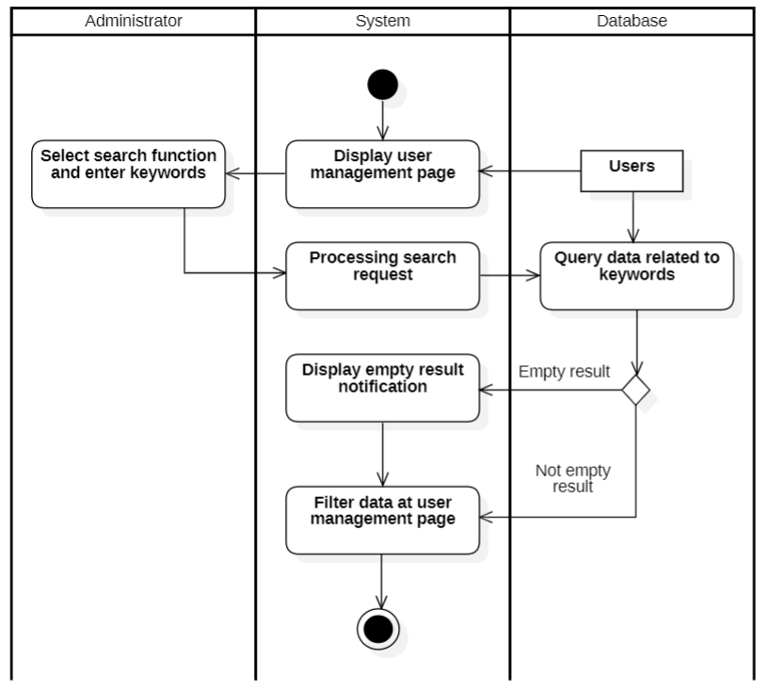

Delete User:

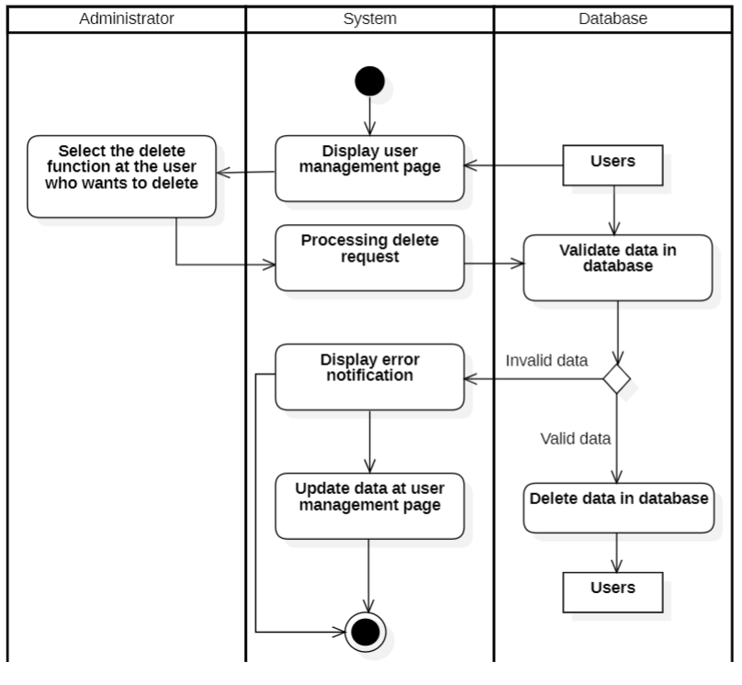

### 3.4.12. Use-case Product management

|  |  |
| --- | --- |
| **Use-case name** | **Manage product (for administrator)** |
| Description | This use case describes how administrator make, update, delete, and search a product. |
| Trigger | The administrator chooses the product management function to create, update, delete, and search for the product. |
| Pre-condition | Administrators’ device must connect to Internet.  Administrators’ account existed.  Administrator’s status is signed in.  Product information must be existed in database.  No external data involved. |
| Post-condition | The product is stored in the database.  The product management page is reloaded with the data queried from the database. |
| Normal flow | 1. The system displays the product management page with the data queried from the database. 2. The administrator chooses one of the following functions: 3. If the administrator chooses the function to create a new product:   The S1 – Create product sub-flows is executed.   1. If the administrator chooses the function to update product:   The S2 – Update product sub-flows is executed.   1. If the administrator chooses the function to search product:   The S3 – Search product sub-flows is executed.   1. If the administrator chooses the function to delete product:   The S4 – Delete product sub-flows is executed. |
|  | **S1 – Create product.**  S1.1. System display product management page with data loaded from database.  S1.2. Administrators select create function.  S1.3. System display product information form.  S1.4. Administrators enter product information.  S1.5. System validate product information in correct format.  S1.6. System validates product information with existed data in database.  S1.7. System stores product information in database.  S1.8. System updates data at product management page with inserted data (new data).  **S2 – Update product.**  S2.1. System display product management page with data loaded from database.  S2.2. Administrators select update function and item to be updated.  S2.3. System display product information form with existed data.  S2.4. Administrators modify product information.  S2.5. System validate product information in correct format.  S2.6. System validates product information with existed data in database.  S2.7. System updates product information in the database.  S2.8. System updates data at product management page with updated data at selected item.  **S3 – Search product.**  S3.1. System display product management page with data loaded from database.  S3.2. Administrators select search function and enter keywords.  S3.3. System processes searching data.  S3.4. System queries data based on keywords.  S3.5. System updates data at product management page (data related to keyword is retained).  **S4 – Delete product.**  S4.1. System display product management page with data loaded from database.  S4.2. Administrators select delete function and item to be deleted.  S4.3. System processes delete request.  S4.4. System validates no external data required product information and selected item existed in database.  S4.5. System deletes product information in the database.  S4.6. System updates data at product management page with selected item deleted. |
| Alternative flow or Exception | **S1 – Create product.**  S1.5a. System display invalid information due to wrong format.  Use-case continue at step S1.4.  S1.6b. System display invalid information because data had been existed in the database.  Use-case continue at step S1.4.  **S2 – Update product**  S2.5a. System display invalid information due to wrong format.  Use-case continue at step S2.4.  S2.6b. System display invalid information because selected data hadn’t been existed in the database.  Use-case continue at step S2.4.  **S3 – Search product.**  S3.4a. System displays empty result notification.  Use-case continue at step S3.5 (no data is retained)  S4 – Delete product.  S4.5a. System display error notification because external data had required that product information or no data existed.  Use-case stop. |

Create Product:

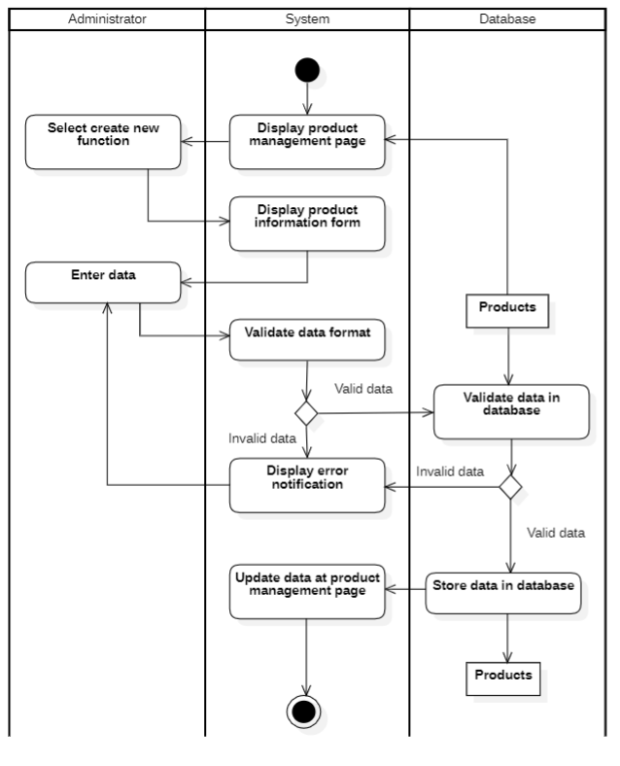

Update Product:

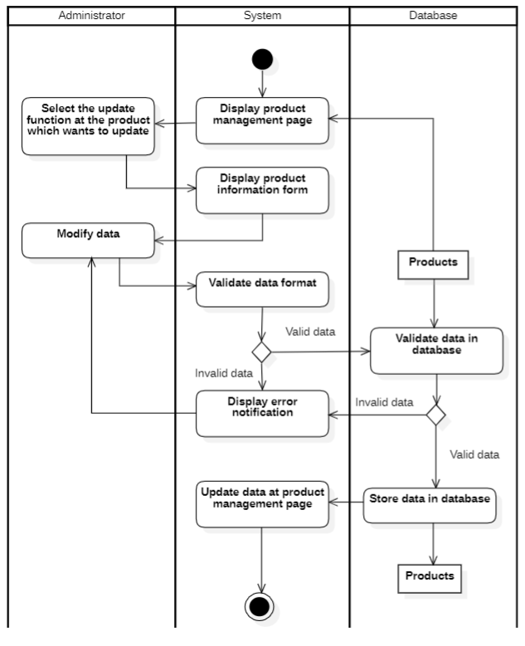

Search Product:

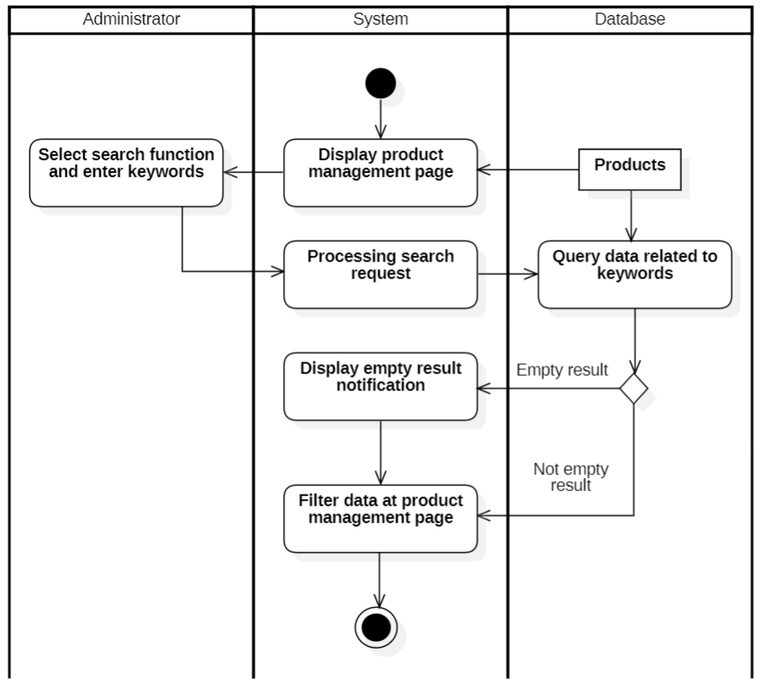

Delete Product:

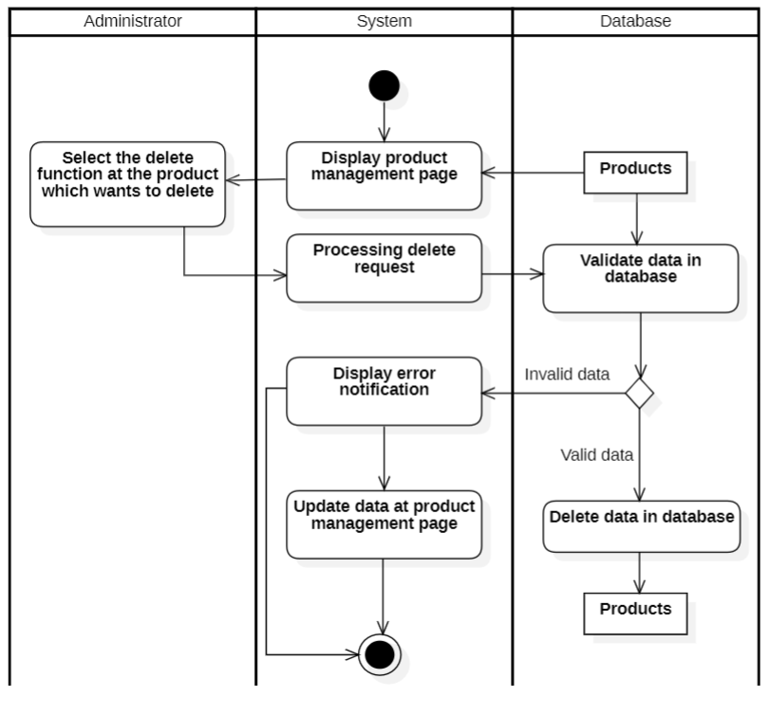

### 3.4.13. Use-case Order management

|  |  |
| --- | --- |
| **Use case name** | **Order management** |
| Description | This use case describes how admin make, update, delete, and search the order. |
| Trigger | The admin chooses the order management function to filter, update, delete and search for the order. |
| Pre-condition | User devices must be connected to the internet.  The User logs into the system with the admin role. |
| Post-condition | The order is stored in the database.  The order management page is reloaded with data queried from database |
| Normal flows | 1. The system displays an order management page with the data queried from the database. 2. The admin chooses one of the following functions: 3. If the admin chooses the function to Filter order by status, then the S1-Filter order sub-flow is performed. 4. If the admin chooses the function to update a new order, then the S2-Update order sub-flow is performed. 5. If the admin chooses the function to delete a new order, then the S3-Delete order sub-flow is performed. 6. If the admin chooses the function to search a new order, then the S4-Search order sub-flow is performed. |
| Sub flows | **S1 – Filter order**  S1.1: The admin chooses filter order by status.  S1.2: System processes filter request.  S1.3: System query status order data from database.  S1.4: The system displays successful notification and displays the order management page with data queried from the database.  **S2 -Update order**  S2.1: The admin chooses one order  to update information.  S2.2: The system displays the order page with the order  information from the database.  S2.3: The admin modifies order and confirms the creation of a new order .  S2.4: The system validates the format of information entered by the admin.  S2.5: The system validates the triggers and constraints in the database.  S2.6: The system stores the order in the database.  S2.7: The system displays successful notification and displays an order management page with data queried from the database.  **S3 - Delete order**  S3.1: The admin chooses one order  to delete information. S3.2: The system displays confirm delete dialog.  S3.3: The admin confirms deletion order  (chooses yes or no). a. If the admin chooses yes b. If the admin chooses no: Flow final.  S3.4: System processes delete request.  S3.5: System check availability of delete request.  S3.6: System deletes order  information in the database.  S3.7: The system stores the order in the database.  S3.8: The system displays successful notification and displays the order management page page.  **S4 – Search order**  S4.1: The admin enters keywords that need to be searched.  S4.2: System processes search request.  S4.3: System query data keywords from database.  S4.4: The system displays successful notification and displays the order management page with data queried from the database. |
| Alternative flows or Exception flows | **S2 – Update order**  S1.3a: The system displays an error notification due to wrong format. This use case continues with step S2.2.  S1.4a: The system displays an error notification due to violating constraints. This use case continues with step S2.2.  **S3 – Delete order :**   3a. System display error notification because external data had required that order  information (showtime) or no data existed. Use-case stop.  **S4 – Search order:**  4a. System displays empty result notifications. Use-case continue at step 4 (no data is retained) |

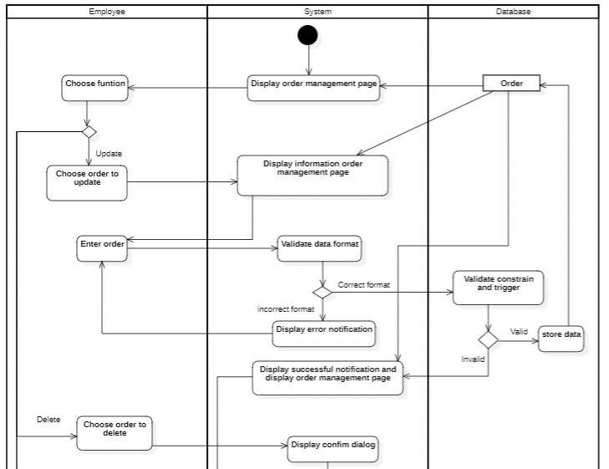

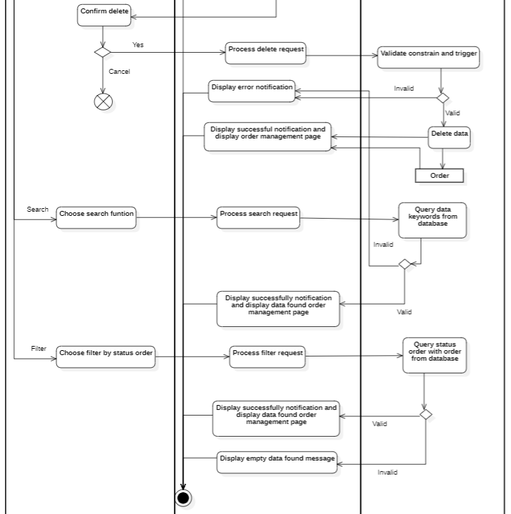

### 3.4.14. Use-case Article management

|  |  |
| --- | --- |
| **Use case name** | **Article management** |
| Description | This use case describes how admin make, update, delete, and search the article. |
| Trigger | The admin chooses the article management function to add, update, delete and search for the article. |
| Pre-condition | User devices must be connected to the internet.  The User logs into the system with the admin role. |
| Post-condition | The article is stored in the database.  The article management page is reloaded with data queried from database |
| Normal flows | 1. The system displays an article management page with the data queried from the database. 2. The admin chooses one of the following functions: 3. If the admin chooses the function to add a new article, then the S1-Add article sub-flow is performed. 4. If the admin chooses the function to update a new article, then the S2-Update article sub-flow is performed. 5. If the admin chooses the function to delete a new article, then the S3-Delete article sub-flow is performed. 6. If the admin chooses the function to search a new article, then the S4-Search article sub-flow is performed. |
| Sub flows | **S1 – Add article**  S1.1: The system displays the article page with the new article  ID from the database.  S1.2: The admin enters the article and confirms the creation of a new article .  S1.3: The system validates the format of information entered by the admin.  S1.4: The system validates the triggers and constraints in the database.  S1.5: The system stores the article in the database.  S1.6: The system displays successful notification and displays an article management page with data queried from the database.  **S2 -Update article**  S2.1: The admin chooses one article  to update information.  S2.2: The system displays the article page with the article  information from the database.  S2.3: The admin modifies the article and confirms the creation of a new article .  S2.4: The system validates the format of information entered by the admin.  S2.5: The system validates the triggers and constraints in the database.  S2.6: The system stores the article in the database.  S2.7: The system displays successful notification and displays an article management page with data queried from the database.  **S3 - Delete article**  S3.1: The admin chooses one article  to delete information. S3.2: The system displays confirm delete dialog.  S3.3: The admin confirms the deletion article  (chooses yes or no). a. If the admin chooses yes b. If the admin chooses no: Flow final.  S3.4: System processes delete request.  S3.5: System check availability of delete request.  S3.6: System deletes article  information in the database.  S3.7: The system stores the article in the database.  S3.8: The system displays successful notification and displays the article management page page.  **S4 – Search article**  S4.1: The admin enters keywords that need to be searched.  S4.2: System processes search request.  S4.3: System query data keywords from database.  S4.4: The system displays successful notification and displays the article management page with data queried from the database. |
| Alternative flows or Exception flows | **S1 – Add article**  S1.3a: The system displays an error notification due to wrong format. This use case continues with step S1.2.  S1.4a: The system displays an error notification due to violating constraints. This use case continues with step S1.2.  **S2 – Update article**  S1.3a: The system displays an error notification due to wrong format. This use case continues with step S2.2.  S1.4a: The system displays an error notification due to violating constraints. This use case continues with step S2.2.  **S3 – Delete article :**   3a. System display error notification because external data had required that article  information (showtime) or no data existed. Use-case stop.  **S4 – Search article:**  4a. System displays empty result notifications. Use-case continue at step 4 (no data is retained) |

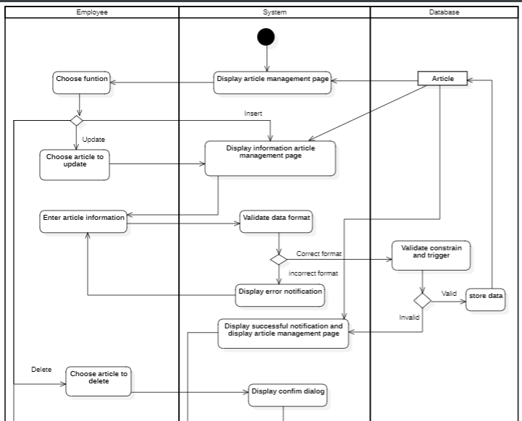 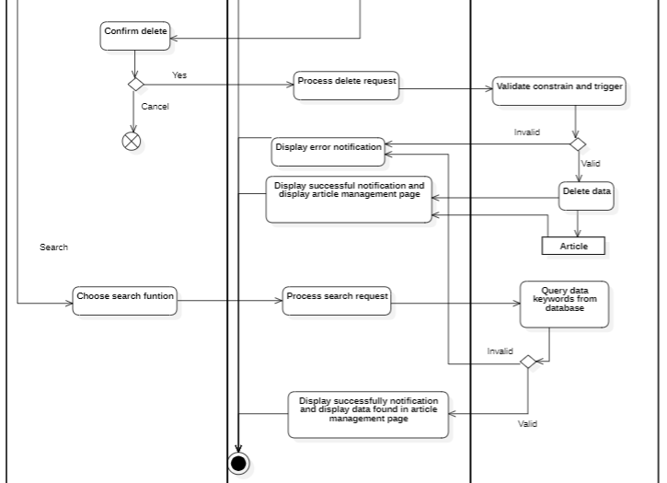

* **Article categories management**

|  |  |
| --- | --- |
| **Use case name** | **Article categories management** |
| Description | This use case describes how admin make, update, delete, and search the article categories. |
| Trigger | The admin chooses the article categories management function to add, update, delete and search for the article categories. |
| Pre-condition | User devices must be connected to the internet.  The User logs into the system with the admin role. |
| Post-condition | The article categories are stored in the database.  The article categories management page is reloaded with data queried from database |
| Normal flows | 1. The system displays an article categories management page with the data queried from the database. 2. The admin chooses one of the following functions: 3. If the admin chooses the function to add a new article category, then the S1-Add article categories sub-flow is performed. 4. If the admin chooses the function to update a new article category, then the S2-Update article categories sub-flow is performed. 5. If the admin chooses the function to delete a new article category, then the S3-Delete article categories sub-flow is performed. 6. If the admin chooses the function to search a new article category, then the S4-Search article categories sub-flow is performed. |
| Sub flows | **S1 – Add article categories**  S1.1: The system displays the article categories page with the new article categories  ID from the database.  S1.2: The admin enters the article categories and confirms the creation of new article categories .  S1.3: The system validates the format of information entered by the admin.  S1.4: The system validates the triggers and constraints in the database.  S1.5: The system stores the article categories in the database.  S1.6: The system displays successful notification and displays an article categories management page with data queried from the database.  **S2 -Update article categories**  S2.1: The admin chooses one article category  to update information.  S2.2: The system displays the article categories page with the article categories  information from the database.  S2.3: The admin modifies the article categories and confirms the creation of new article categories .  S2.4: The system validates the format of information entered by the admin.  S2.5: The system validates the triggers and constraints in the database.  S2.6: The system stores the article categories in the database.  S2.7: The system displays successful notification and displays an article categories management page with data queried from the database.  **S3 - Delete article categories**  S3.1: The admin chooses one article category  to delete information. S3.2: The system displays confirm delete dialog.  S3.3: The admin confirms the deletion article categories  (chooses yes or no). a. If the admin chooses yes b. If the admin chooses no: Flow final.  S3.4: System processes delete request.  S3.5: System check availability of delete request.  S3.6: System deletes article categories  information in the database.  S3.7: The system stores the article categories in the database.  S3.8: The system displays successful notification and displays the article categories management page page.  **S4 – Search article categories**  S4.1: The admin enters keywords that need to be searched.  S4.2: System processes search request.  S4.3: System query data keywords from database.  S4.4: The system displays successful notification and displays the article categories management page with data queried from the database. |
| Alternative flows or Exception flows | **S1 – Add article categories**  S1.3a: The system displays an error notification due to wrong format. This use case continues with step S1.2.  S1.4a: The system displays an error notification due to violating constraints. This use case continues with step S1.2.  **S2 – Update article categories**  S1.3a: The system displays an error notification due to wrong format. This use case continues with step S2.2.  S1.4a: The system displays an error notification due to violating constraints. This use case continues with step S2.2.  **S3 – Delete article categories :**   3a. System display error notification because external data had required that article categories  information (showtime) or no data existed. Use-case stop.  **S4 – Search article categories:**  4a. System displays empty result notifications. Use-case continue at step 4 (no data is retained) |

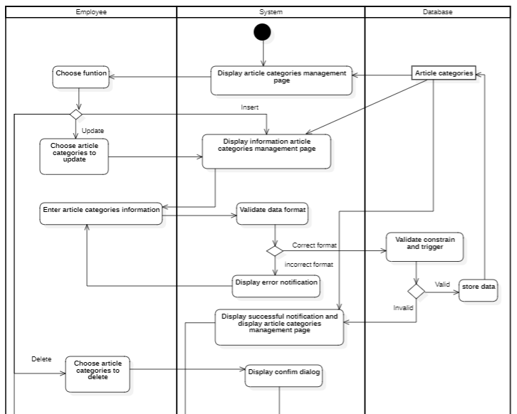

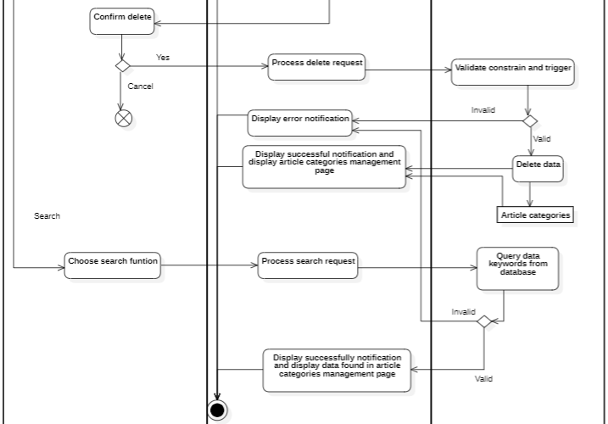

### 3.4.15. Use-case Manage feedback

* **FeedBack management**

|  |  |
| --- | --- |
| **Use case name** | **FeedBack management** |
| Description | This use case describes how admin make, update, delete, and search the feedback. |
| Trigger | The admin chooses the feedback management function to add, update, delete and search for the feedback. |
| Pre-condition | User devices must be connected to the internet.  The User logs into the system with the admin role. |
| Post-condition | The feedback is stored in the database.  The feedback management page is reloaded with data queried from database |
| Normal flows | 1. The system displays a feedback management page with the data queried from the database. 2. The admin chooses one of the following functions: 3. If the admin chooses the function to add new feedback, then the S1-Add feedback sub-flow is performed. 4. If the admin chooses the function to update new feedback, then the S2-Update feedback sub-flow is performed. 5. If the admin chooses the function to delete new feedback, then the S3-Delete feedback sub-flow is performed. 6. If the admin chooses the function to search for new feedback, then the S4-Search feedback sub-flow is performed. |
| Sub flows | **S1 – Add feedback**  S1.1: The system displays the feedback page with the new feedback  ID from the database.  S1.2: The admin enters feedback and confirms the creation of a new feedback .  S1.3: The system validates the format of information entered by the admin.  S1.4: The system validates the triggers and constraints in the database.  S1.5: The system stores the feedback in the database.  S1.6: The system displays successful notification and displays a feedback management page with data queried from the database.  **S2 -Update feedback**  S2.1: The admin chooses one feedback  to update information.  S2.2: The system displays the feedback page with the feedback  information from the database.  S2.3: The admin modifies feedback and confirms the creation of a new feedback .  S2.4: The system validates the format of information entered by the admin.  S2.5: The system validates the triggers and constraints in the database.  S2.6: The system stores the feedback in the database.  S2.7: The system displays successful notification and displays a feedback management page with data queried from the database.    **S3 - Delete feedback**  S3.1: The admin chooses one feedback  to delete information. S3.2: The system displays confirm delete dialog.  S3.3: The admin confirms deletion feedback  (chooses yes or no). a. If the admin chooses yes b. If the admin chooses no: Flow final.  S3.4: System processes delete request.  S3.5: System check availability of delete request.  S3.6: System deletes feedback  information in the database.  S3.7: The system stores the feedback in the database.  S3.8: The system displays successful notification and displays the feedback management page page.  **S4 – Search feedback**  S4.1: The admin enters keywords that need to be searched.  S4.2: System processes search request.  S4.3: System query data keywords from database.  S4.4: The system displays successful notification and displays the feedback management page with data queried from the database. |
| Alternative flows or Exception flows | **S1 – Add feedback**  S1.3a: The system displays an error notification due to wrong format. This use case continues with step S1.2.  S1.4a: The system displays an error notification due to violating constraints. This use case continues with step S1.2.  **S2 – Update feedback**  S1.3a: The system displays an error notification due to wrong format. This use case continues with step S2.2.  S1.4a: The system displays an error notification due to violating constraints. This use case continues with step S2.2.  **S3 – Delete feedback :**   3a. System display error notification because external data had required that feedback  information (showtime) or no data existed. Use-case stop.  **S4 – Search feedback:**  4a. System displays empty result notifications. Use-case continue at step 4 (no data is retained) |

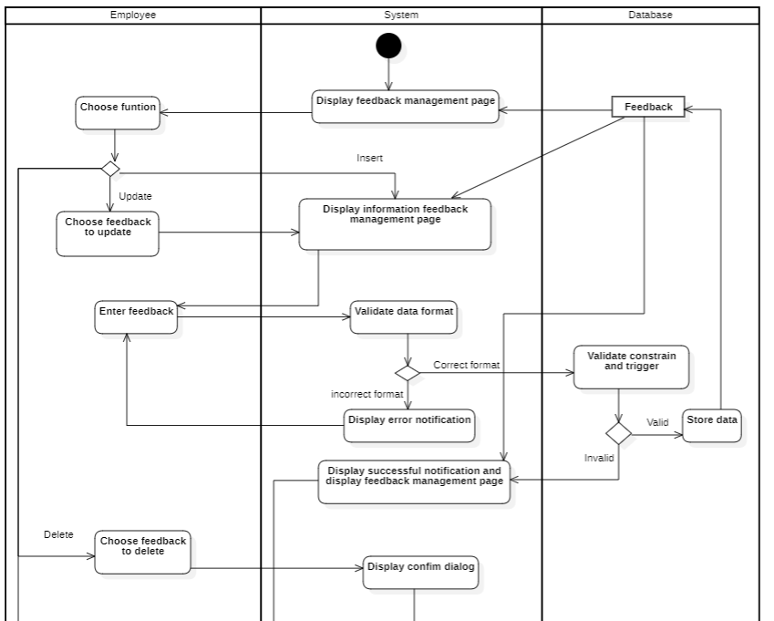

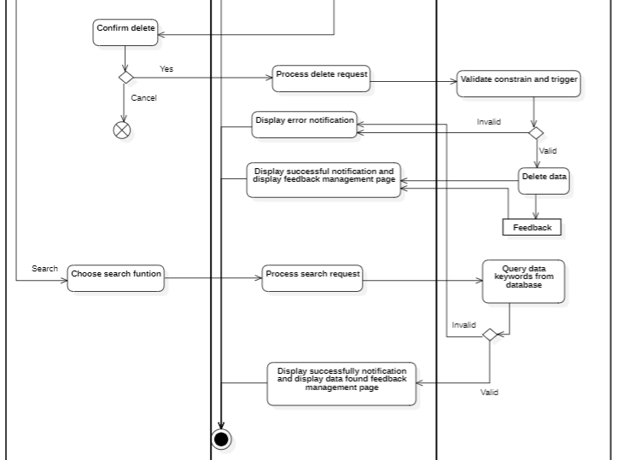

### 3.4.16. Interface management

* **Social media management**

|  |  |
| --- | --- |
| **Use case name** | **Social media management** |
| Description | This use case describes how admin make, update, delete, and search the social media. |
| Trigger | The admin chooses the social media management function to add, update, delete and search for the social media. |
| Pre-condition | User devices must be connected to the internet.  The User logs into the system with the admin role. |
| Post-condition | The social media is stored in the database.  The social media management page is reloaded with data queried from database |
| Normal flows | 1. The system displays a social media management page with the data queried from the database. 2. The admin chooses one of the following functions: 3. If the admin chooses the function to add a new social media , then the S1-Add social media  sub-flow is performed 4. If the admin chooses the function to update a new social media , then the S2-Update social media  sub-flow is performed 5. If the admin chooses the function to delete a new social media , then the S3-Delete social media  sub-flow is performed 6. If the admin chooses the function to search a new social media , then the S4-Search social media  sub-flow is performed |
| Sub flows | **S1 – Add social media**  S1.1: The system displays the social media page with the new social media  ID from the database.  S1.2: The admin enters the social media and confirms the creation of a new social media .  S1.3: The system validates the format of information entered by the admin.  S1.4: The system validates the triggers and constraints in the database.  S1.5: The system stores the social media in the database.  S1.6: The system displays successful notification and displays an social media management page with data queried from the database.  **S2 -Update social media**  S2.1: The admin chooses one article category  to update information.  S2.2: The system displays the social media page with the social media  information from the database.  S2.3: The admin modifies the social media and confirms the creation of new social media .  S2.4: The system validates the format of information entered by the admin.  S2.5: The system validates the triggers and constraints in the database.  S2.6: The system stores the social media in the database.  S2.7: The system displays successful notification and displays a social media management page with data queried from the database.  **S3 - Delete social media**  S3.1: The admin chooses one social media  to delete information. S3.2: The system displays confirm delete dialog.  S3.3: The admin confirms the deletion of social media  (chooses yes or no).  a. If the admin chooses yes  b. If the admin chooses no: Flow final.  S3.4: System processes delete request.  S3.5: System check availability of delete request.  S3.6: System deletes social media  information in the database.  S3.7: The system stores the social media in the database.  S3.8: The system displays successful notification and displays the social media management page page.  **S4 – Search social media**  S4.1: The admin enters keywords that need to be searched.  S4.2: System processes search request.  S4.3: System query data keywords from database.  S4.4: The system displays successful notification and displays the social media management page with data queried from the database. |
| Alternative flows or Exception flows | **S1 – Add social media**  S1.3a: The system displays an error notification due to wrong format. This use case continues with step S1.2.  S1.4a: The system displays an error notification due to violating constraints. This use case continues with step S1.2.  **S2 – Update social media**  S1.3a: The system displays an error notification due to wrong format. This use case continues with step S2.2.  S1.4a: The system displays an error notification due to violating constraints. This use case continues with step S2.2.  **S3 – Delete social media :**   3a. System display error notification because external data had required that social media  information (showtime) or no data existed. Use-case stop.  **S4 – Search social media:**  4a. System displays empty result notifications. Use-case continue at step 4 (no data is retained) |

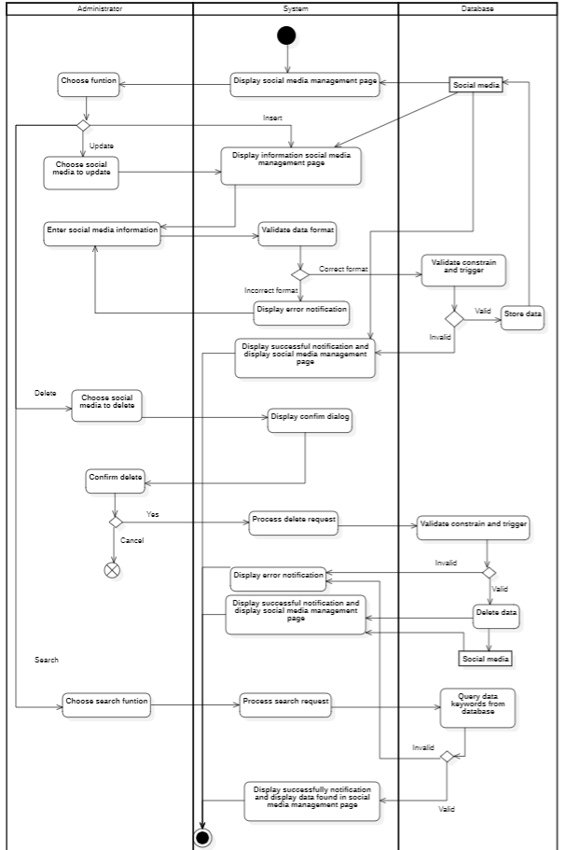

* **Footer management**

|  |  |
| --- | --- |
| **Use case name** | **Footer management** |
| Description | This use case describes how admin make, update, delete, and search the footer. |
| Trigger | The admin chooses the footer management function to add, update, delete and search for the footer. |
| Pre-condition | User devices must be connected to the internet.  The User logs into the system with the admin role. |
| Post-condition | The footer is stored in the database.  The footer management page is reloaded with data queried from database |
| Normal flows | 1. The system displays a footer management page with the data queried from the database. 2. The admin chooses one of the following functions: 3. If the admin chooses the function to add a new footer, then the S1-Add footer sub-flow is performed. 4. If the admin chooses the function to update a new footer, then the S2-Update footer sub-flow is performed. 5. If the admin chooses the function to delete a new footer, then the S3-Delete footer sub-flow is performed. 6. If the admin chooses the function to search a new footer, then the S4-Search footer sub-flow is performed. |
| Sub flows | **S1 – Add footer**  S1.1: The system displays the footer page with the new footer  ID from the database.  S1.2: The admin enters the footer and confirms the creation of a new footer .  S1.3: The system validates the format of information entered by the admin.  S1.4: The system validates the triggers and constraints in the database.  S1.5: The system stores the footer in the database.  S1.6: The system displays successful notification and displays a footer management page with data queried from the database.  **S2 -Update footer**  S2.1: The admin chooses one article category  to update information.  S2.2: The system displays the footer page with the footer  information from the database.  S2.3: The admin modifies the footer and confirms the creation of a new footer .  S2.4: The system validates the format of information entered by the admin.  S2.5: The system validates the triggers and constraints in the database.  S2.6: The system stores the footer in the database.  S2.7: The system displays successful notification and displays a footer management page with data queried from the database.  **S3 - Delete footer**  S3.1: The admin chooses one article category  to delete information. S3.2: The system displays confirm delete dialog.  S3.3: The admin confirms the deletion of footer  (chooses yes or no).  a. If the admin chooses yes  b. If the admin chooses no: Flow final.  S3.4: System processes delete request.  S3.5: System check availability of delete request.  S3.6: System deletes footer  information in the database.  S3.7: The system stores the footer in the database.  S3.8: The system displays successful notification and displays the footer management page page.  **S4 – Search footer**  S4.1: The admin enters keywords that need to be searched.  S4.2: System processes search request.  S4.3: System query data keywords from database.  S4.4: The system displays successful notification and displays the footer management page with data queried from the database. |
| Alternative flows or Exception flows | **S1 – Add footer**  S1.3a: The system displays an error notification due to wrong format. This use case continues with step S1.2.  S1.4a: The system displays an error notification due to violating constraints. This use case continues with step S1.2.  **S2 – Update footer**  S1.3a: The system displays an error notification due to wrong format. This use case continues with step S2.2.  S1.4a: The system displays an error notification due to violating constraints. This use case continues with step S2.2.  **S3 – Delete footer :**   3a. System display error notification because external data had required that footer  information (showtime) or no data existed. Use-case stop.  **S4 – Search footer:**  4a. System displays empty result notifications. Use-case continue at step 4 (no data is retained) |

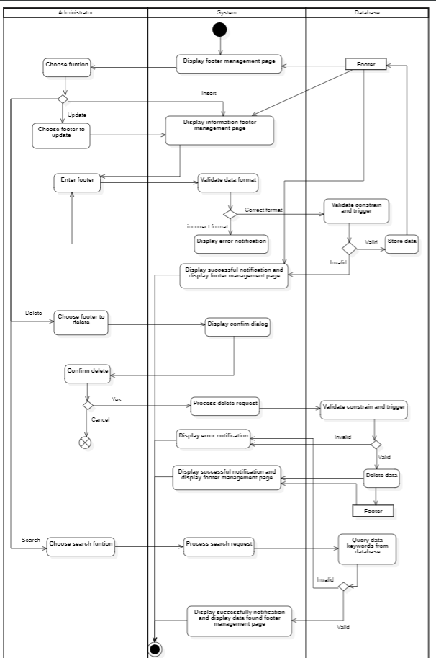

* **Brand management**

|  |  |
| --- | --- |
| **Use case name** | **Brand management** |
| Description | This use case describes how admin make, update, delete, and search the brand. |
| Trigger | The admin chooses the brand management function to add, update, delete and search for the brand. |
| Pre-condition | User devices must be connected to the internet.  The User logs into the system with the admin role. |
| Post-condition | The brand is stored in the database.  The brand management page is reloaded with data queried from database |
| Normal flows | 1. The system displays a brand management page with the data queried from the database. 2. The admin chooses one of the following functions: 3. If the admin chooses the function to add a new brand, then the S1-Add brand sub-flow is performed. 4. If the admin chooses the function to update a new brand, then the S2-Update brand sub-flow is performed. 5. If the admin chooses the function to delete a new brand, then the S3-Delete brand sub-flow is performed. 6. If the admin chooses the function to search a new brand, then the S4-Search brand sub-flow is performed. |
| Sub flows | **S1 – Add brand**  S1.1: The system displays the brand page with the new brand  ID from the database.  S1.2: The admin enters the brand and confirms the creation of a new brand .  S1.3: The system validates the format of information entered by the admin.  S1.4: The system validates the triggers and constraints in the database.  S1.5: The system stores the brand in the database.  S1.6: The system displays successful notification and displays a brand management page with data queried from the database.  **S2 -Update brand**  S2.1: The admin chooses one article category  to update information.  S2.2: The system displays the brand page with the brand information from the database.  S2.3: The admin modifies the brand and confirms the creation of a new brand .  S2.4: The system validates the format of information entered by the admin.  S2.5: The system validates the triggers and constraints in the database.  S2.6: The system stores the brand in the database.  S2.7: The system displays successful notification and displays a brand management page with data queried from the database.    **S3 - Delete brand**  S3.1: The admin chooses one article category  to delete information. S3.2: The system displays confirm delete dialog.  S3.3: The admin confirms the deletion of the brand (chooses yes or no).  a. If the admin chooses yes  b. If the admin chooses no: Flow final.  S3.4: System processes delete request.  S3.5: System check availability of delete request.  S3.6: System deletes brand  information in the database.  S3.7: The system stores the brand in the database.  S3.8: The system displays successful notification and displays the brand management page page.  **S4 – Search brand**  S4.1: The admin enters keywords that need to be searched.  S4.2: System processes search request.  S4.3: System query data keywords from database.  S4.4: The system displays successful notification and displays the brand management page with data queried from the database. |
| Alternative flows or Exception flows | **S1 – Add brand**  S1.3a: The system displays an error notification due to wrong format. This use case continues with step S1.2.  S1.4a: The system displays an error notification due to violating constraints. This use case continues with step S1.2.  **S2 – Update brand**  S1.3a: The system displays an error notification due to wrong format. This use case continues with step S2.2.  S1.4a: The system displays an error notification due to violating constraints. This use case continues with step S2.2.  **S3 – Delete brand :**   3a. System display error notification because external data had required that brand  information (showtime) or no data existed. Use-case stop.  **S4 – Search brand:**  4a. System displays empty result notifications. Use-case continue at step 4 (no data is retained) |

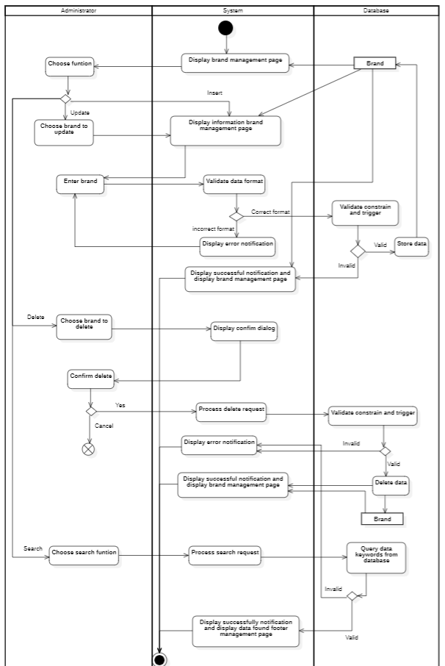

* **Slide management**

|  |  |
| --- | --- |
| **Use case name** | **Slide management** |
| Description | This use case describes how admin make, update, delete, and search the slide. |
| Trigger | The admin chooses the slide management function to add, update, delete and search for the slide. |
| Pre-condition | User devices must be connected to the internet.  The User logs into the system with the admin role. |
| Post-condition | The slide is stored in the database.  The slide management page is reloaded with data queried from database |
| Normal flows | 1. The system displays a slide management page with the data queried from the database. 2. The admin chooses one of the following functions: 3. If the admin chooses the function to add a new slide, then the S1-Add slide sub-flow is performed. 4. If the admin chooses the function to update a new slide, then the S2-Update slide sub-flow is performed. 5. If the admin chooses the function to delete a new slide, then the S3-Delete slide sub-flow is performed. 6. If the admin chooses the function to search a new slide, then the S4-Search slide sub-flow is performed. |
| Sub flows | **S1 – Add slide**  S1.1: The system displays the slide page with the new slide  ID from the database.  S1.2: The admin enters the slide and confirms the creation of a new slide .  S1.3: The system validates the format of information entered by the admin.  S1.4: The system validates the triggers and constraints in the database.  S1.5: The system stores the slide in the database.  S1.6: The system displays successful notification and displays a slide management page with data queried from the database.  **S2 -Update slide**  S2.1: The admin chooses one article category  to update information.  S2.2: The system displays the slide page with the slide information from the database.  S2.3: The admin modifies the slide and confirms the creation of a new slide .  S2.4: The system validates the format of information entered by the admin.  S2.5: The system validates the triggers and constraints in the database.  S2.6: The system stores the slide in the database.  S2.7: The system displays successful notification and displays a slide management page with data queried from the database.    **S3 - Delete slide**  S3.1: The admin chooses one article category  to delete information. S3.2: The system displays confirm delete dialog.  S3.3: The admin confirms the deletion of the slide (chooses yes or no).  a. If the admin chooses yes  b. If the admin chooses no: Flow final.  S3.4: System processes delete request.  S3.5: System check availability of delete request.  S3.6: System deletes slide  information in the database.  S3.7: The system stores the slide in the database.  S3.8: The system displays successful notification and displays the slide management page page.  **S4 – Search slide**  S4.1: The admin enters keywords that need to be searched.  S4.2: System processes search request.  S4.3: System query data keywords from database.  S4.4: The system displays successful notification and displays the slide management page with data queried from the database. |
| Alternative flows or Exception flows | **S1 – Add slide**  S1.3a: The system displays an error notification due to wrong format. This use case continues with step S1.2.  S1.4a: The system displays an error notification due to violating constraints. This use case continues with step S1.2.  **S2 – Update slide**  S1.3a: The system displays an error notification due to wrong format. This use case continues with step S2.2.  S1.4a: The system displays an error notification due to violating constraints. This use case continues with step S2.2.  **S3 – Delete slide :**   3a. System display error notification because external data had required that slide  information (showtime) or no data existed. Use-case stop.  **S4 – Search slide:**  4a. System displays empty result notifications. Use-case continue at step 4 (no data is retained) |

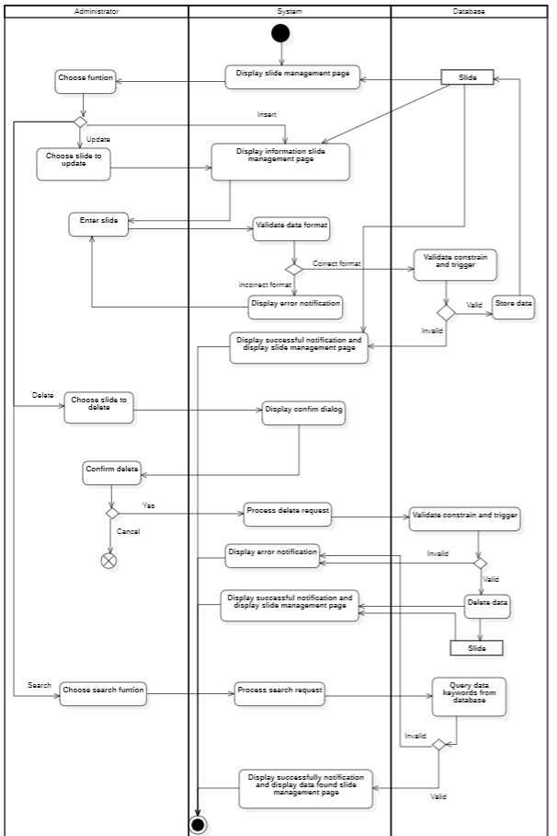

* **Menu management**

|  |  |
| --- | --- |
| **Use case name** | **Menu management** |
| Description | This use case describes how admin make, update, delete, and search the menu. |
| Trigger | The admin chooses the menu management function to add, update, delete and search for the menu. |
| Pre-condition | User devices must be connected to the internet.  The User logs into the system with the admin role. |
| Post-condition | The menu is stored in the database.  The menu management page is reloaded with data queried from database |
| Normal flows | 1. The system displays a menu management page with the data queried from the database. 2. The admin chooses one of the following functions: 3. If the admin chooses the function to add a new menu, then the S1-Add menu sub-flow is performed. 4. If the admin chooses the function to update a new menu, then the S2-Update menu sub-flow is performed. 5. If the admin chooses the function to delete a new menu, then the S3-Delete menu sub-flow is performed. 6. If the admin chooses the function to search a new menu, then the S4-Search menu sub-flow is performed. |
| Sub flows | **S1 – Add menu**  S1.1: The system displays the menu page with the new menu  ID from the database.  S1.2: The admin enters the menu and confirms the creation of a new menu .  S1.3: The system validates the format of information entered by the admin.  S1.4: The system validates the triggers and constraints in the database.  S1.5: The system stores the menu in the database.  S1.6: The system displays successful notification and displays a menu management page with data queried from the database.  **S2 -Update menu**  S2.1: The admin chooses one article category  to update information.  S2.2: The system displays the menu page with the menu information from the database.  S2.3: The admin modifies the menu and confirms the creation of a new menu .  S2.4: The system validates the format of information entered by the admin.  S2.5: The system validates the triggers and constraints in the database.  S2.6: The system stores the menu in the database.  S2.7: The system displays successful notification and displays a menu management page with data queried from the database.  **S3 - Delete menu**  S3.1: The admin chooses one article category  to delete information. S3.2: The system displays confirm delete dialog.  S3.3: The admin confirms the deletion of the menu (chooses yes or no).  a. If the admin chooses yes  b. If the admin chooses no: Flow final.  S3.4: System processes delete request.  S3.5: System check availability of delete request.  S3.6: System deletes menu  information in the database.  S3.7: The system stores the menu in the database.  S3.8: The system displays successful notification and displays the menu management page page.  **S4 – Search menu**  S4.1: The admin enters keywords that need to be searched.  S4.2: System processes search request.  S4.3: System query data keywords from database.  S4.4: The system displays successful notification and displays the menu management page with data queried from the database. |
| Alternative flows or Exception flows | **S1 – Add menu**  S1.3a: The system displays an error notification due to wrong format. This use case continues with step S1.2.  S1.4a: The system displays an error notification due to violating constraints. This use case continues with step S1.2.  **S2 – Update menu**  S1.3a: The system displays an error notification due to wrong format. This use case continues with step S2.2.  S1.4a: The system displays an error notification due to violating constraints. This use case continues with step S2.2.  **S3 – Delete menu :**   3a. System display error notification because external data had required that menu  information (showtime) or no data existed. Use-case stop.  **S4 – Search menu:**  4a. System displays empty result notifications. Use-case continue at step 4 (no data is retained) |

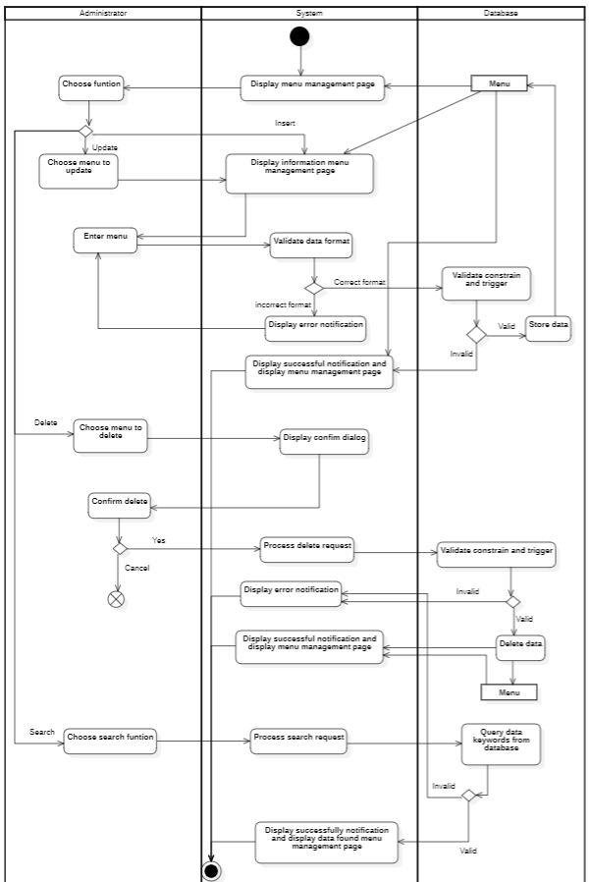

* **Menu type management**

|  |  |
| --- | --- |
| **Use case name** | **Menu type management** |
| Description | This use case describes how admin make, update, delete, and search the menu type. |
| Trigger | The admin chooses the menu type management function to add, update, delete and search for the menu type. |
| Pre-condition | User devices must be connected to the internet.  The User logs into the system with the admin role. |
| Post-condition | The menu type is stored in the database.  The menu type management page is reloaded with data queried from database |
| Normal flows | 1. The system displays a menu type management page with the data queried from the database. 2. The admin chooses one of the following functions: 3. If the admin chooses the function to add a new menu type, then the S1-Add menu type sub-flow is performed. 4. If the admin chooses the function to update a new menu type, then the S2-Update menu type sub-flow is performed. 5. If the admin chooses the function to delete a new menu type, then the S3-Delete menu type sub-flow is performed. 6. If the admin chooses the function to search a new menu type, then the S4-Search menu type sub-flow is performed. |
| Sub flows | **S1 – Add menu type**  S1.1: The system displays the menu type page with the new menu type  ID from the database.  S1.2: The admin enters the menu type and confirms the creation of a new menu type .  S1.3: The system validates the format of information entered by the admin.  S1.4: The system validates the triggers and constraints in the database.  S1.5: The system stores the menu type in the database.  S1.6: The system displays successful notification and displays a menu type management page with data queried from the database.  **S2 -Update menu type**  S2.1: The admin chooses one article category  to update information.  S2.2: The system displays the menu type page with the menu type information from the database.  S2.3: The admin modifies the menu type and confirms the creation of a new menu type .  S2.4: The system validates the format of information entered by the admin.  S2.5: The system validates the triggers and constraints in the database.  S2.6: The system stores the menu type in the database.  S2.7: The system displays successful notification and displays a menu type management page with data queried from the database.    **S3 - Delete menu type**  S3.1: The admin chooses one article category  to delete information. S3.2: The system displays confirm delete dialog.  S3.3: The admin confirms the deletion of the menu type (chooses yes or no).  a. If the admin chooses yes  b. If the admin chooses no: Flow final.  S3.4: System processes delete request.  S3.5: System check availability of delete request.  S3.6: System deletes menu type  information in the database.  S3.7: The system stores the menu type in the database.  S3.8: The system displays successful notification and displays the menu type management page page.  **S4 – Search menu type**  S4.1: The admin enters keywords that need to be searched.  S4.2: System processes search request.  S4.3: System query data keywords from database.  S4.4: The system displays successful notification and displays the menu type management page with data queried from the database. |
| Alternative flows or Exception flows | **S1 – Add menu type**  S1.3a: The system displays an error notification due to wrong format. This use case continues with step S1.2.  S1.4a: The system displays an error notification due to violating constraints. This use case continues with step S1.2.  **S2 – Update menu type**  S1.3a: The system displays an error notification due to wrong format. This use case continues with step S2.2.  S1.4a: The system displays an error notification due to violating constraints. This use case continues with step S2.2.  **S3 – Delete menu type :**   3a. System display error notification because external data had required that menu type  information (showtime) or no data existed. Use-case stop.  **S4 – Search menu type:**  4a. System displays empty result notifications. Use-case continue at step 4 (no data is retained) |

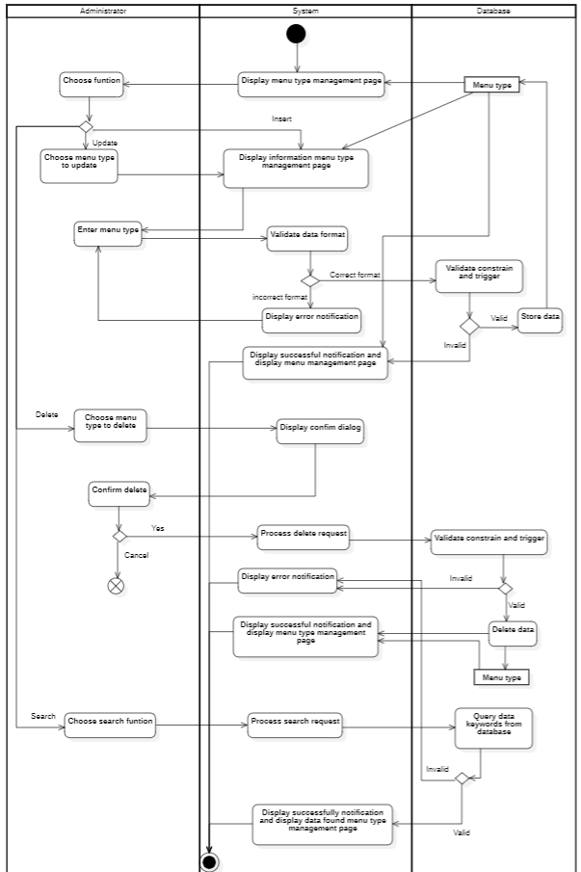

## 3.5 Sequence diagram vs Class diagram

### 3.5.1. Sign Up

#### 3.5.1.1. Sequenece diagram

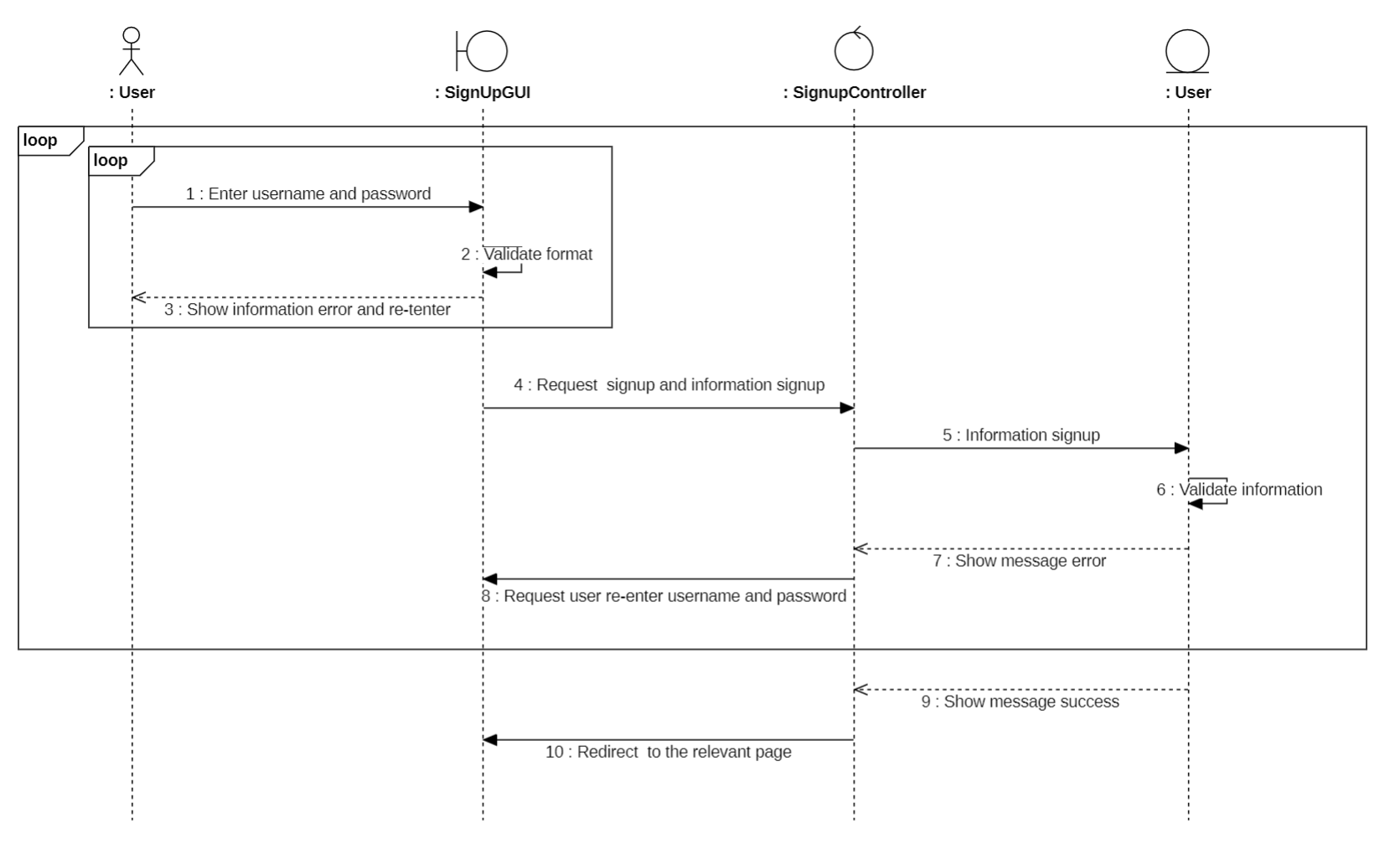

#### 3.5.1.2. Class diagram

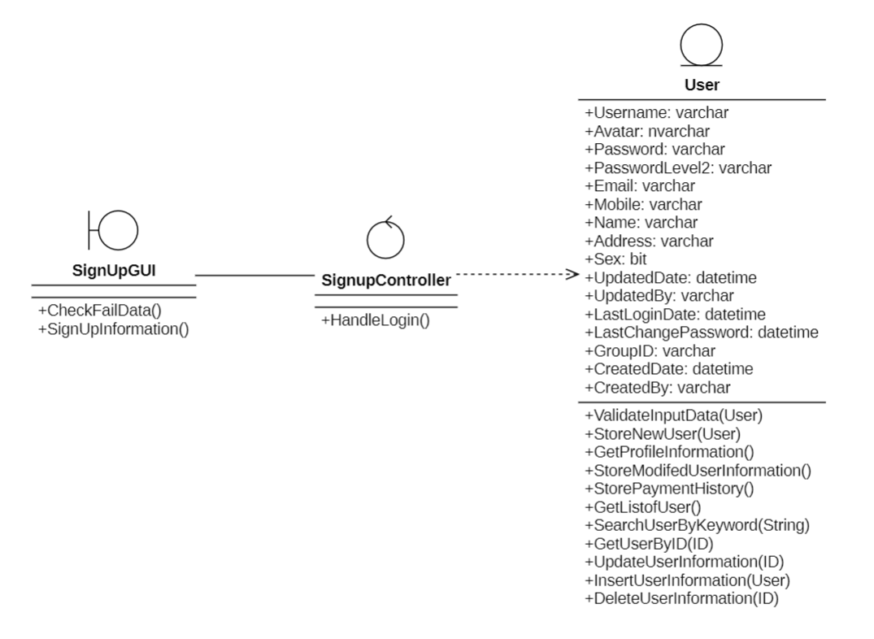

### 3.5.2. Sign In

#### 3.5.2.1. Sequenece diagram

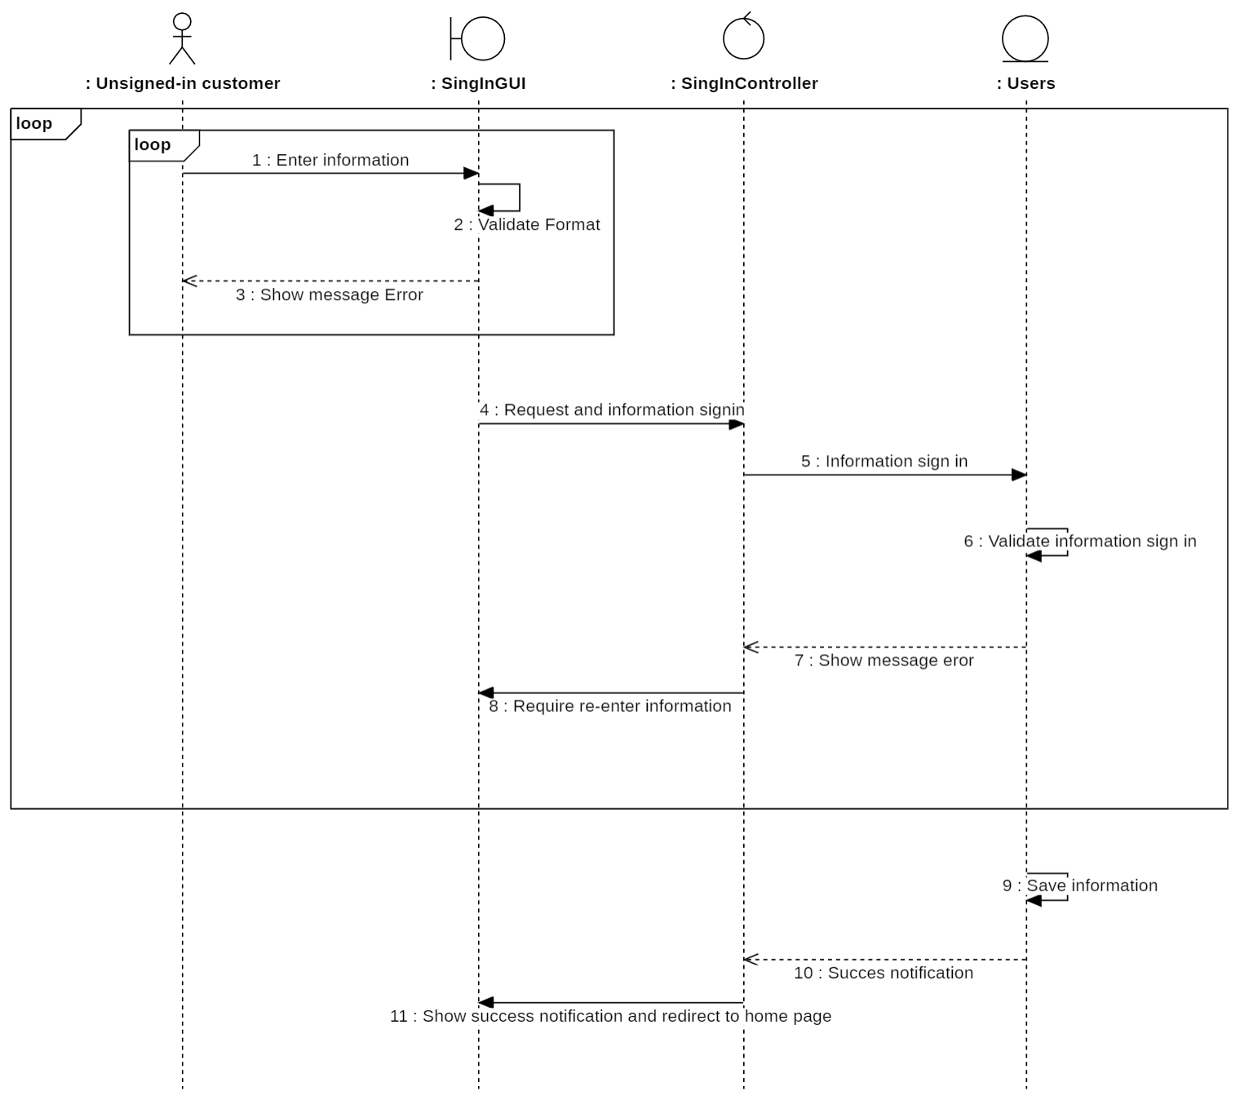

#### 3.5.2.2. Class diagram

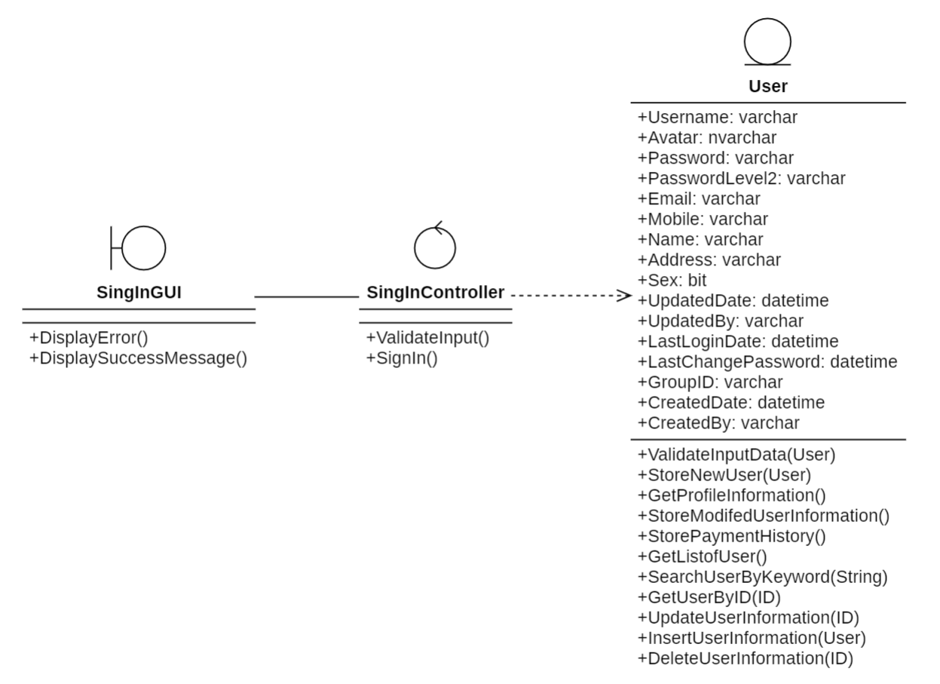

### 3.5.3. Search Product

#### 3.5.3.1. Sequenece diagram

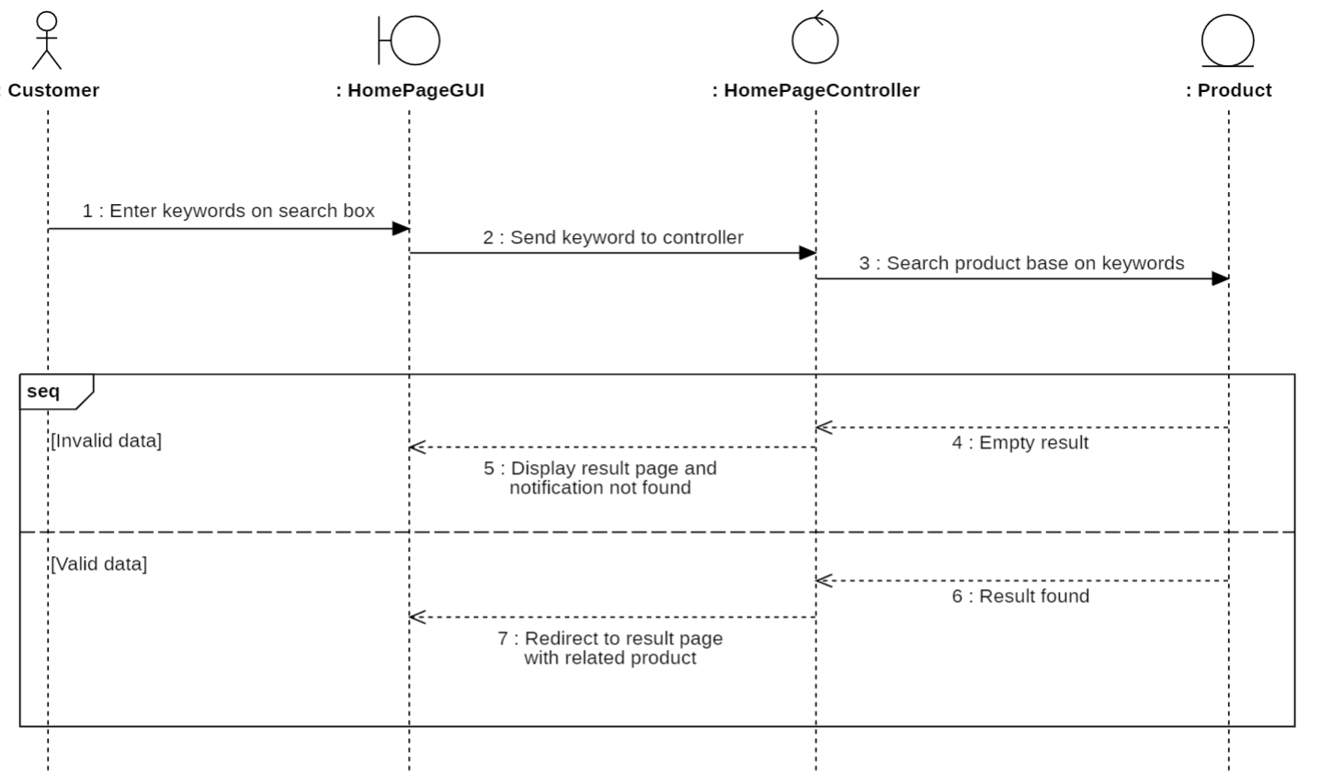

#### 3.5.3.2. Class diagram

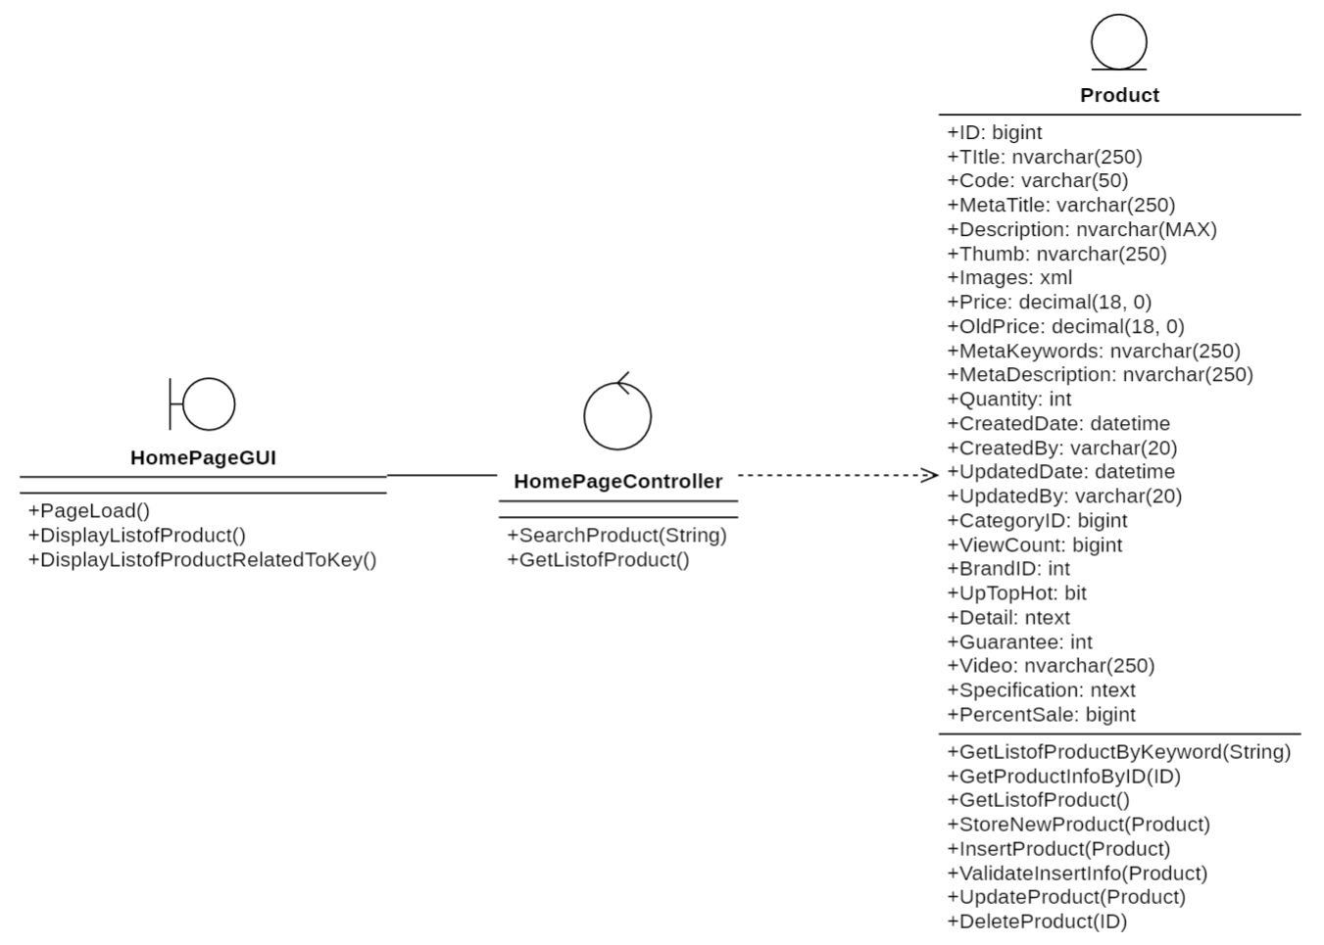

### 3.5.4. Explore Product

#### 3.5.4.1. Sequenece diagram

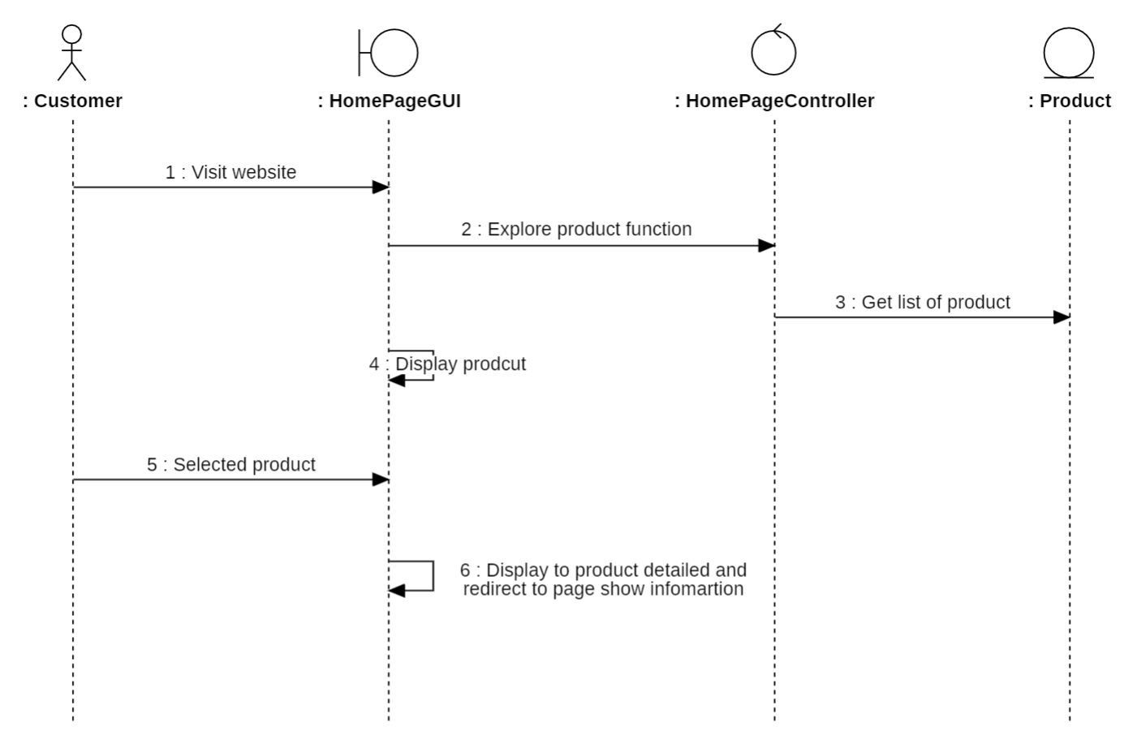

#### 3.5.4.2. Class diagram

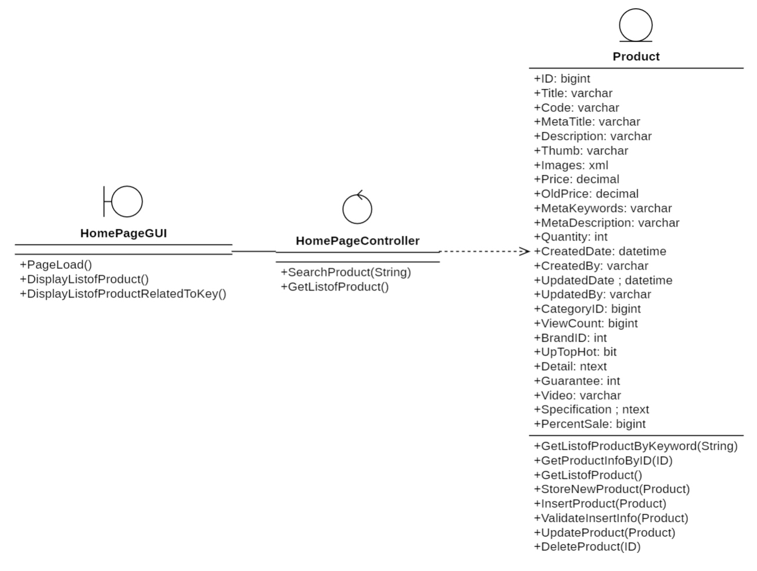

### 3.5.5. Manage profile

#### 3.5.5.1. Sequenece diagram

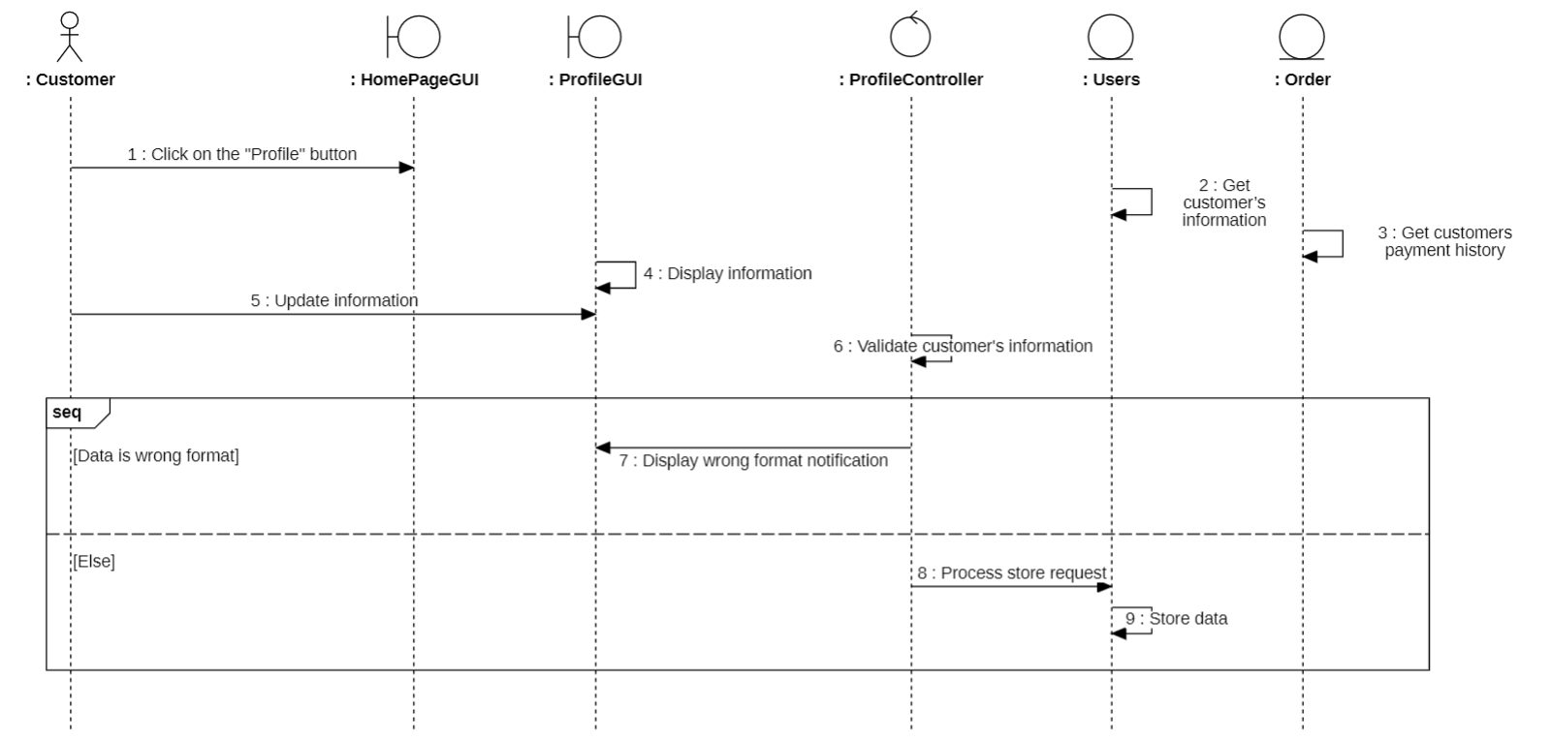

#### 3.5.5.2. Class diagram

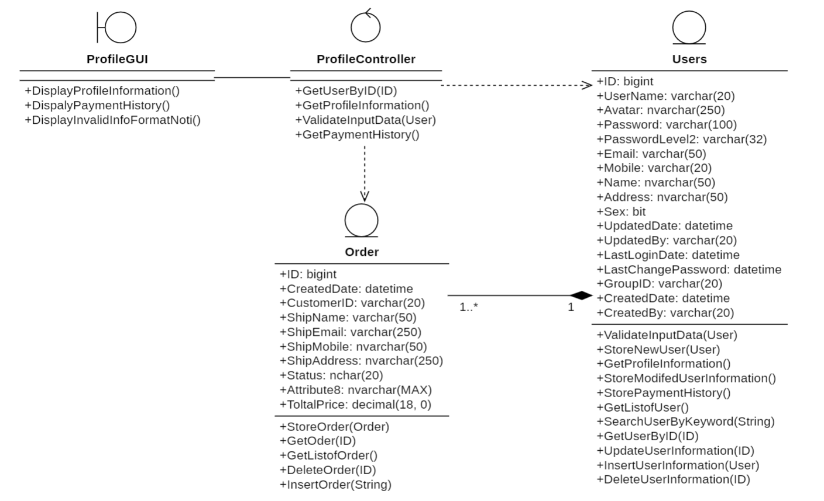

### 3.5.6. Recreate Password

#### 3.5.6.1. Sequenece diagram

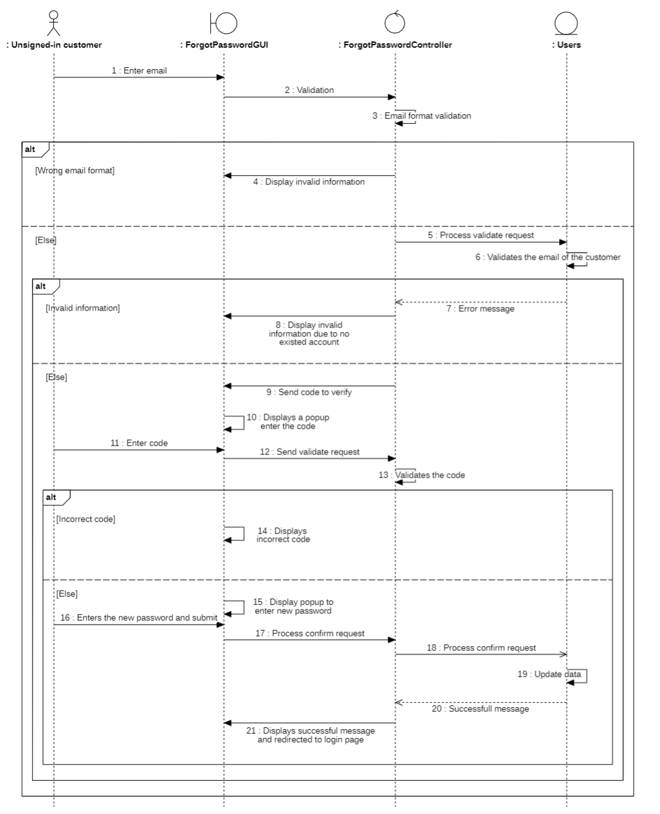

#### 3.5.6.2. Class diagram

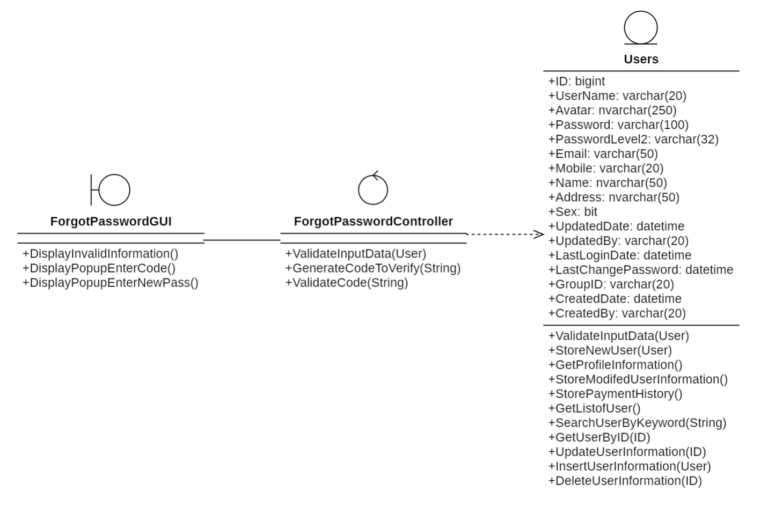

### 3.5.7. Product reviews

#### 3.5.7.1. Sequenece diagram

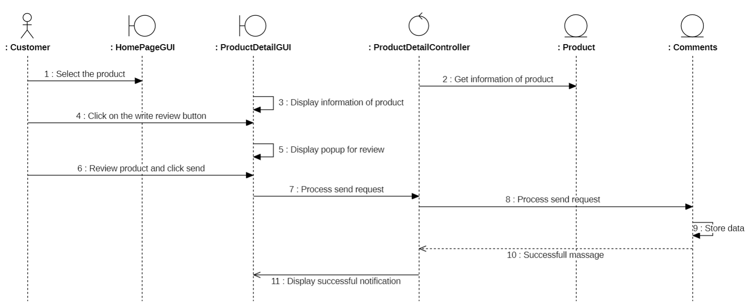

#### 3.5.7.2. Class diagram

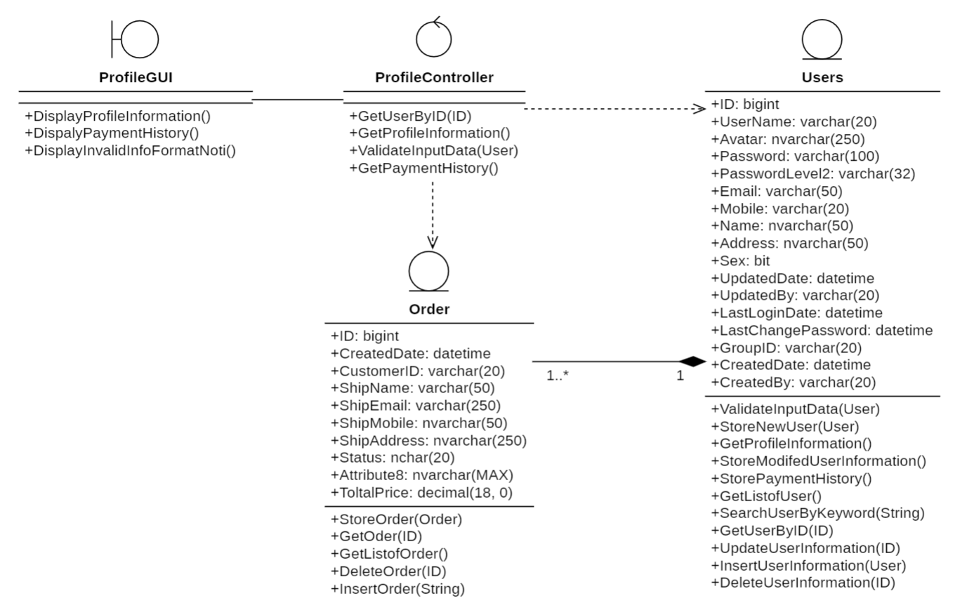

### 3.5.8. Choose to buy the product

#### 3.5.8.1. Sequenece diagram

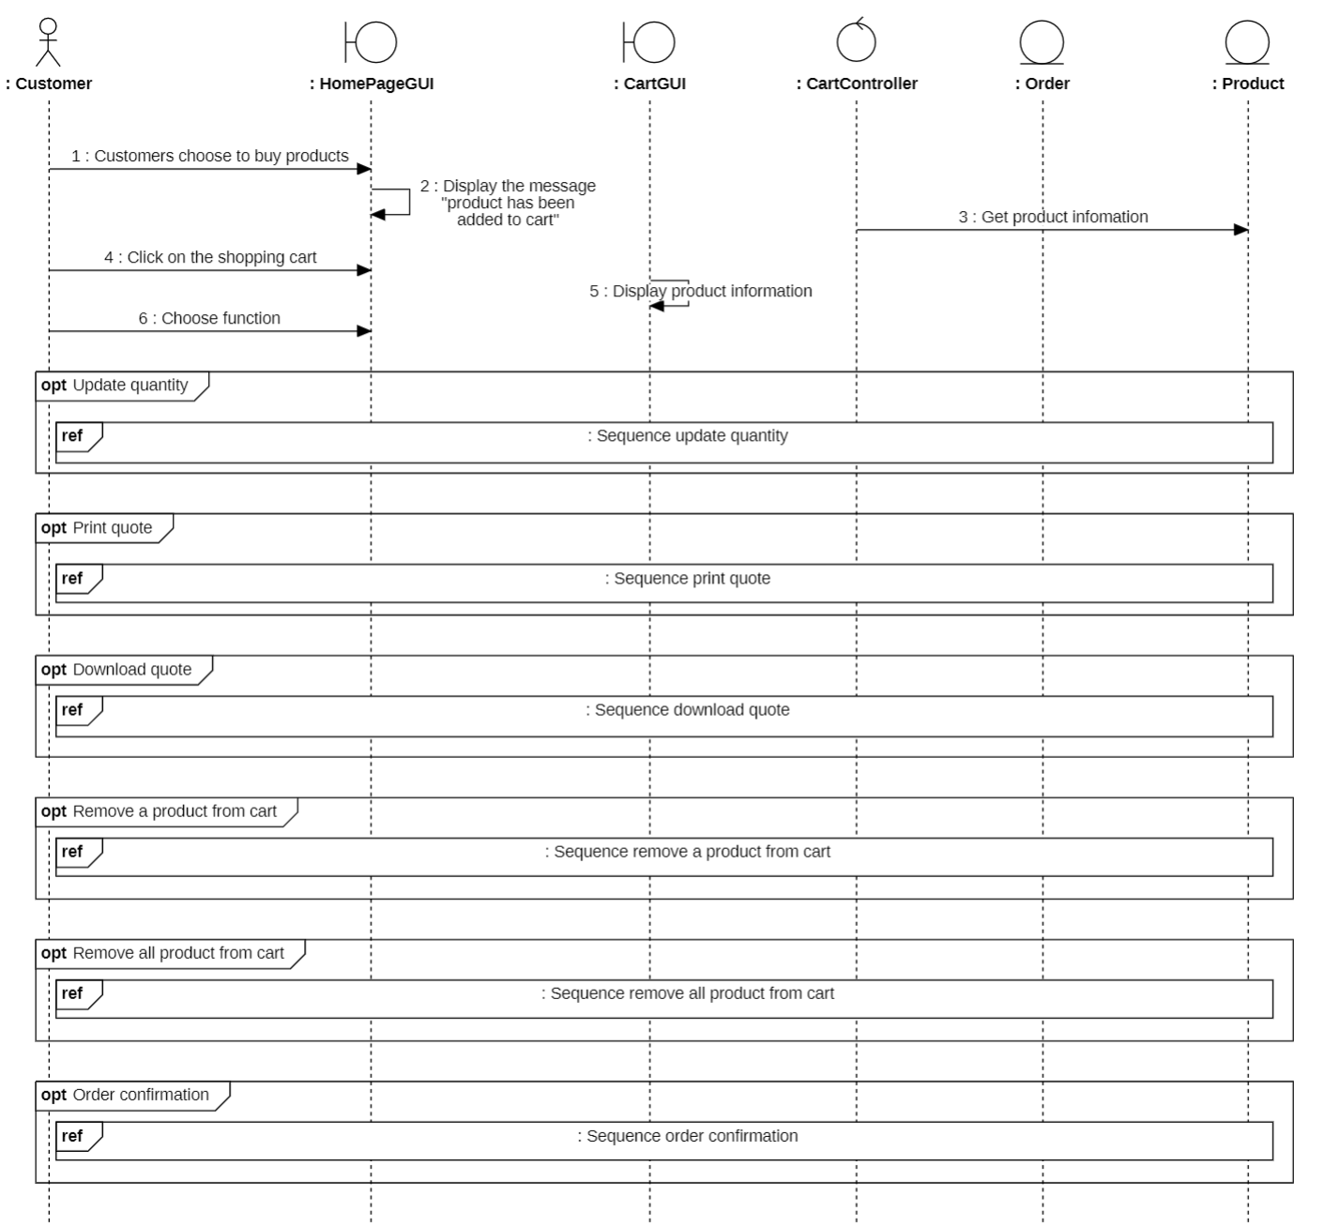

* **Update Quantity:**

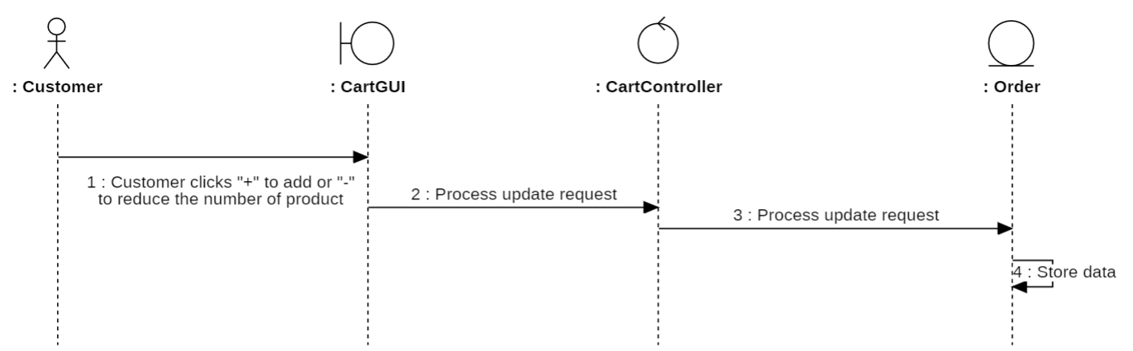

* **Print Quote:**

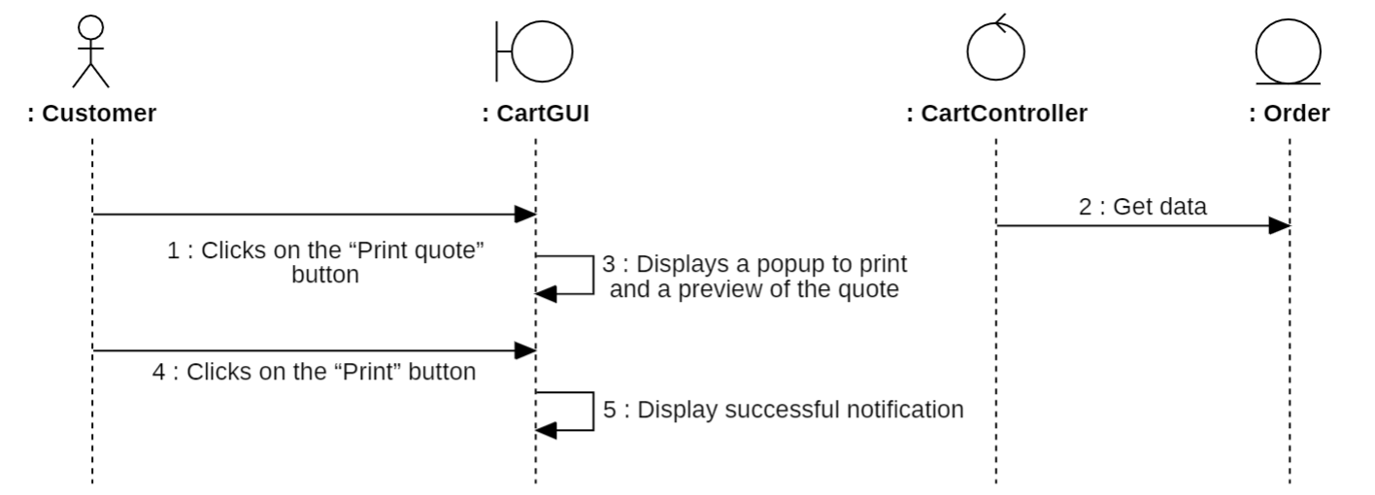

* **Download Quote:**

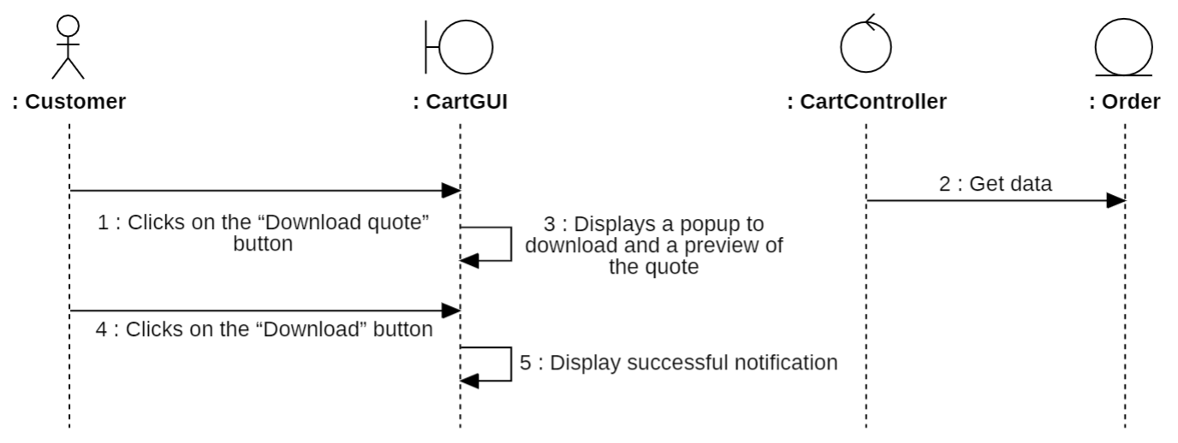

* **Remove A Product From Cart:**

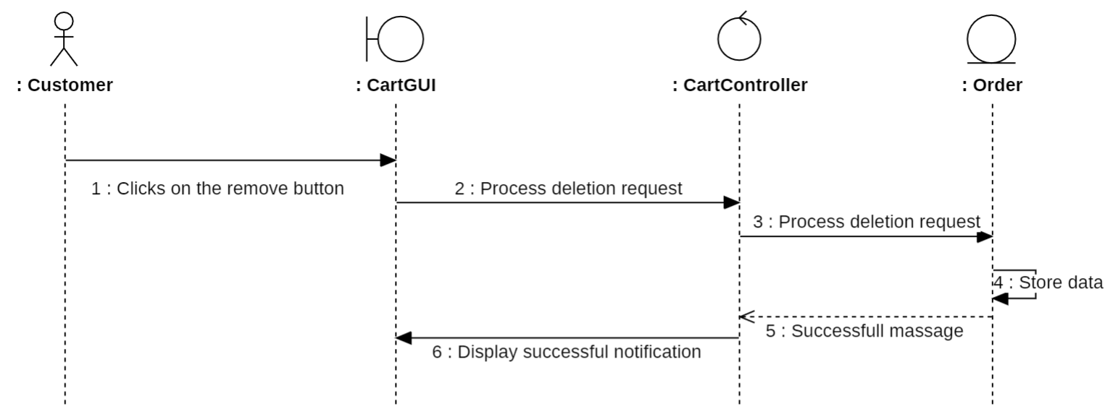

* **Remove All Product From Cart:**

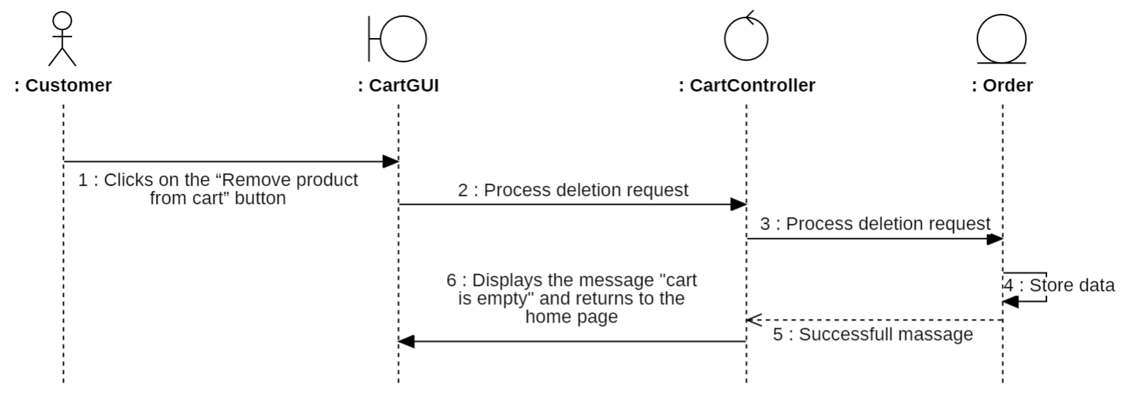

* **Order Confirmation:**

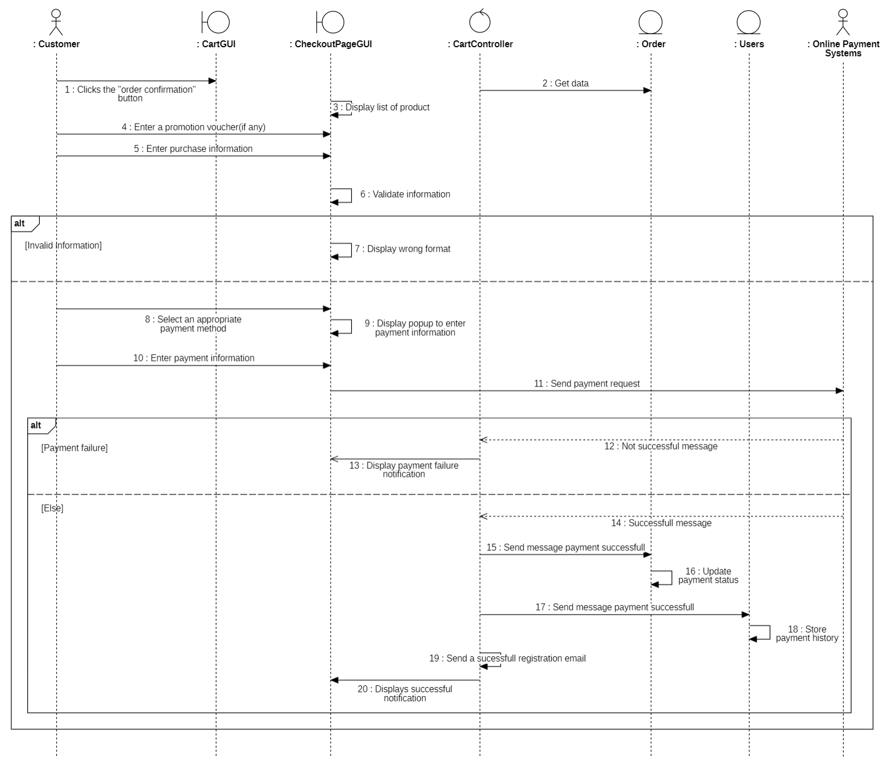

#### 3.5.8.2. Class diagram

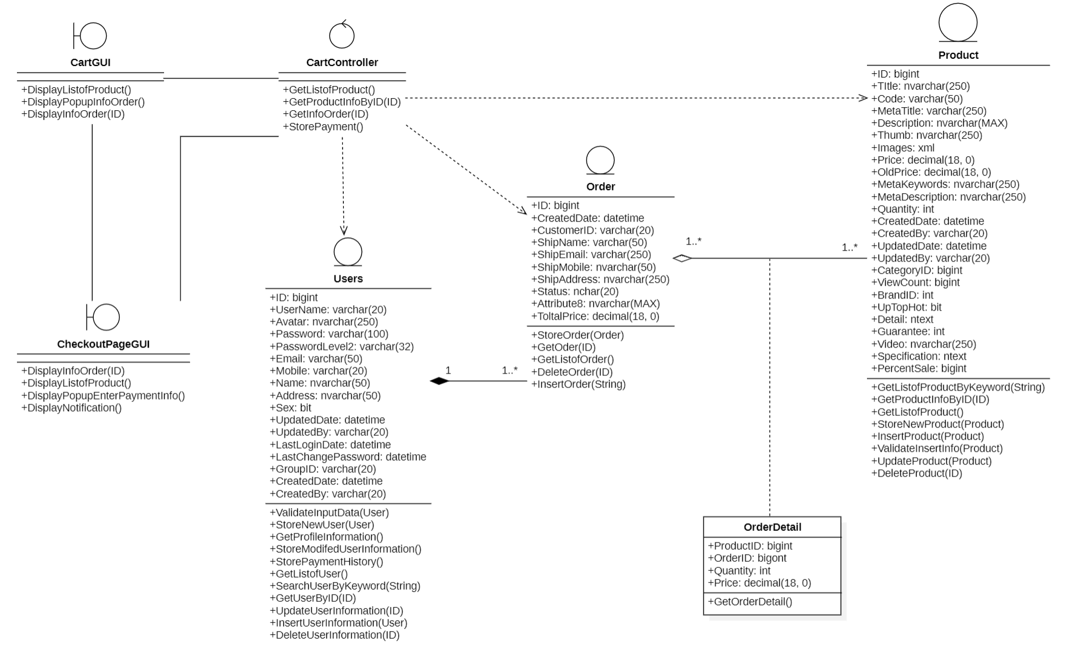

### 3.5.9. Sign-in for Administrator

#### 3.5.9.1. Sequenece diagram

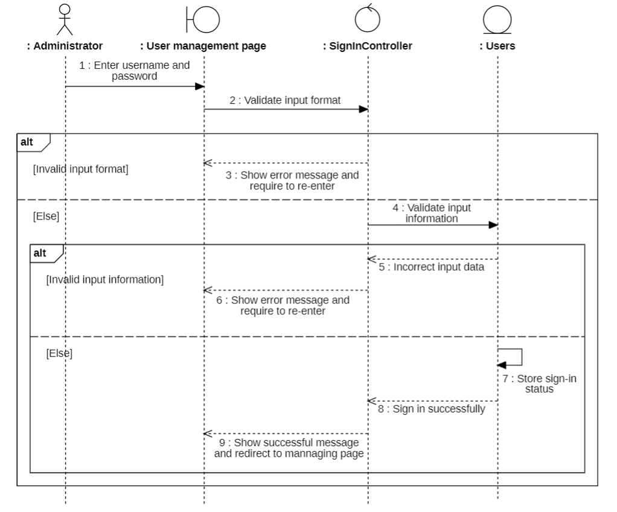

#### 3.5.9.2. Class diagram

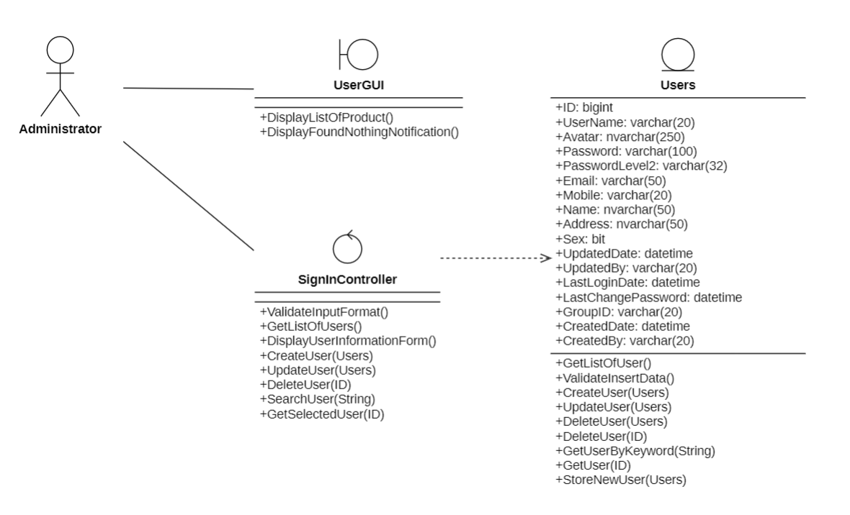

### 3.5.10. Analysis revenue

#### 3.5.10.1. Sequenece diagram

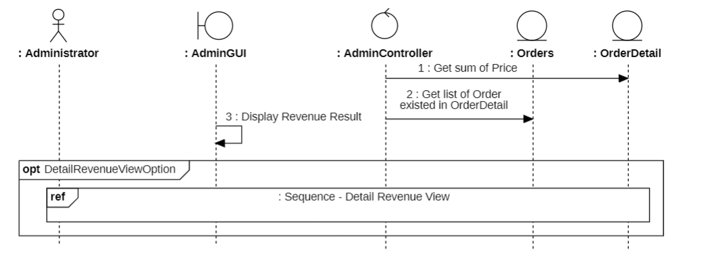

Detail Revenue View:

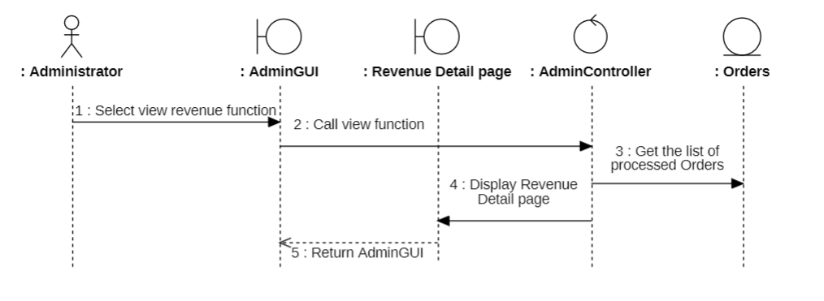

#### 3.5.10.2. Class diagram

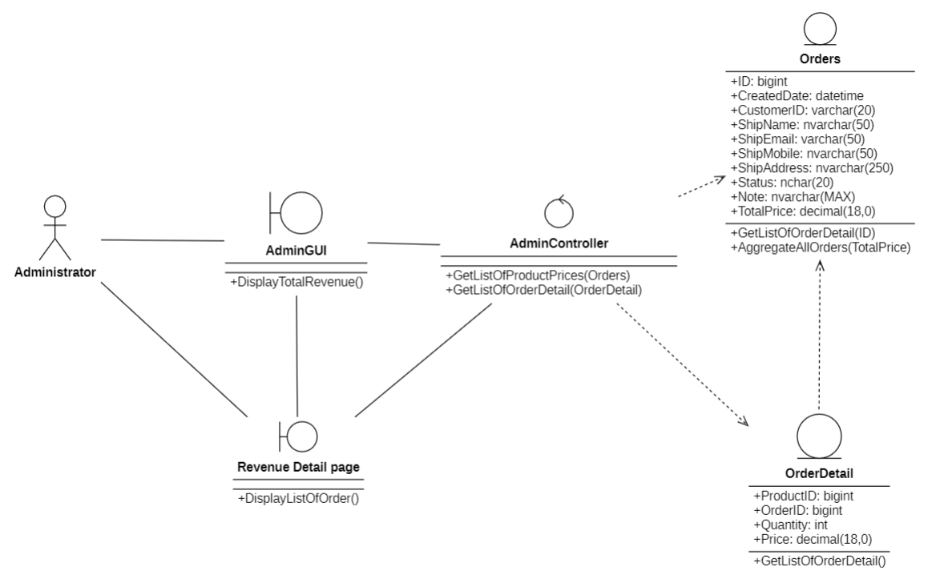

### 3.5.11. User management

#### 3.5.11.1. Sequenece diagram

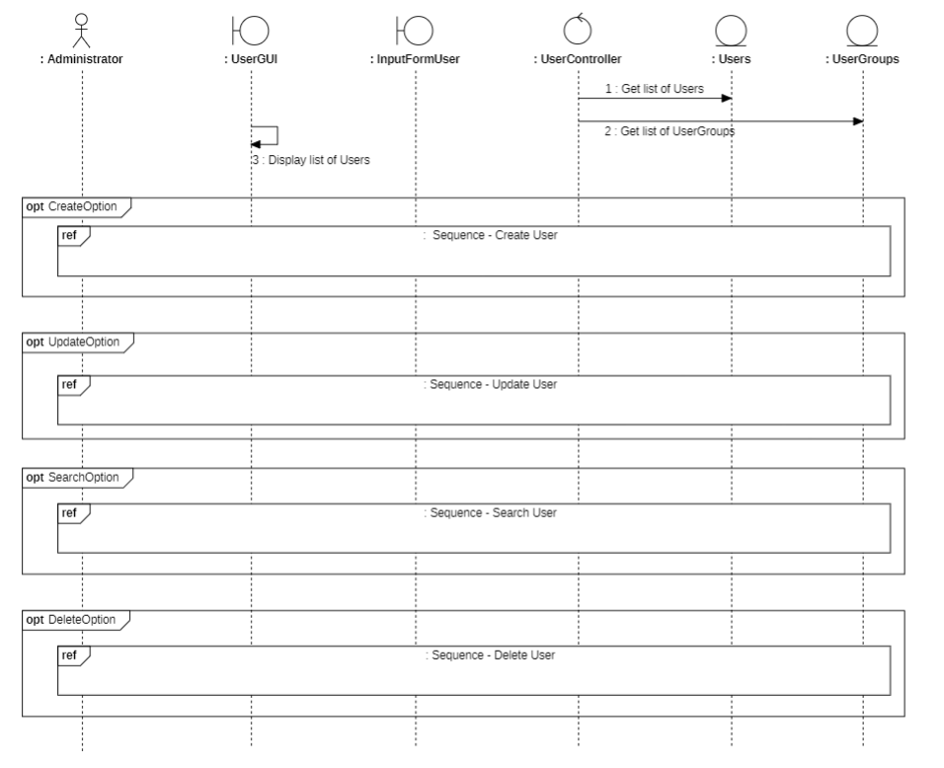

* **Create User:**

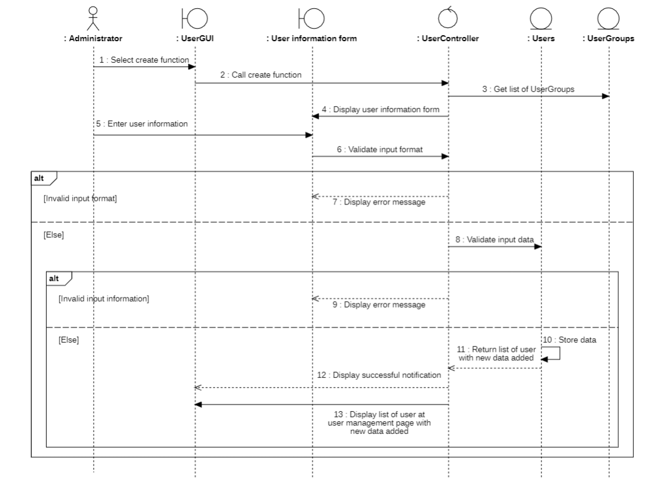

* **Update User:**

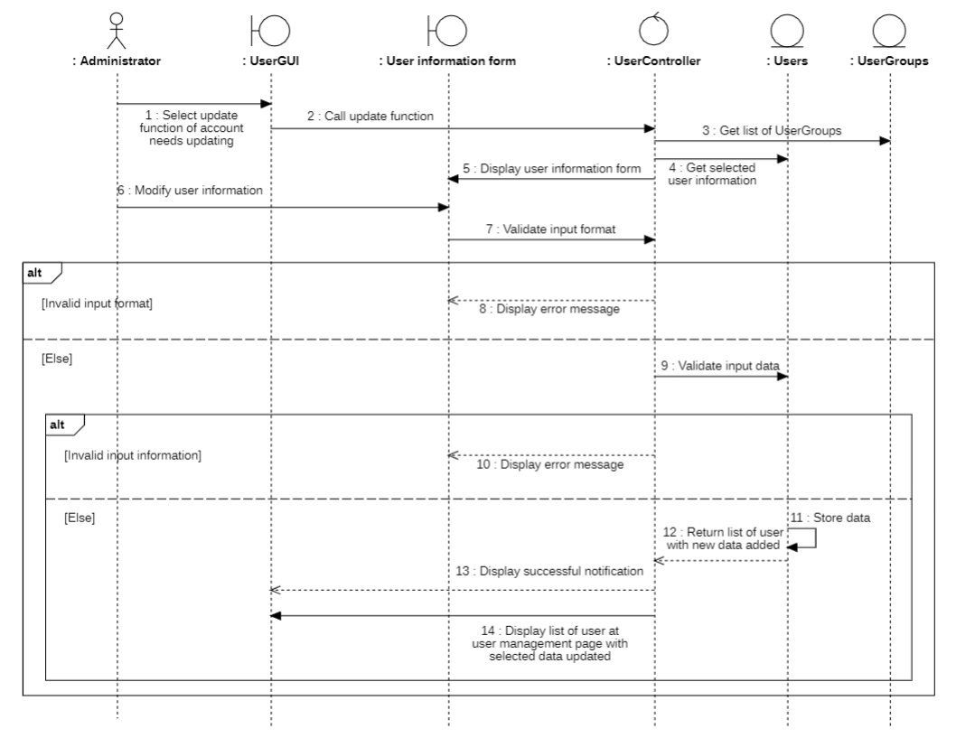

* **Search User:**

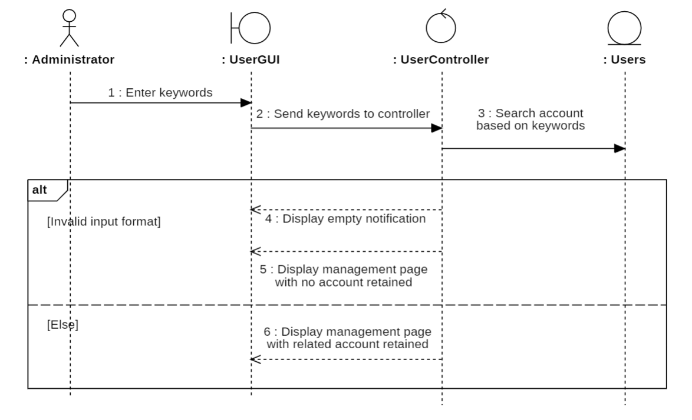

* **Delete User:**

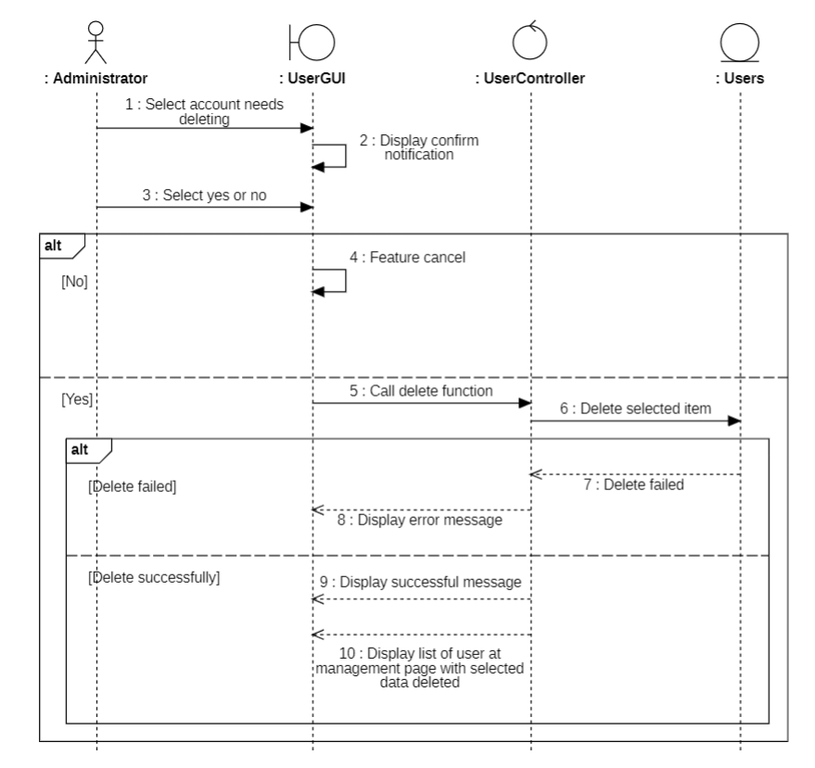

#### 3.5.11.2. Class diagram

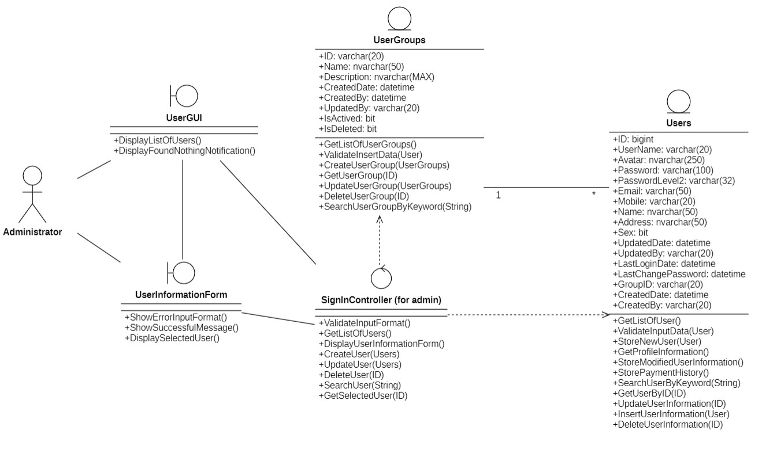

### 3.5.12. Product management

#### 3.5.12.1. Sequenece diagram

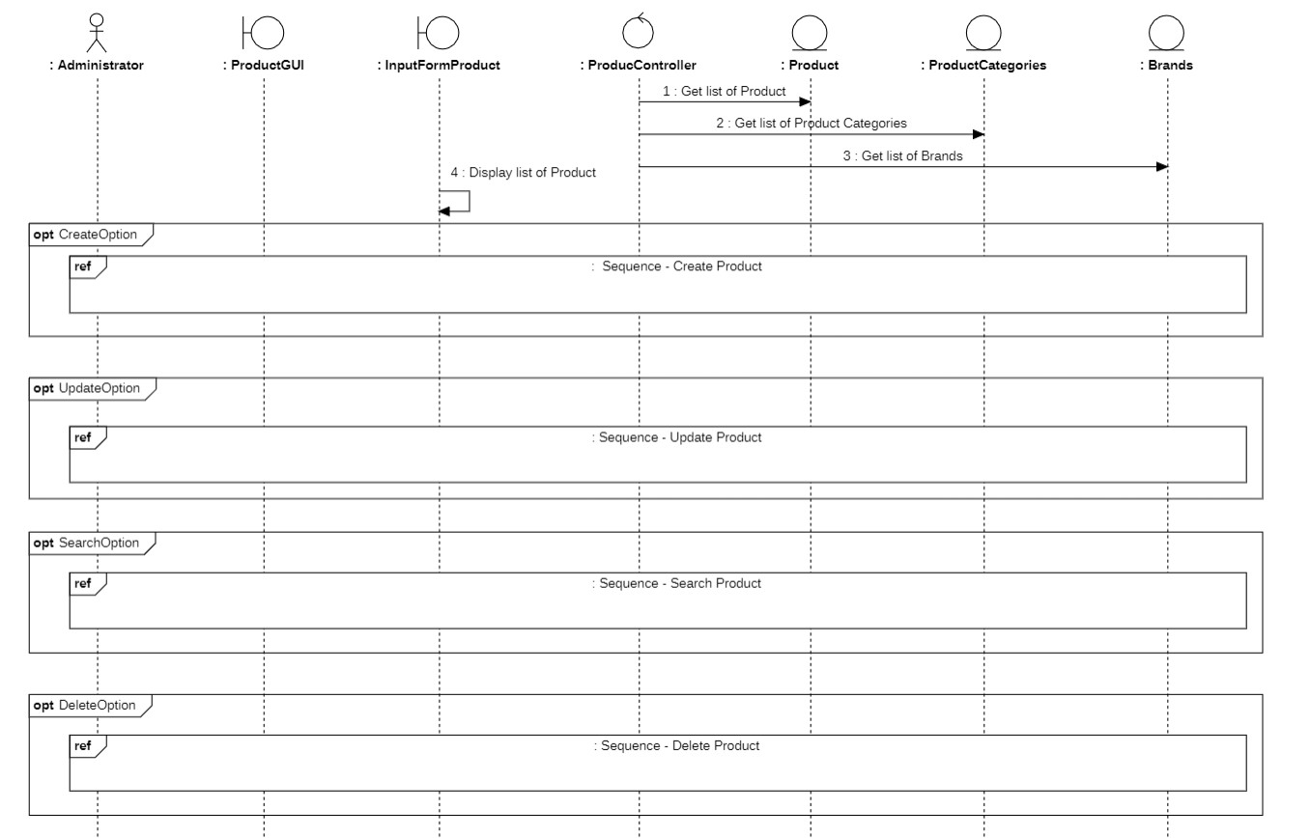

Create Product:

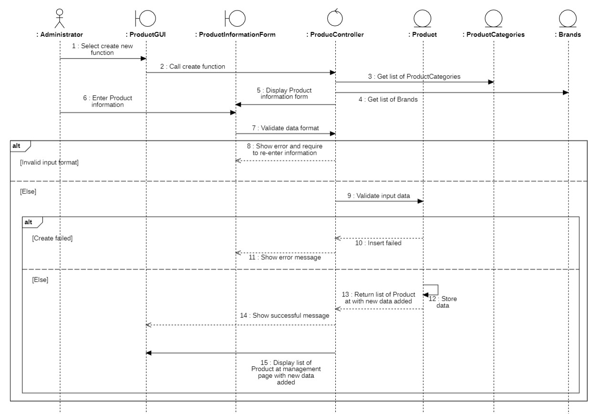

* **Update Product:**

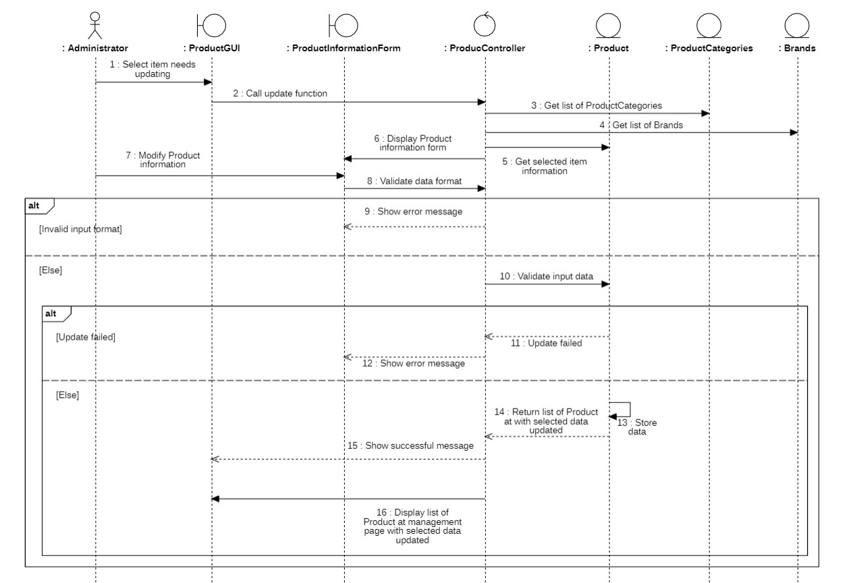

* **Search Product:**

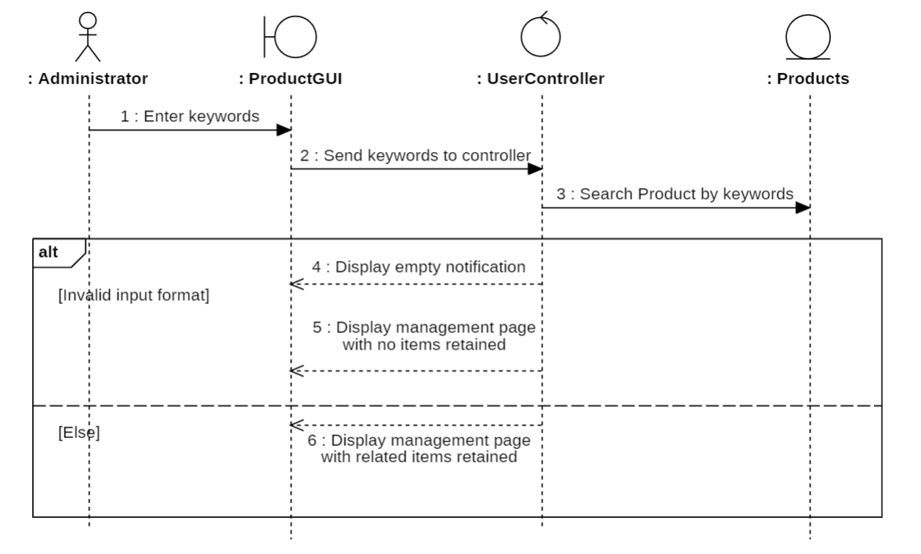

* **Delete Product:**

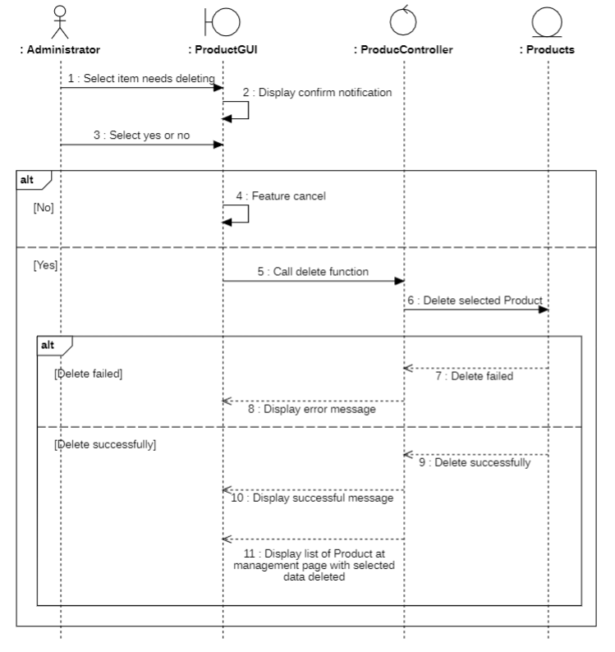

#### 3.5.12.2. Class diagram

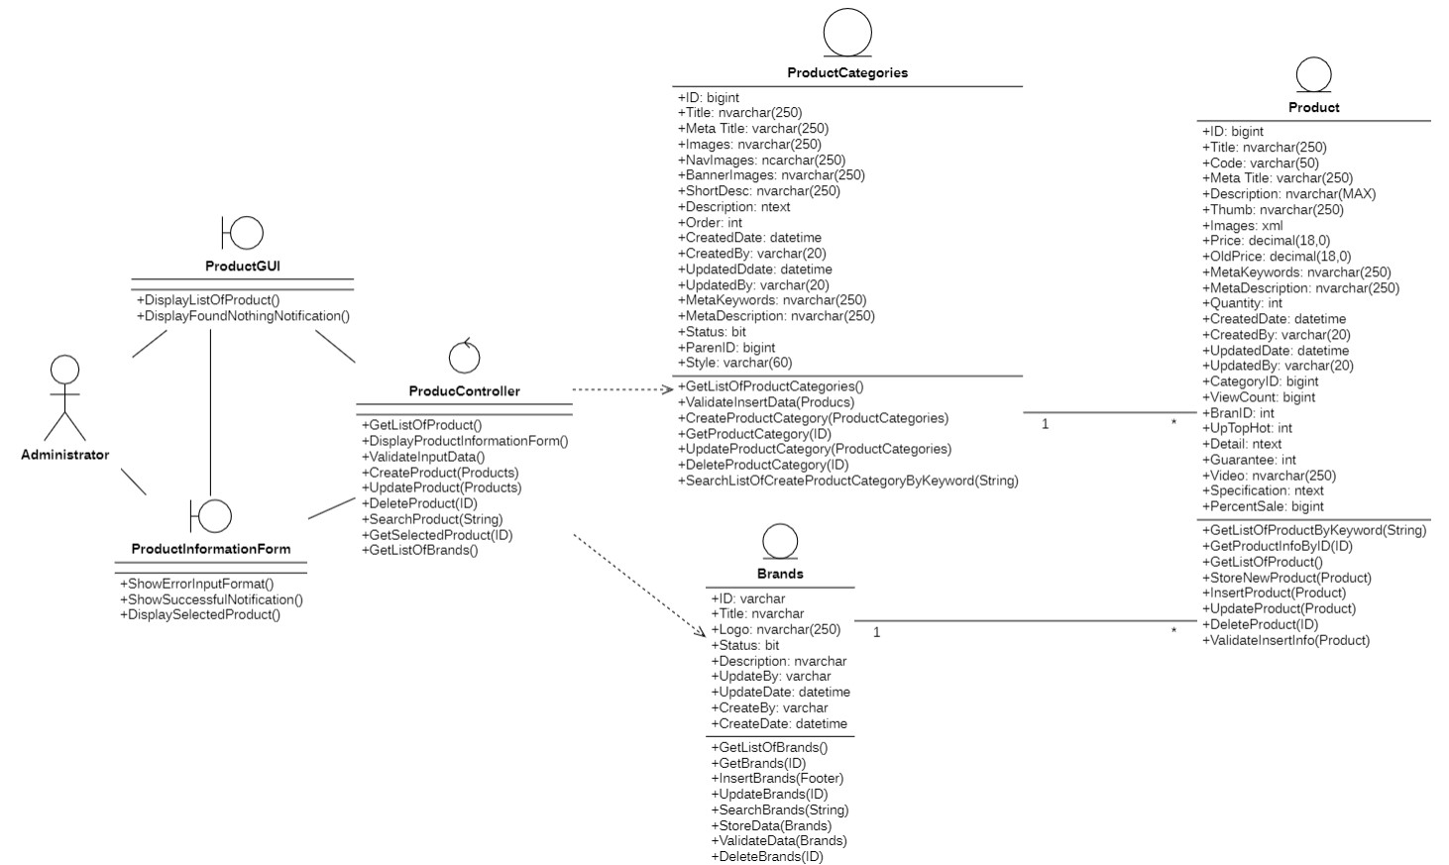

### 3.5.13. Order management

#### 3.5.13.1. Sequenece diagram

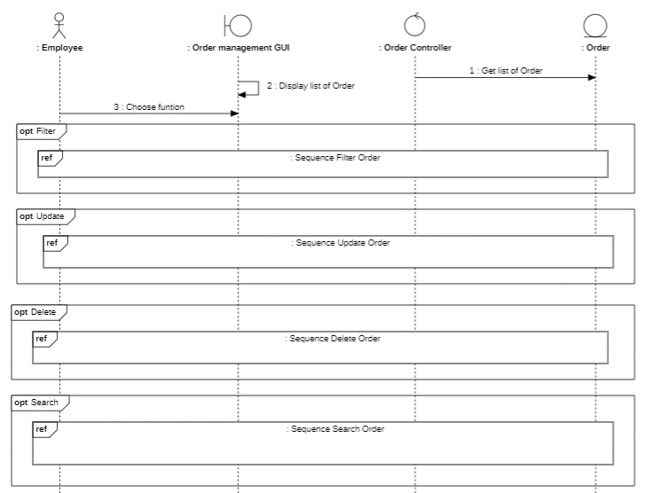

* **Delete:**

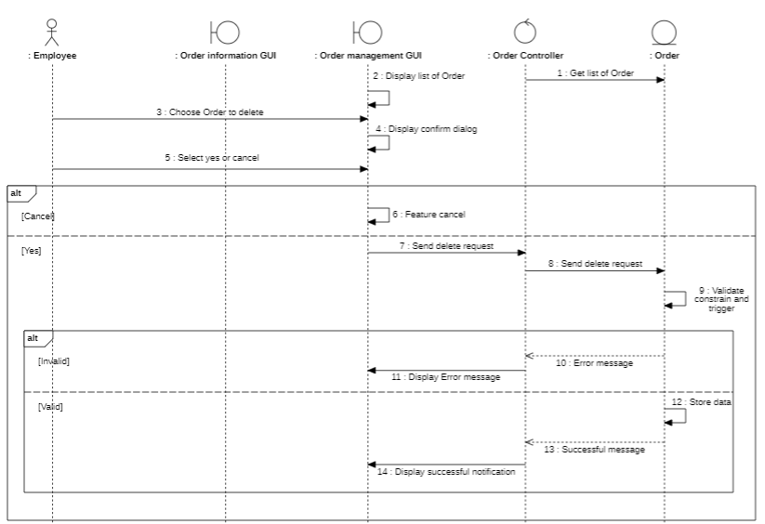

* **Update:**

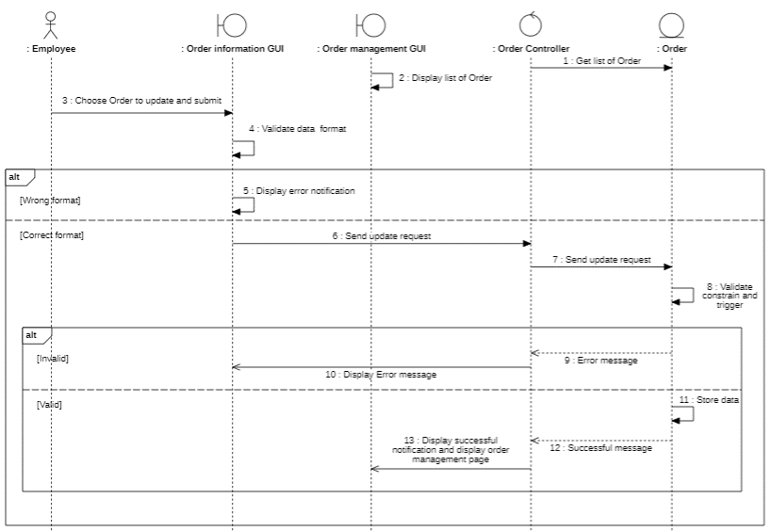

* **Search:**

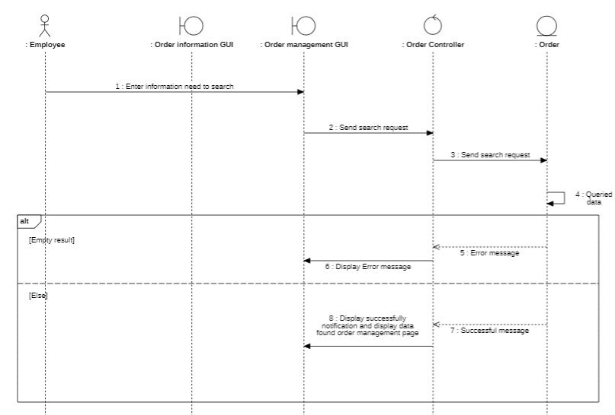

* **Filter:**

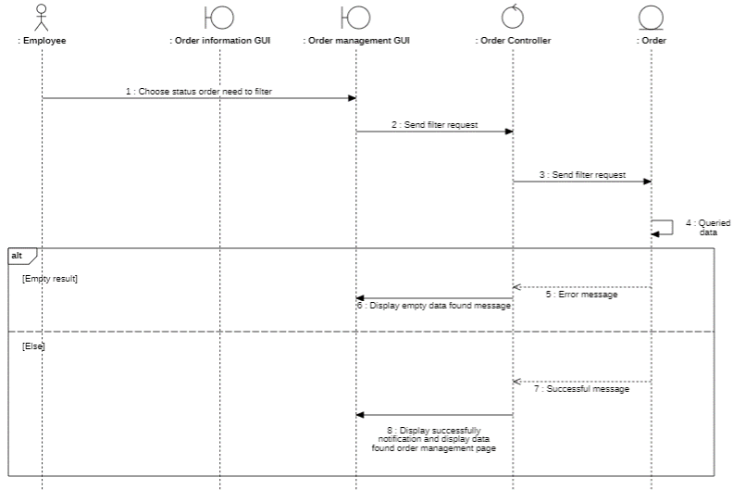

#### 3.5.13.2. Class diagram

3.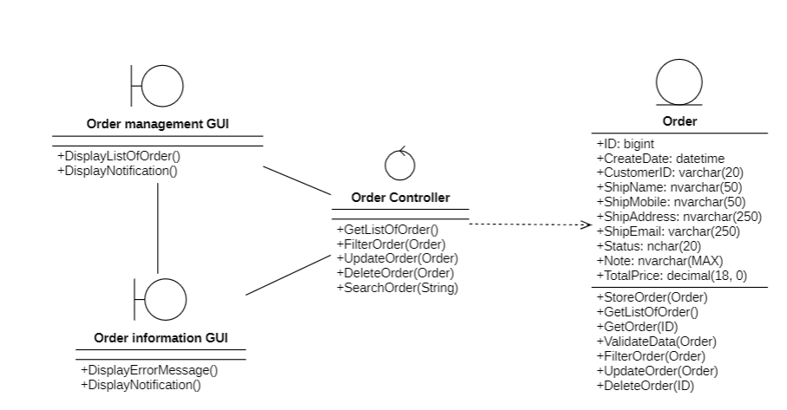

### 3.5.14. Article management

#### 3.5.14.1. Sequenece diagram

Article:

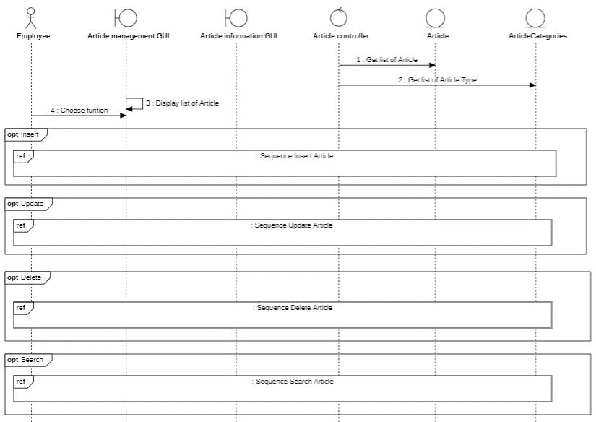

* **Insert:**

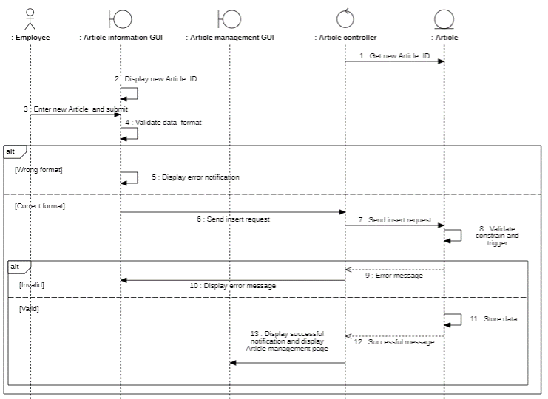

* **Update**

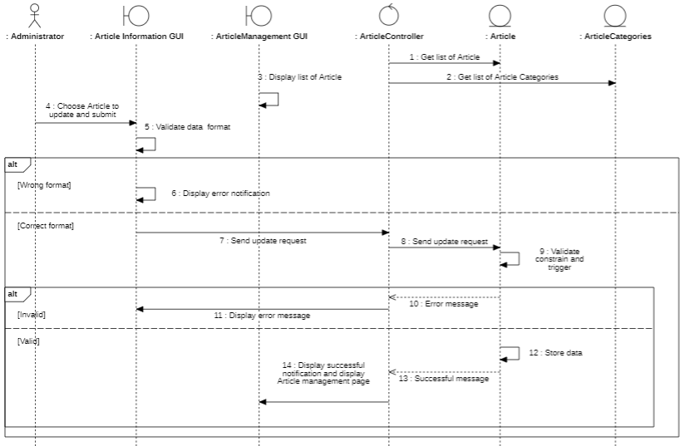

* **Delete**

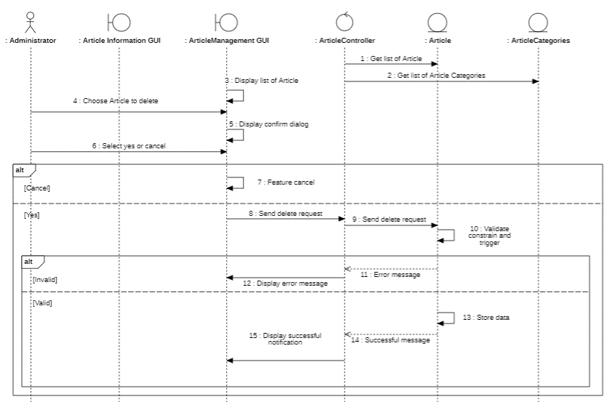

* **Search**

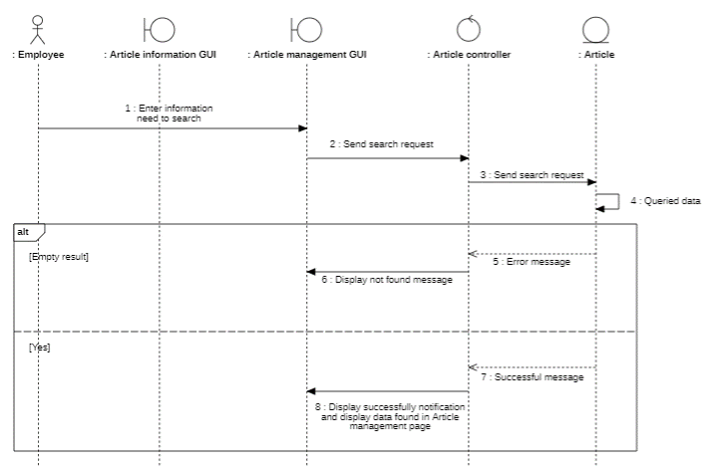

* **Article Categories**

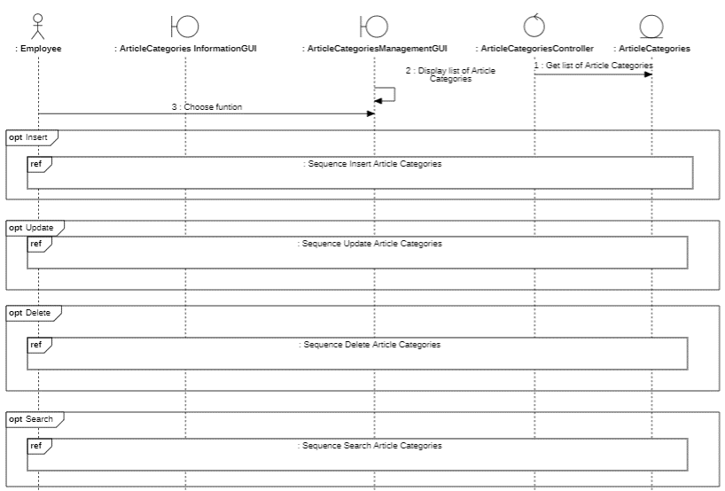

* **Insert**

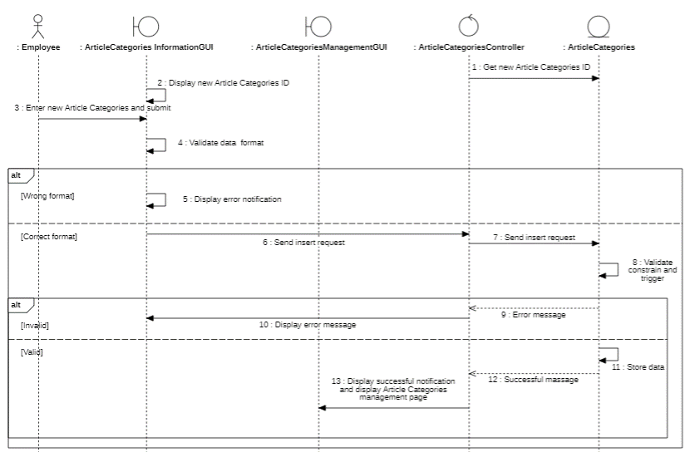

* **Update**

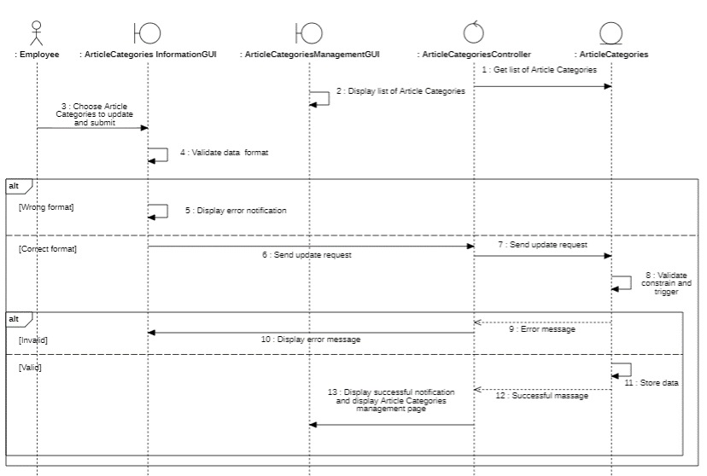

* **Delete**

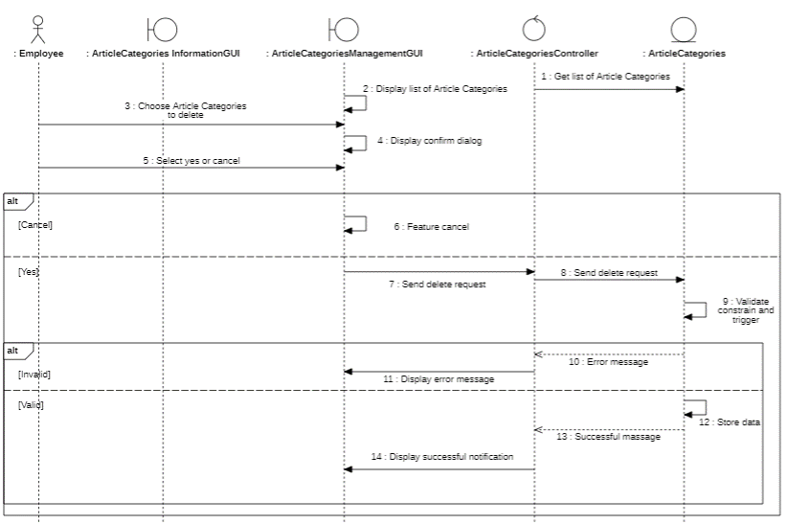

* **Search**

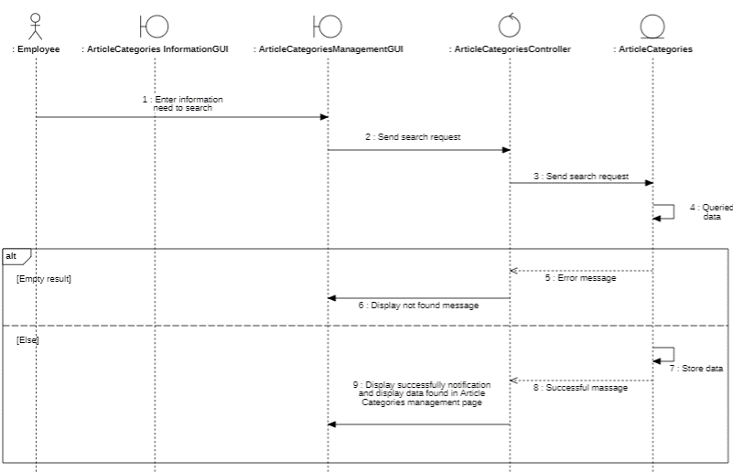

#### 3.5.14.2. Class diagram

* **Article**

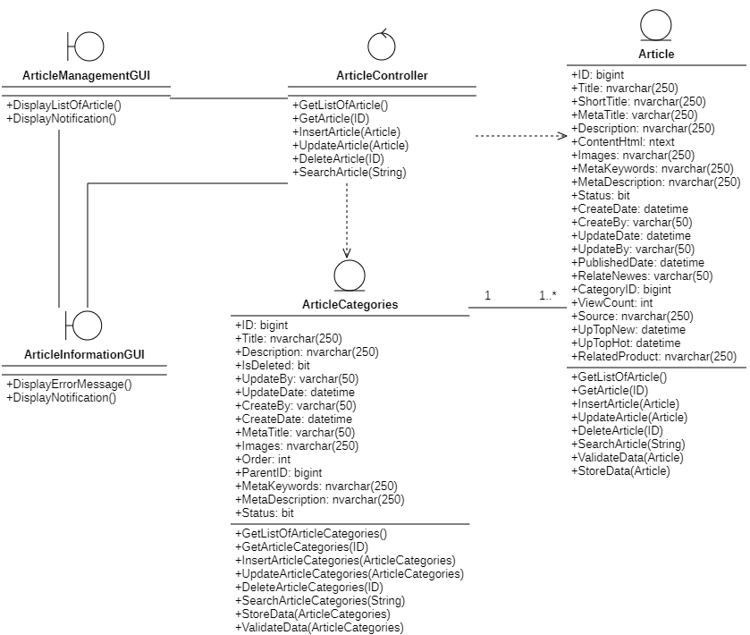

* **Article Categories**

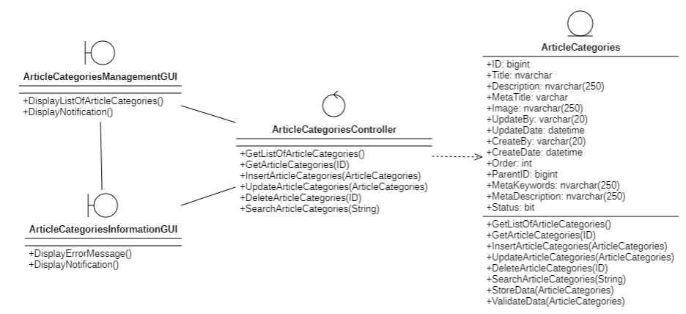

### 3.5.15. Manage feedback

#### 3.5.15.1. Sequenece diagram

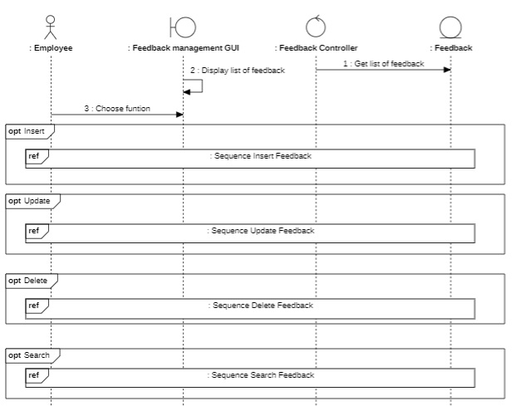

* **Insert**

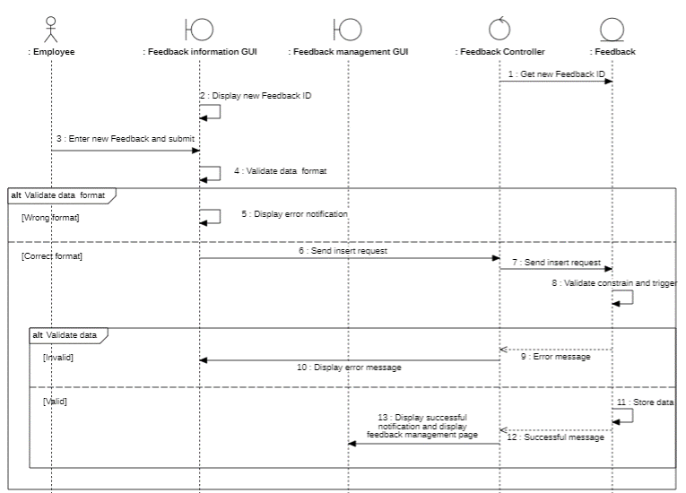

* **Delete**

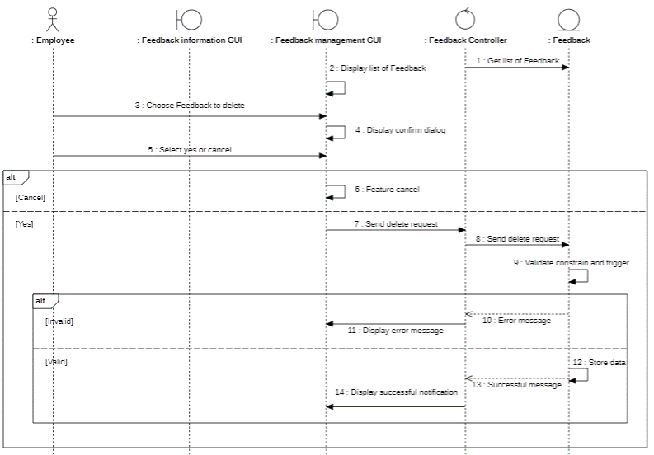

* **Update**

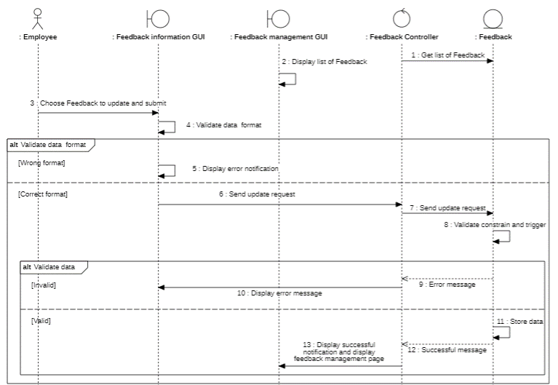

* **Search**

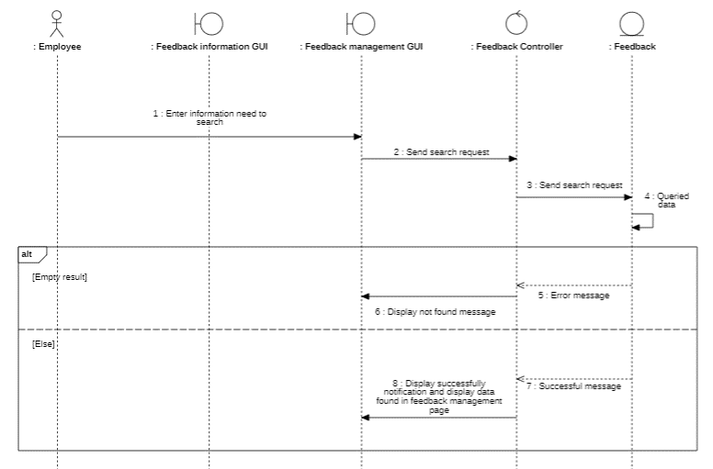

#### 3.5.15.2. Class diagram

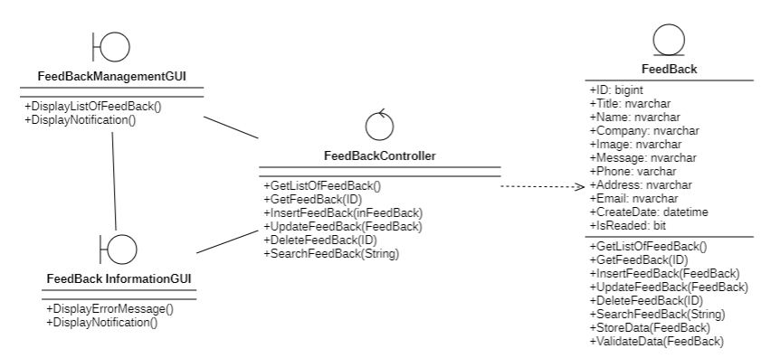

### 3.5.16. Interface management

#### 3.5.16.1. Sequenece diagram

* **Social media Sequence diagram**

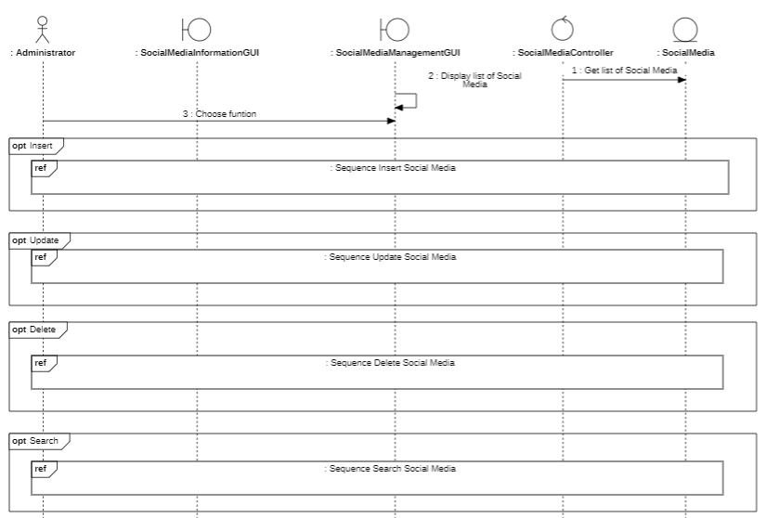

* **Sequence Insert Social Media**

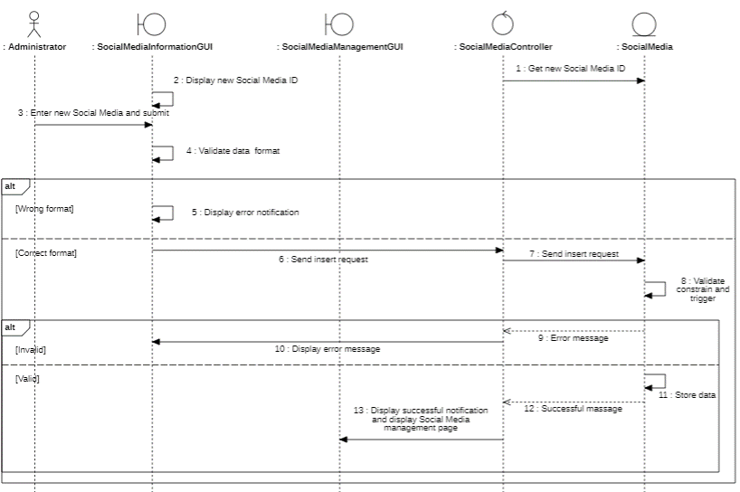

* **Sequence Update Social Media**

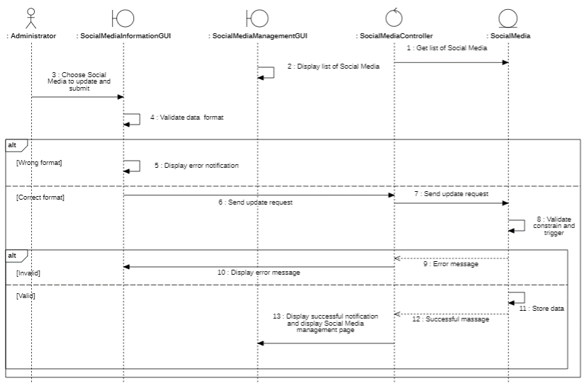

* **Sequence Delete Social Media**

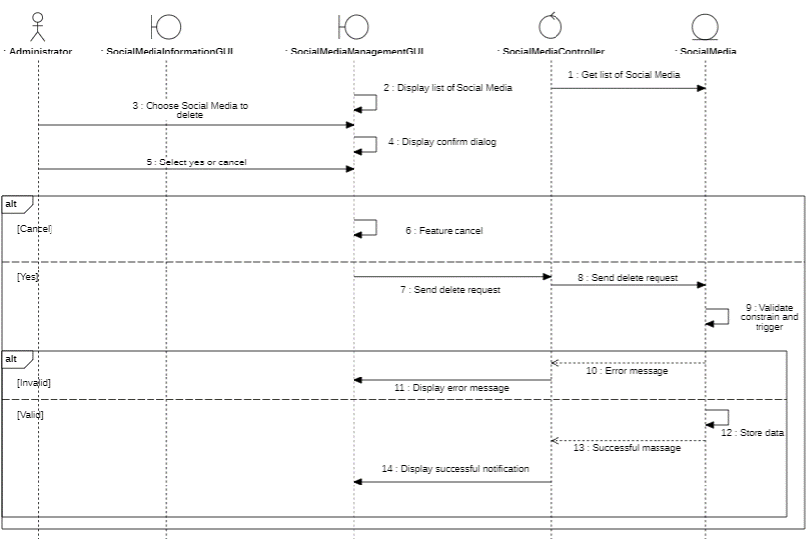

* **Sequence Search Social media**

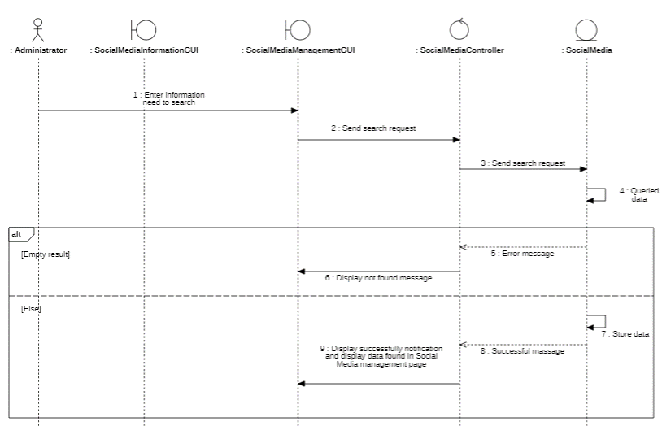

* **Footer Sequence diagram**

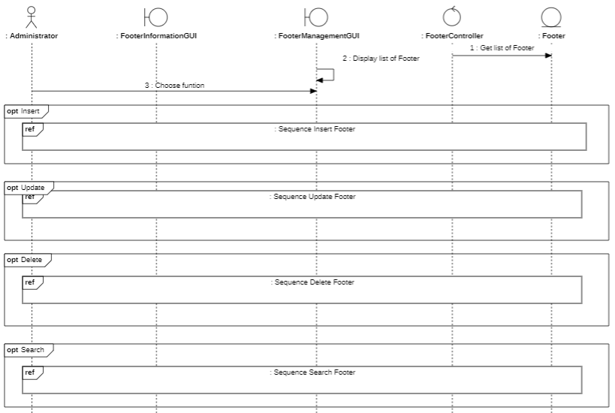

* **Sequence Insert Footer**

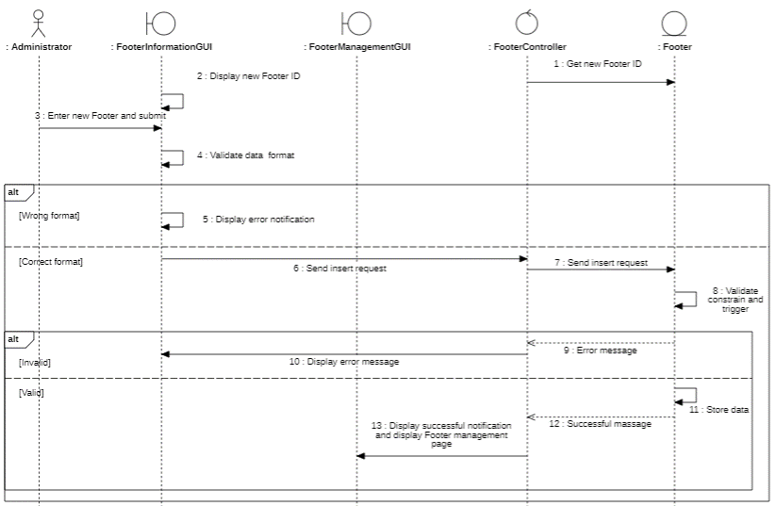

* **Sequence Update Footer**

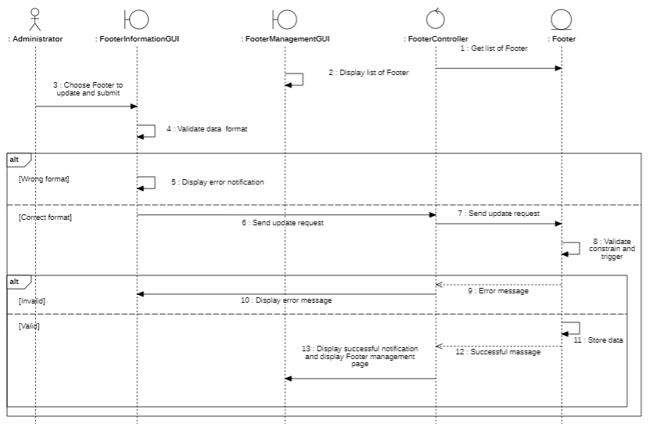

* **Sequence Delete Footer**

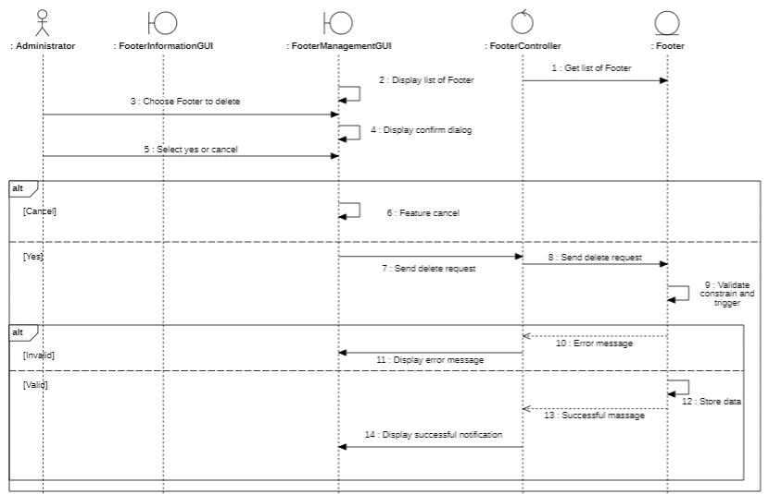

* **Sequence Search Footer**

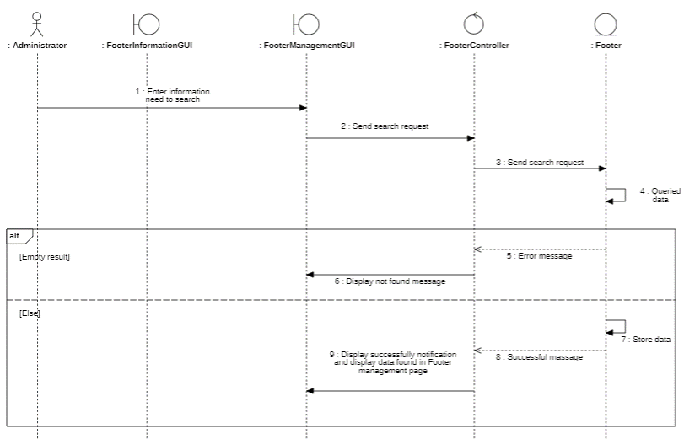

* **Brand Sequence diagram**

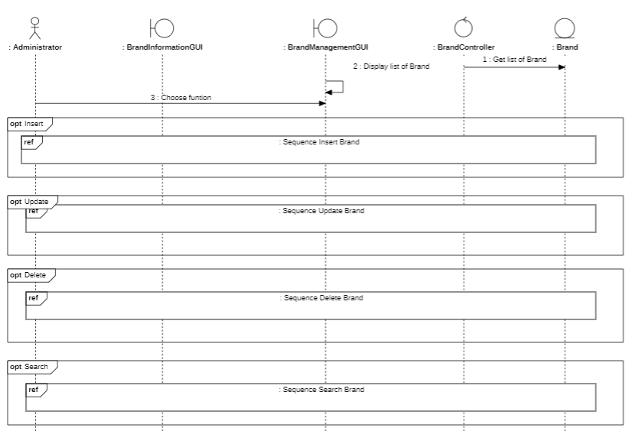

* **Sequence Insert Brand**

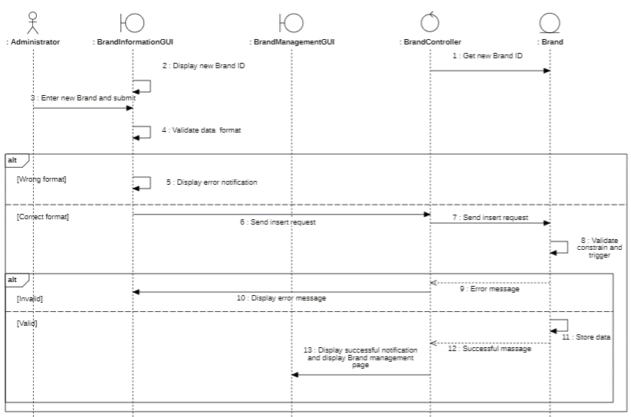

* **Sequence Update Brand**

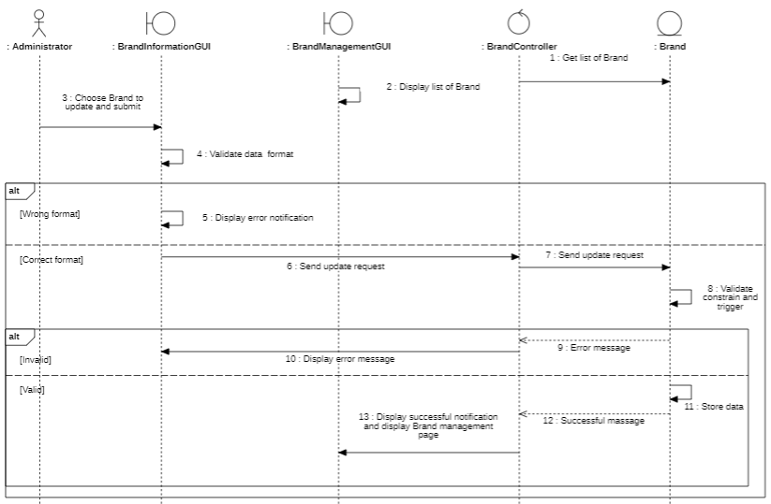

* **Sequence Delete Brand**

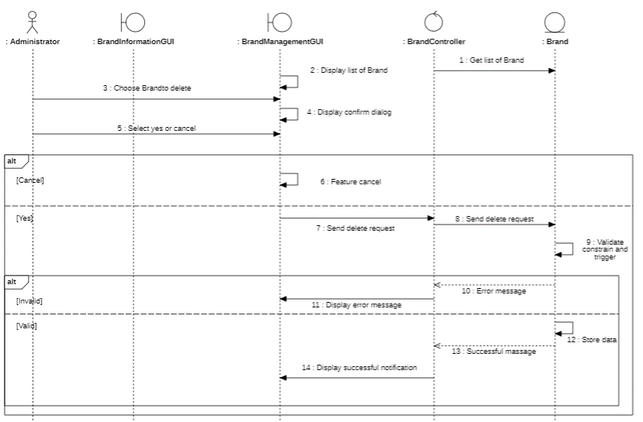

* **Sequence Search Brand**

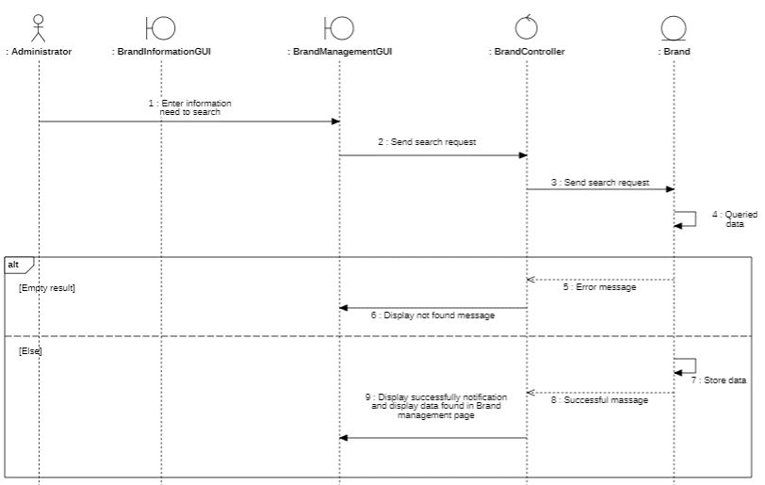

* **Slide Sequence diagram**

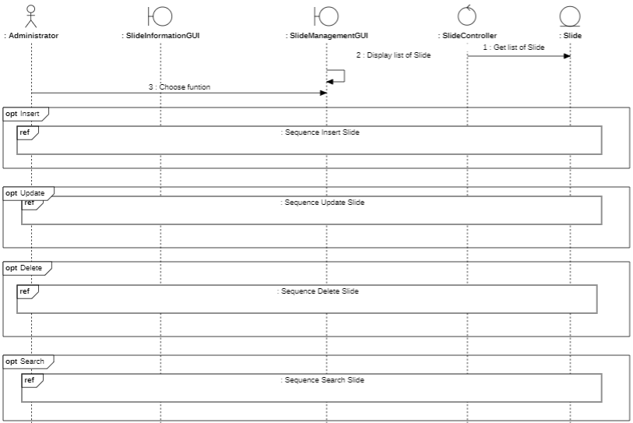

* **Sequence Insert Slide**

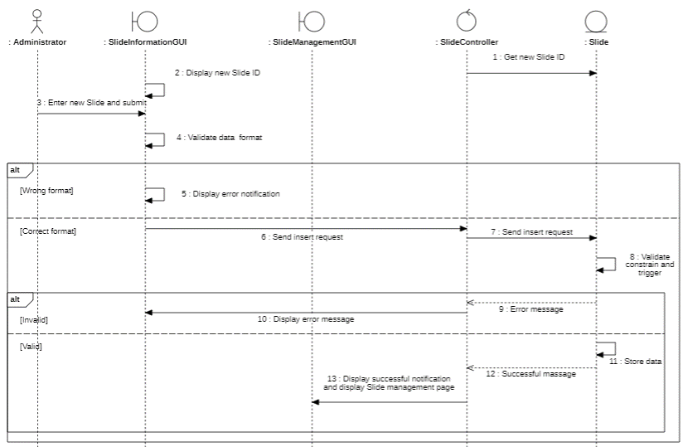

* **Sequence Update Slide**

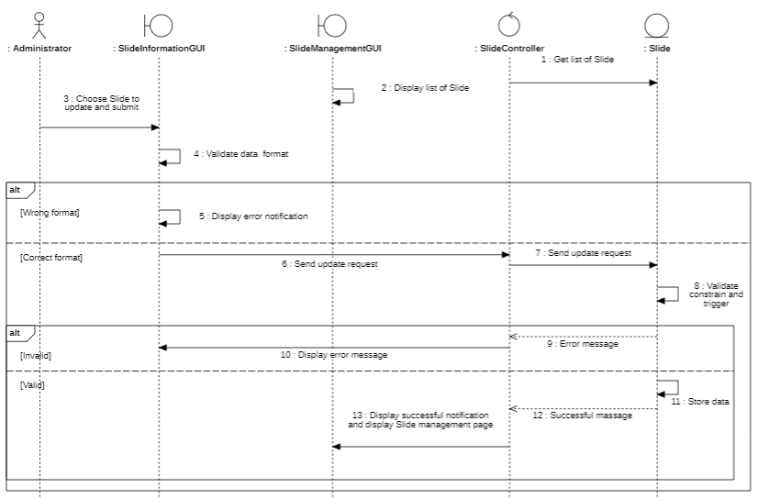

* **Sequence Delete Slide**

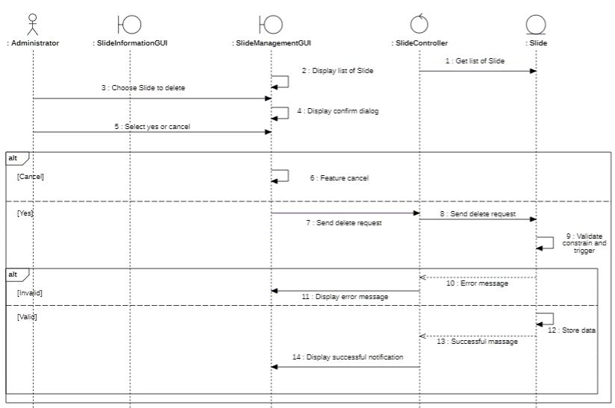

* **Sequence Search Slide**

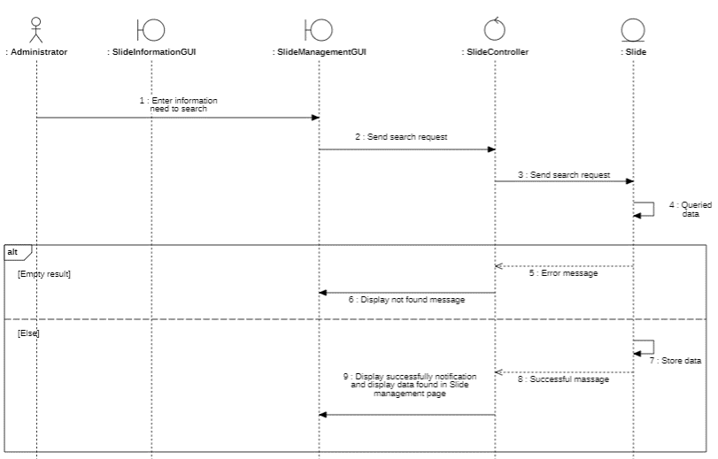

* **Menu Sequence diagram**

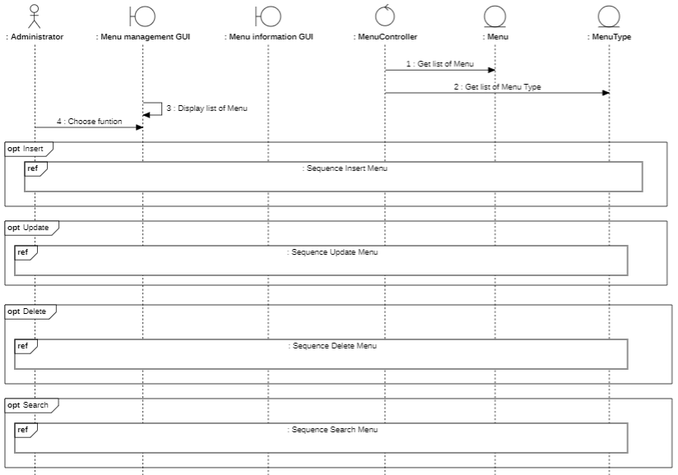

* **Sequence Insert Menu**

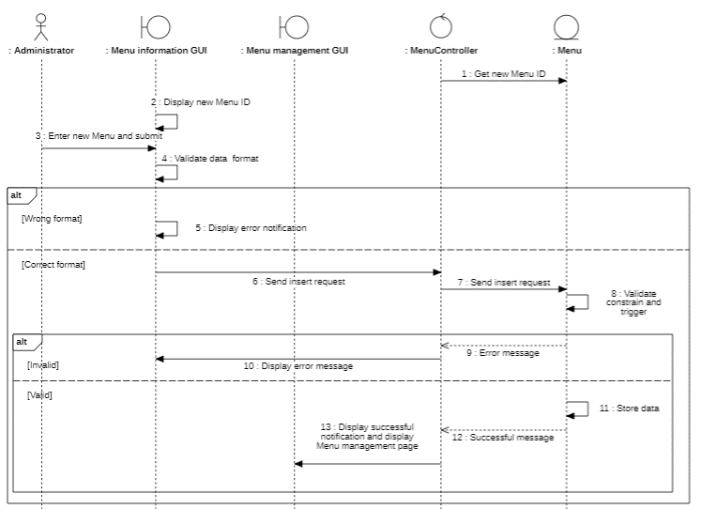

* **Sequence Update Menu**

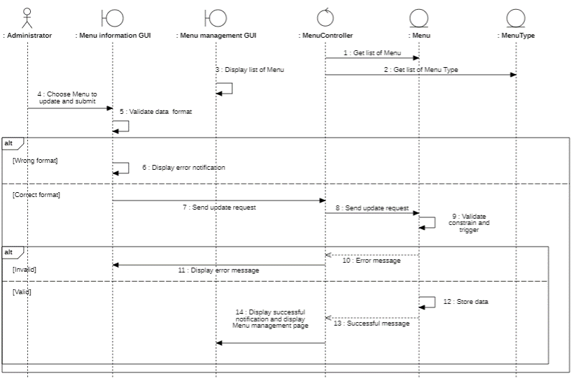

* **Sequence Delete Menu**

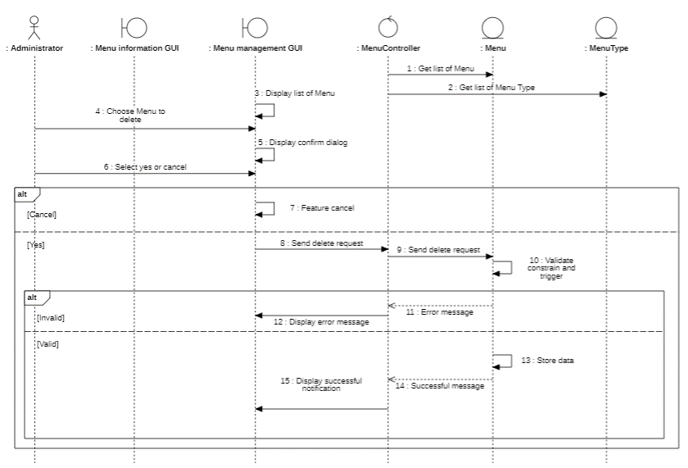

* **Sequence Search Menu**

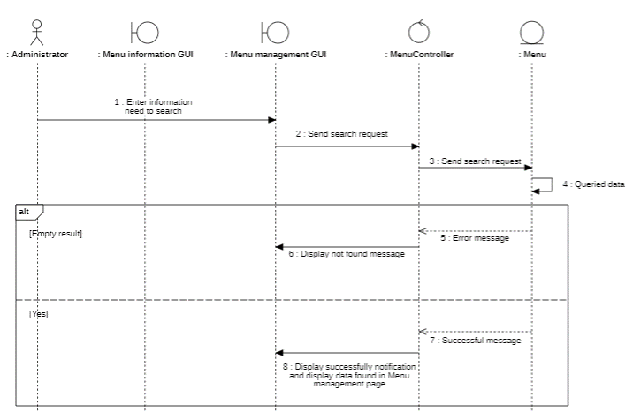

* **Menu Type Sequence diagram**

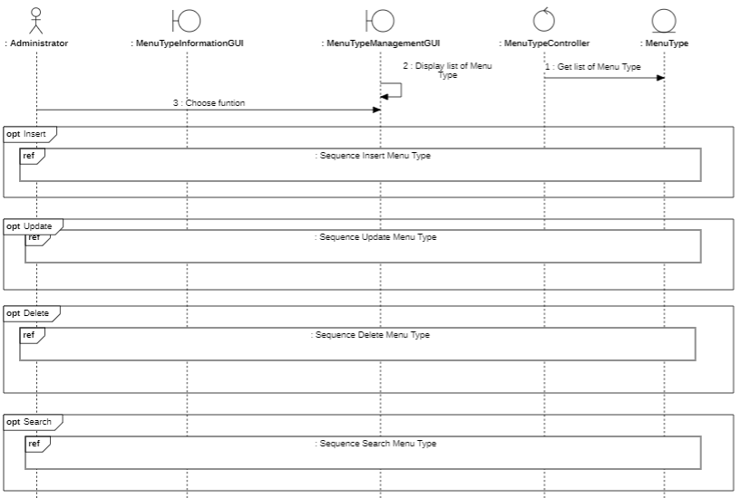

* **Sequence Insert Menu Type**

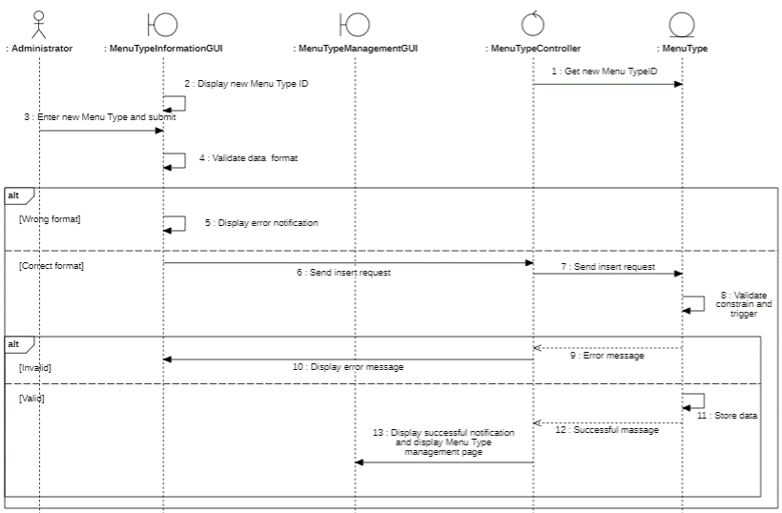

* **Sequence Update Menu Type**

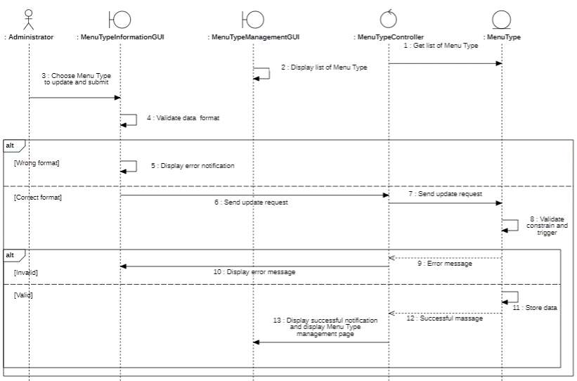

* **Sequence Delete Menu Type**

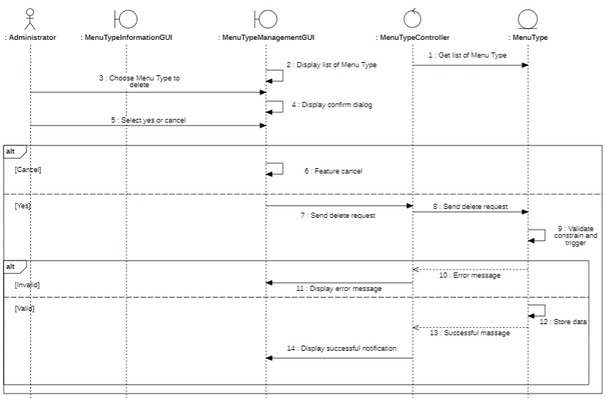

* **Sequence Search Menu Type**

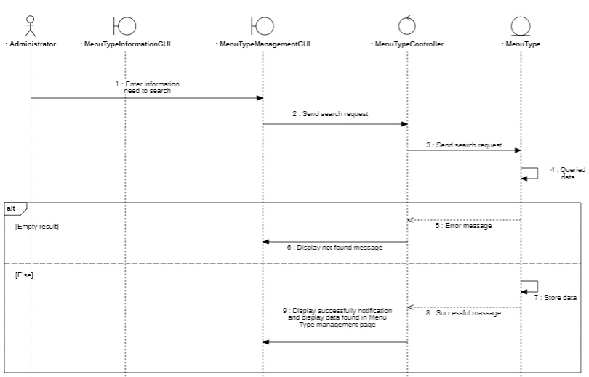

#### 3.5.16.2. Class diagram

**Social Media**

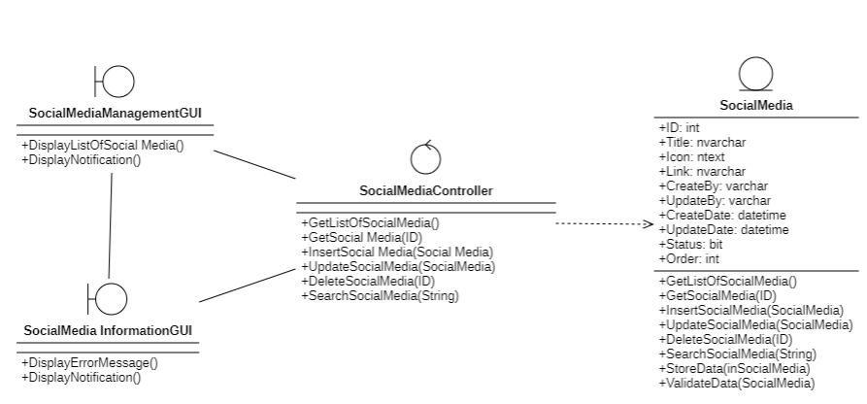

Footer

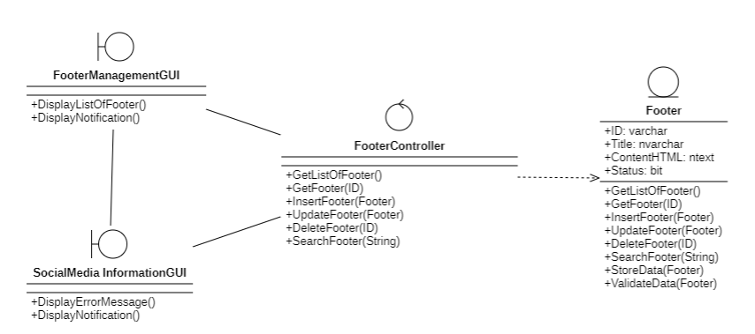

* **Brands**

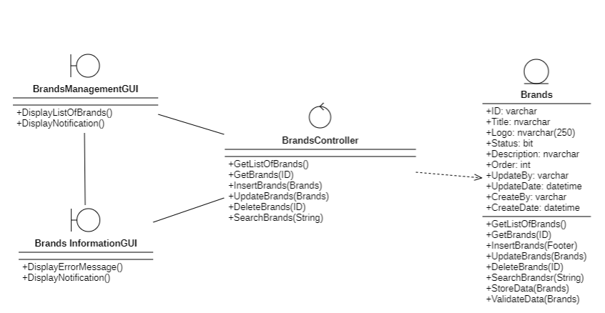

* **Slide**

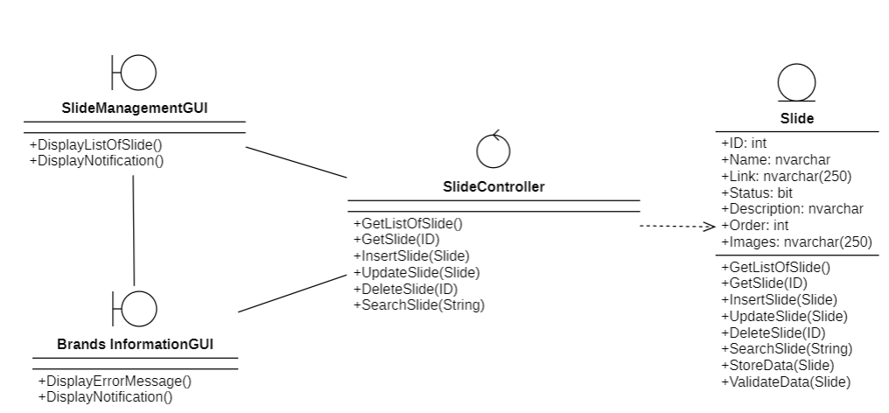

* **Menu**

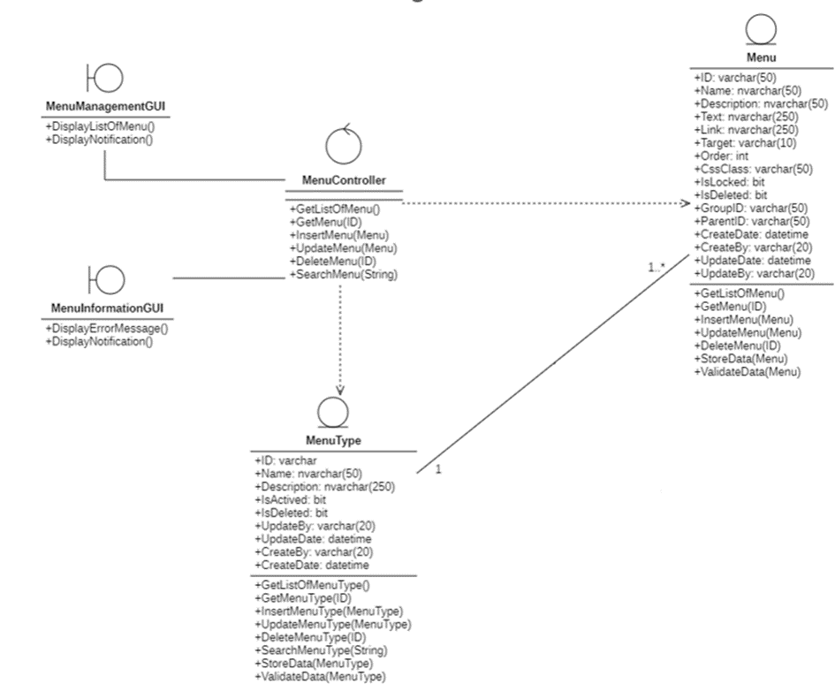

* **Menu Type**

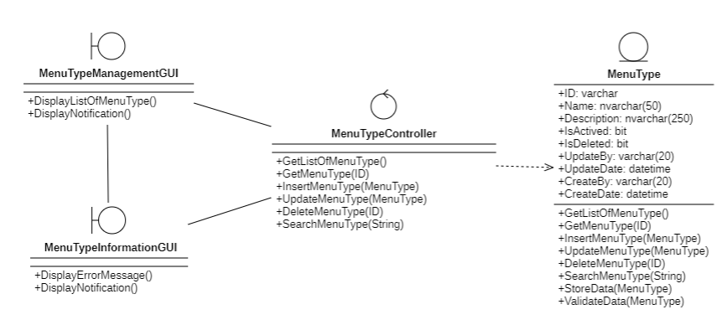

## 3.6 Class diagram and entity class diagram

### 3.6.1 Customer overview class diagram

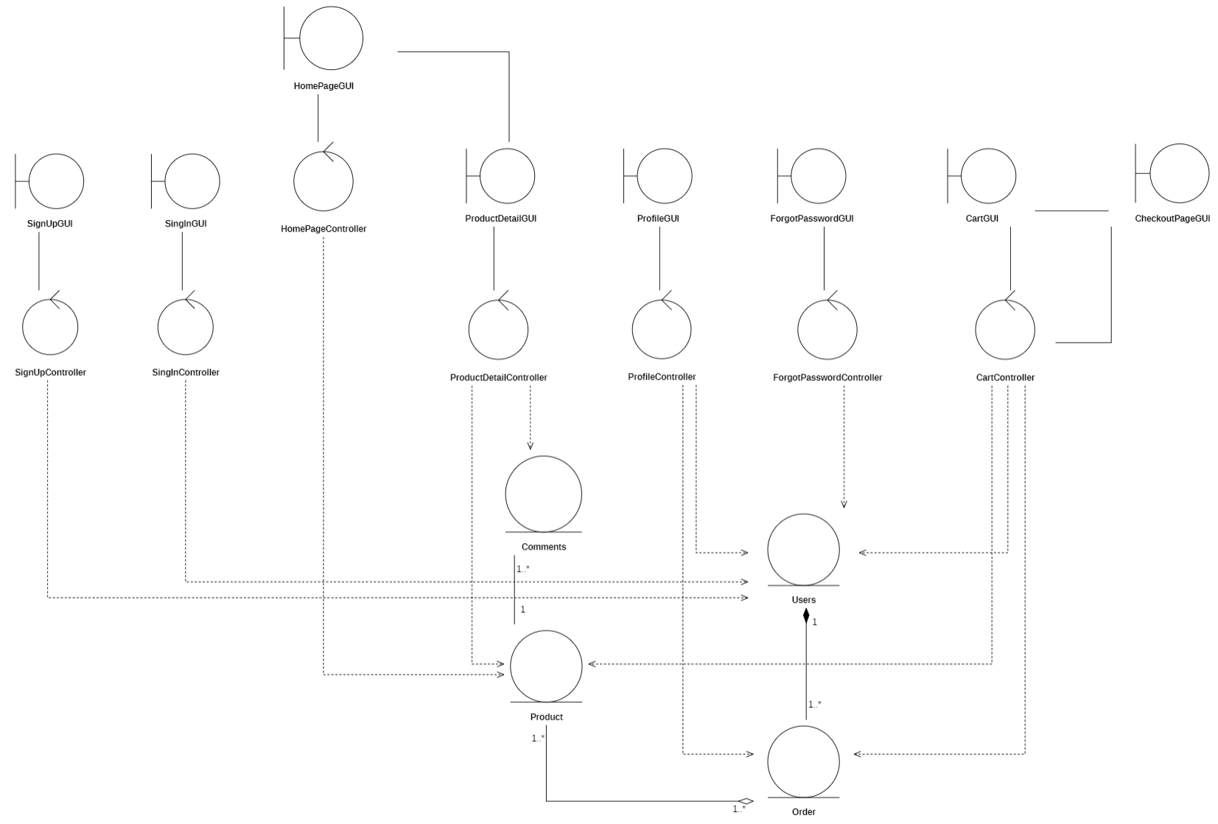

### 3.6.2 Administrator overview class diagram

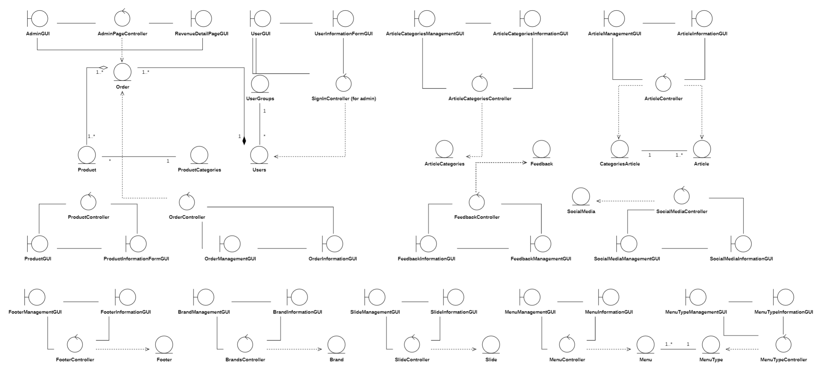

### 3.6.3 Entity class diagram

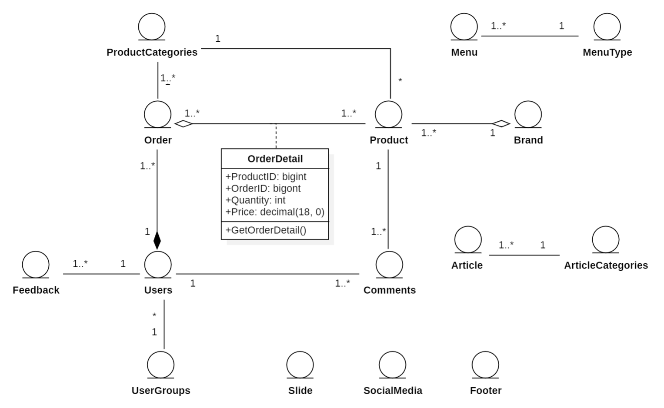

### 3.6.4. Class specification

#### 3.6.4.1. Users

|  |  |  |
| --- | --- | --- |
| Users | Function | Meaning |
| Attribute | ID: bigint | Users ID generate d by systems |
| Username: varchar (20) | Username login |
| Avatar: nvarchar(250) | Avatar for user |
| Password: varchar (100) | Password of user |
| PasswordLevel2: varchar (32) | Password security when purchasing |
| Email: varchar (50) | Email register of user |
| Mobile: varchar (20) | Mobile phone number of user |
| Name: varchar (50) | Name of user |
| Address: nvarchar(50) | Address of user |
| Sex: bit | Male or female |
| Updated Date: datetime | Date of information update |
| Updated By: varchar (20) | Provide updater information |
| Last Login Date: datetime | Last time logged into the system |
| Last Change Password: datetime | Time of last password change of user |
| Group ID: varchar (20) | Group ID |
| Created Date: datetime | User created on date |
| Created By: varchar (20) | User created by someone |
| Operation | Validate Input Date (User) | Check that the date format is correct |
| Store New User (User) | Save information user to database |
| Get Profile Information | Get user information from database |
| Store Modified User Information | Stores modified user information |
| Get List of User | Get list of users to perform on the customer management  page of administrator |
| Search User by Keyword (String) | Search users related to  keyword for displaying on the  users management. |
| Get User by ID (ID) | Get user by ID |
| Update User Information (ID) | Update information of user |
| Insert User Information (User) | Add user |
| Delete User Information (ID) | Delete user |

#### 3.6.4.2. Product

|  |  |  |
| --- | --- | --- |
| Product | Function | Meaning |
| Attribute | ID: bigint | Product ID generated by systems |
| Title: varchar(250) | It is a specific way to identify or promote a product |
| Code: varchar (50) | Code of product |
| Meta Title: varchar (250) | The meta title of a product is the title displayed on the browser or search results. It describes the content of a website or product and aids in search engine optimization (SEO). |
| Description: nvarchar(MAX) | The "description" of a product is the description of that product, commonly used in e-commerce websites. |
| Thump: nvarchar(250) | A product's "thumb" is usually a small image or icon that represents that product. The “what” here refers to whether this image is commonly used to represent the product on a website, in a product catalog, or in search results. |
| Images: xml | "Images" of a product are illustrations for that product. They are often used to display products from multiple angles and help consumers get a comprehensive view of the product before purchasing. |
| Price: decimal(18,0) | Prices of product |
| Old Price: decimal(18,0) | The "Old Price" of a product is the original or original price of the product before any discounts. This information is often used to compare current prices, helping buyers better understand the extent of the discount and the value of the offer. |
| Meta Keywords: nvarchar(250) | A product's "Meta Keywords" are keywords that describe the product, often used in website source code to help search engines understand the page's content. |
| Meta Description: nvarchar(250) | The "Meta Description" of a product is a brief text description of the product, often displayed in search results on search engines. |
| Quantity: int | The "Quantity" of a product is the number of units of that product available for sale. This information is important so that buyers know how much product is left and make purchasing decisions based on product availability. |
| Created Date: datetime | The "Created Date" of a product is the date that product was created or added to the system. |
| Created By: varchar(20) | The "Created By" of a product is information about the person or organization that created that product. This information can provide transparency and credibility about a product's origin, and help consumers better understand the product's inspiration and quality. |
| Category ID: bigint | A product's "Category ID" is the code or identifier for the category to which the product belongs. This information helps the system classify and organize products into specific categories on the website or in the product database.  ​ |
| View Count: bigint | The "View Count" of a product is the number of times that product has been viewed on the sales website or product information page. This information is often used to measure a product's interest and popularity among consumers. |
| Brand ID: int | The "Brand ID" of a product is the brand identifier, which is a special code or symbol used to identify the product's brand. |
| Up Top Hot: bit | This makes it easier for buyers to find products that are highly rated or of great interest.  ​ |
| Detail: ntext | Detail of product |
| Guarantee: int | The "guarantee" of a product is a promise from the manufacturer or seller about the quality, performance or customer satisfaction of that product. |
| Video: nvarchar(250) | Videos describe of video |
| Percent Sale: bigint | "Percent Sale" of a product is the percentage discount compared to the original price. This information is often used to indicate the extent of a product's discount, helping buyers better understand the special offer they can receive.  ​ |
| Operation | Get List of Product by Keyword (String) | Get List of Product by Keyword |
| Get Product Info by ID (ID) | Get information product |
| Get List of Product by Keyword (String) | Get List of Product by Keyword |
| Store New Product (Product) | Save new product has been in |
| Insert Product (Product) | Insert product |
| Validate Insert Info (Product) | Check information of product |
| Update Product (Product) | Update information of product |
| Delete Product (ID) | Delete product |

#### 3.6.4.3. Comments

|  |  |  |
| --- | --- | --- |
| Comments | Function | Meaning |
| Comment | ID : bigint | Comment ID generated by system |
| Username: varchar(20) | Account name comment |
| Email: varchar(250) | Email of account comment |
| Full Name: nvarchar(250) | Full name of user |
| Review: nvarchar(MAX) | Review |
| Sent Date: datetime | Date of dispatch |
| Product ID : bigint | Product ID generated by systems |
| Approved: bit | Approved |
| Stars: bit | Evaluate |
| Operation | Insert Comment (String) | Insert new comment |
| Update Comment (String) | Update comment |
| Delete Comment (String) | Delete comment |
| Store New Comment (String) | Save comment to database |

#### 3.6.4.4. Home page controller

|  |  |  |
| --- | --- | --- |
| Home Page Controller | | |
| Operation | Function | Meaning |
| Search Product (String) | Search product |
| Get List of Product | Get list of product |

#### 3.6.4.5. Product detail controller

|  |  |  |
| --- | --- | --- |
| Product detail Controller | | |
| Operation | Function | Meaning |
| Search Product (String) | Search product |
| Get Product by Id (ID) | Get product by id |
| Get List of Comment (Product ID) | Get list comment of product |

#### 3.6.4.6. Profile controller

|  |  |  |
| --- | --- | --- |
| Profile Controller | | |
| Operation | Function | Meaning |
| Get User by ID (ID) | Get information of user by id |
| Get Profile Information | Get profile information |
| Validate Input Data (User) | Check data of user |
| Get Payment History | Show history payment of user |

#### 3.6.4.7. Password controller

|  |  |  |
| --- | --- | --- |
| Password Controller | | |
| Operation | Function | Meaning |
| Validate Input Data (User) | Check input data of user |
| Generate Code To Verify (String) | Generated code to verify and login |
| Validate Code (String) | Check code equal to system |

#### 3.6.4.8. Cart controller

|  |  |  |
| --- | --- | --- |
| Cart Controller | | |
| Operation | Function | Meaning |
| Get List of Product | Get list of products |
| Get Product Info by ID (ID) | Get information of product |
| Get Info Order (ID) | Get information of order |
| Store Payment () | Store payment when user buying |

#### 3.6.4.9. Checkout page controller

|  |  |  |
| --- | --- | --- |
| Checkout Page Controller | | |
| Operation | Function | Meaning |
| Get Info Order (ID) | Get information of order |
| Get List of Product | Get list of products |
| Get Product Info by ID (ID) | Get information of product by ID |

#### 3.6.4.10. Sign-in controller

|  |  |  |
| --- | --- | --- |
| Sign In Controller | | |
| Operation | Function | Meaning |
| Validate Input() | Check input data |
| Sign in () | Sign in to system |

#### 3.6.4.11. Sign-up controller

|  |  |  |
| --- | --- | --- |
| Signup Controller | | |
| Operation | Function | Meaning |
| Handle Login () | The process of authenticating and accessing a system or account. |

#### 3.6.4.12. Order Controller

|  |  |  |
| --- | --- | --- |
| Order Controller | | |
| Operation | Function | Meaning |
| GetListOfOrder() | Request database to get a list of all orders. |
| GetOrder(ID) | Return a order information matched with the ID. This function is used to get a specific data to pour in the information form |
| FilterOrder(Order) | Filter order by the status order |
| UpdateOrder(Order) | Update information of an existed order |
| DeleteOrder(Order) | Delete a order existed in the database |
| SearchOrder(String) | Return a list of orders related to the keyword |

#### 3.6.4.13. Article Controller

|  |  |  |
| --- | --- | --- |
| Article Controller | | |
| Operation | Function | Meaning |
| GetListOfArticle() | Request database to get a list of all Articles. |
| GetArticle(ID) | Return an Article information matched with the ID. This function is used to get a specific data to pour in the information form |
| InsertArticle(Article) | Create new Article in the database |
| UpdateArticle( Article) | Update information of an existed Article |
| DeleteArticle(Article) | Delete a Article existed in the database |
| SearchArticle( String) | Return a list of Articles related to the keyword |

#### 3.6.4.14. Article Categories Controller

|  |  |  |
| --- | --- | --- |
| Article Categories Controller | | |
| Operation | Function | Meaning |
| GetListOfArticle Categories() | Request database to get a list of all Article Categories. |
| GetArticle Categories(ID) | Return an Article Categories information matched with the ID. This function is used to get a specific data to pour in the information form |
| InsertArticle Categories(Article Categories) | Create new Article Categories in the database |
| UpdateArticle Categories( Article Categories) | Update information of an existed Article Categories |
| DeleteArticle Categories( Article Categories) | Delete a Article Categories existed in the database |
| SearchArticle Categories( String) | Return a list of Article Categories related to the keyword |

#### 3.6.4.15. FeedBack Controller

|  |  |  |
| --- | --- | --- |
| FeedBack Controller | | |
| Operation | Function | Meaning |
| GetListOfFeedBack () | Request database to get a list of all FeedBack. |
| Get FeedBack (ID) | Return a FeedBack information matched with the ID. This function is used to get a specific data to pour in the information form |
| Insert FeedBack(FeedBack) | Create new FeedBack in the database |
| Update FeedBack(FeedBack) | Update information of an existed FeedBack |
| Delete FeedBack( FeedBack) | Delete a FeedBack existed in the database |
| Search FeedBack(String) | Return a list of FeedBack related to the keyword |

#### 3.6.4.16. Footer Controller

|  |  |  |
| --- | --- | --- |
| Footer Controller | | |
| Operation | Function | Meaning |
| GetListOfFooter() | Request database to get a list of all Footer. |
| GetFooter(ID) | Return a Footer information matched with the ID. This function is used to get a specific data to pour in the information form |
| InsertFooter(Footer) | Create new Footer in the database |
| Update Footer(Footer) | Update information of an existed Footer |
| DeleteFooter(Footer) | Delete a Footer existed in the database |
| Search Footer(String) | Return a list of Footer related to the keyword |

#### 3.6.4.17. Slide Controller

|  |  |  |
| --- | --- | --- |
| Slide Controller | | |
| Operation | Function | Meaning |
| GetListOfSlide() | Request database to get a list of all Slide. |
| GetSlide(ID) | Return a Slide information matched with the ID. This function is used to get a specific data to pour in the information form |
| InsertSlide( Slide) | Create new Slide in the database |
| Update Slide(Slide) | Update information of an existed Slide |
| DeleteSlide( Slide) | Delete a Slide existed in the database |
| Search Slide(String) | Return a list of Slide related to the keyword |

#### 3.6.4.18. Brands Controller

|  |  |  |
| --- | --- | --- |
| Brands Controller | | |
| Operation | Function | Meaning |
| GetListOfBrands() | Request database to get a list of all Brands. |
| Get Brands(ID) | Return a Brands information matched with the ID. This function is used to get a specific data to pour in the information form |
| Insert Brands(Brands) | Create new Brands in the database |
| Update Brands(Brands) | Update information of an existed Brands |
| Delete Brands(Brands) | Delete a Brands existed in the database |
| Search Brands(String) | Return a list of Brands related to the keyword |

#### 3.6.4.17. Social Media Controller

|  |  |  |
| --- | --- | --- |
| Social Media  Controller | | |
| Operation | Function | Meaning |
| GetListOfSocialMedia () | Request database to get a list of all Social Media. |
| Get SocialMedia (ID) | Return Social Media information matched with the ID. This function is used to get a specific data to pour in the information form |
| Insert SocialMedia (Social Media) | Create new Social Media in the database |
| Update SocialMedia (SocialMedia) | Update information of an existed social media |
| Delete SocialMedia (SocialMedia ) | Delete a social media existed in the database |
| Search SocialMedia (String) | Return a list of Social Media related to the keyword |

#### 3.6.4.18. Menu Controller

|  |  |  |
| --- | --- | --- |
| Menu Controller | | |
| Operation | Function | Meaning |
| GetListOfMenu () | Request database to get a list of all Menu. |
| Get Menu (ID) | Return a Menu information matched with the ID. This function is used to get a specific data to pour in the information form |
| Insert Menu (Menu) | Create new Menu in the database |
| Update Menu (Menu) | Update information of an existed Menu |
| Delete Menu (Menu) | Delete a Menu existed in the database |
| Search Menu (String) | Return a list of Menu related to the keyword |

#### 3.6.4.19. Menu Type Controller

|  |  |  |
| --- | --- | --- |
| Menu Type Controller | | |
| Operation | Function | Meaning |
| GetListOfMenuType () | Request database to get a list of all Menu Type |
| Get MenuType (ID) | Return a Menu Type information matched with the ID. This function is used to get a specific data to pour in the information form |
| Insert Menu Type (MenuType) | Create new Menu Type in the database |
| Update Menu Type (MenuType) | Update information of an existed Menu Type |
| Delete MenuType (MenuType) | Delete a Menu Type existed in the database |
| Search MenuType (String) | Return a list of Menu Type related to the keyword |

#### 3.6.4.20. Order

|  |  |  |
| --- | --- | --- |
| Order | | |
| Attribute | Variable | Meaning |
| ID: bigint | Order ID generated by system automatically |
| CreateDate: datetime | The creation day of the Order |
| CustomerID: varchar (20) | Customer ID |
| ShipName: nvarchar (50) | Name of deliver |
| ShipMobile: nvarchar(50) | Mobile of deliver |
| ShipAddress: nvarchar (250) | Delivery address |
| ShipEmail: varchar (250) | Email of deliver |
| Status: nchar(20) | Status of order |
| Note: nvarchar(MAX) | Note of order |
| TotalPrice: decimal (18, 0) | Total Price of order |
| Operation | Function | Meaning |
| GetListOfOrder () | Request database to get a list of all Order . |
| GetOrder (ID) | Return an Order information matched with the ID. This function is used to get a specific data to pour in the information form |
| FilterOrder (Order ) | Filter order by the status order |
| UpdateOrder (Order) | Update information of an existed Order |
| DeleteOrder (Order ) | Delete an Order existed in the database |
| Search Order (String) | Return a list of Order related to the keyword |
| StoreOrder(Order) | Store data into database after validating |
| ValidateData(Order) | Constraint and trigger validation of the data |

#### 3.6.4.21. Article

|  |  |  |
| --- | --- | --- |
| Article | | |
| Attribute | Variable | Meaning |
| ID: bigint | Article ID generated by system automatically |
| Title: nvarchar(250) | Title of the Article |
| ShortTitle:nvarchar(250) | Short Title of the Article |
| MetaTitle:varchar(250) | MetaTitle of the Article |
| Description:nvarchar(max) | Description of the Article |
| ContentHtml:ntext | ContentHtml of the Article |
| CreateDate: datetime | The creation day of the Article |
| CreatedBy:varchar(50) | Article creator |
| UpdatedDate:datetime | The update day of the Article |
| UpdatedBy:varchar(50) | Person who updates Article |
| Images:nvarchar(250) | Path images of the Article |
| MetaKeywords:nvarchar(250) | Meta Keywords of the Article |
| MetaDescription:nvarchar(250) | Meta Description of the Article |
| PublishedDate:datetime | Published Date of the Article |
| RelatedNewes:varchar(50) | Related News of the Article |
| CategoryID:bigint | Category ID of the Article |
| ViewCount:int | Count views of the Article |
| Source: nvarchar(50) | Source of the Article |
| Status: nchar(20) | Status of Article |
| UpTopNew:datetime | Day up top new |
| UpTopHot:datetime | Day up top hot |
| RelatedProduct:nvarchar(250) | Products related to the article |
| Operation | Function | Meaning |
| GetListOfArticle () | Request database to get a list of all Article |
| GetArticle (ID) | Return an Article information matched with the ID. This function is used to get a specific data to pour in the information form |
| InsertArticle (Article) | Create new Article in the database |
| UpdateArticle (Article) | Update information of an existed Article |
| DeleteArticle (Article ) | Delete Article existed in the database |
| SearchArticle (String) | Return a list of Article related to the keyword |
| StoreArticle(Article) | Store data into database after validate |
| ValidateData(Article) | Constraint and trigger validation of the data |

#### 3.6.4.22. Article Categories

|  |  |  |
| --- | --- | --- |
| Article Categories | | |
| Attribute | Variable | Meaning |
| ID: bigint | Article Categories ID generated by system automatically |
| Title: nvarchar(250) | Title of the Article Categories |
| MetaTitle:varchar(250) | Meta Title of the Article Categories |
| Description:nvarchar(max) | Description of the Article Categories |
| CreateDate: datetime | The creation day of the Article Categories |
| CreatedBy:varchar(50) | Article Categories creator |
| UpdatedDate:datetime | The update day of the Article Categories |
| UpdatedBy:varchar(50) | Person who updates Article Categories |
| Image:nvarchar(250) | Path images of the Article Categories |
| MetaKeywords:nvarchar(250) | Meta Keywords of the Article Categories |
| MetaDescription:nvarchar(250) | Meta Description of the Article Categories |
| Operation | Function | Meaning |
| GetListOfArticleCategories () | Request database to get a list of all Article Categories. |
| GetArticleCategories (ID) | Return an Article Categories information matched with the ID. This function is used to get a specific data to pour in the information form |
| InsertArticleCategories (ArticleCategories) | Create new Article Categories in the database |
| UpdateArticleCategories (ArticleCategories) | Update information of an existed Article Categories |
| DeleteArticleCategories (ArticleCategories) | Delete Article Categories existed in the database |
| SearchArticleCategories (String) | Return a list of Article Categories related to the keyword |
| StoreArticleCategories(ArticleCategories) | Store data into database after validating |
| ValidateData(ArticleCategories) | Constraint and trigger validation of the data |

#### 3.6.4.23. Feed Back

|  |  |  |
| --- | --- | --- |
| Feed Back | | |
| Attribute | Variable | Meaning |
| ID: bigint | FeedBack ID generated by system automatically |
| Title: nvarchar(250) | Title of the FeedBack |
| Name:nvarchar(250) | Name of person writing feedback |
| Company:nvarchar(max) | Name Company of person writing feedback |
| CreateDate: datetime | The creation day of the FeedBack |
| Address:nvarchar(max) | Name Address of person writing feedback |
| Phone:varchar(50) | Phone of person writing feedback |
| Email:varchar(50) | Email of person writing feedback |
| Message:nvarchar(250) | Message of the FeedBack |
| IsReaded:bit | Feedback status has been read or not |
| Operation | Function | Meaning |
| GetListOfFeedBack () | Request database to get a list of all Feedback |
| GetFeedBack (ID) | Return an FeedBack information matched with the ID. This function is used to get a specific data to pour in the information form |
| InsertFeedBack ( FeedBack ) | Create new FeedBack in the database |
| UpdateFeedBack (FeedBack ) | Update information of an existed FeedBack |
| DeleteFeedBack ( FeedBack ) | Delete  Feedback existed in the database |
| SearchFeedBack (String) | Return a list of FeedBack related to the keyword |
| StoreFeedBack(FeedBack) | Store data into database after validating |
| ValidateData(FeedBack) | Constraint and trigger validation of the data |

#### 3.6.4.24. Social Media

|  |  |  |
| --- | --- | --- |
| Social Media | | |
| Attribute | Variable | Meaning |
| ID: int | Social Media ID generated by system automatically |
| Title: nvarchar(250) | Title of the Social Media |
| Link:nvarchar(250) | Link of the Social Media |
| Icon:ntext | Icon of the Social Media |
| CreateDate: datetime | The creation day of the Social Media |
| CreatedBy:varchar(50) | Social Media creator |
| UpdatedDate:datetime | The update day of the Social Media |
| UpdatedBy:varchar(50) | Person who updates Social Media |
| Order:int | Number order of the Social Media |
| Status:bit | Status of the Social Media |
| Operation | Function | Meaning |
| GetListOfSocialMedia () | Request database to get a list of all Social Media. |
| GetSocialMedia (ID) | Return on Social Media information matched with the ID. This function is used to get a specific data to pour in the information form |
| InsertSocialMedia (SocialMedia ) | Create new Social Media in the database |
| UpdateSocialMedia (SocialMedia) | Update information of an existed Social Media |
| DeleteSocialMedia (SocialMedia) | Delete Social Media existed in the database |
| SearchSocialMedia (String) | Return a list of Social Media related to the keyword |
| StoreSocialMedia(SocialMedia) | Store data into database after validate |
| ValidateData(SocialMedia) | Constraint and trigger validation of the data |

#### 3.6.4.25. Footer

|  |  |  |
| --- | --- | --- |
| Footer | | |
| Attribute | Variable | Meaning |
| ID:varchar(50) | Footer ID generated by system automatically |
| Title: nvarchar(250) | Title of the Footer |
| Status:bit | Status of the Footer |
| ContentHTML:ntext | Content HTML of the Footer |
| Operation | Function | Meaning |
| GetListOfFooter() | Request database to get a list of all Footers |
| GetFooter(ID) | Return on Footer information matched with the ID. This function is used to get a specific data to pour in the information form |
| InsertFooter( Footer  ) | Create new Footer in the database |
| UpdateFooter(Footer  ) | Update information of an existed Footer |
| DeleteFooter( Footer  ) | Delete Footer existed in the database |
| SearchFooter(String) | Return a list of Footer related to the keyword |
| StoreFooter (Footer) | Store data into database after validate |
| ValidateData(Footer) | Constraint and trigger validation of the data |

#### 3.6.4.26. Slide

|  |  |  |
| --- | --- | --- |
| Slide | | |
| Attribute | Variable | Meaning |
| ID:int | Slide ID generated by system automatically |
| Name:nvarchar(250) | Name of the Slide |
| Link:nvarchar(250) | Link of the Slide |
| Images:nvarchar(250) | Path images of the Slide |
| Description: nvarchar(250) | Description of the Slide |
| Status:bit | Status of the Slide |
| Order:int | Number order of the Slide |
| Operation | Function | Meaning |
| GetListOfSlide() | Request database to get a list of all Slides |
| GetSlide(ID) | Return on Slide information matched with the ID. This function is used to get a specific data to pour in the information form |
| InsertSlide( Slide  ) | Create new Slide in the database |
| UpdateSlide(Slide  ) | Update information of an existed Slide |
| DeleteSlide( Slide  ) | Delete Slide existed in the database |
| SearchSlide(String) | Return a list of Slide related to the keyword |
| StoreSlide (Slide) | Store data into database after validate |
| ValidateData(Slide) | Constraint and trigger validation of the data |

#### 3.6.4.27. Brands

|  |  |  |
| --- | --- | --- |
| Brands | | |
| Attribute | Variable | Meaning |
| ID:int | Brand ID generated by system automatically |
| Title: nvarchar(250) | Title of the Brand |
| Description: nvarchar(250) | Description of the Brand |
| Logo:nvarchar(250) | Logo of the Brand |
| CreateDate: datetime | The creation day of the Brand |
| CreatedBy:varchar(50) | Brand creator |
| UpdatedDate:datetime | The update day of the Brand |
| UpdatedBy:varchar(50) | Person who updates Brand |
| Status:bit | Status of the Brand |
| Order:int | Number order of the Brand |
| Operation | Function | Meaning |
| GetListOfBrand() | Request database to get a list of all brands. |
| GetBrand(ID) | Return on Brand   information matched with the ID. This function is used to get a specific data to pour in the information form |
| InsertBrand (Brand  ) | Create new Brand in the database |
| UpdateBrand (Brand  ) | Update information of an existed Brand |
| DeleteBrand( Brand  ) | Delete Brand existed in the database |
| SearchBrand(String) | Return a list of Brand related to the keyword |
| StoreBrand (Brand) | Store data into database after validating |
| ValidateData(Brand) | Constraint and trigger validation of the data |

#### 3.6.4.28. Menu

|  |  |  |
| --- | --- | --- |
| Menu | | |
| Attribute | Variable | Meaning |
| ID:varchar(50) | Menu ID generated by system automatically |
| Name: nvarchar(250) | Name of the Menu |
| Text: nvarchar(250) | Text of the Menu |
| Link: nvarchar(250) | Link of the Menu |
| Target: nvarchar(250) | Target of the Menu |
| Description: nvarchar(250) | Description of the Menu |
| CssClass:varchar(50) | Content class css of the Menu |
| CreateDate: datetime | The creation day of the Menu |
| CreatedBy:varchar(50) | Menu creator |
| UpdatedDate:datetime | The update day of the Menu |
| GroupID:varchar(50) | ID Menu of Type |
| ParentID:varchar(50) | Parent ID of the Menu |
| UpdatedBy:varchar(50) | Person who updates Menu |
| IsLocked:bit | Status IsLocked of the Menu |
| IsDeleted:bit | Status IsDeleted of the Menu |
| Order:int | Number order of the Menu |
| Operation | Function | Meaning |
| GetListOfMenu() | Request database to get a list of all Menus. |
| GetMenu(ID) | Return on Menu information matched with the ID. This function is used to get a specific data to pour in the information form |
| InsertMenu( Menu  ) | Create new Menu in the database |
| UpdateMenu(Menu  ) | Update information of an existed Menu |
| DeleteMenu( Menu  ) | Delete Menu existed in the database |
| SearchMenu(String) | Return a list of Menu related to the keyword |
| StoreMenu (Menu) | Store data into database after validating |
| ValidateData(Menu) | Constraint and trigger validation of the data |

#### 3.6.5.29. Menu Type

|  |  |  |
| --- | --- | --- |
| Menu Type | | |
| Attribute | Variable | Meaning |
| ID:varchar(50) | Menu Type ID generated by system automatically |
| Description: nvarchar(250) | Description of the Menu Type |
| Name:nvarchar(50) | Name of the Menu Type |
| CreateDate: datetime | The creation day of the Menu Type |
| CreatedBy:varchar(50) | Menu Type creator |
| UpdatedDate:datetime | The update day of the Menu Type |
| UpdatedBy:varchar(50) | Person who updates Menu Type |
| IsActived:bit | Status IsActived of the Menu Type |
| IsDeleted:bit | Status IsDeleted of the Menu Type |
| Operation | Function | Meaning |
| GetListOfMenuType() | Request database to get a list of all Menu Type. |
| GetMenuType(ID) | Return on Menu Type   information matched with the ID. This function is used to get a specific data to pour in the information form |
| InsertMenuType( MenuType  ) | Create new Menu Type in the database |
| UpdateMenuType(MenuType  ) | Update information of an existed Menu Type |
| DeleteMenuType( MenuType  ) | Delete Menu Type existed in the database |
| SearchMenuType  (String) | Return a list of Menu Type related to the keyword |
| StoreMenuType (MenuType) | Store data into database after validating |
| ValidateData(MenuType) | Constraint and trigger validation of the data |

## 3.7 State Diagram

## 3.7.1. Customer account

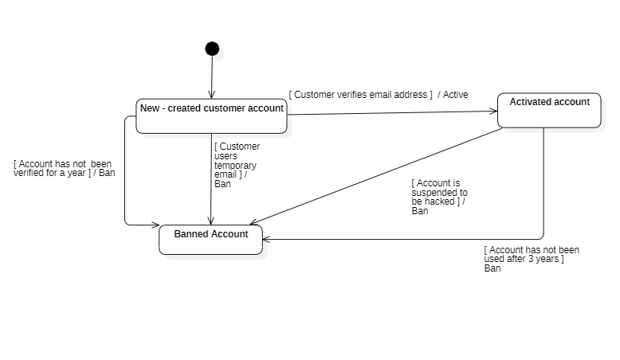

## 3.7.2. Shopping cart

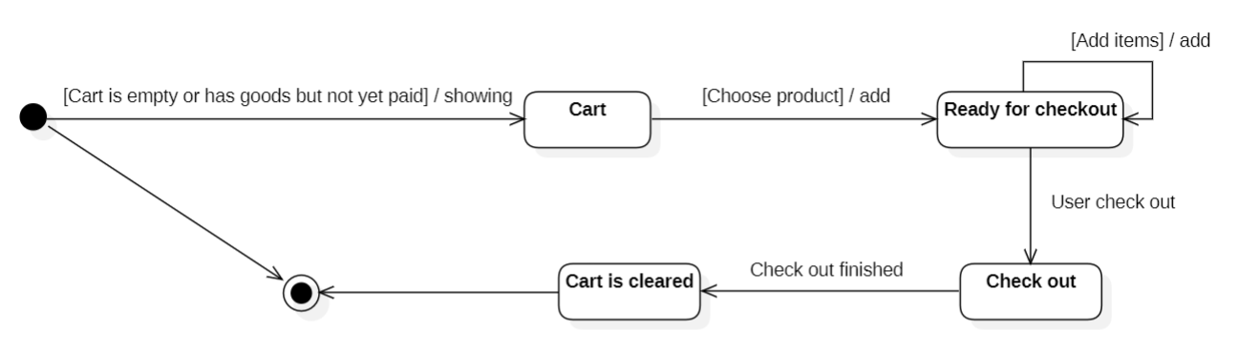

## 3.7.3. Product

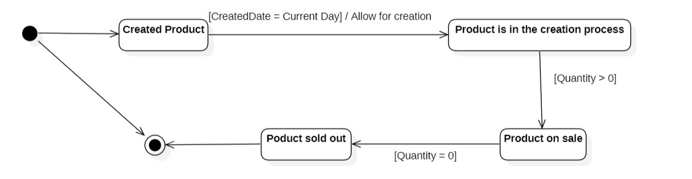

## 3.8. Mapping to Relational Model diagram from Entity class diagram

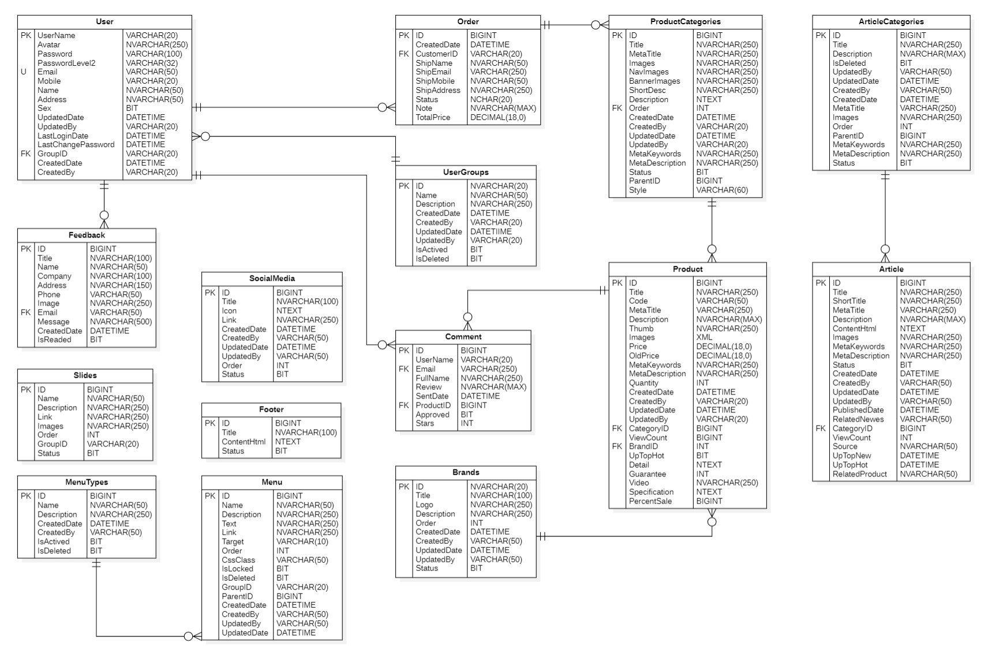

# CHAPTER 4: IMPLEMENTATION AND TESTING

## 4.1 Introduction to the implementation environment

* Operating system: Window 10
* Database: SQL Server 2019
* Text Editor: Visual Studio 2019
* Web server: IIS Express
* Web GUI: ASP.NET Core MVC framework.
* Web server:
* Operating system: Window 10 or upper.
* To be installed: Visual Studio 2019 or upper.

## 4.2 User Interface

### 4.2.1. Customer interface

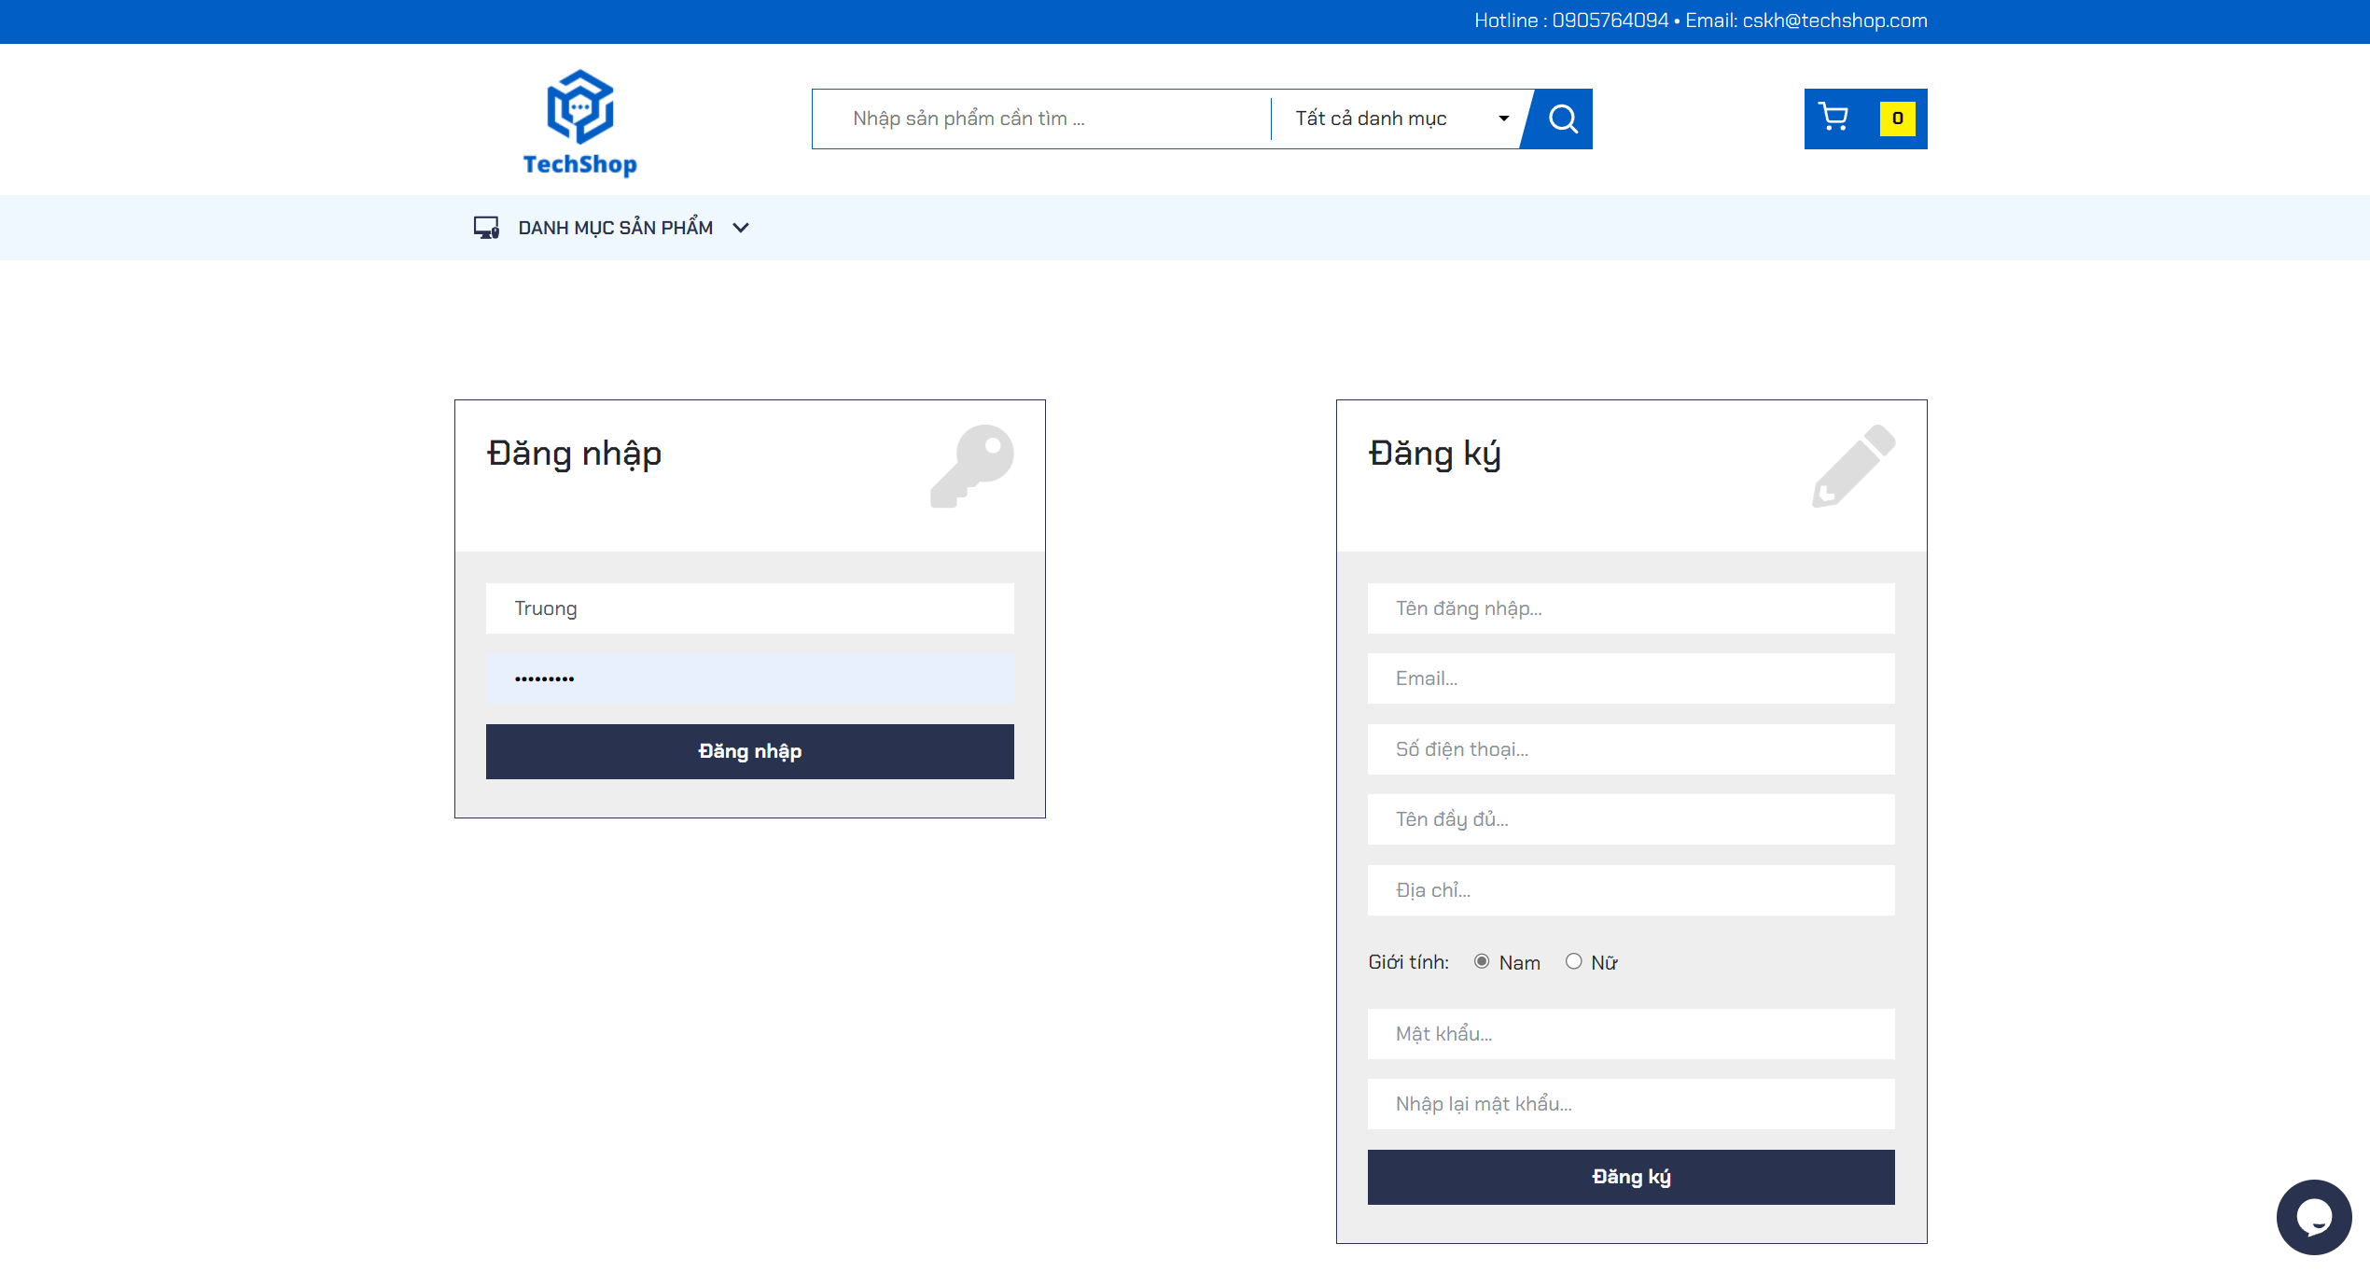

Picture 1: Login interface for users

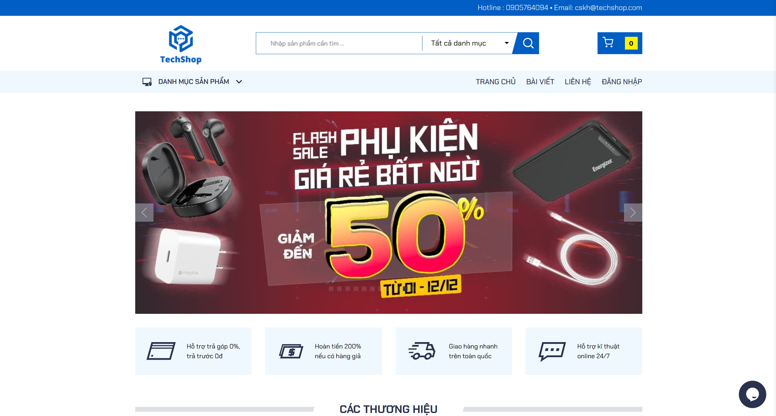

Picture 2: Banner interface

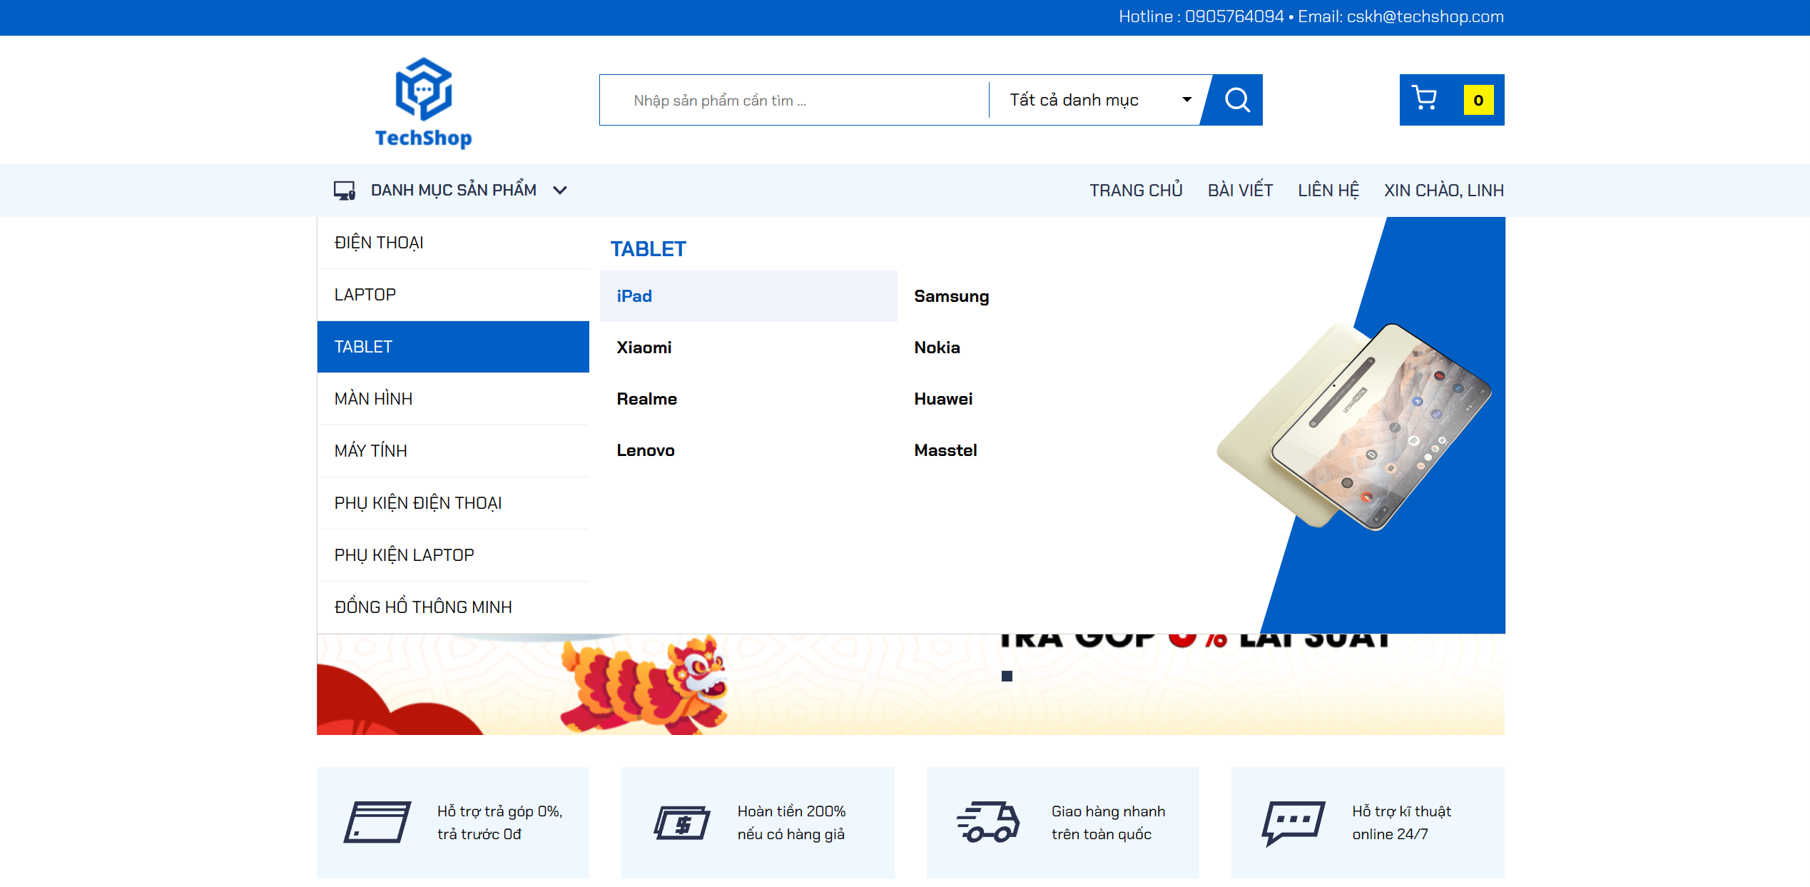

Picture 3: List of products

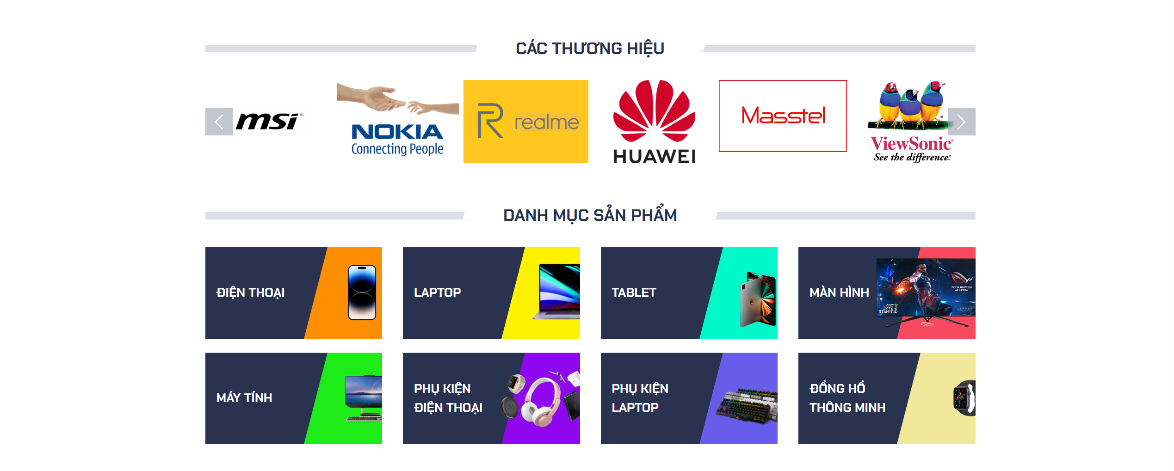

Picture 4: The interface displays brands and product categories

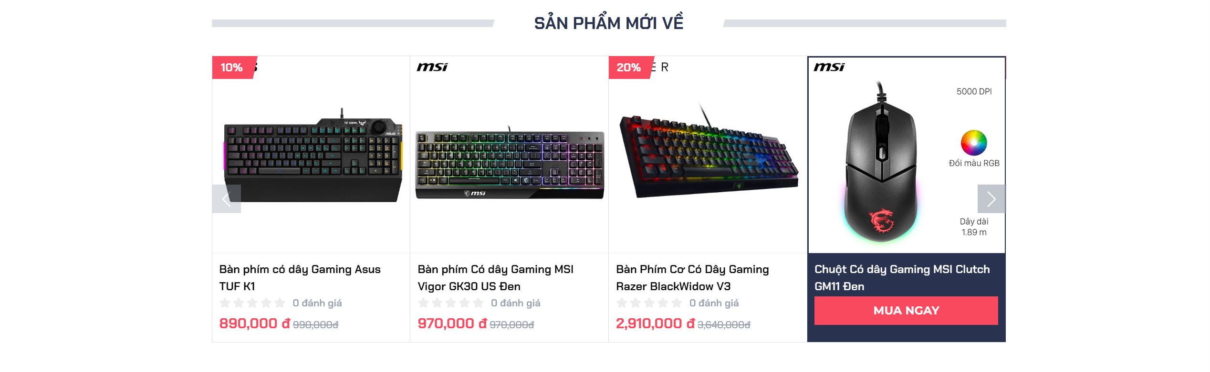

Picture 5: Display new products

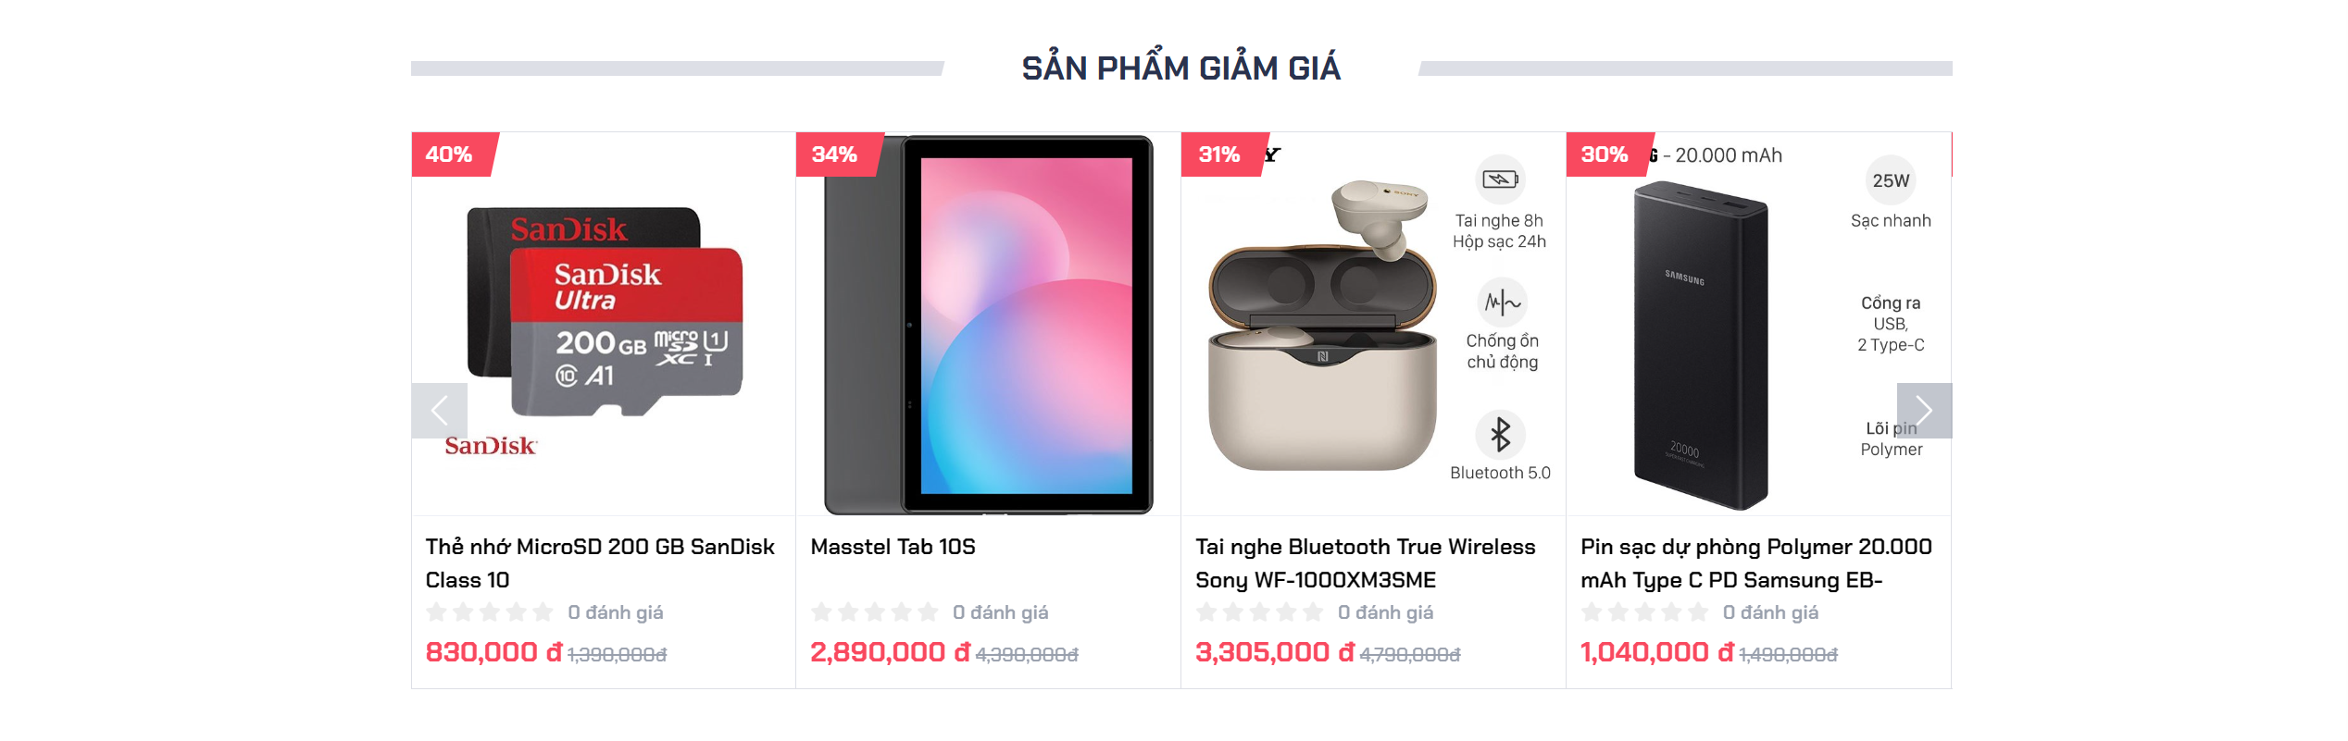

Picture 6: Display products on sale

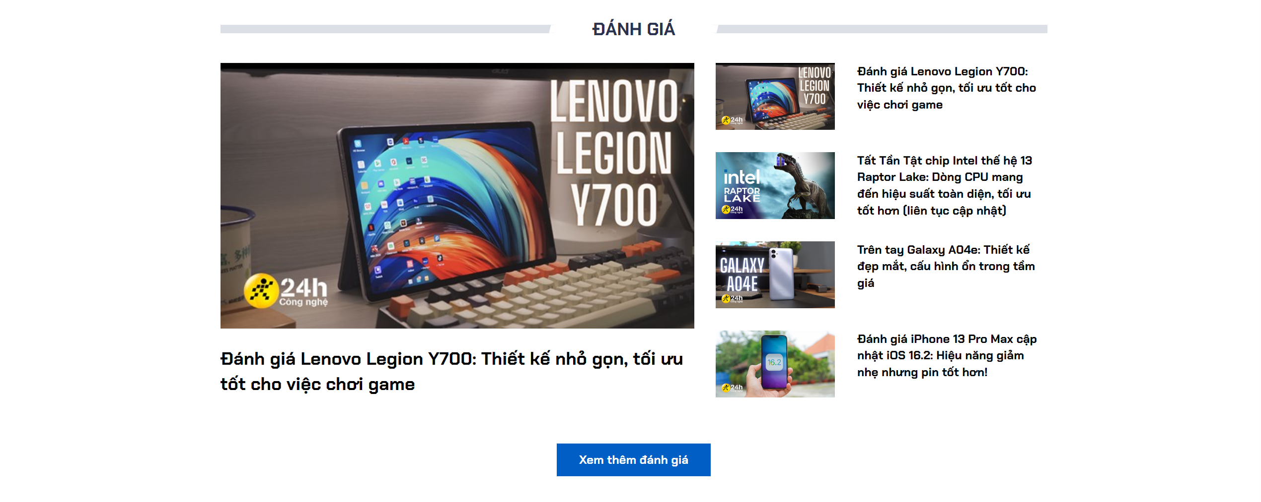

Picture 7: Displays product review articles

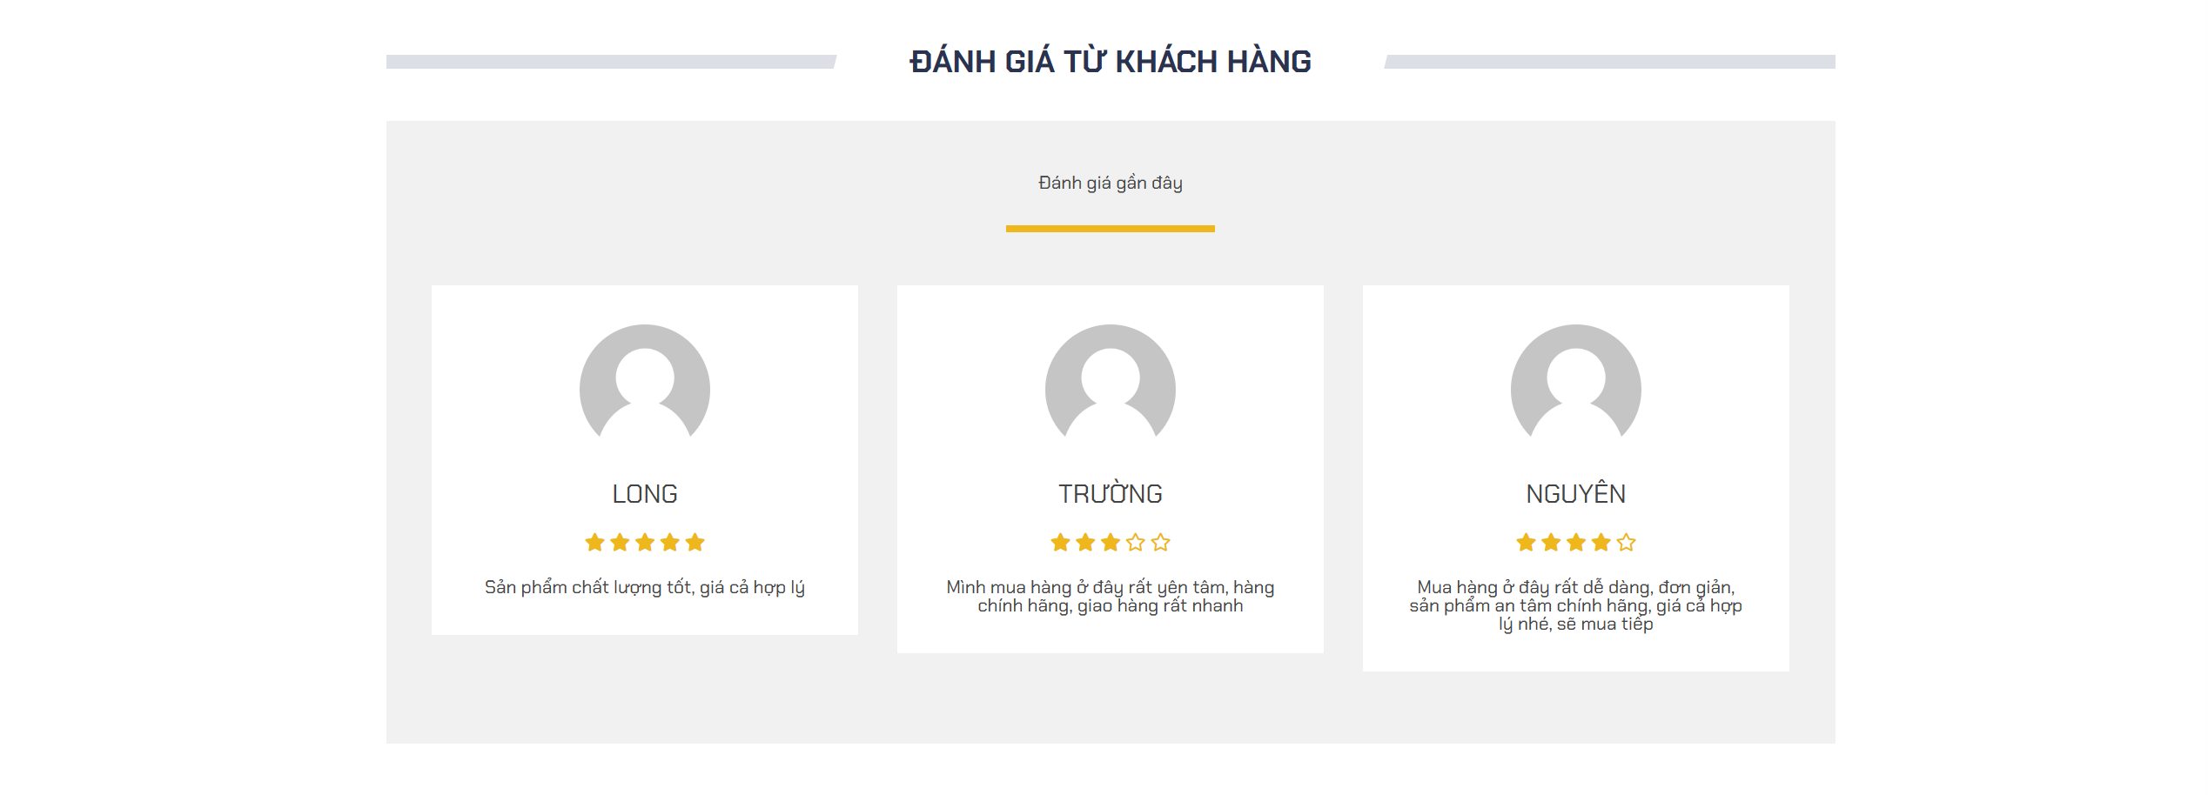

Picture 8: Display reviews from customers

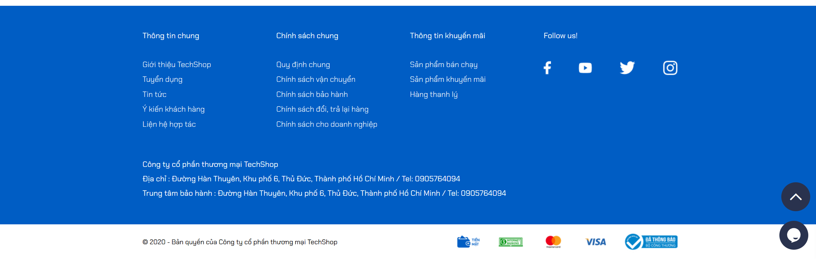

Picture 9: Website footer interface

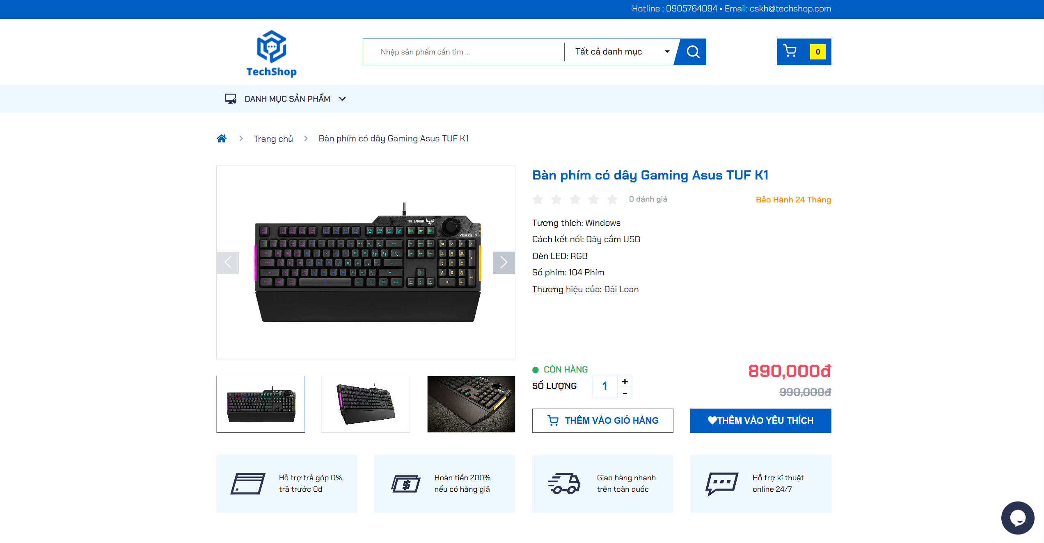

Picture 10: The interface displays detailed product information

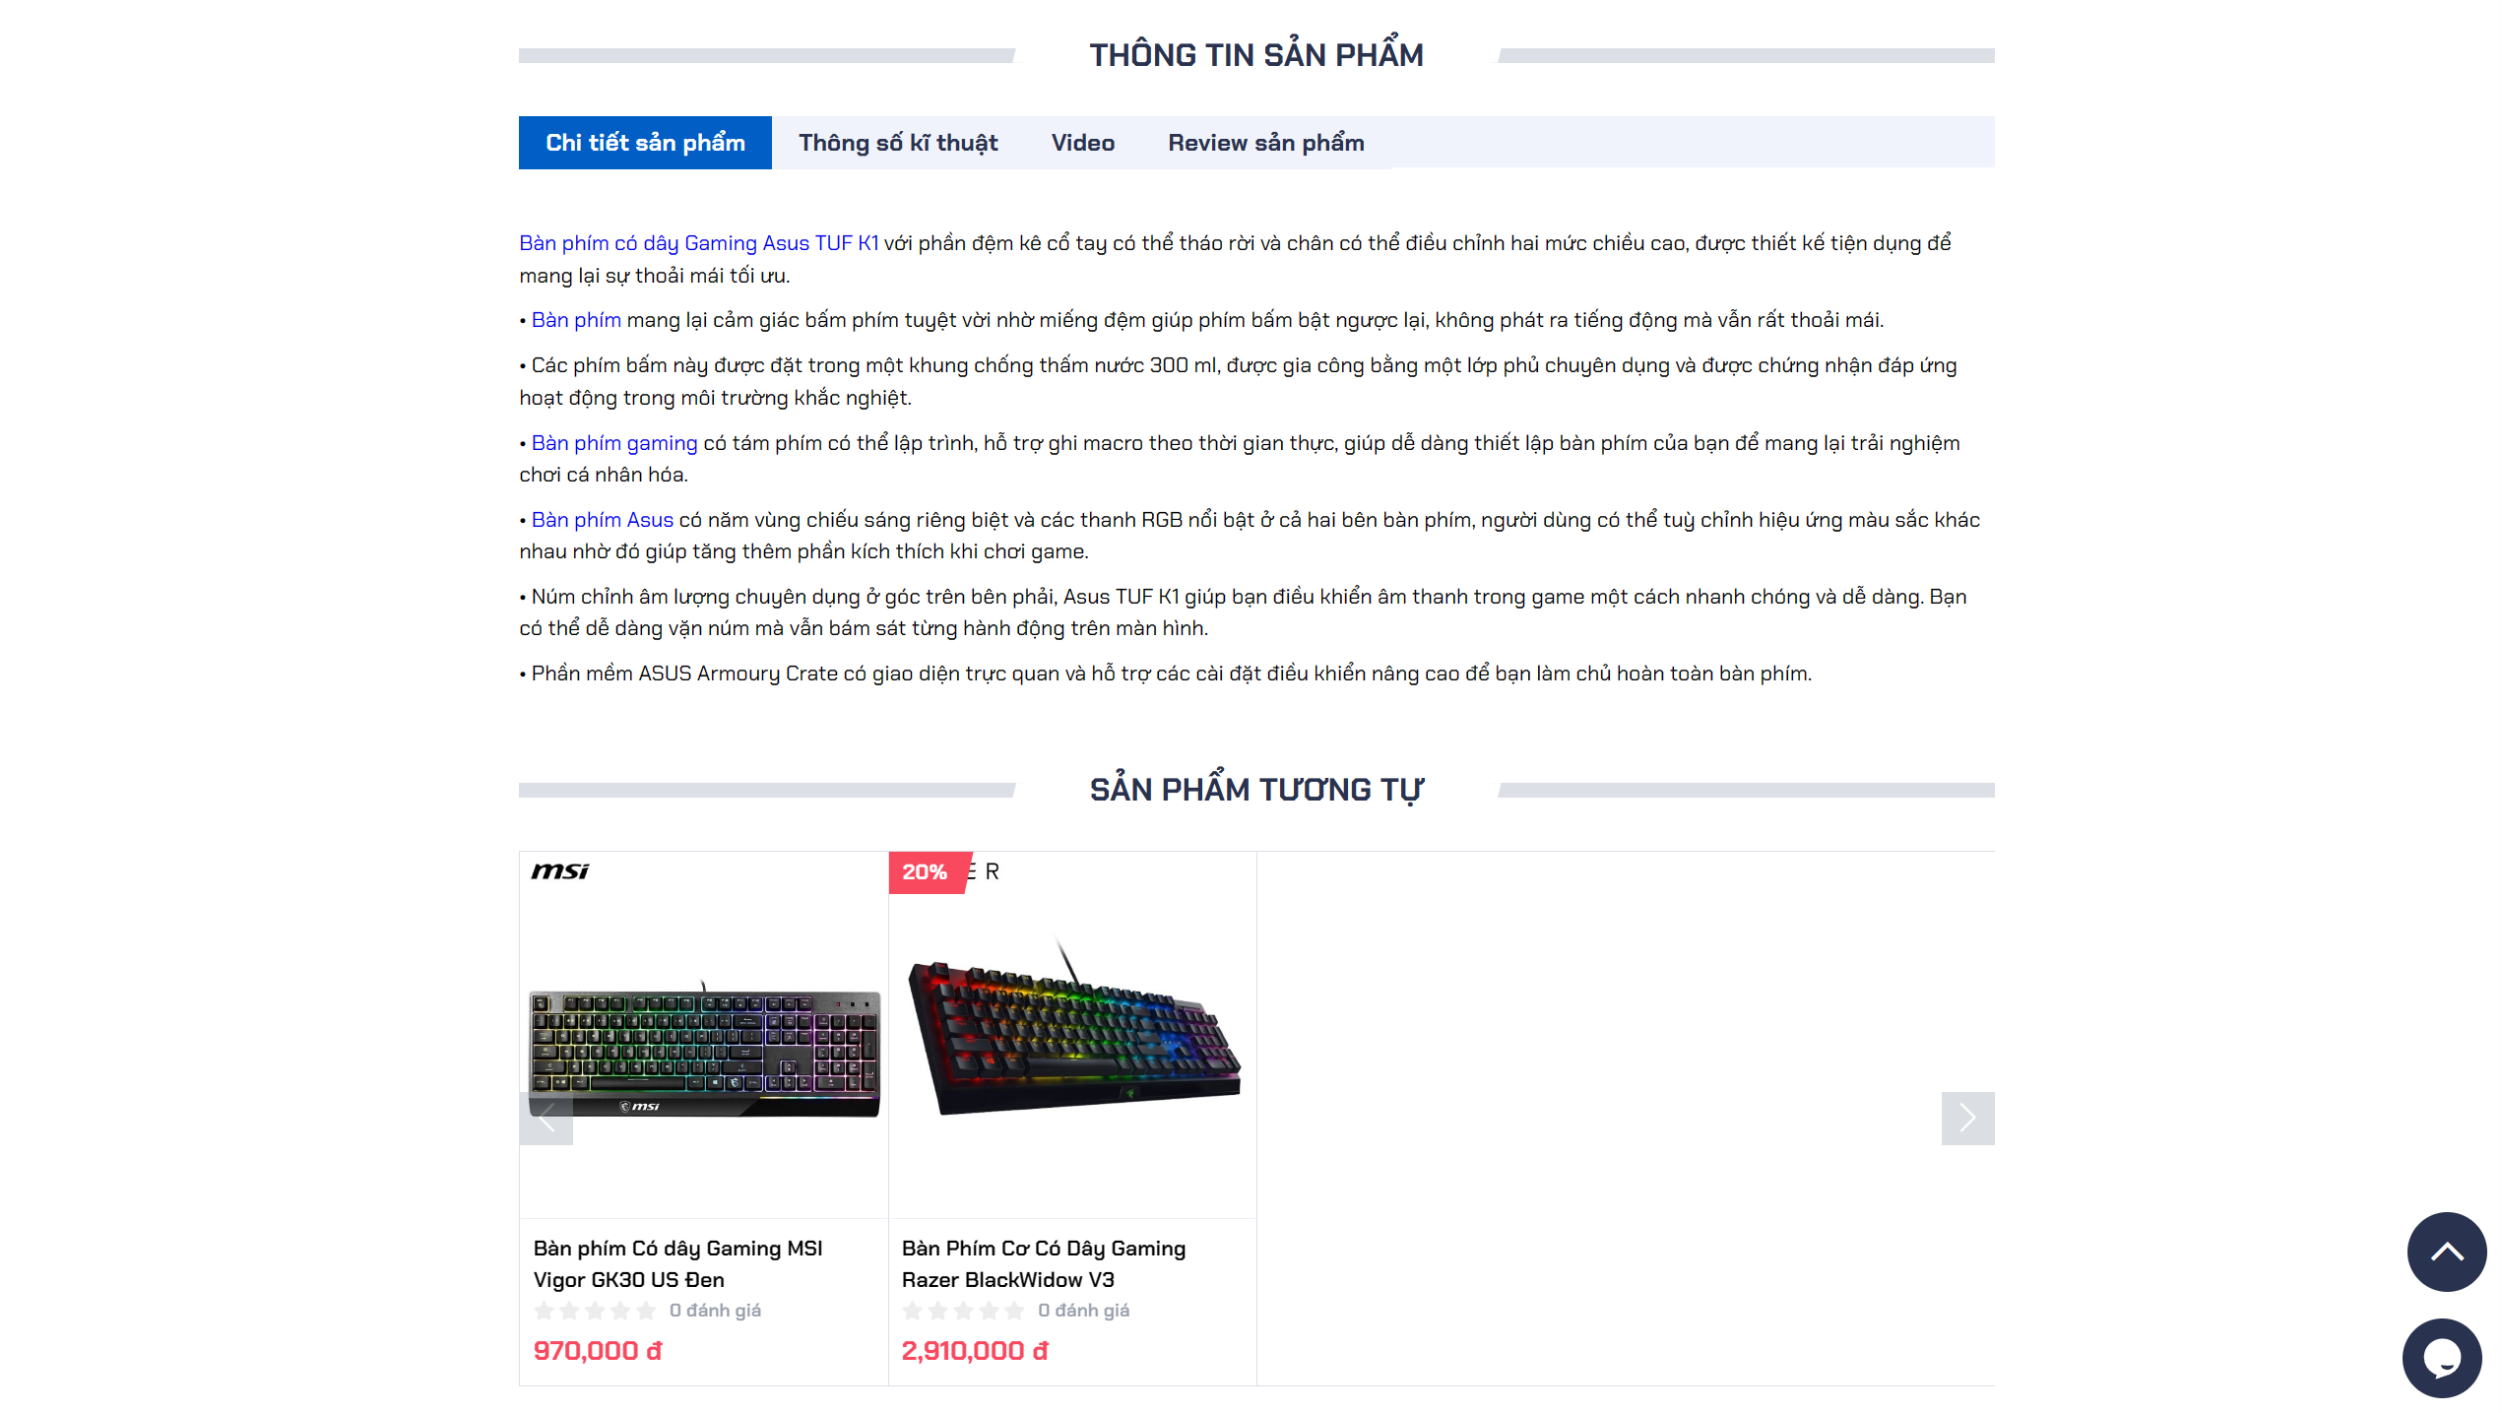

Picture 11: Display product information and recommend similar products

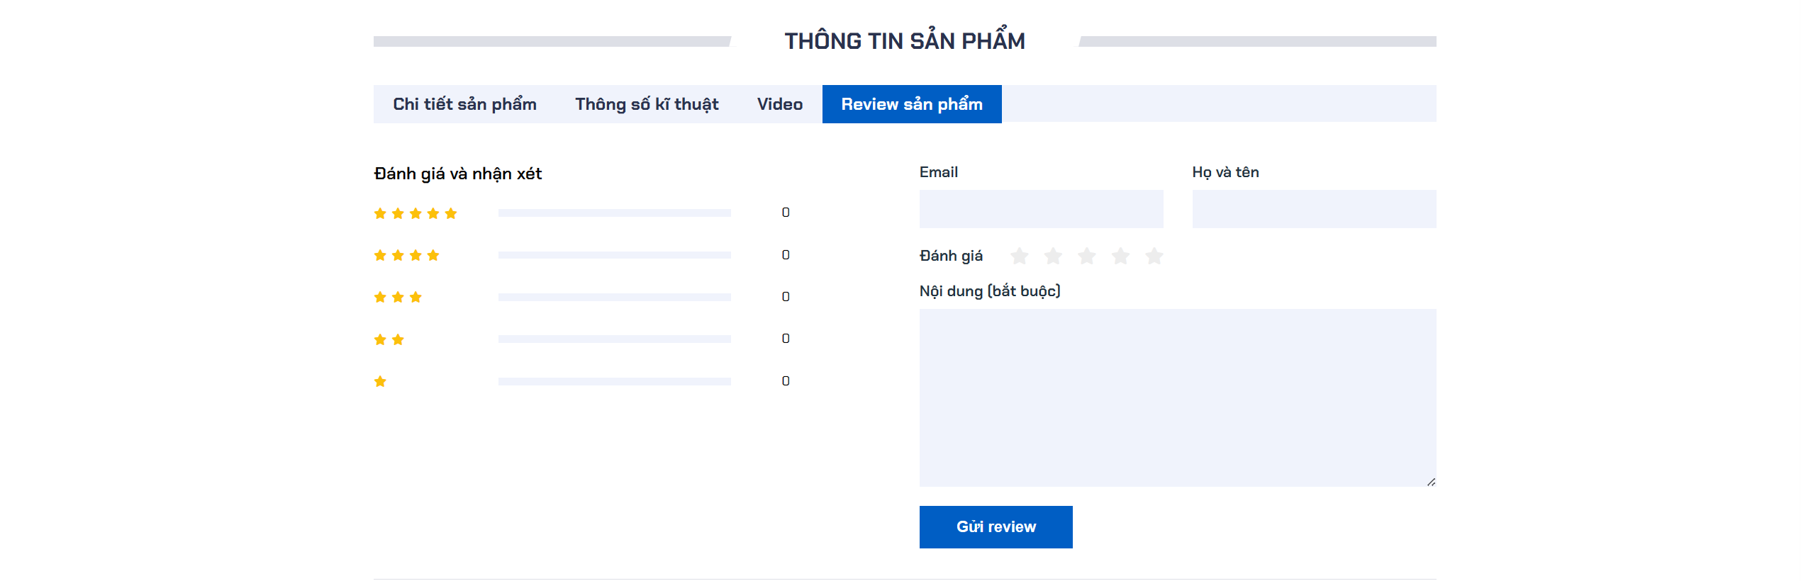

Picture 12: Product review form

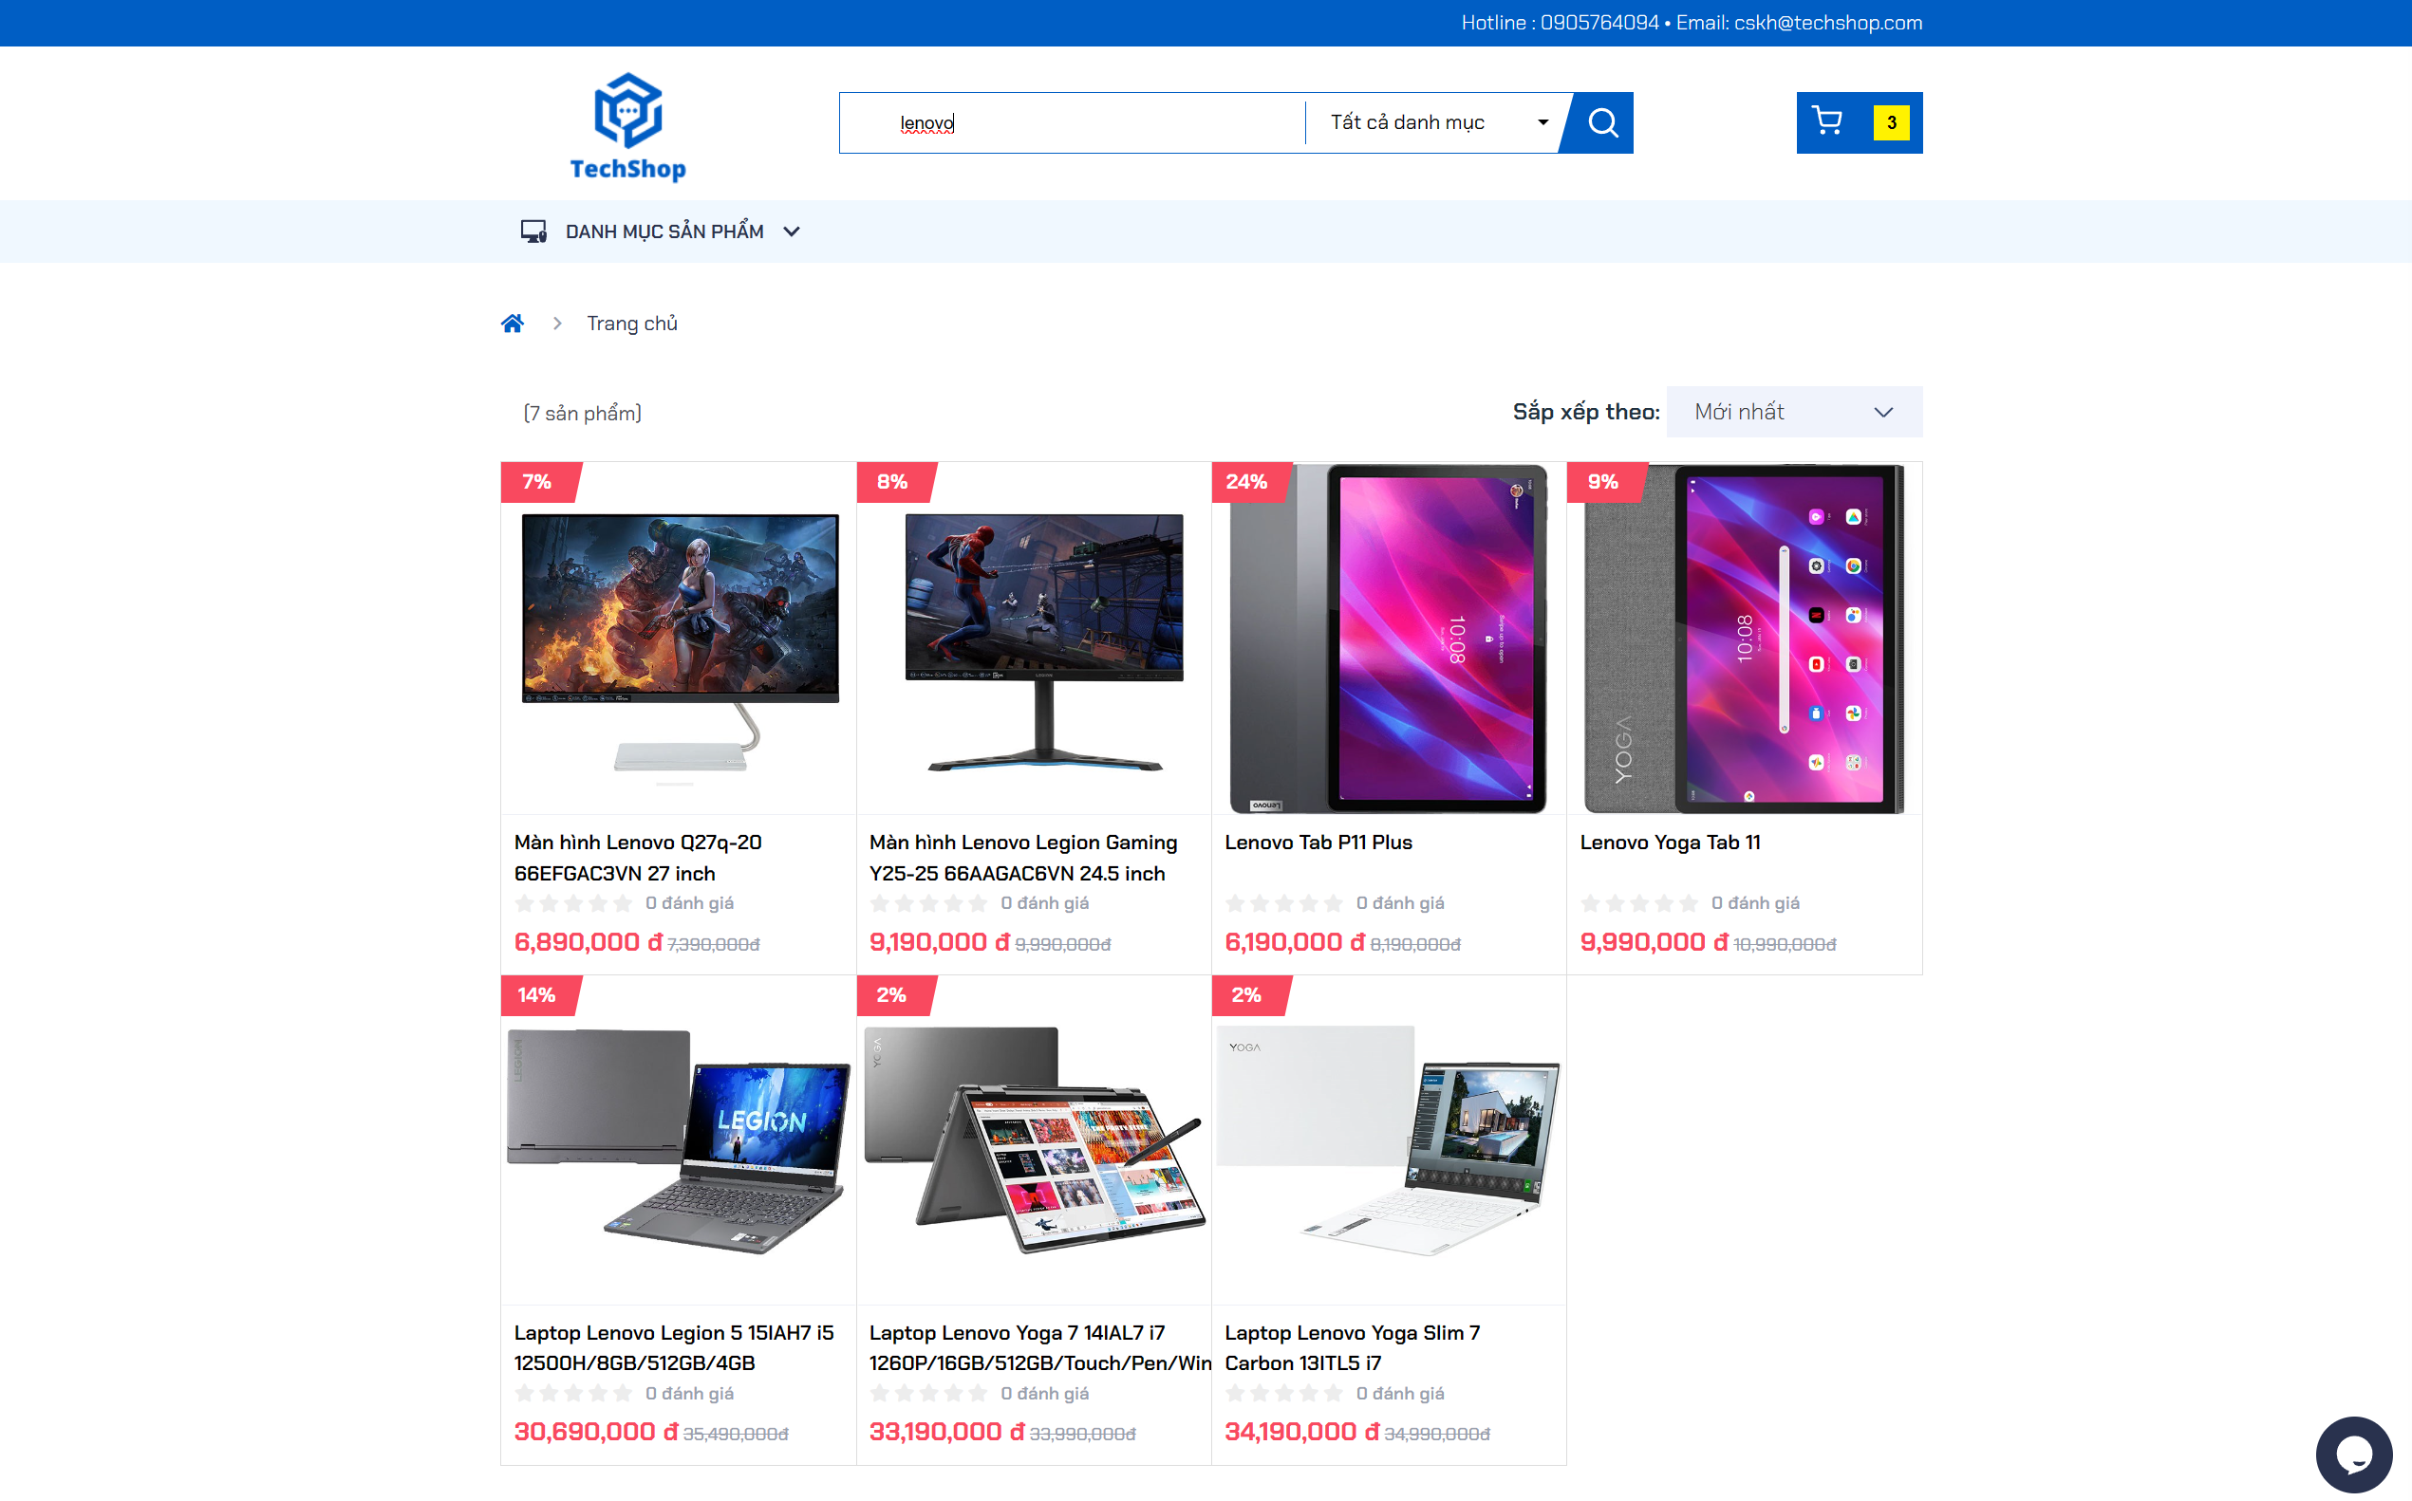

Picture 13: Product search function

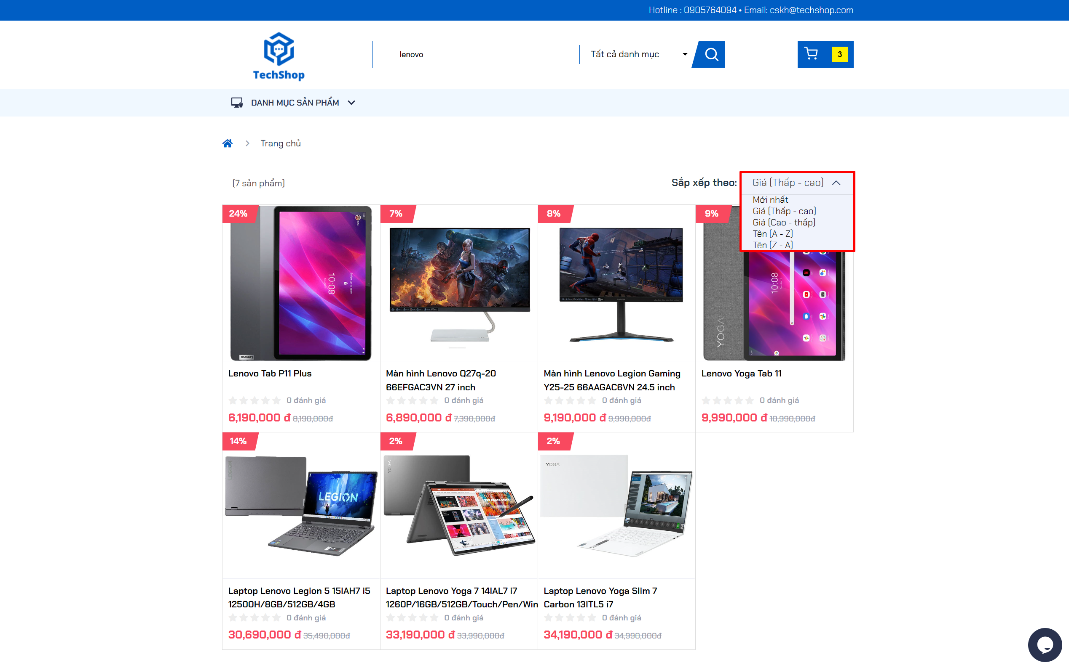

Picture 14: Filter function to sort found products

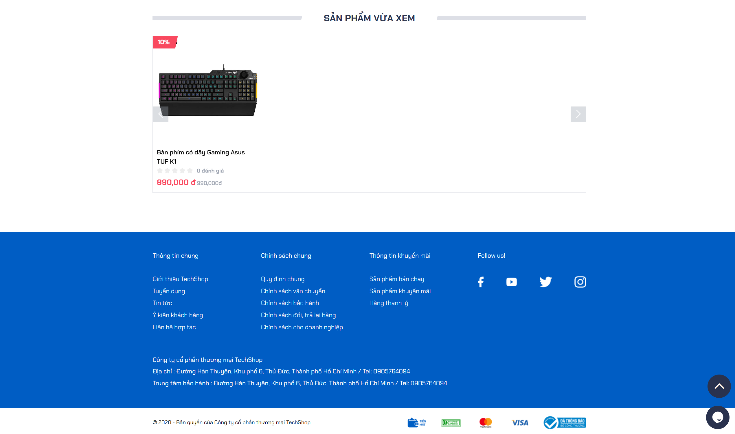

Picture 15: Displays recently viewed products at the bottom of the page

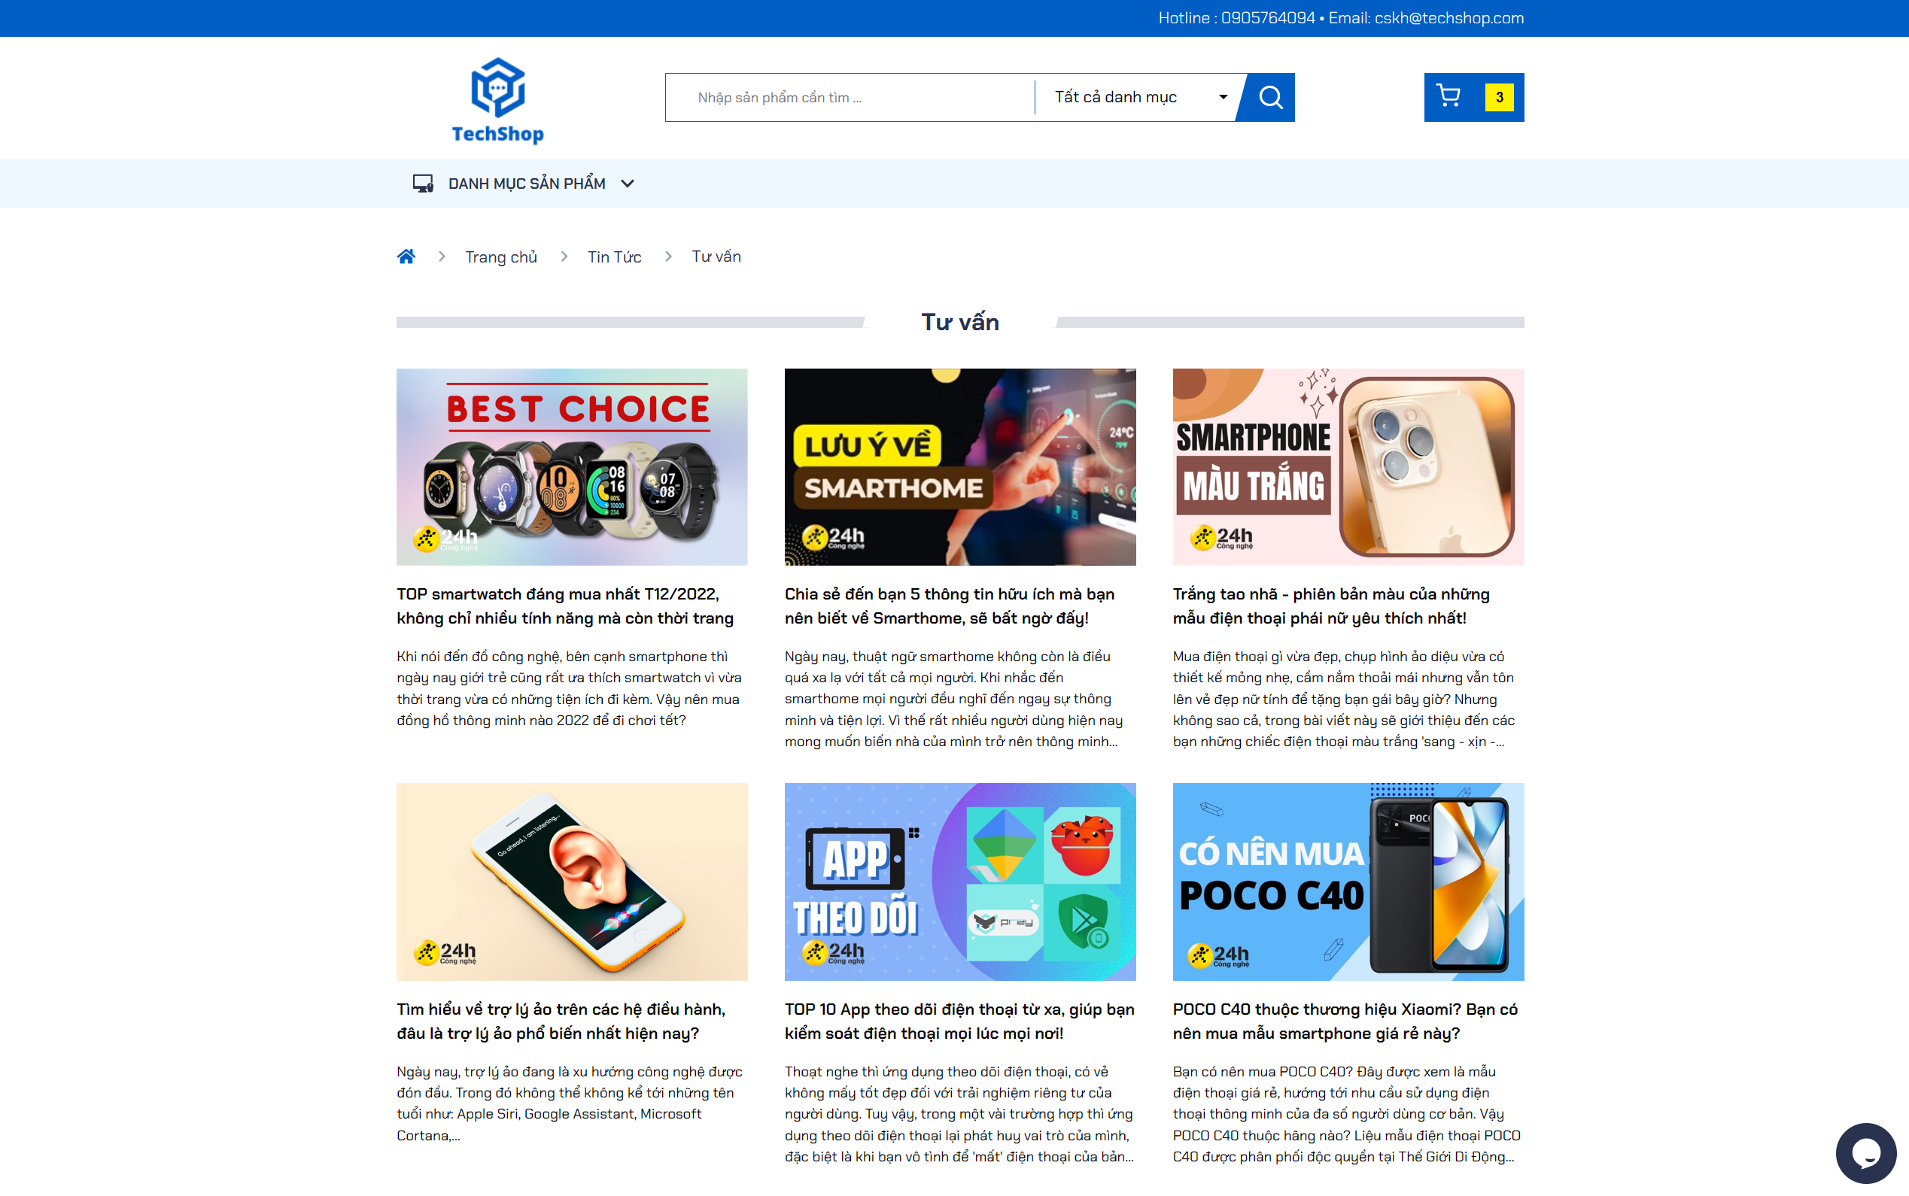

Picture 16: Page interface of product advice articles

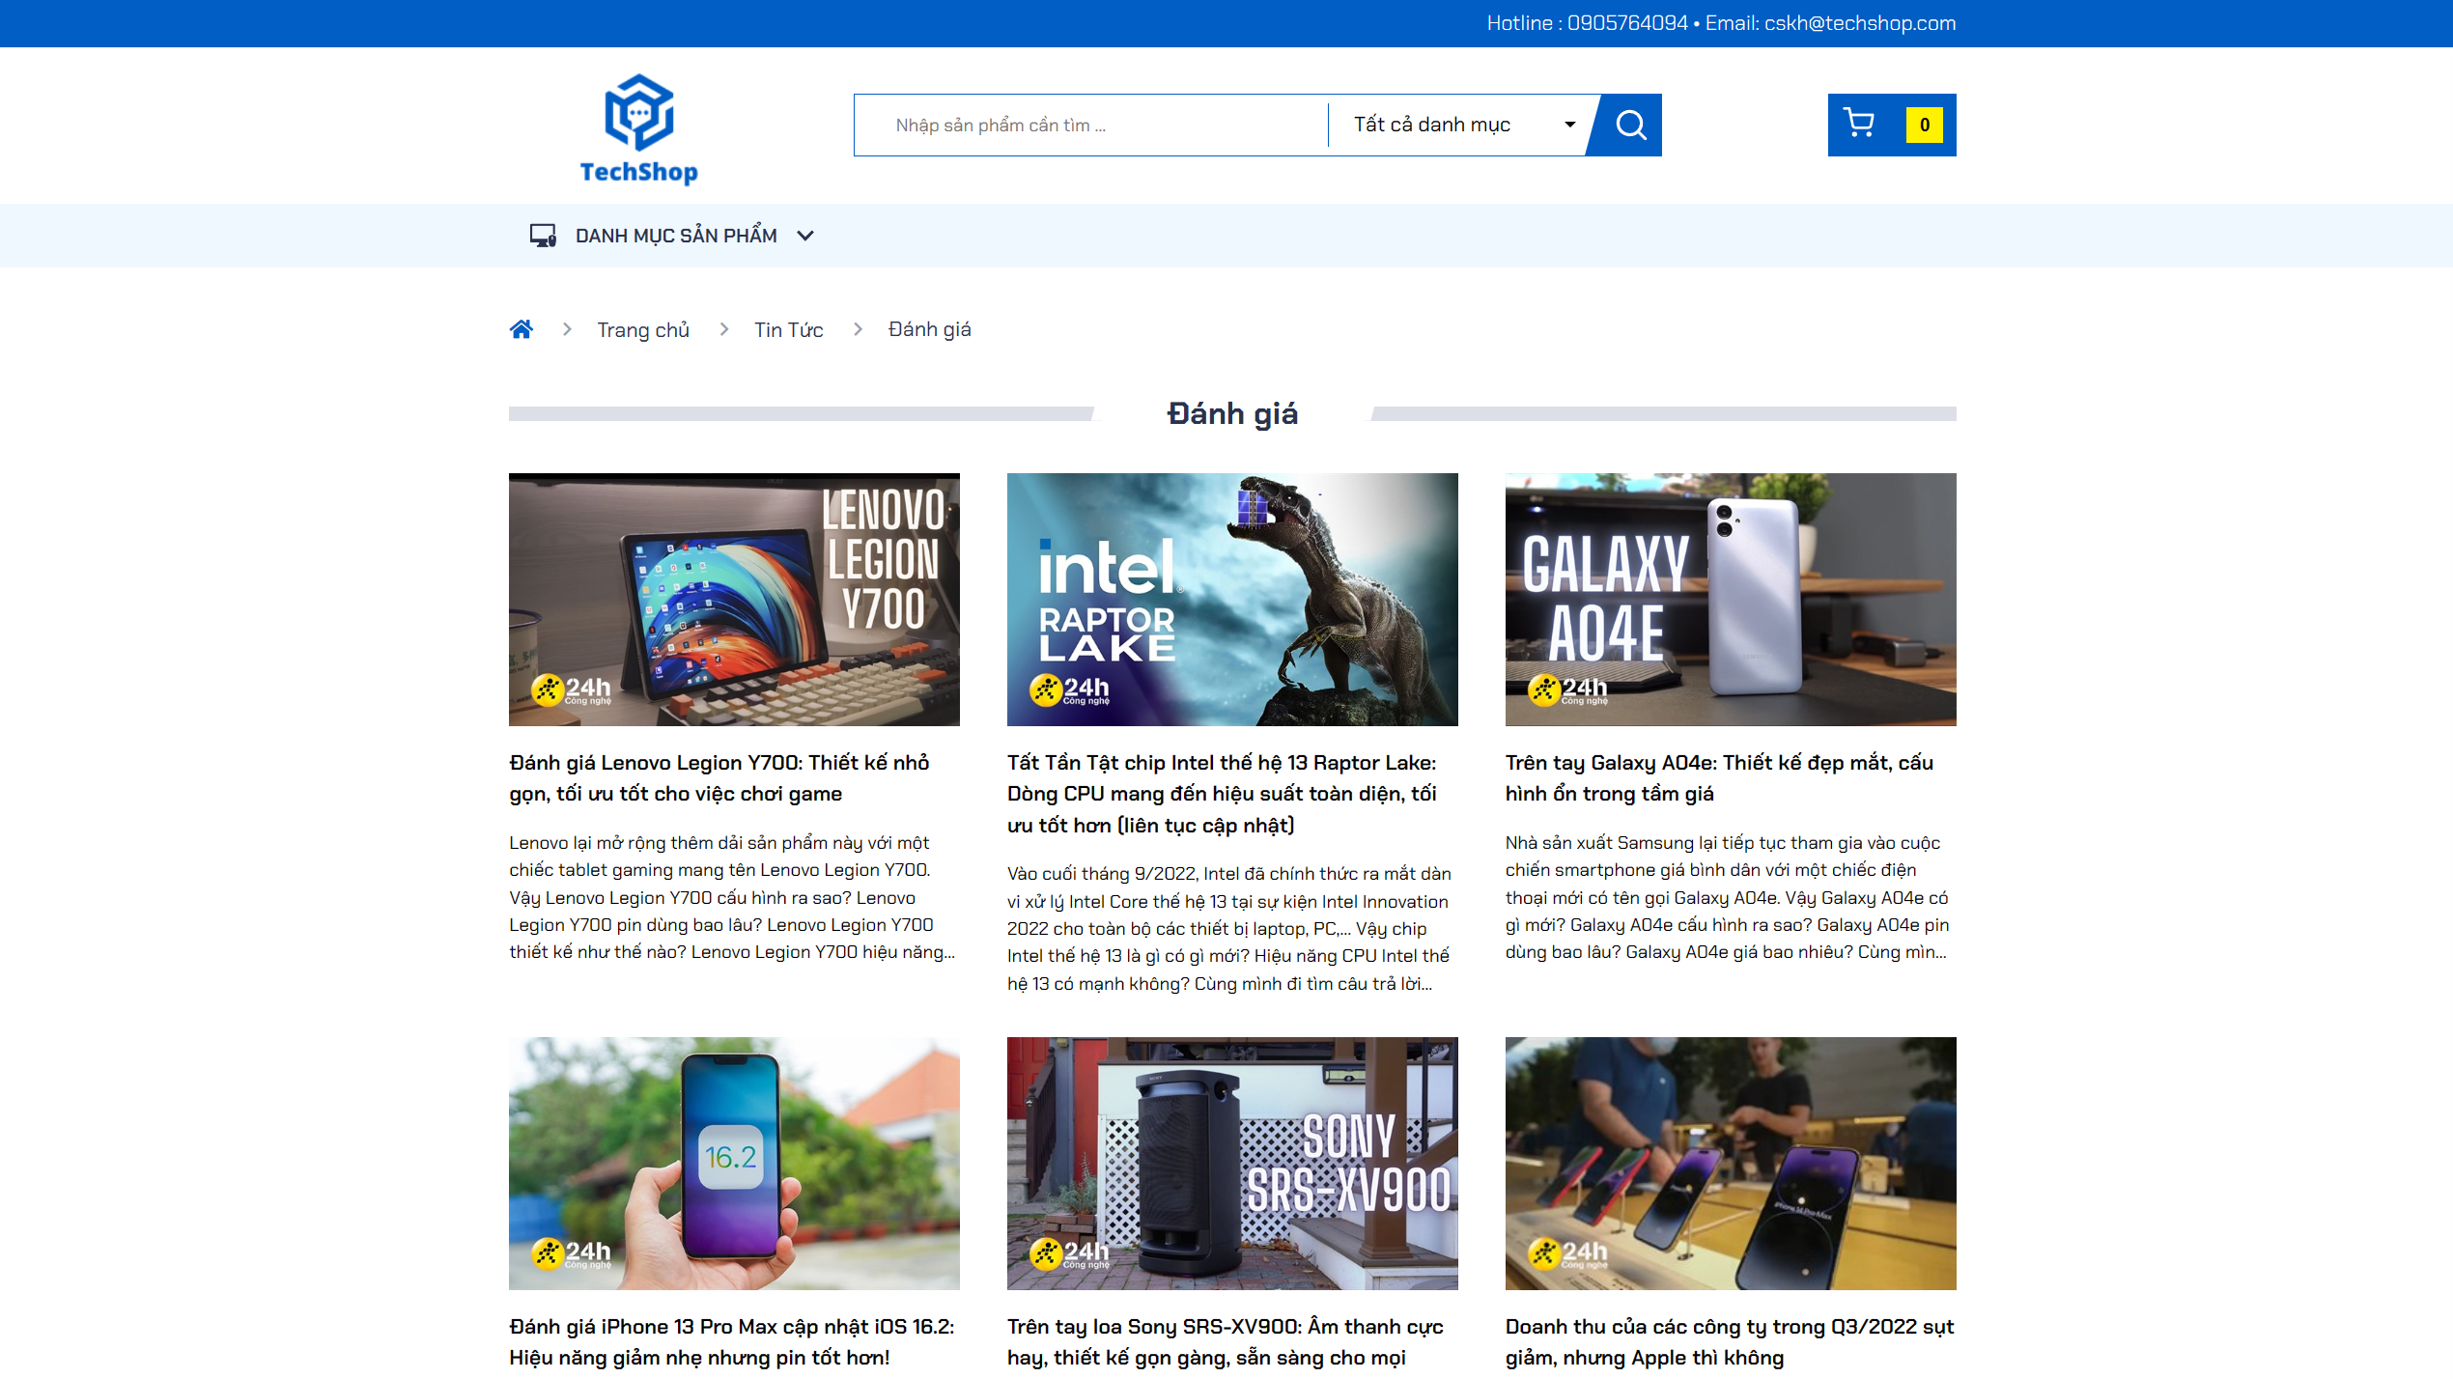

Picture 17: Product review page interface

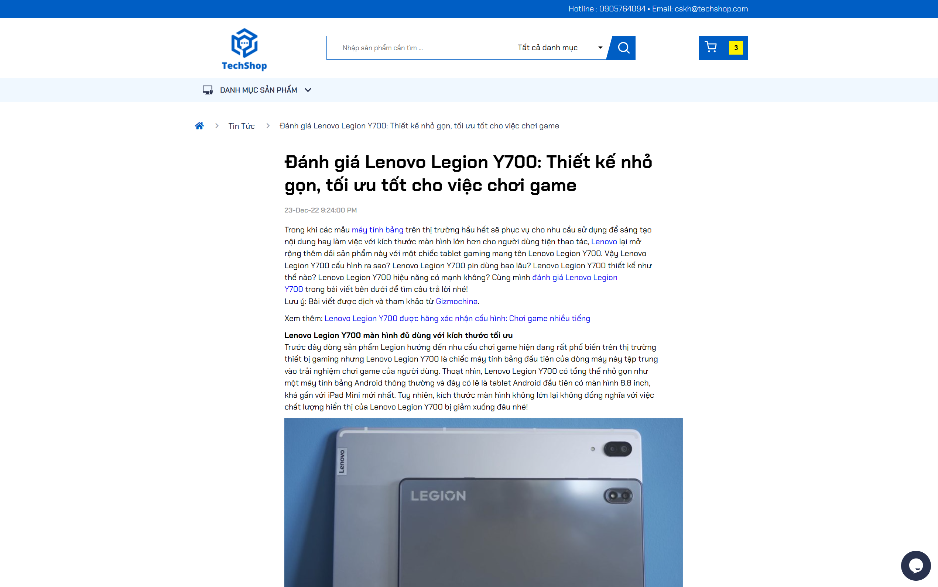

Picture 18: A product review article

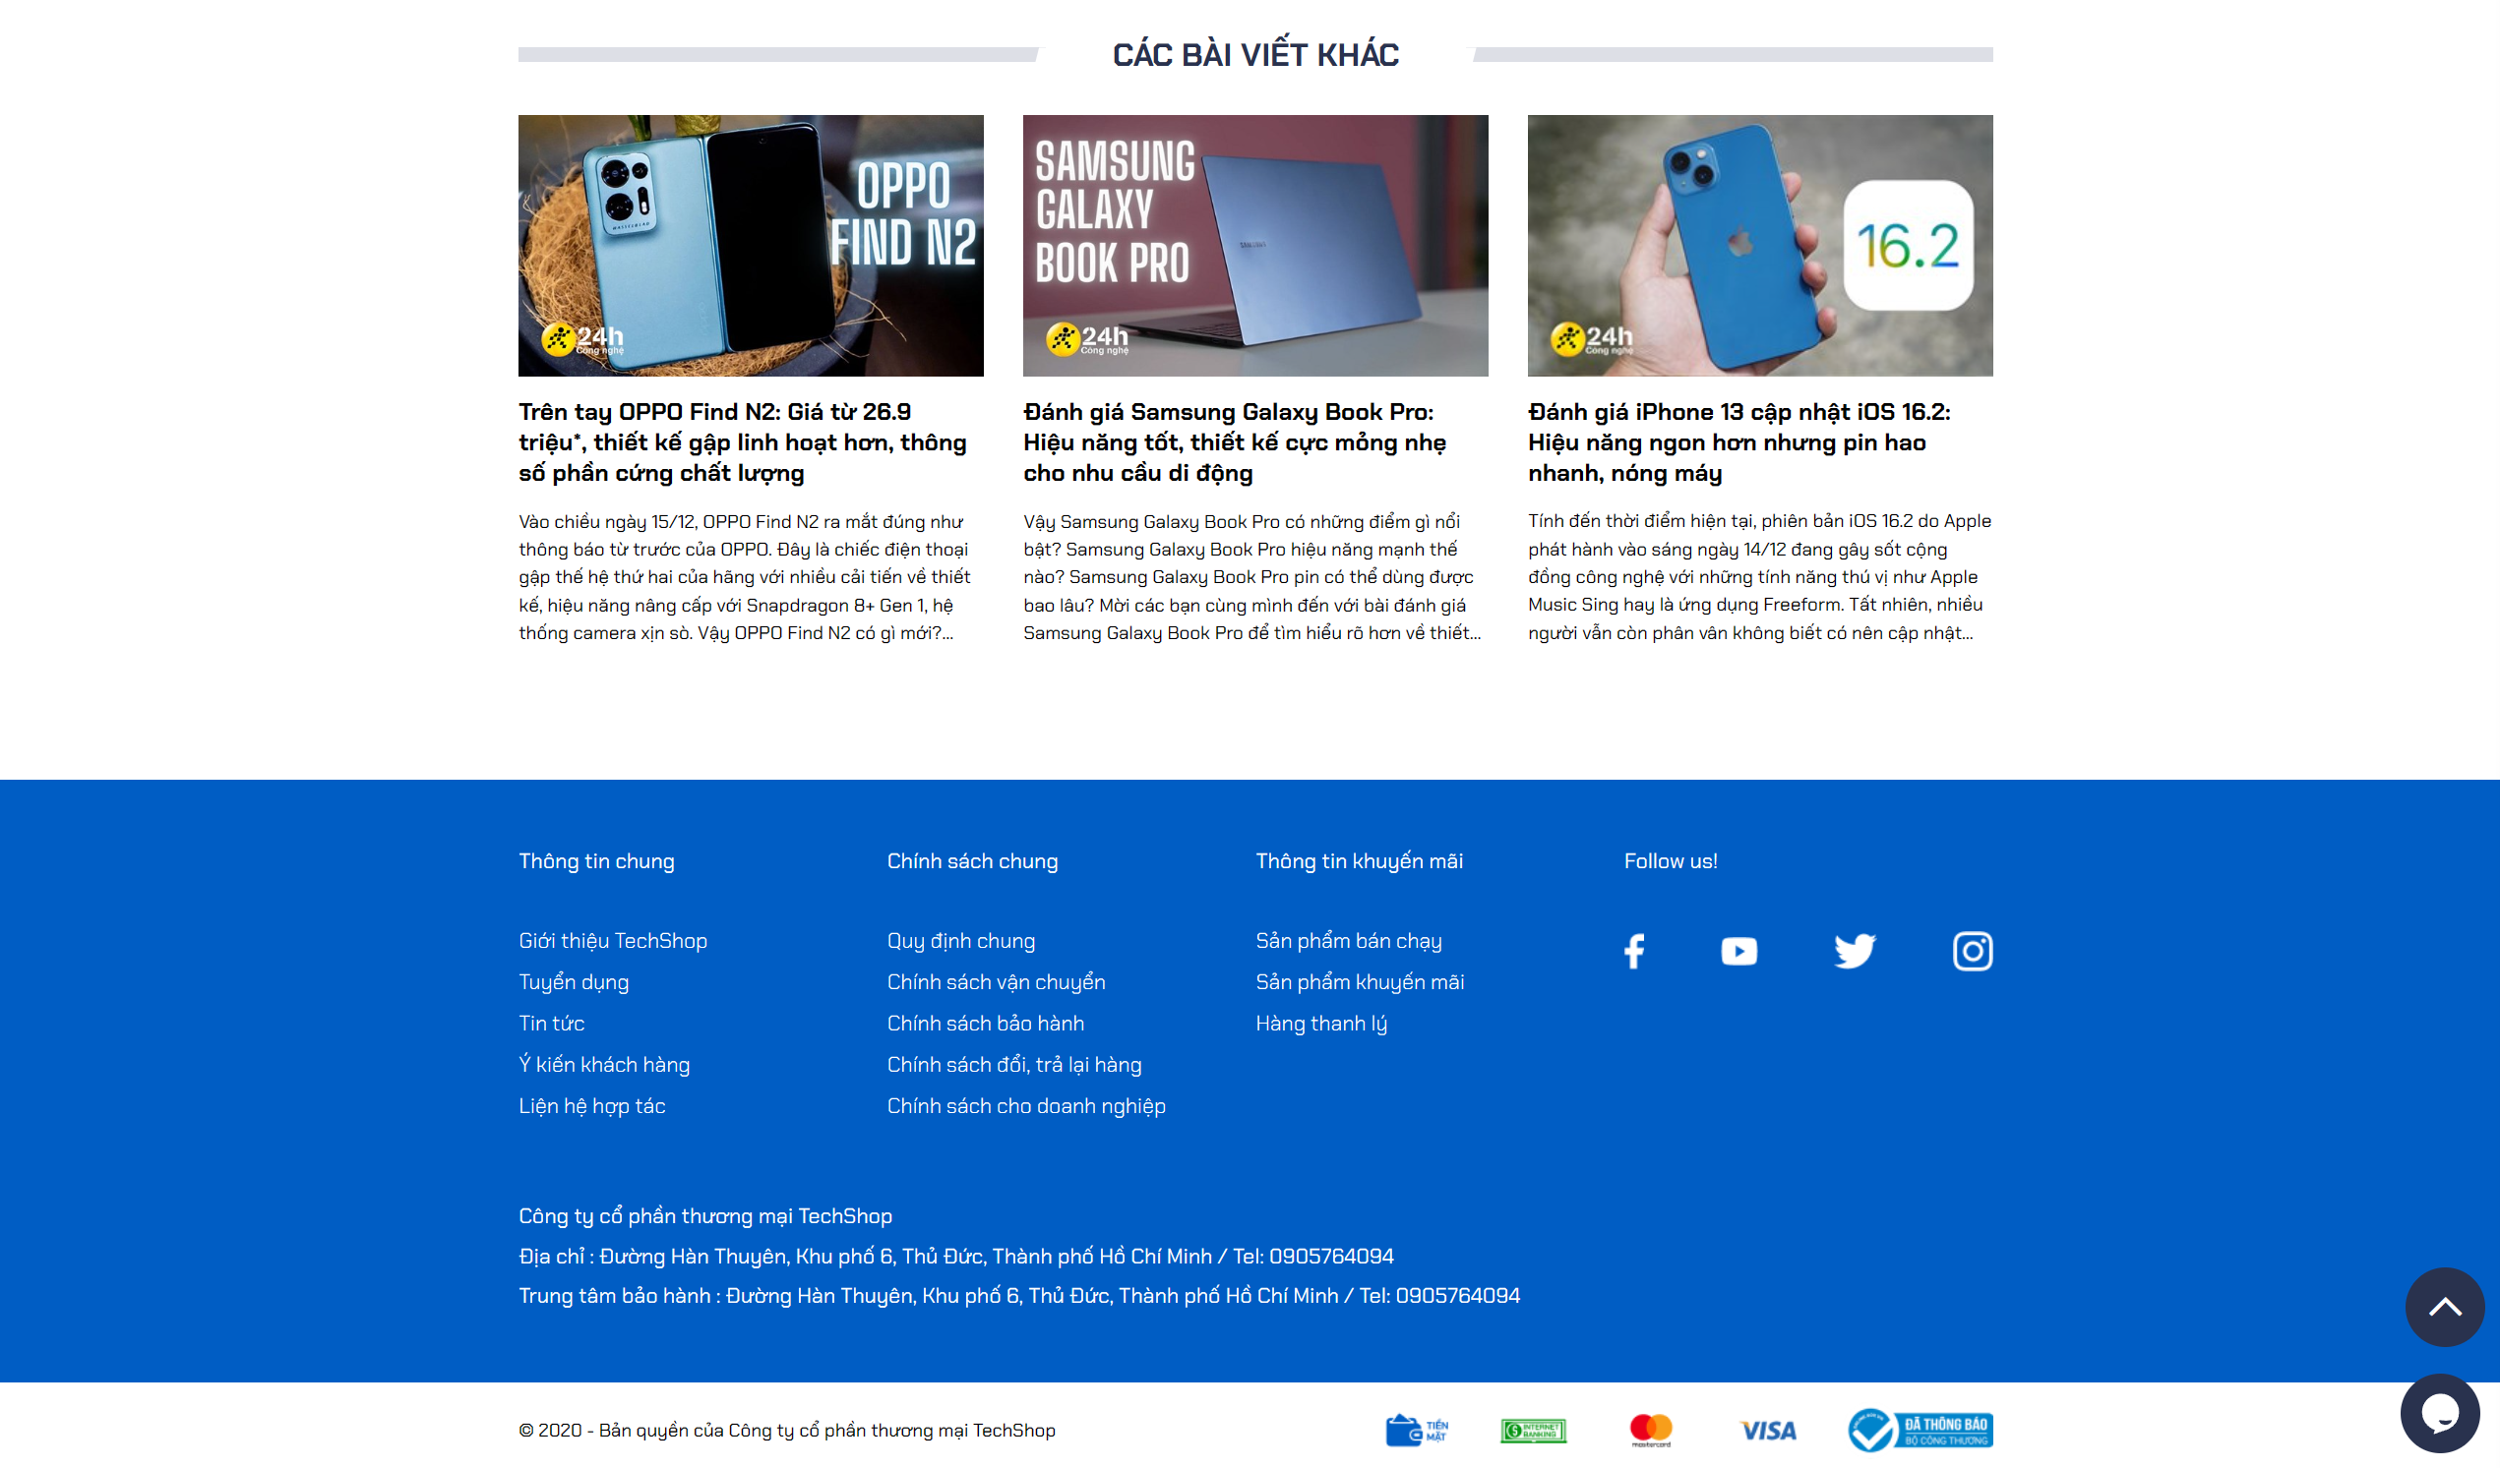

Picture 19: Suggest other articles

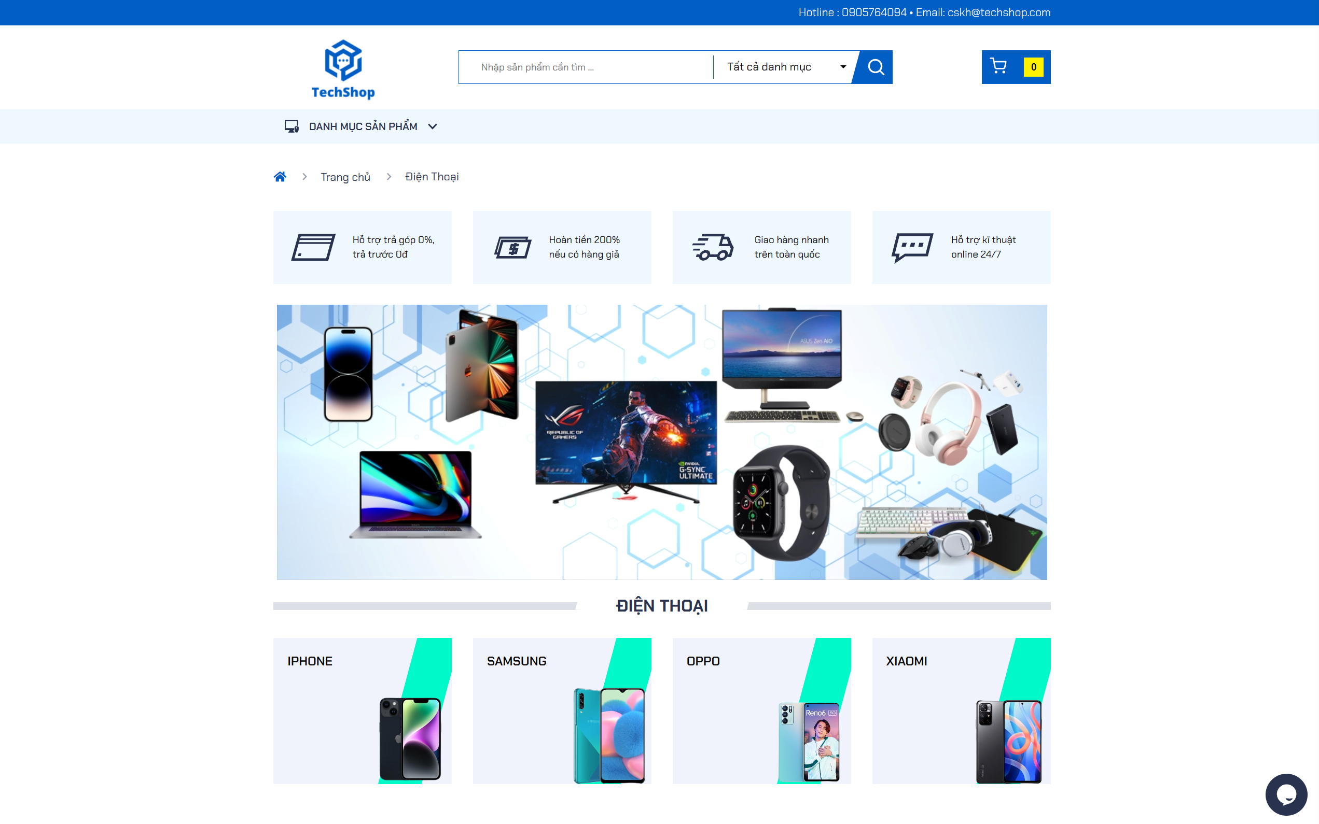

Picture 20: Phone product catalog

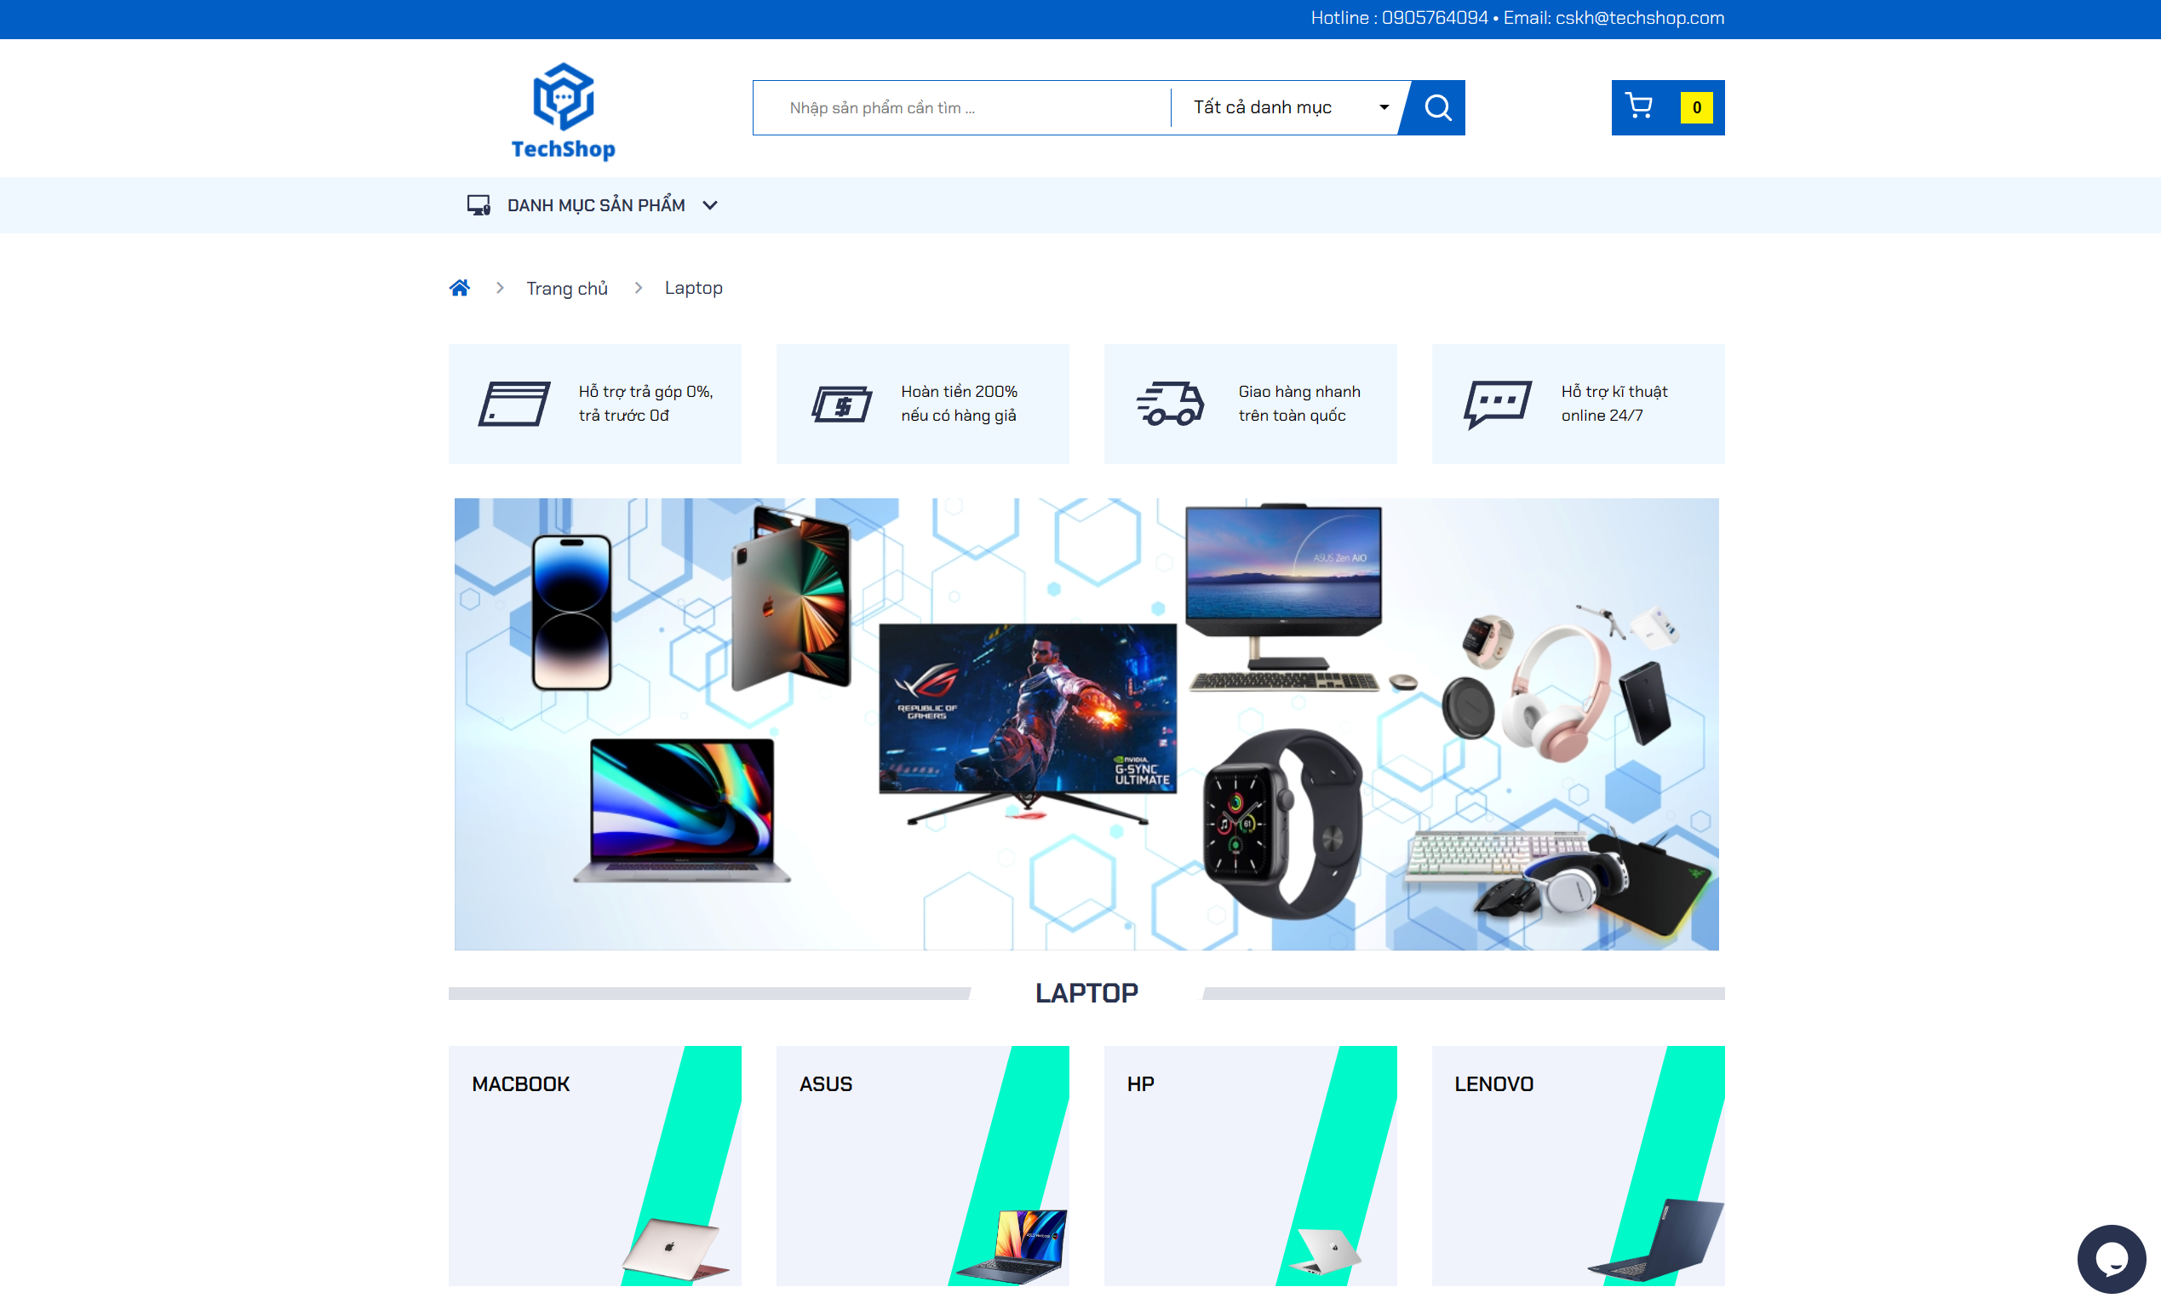

Picture 21: Laptop product catalog

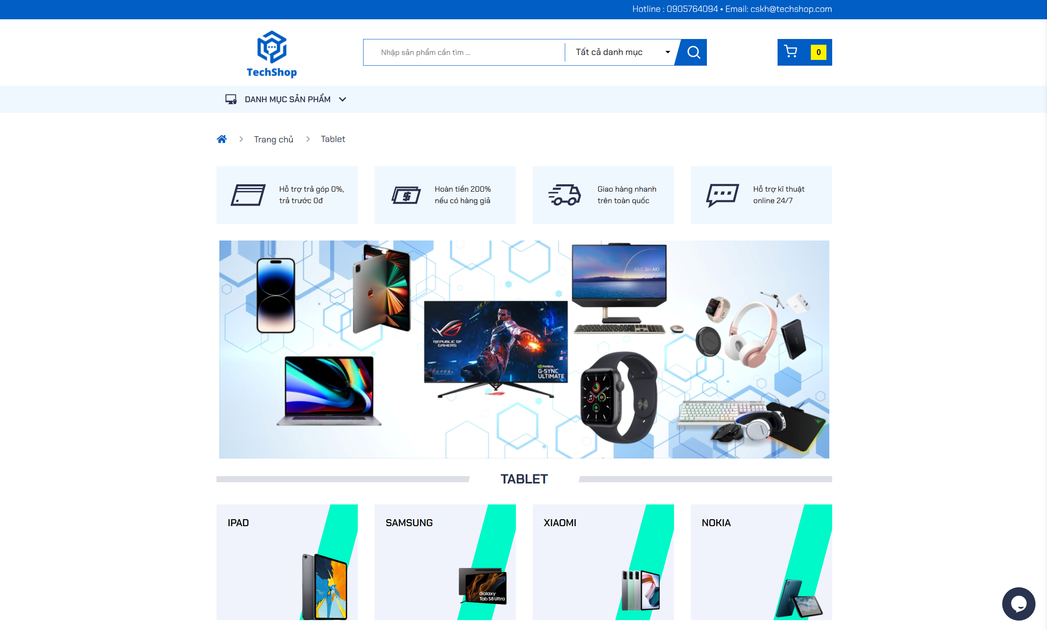

Picture 22: Tablet product catalog

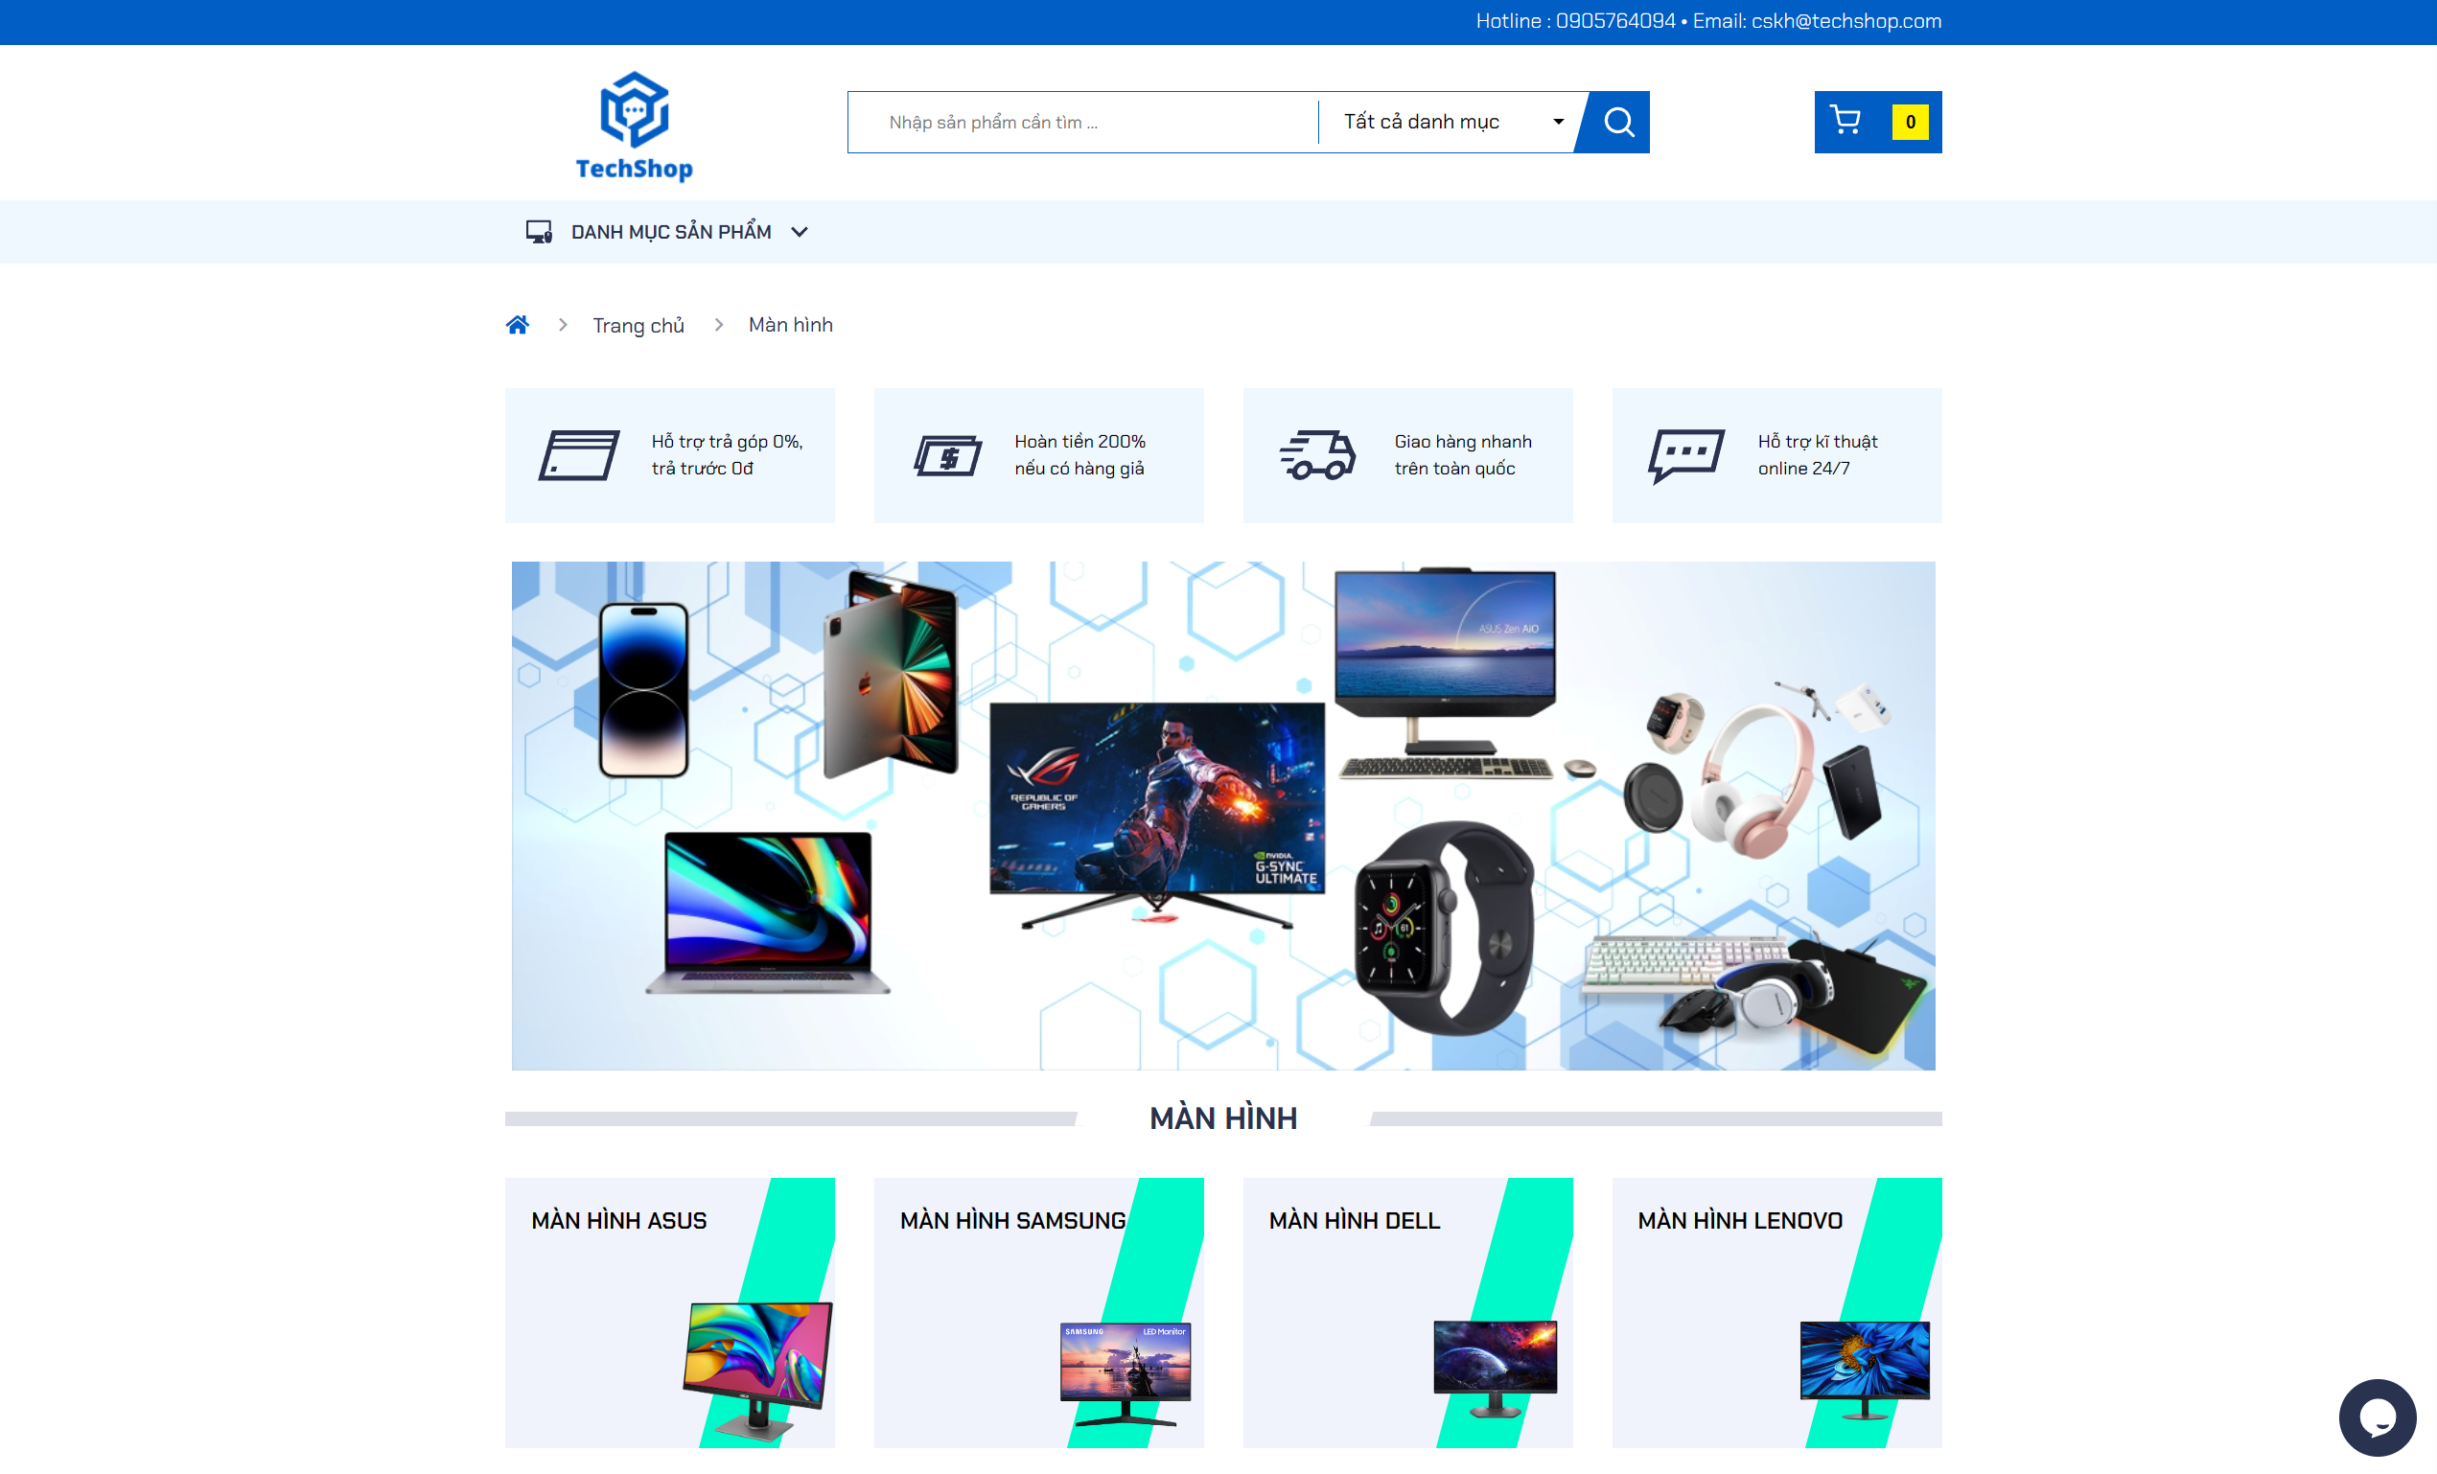

Picture 23: Screen product catalog

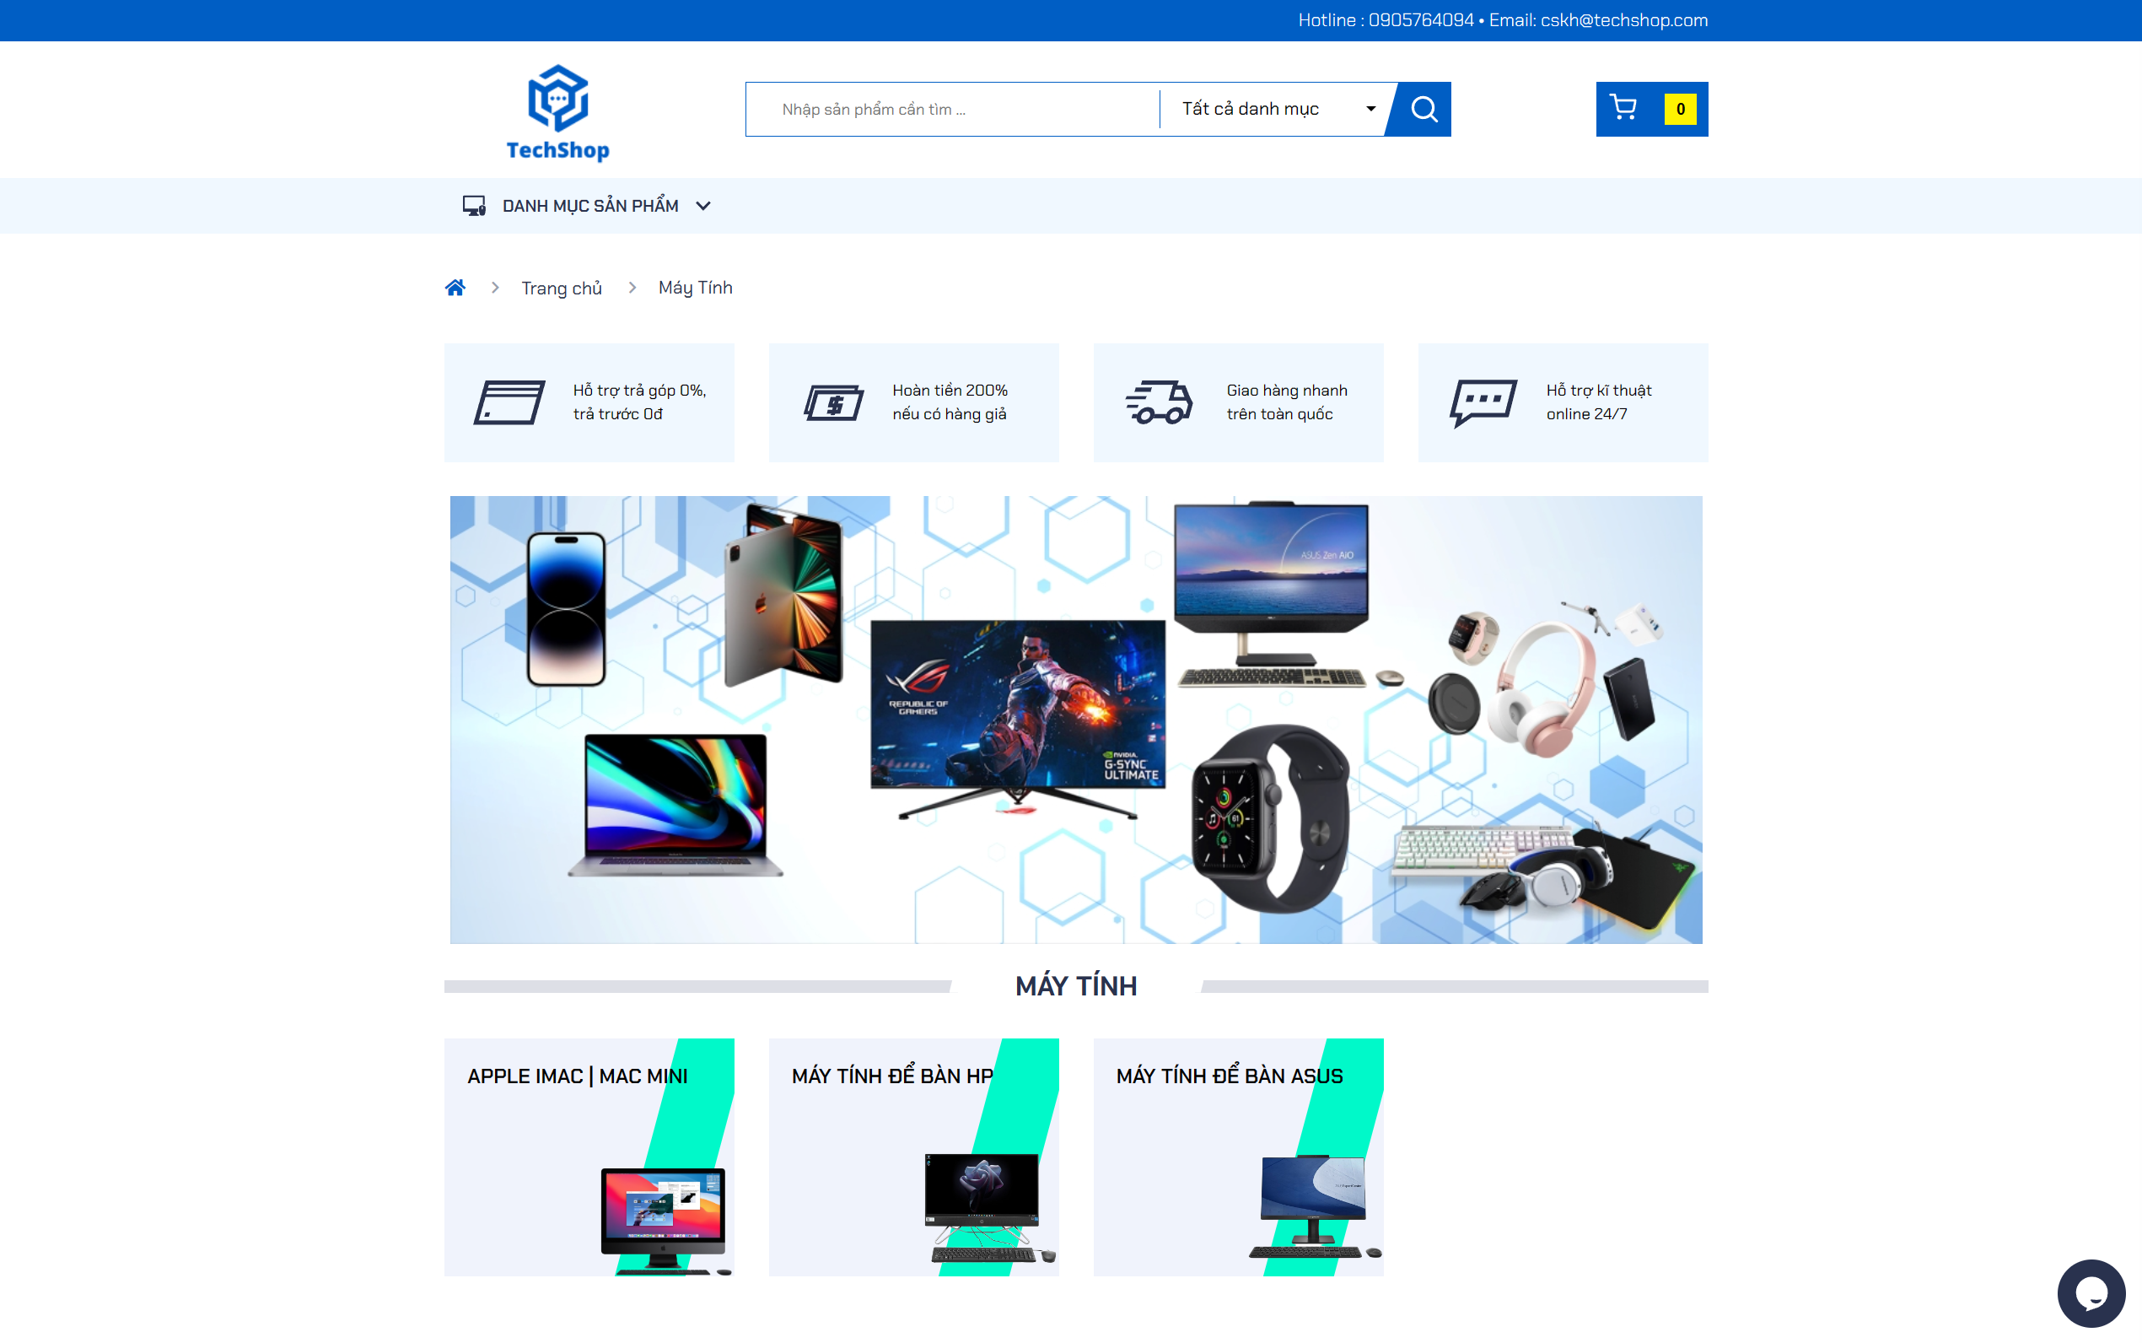

Picture 24: Desktop product catalog

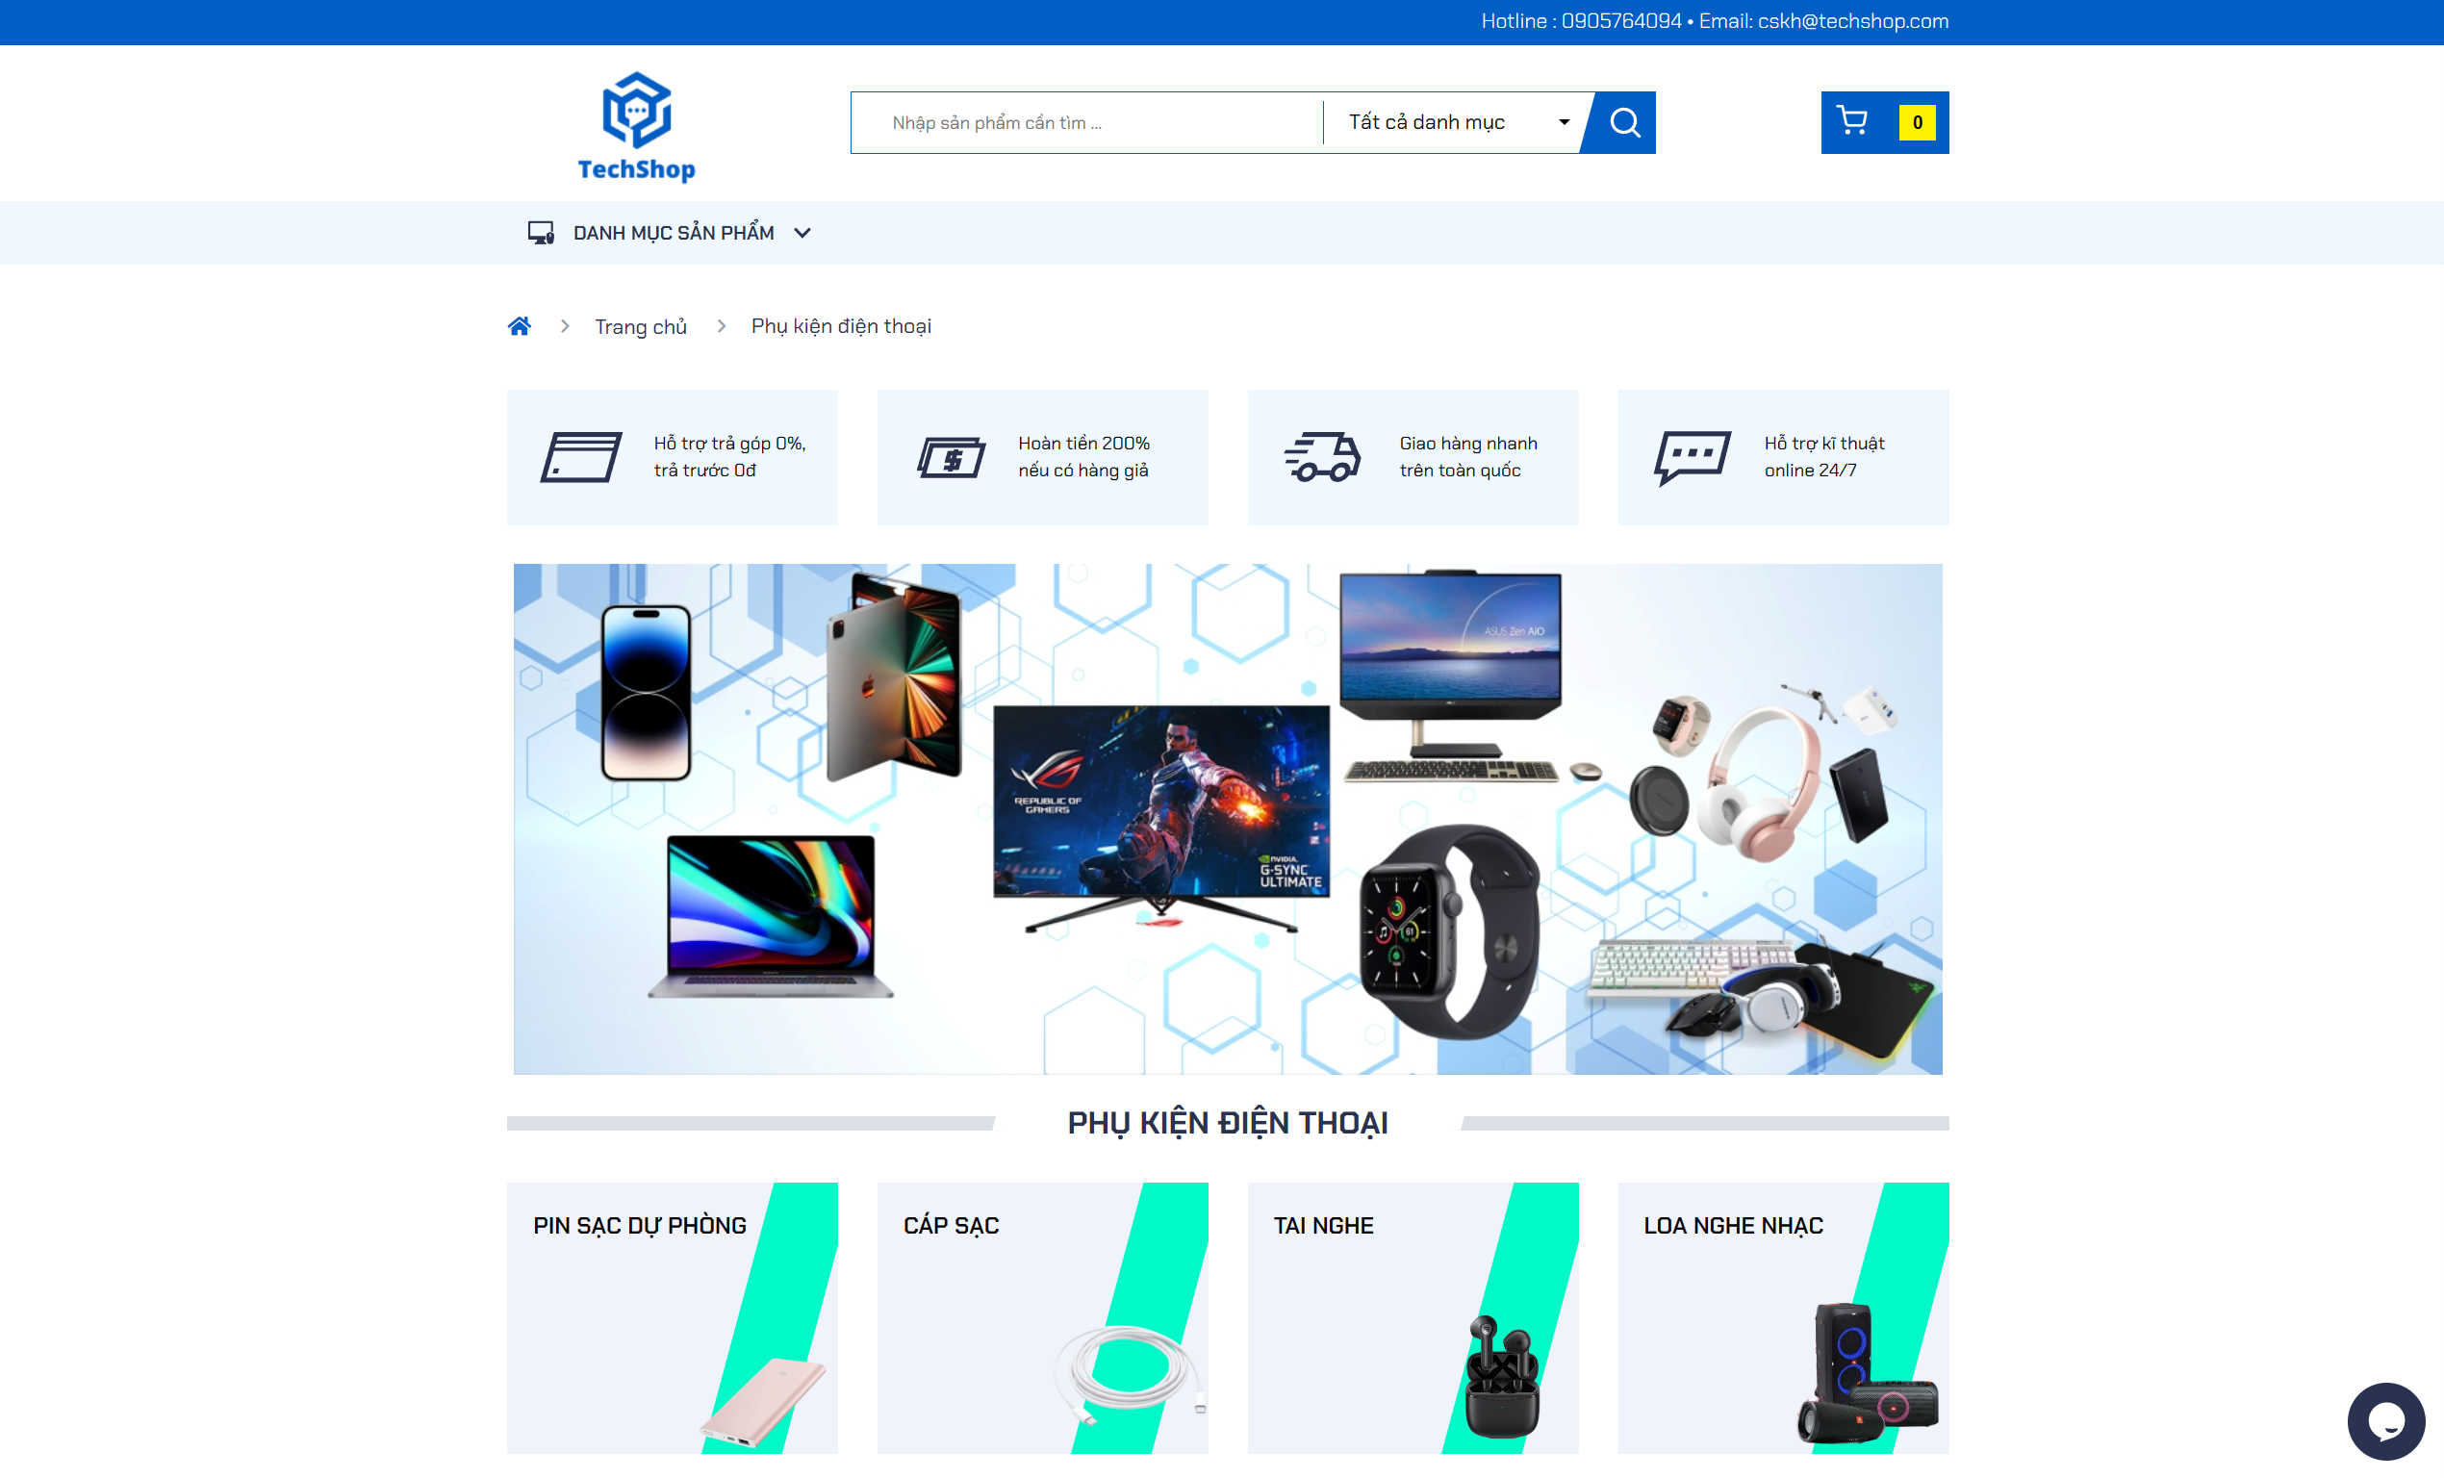

Picture 25: Phone accessories product catalog

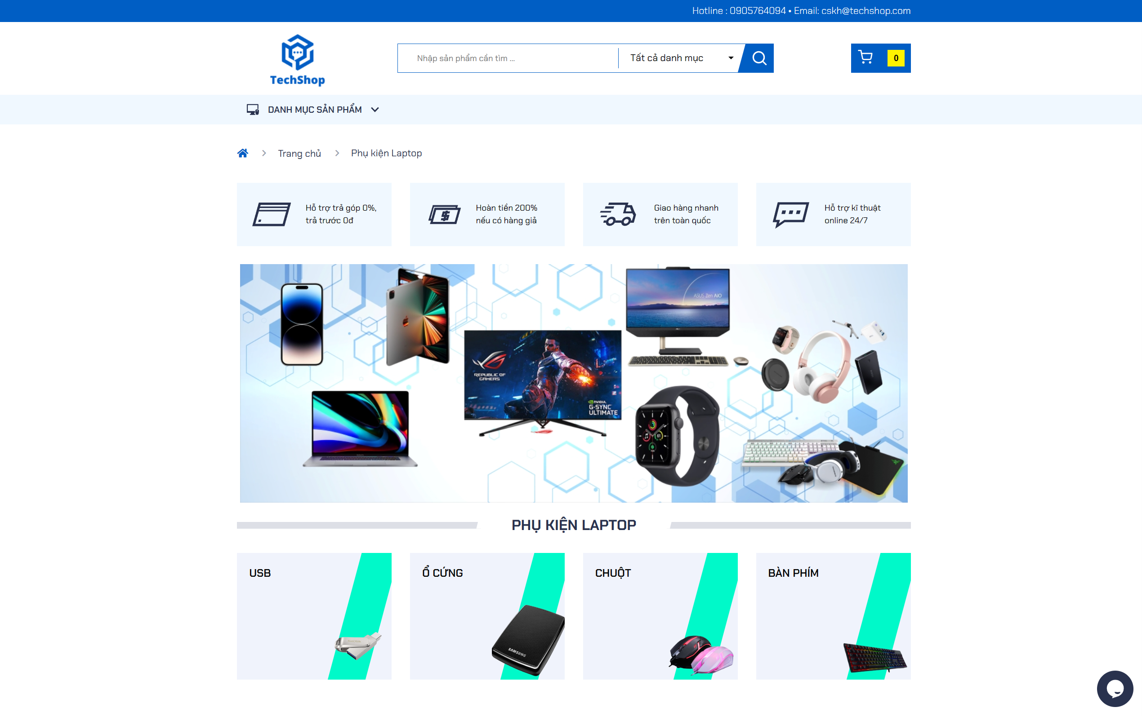

Picture 26: Laptop accessories product catalog

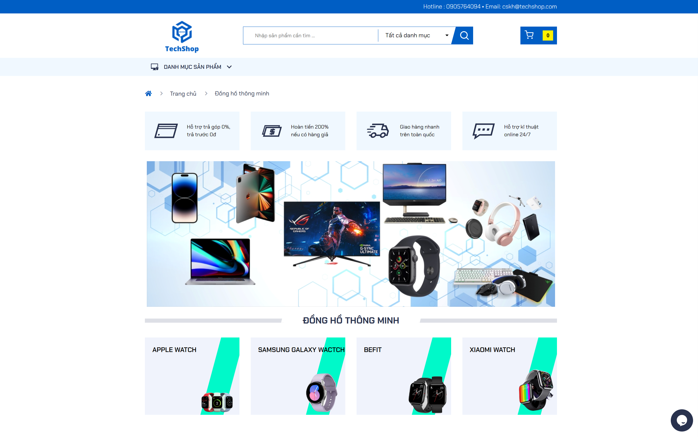

Picture 27: Smart watch product catalog

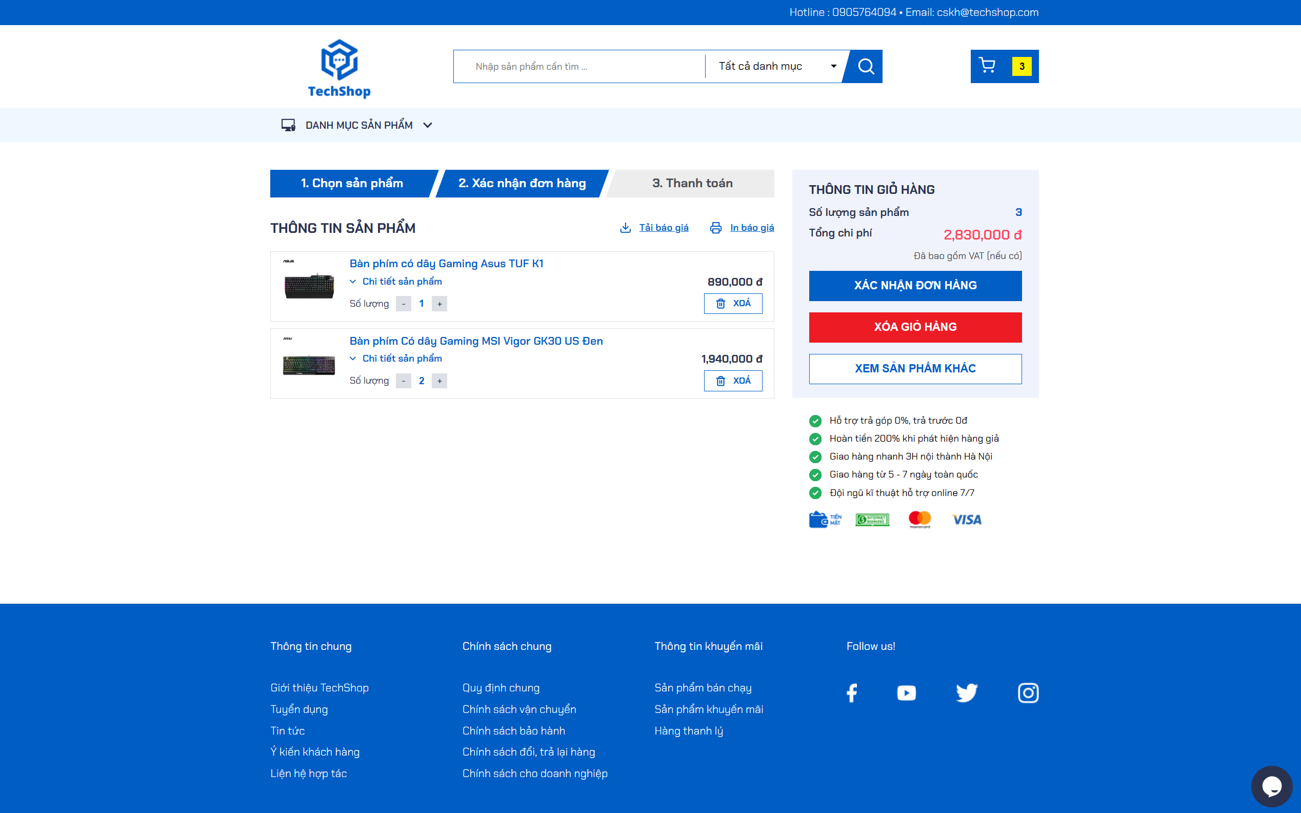

Picture 28: Shopping cart details page interface

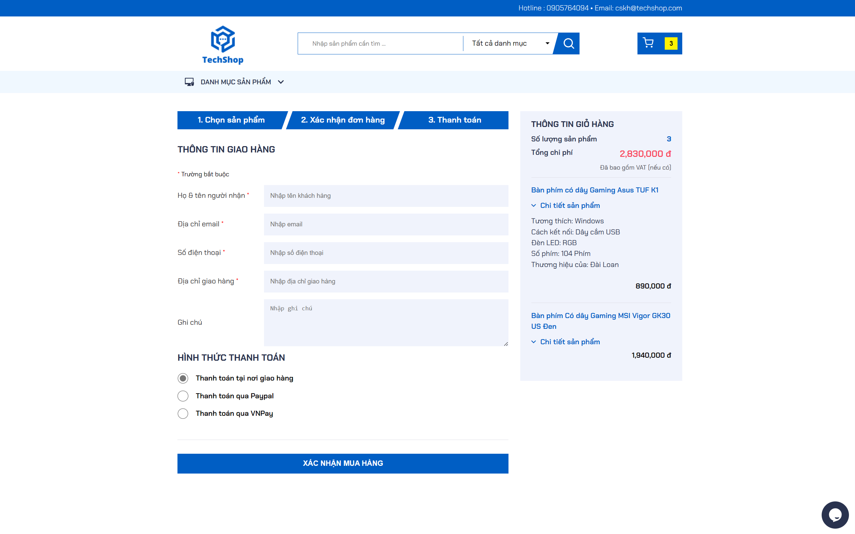

Picture 29: Payment page interface

### 4.2.2. Admin interface

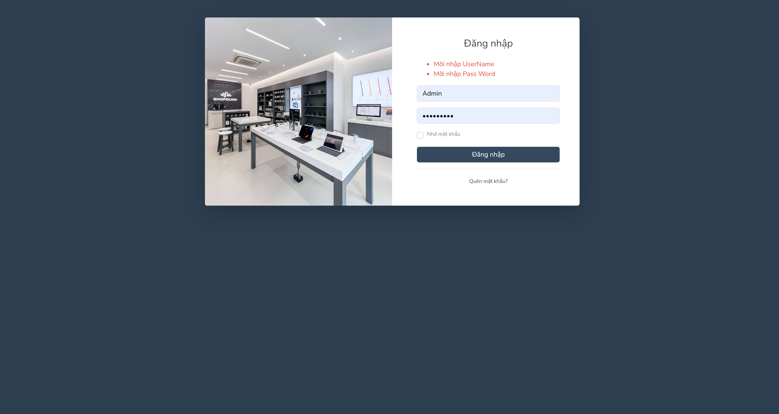

Picture 30: Login interface for admin

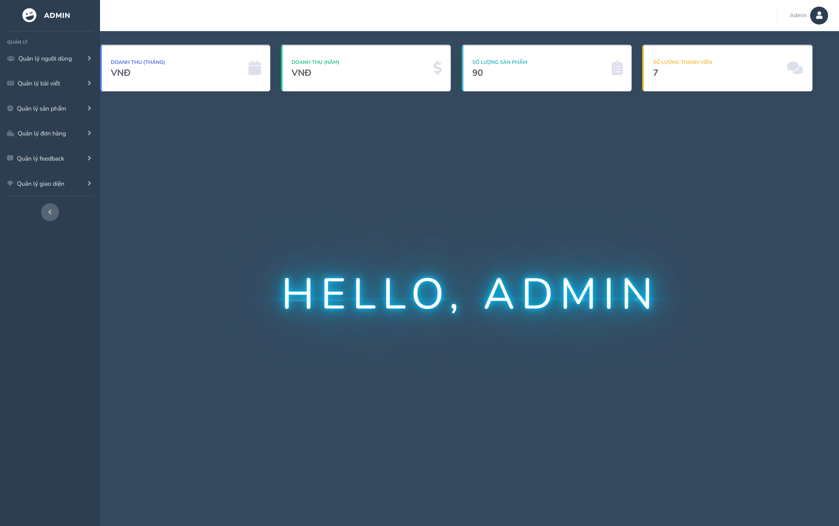

Picture 31: Interface to view revenue statistics

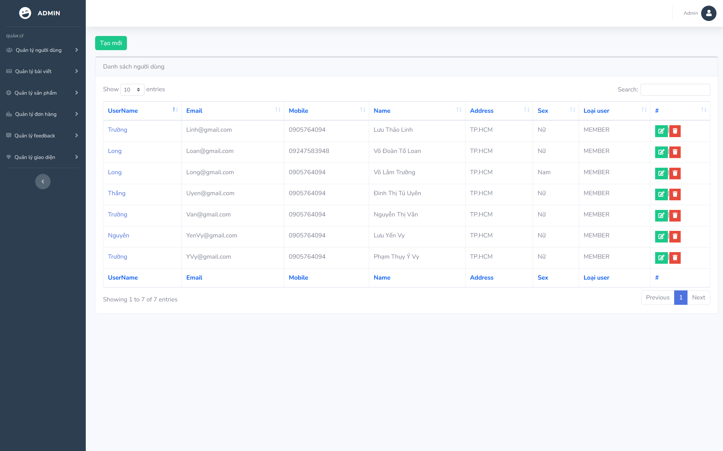

Picture 32: User management interface

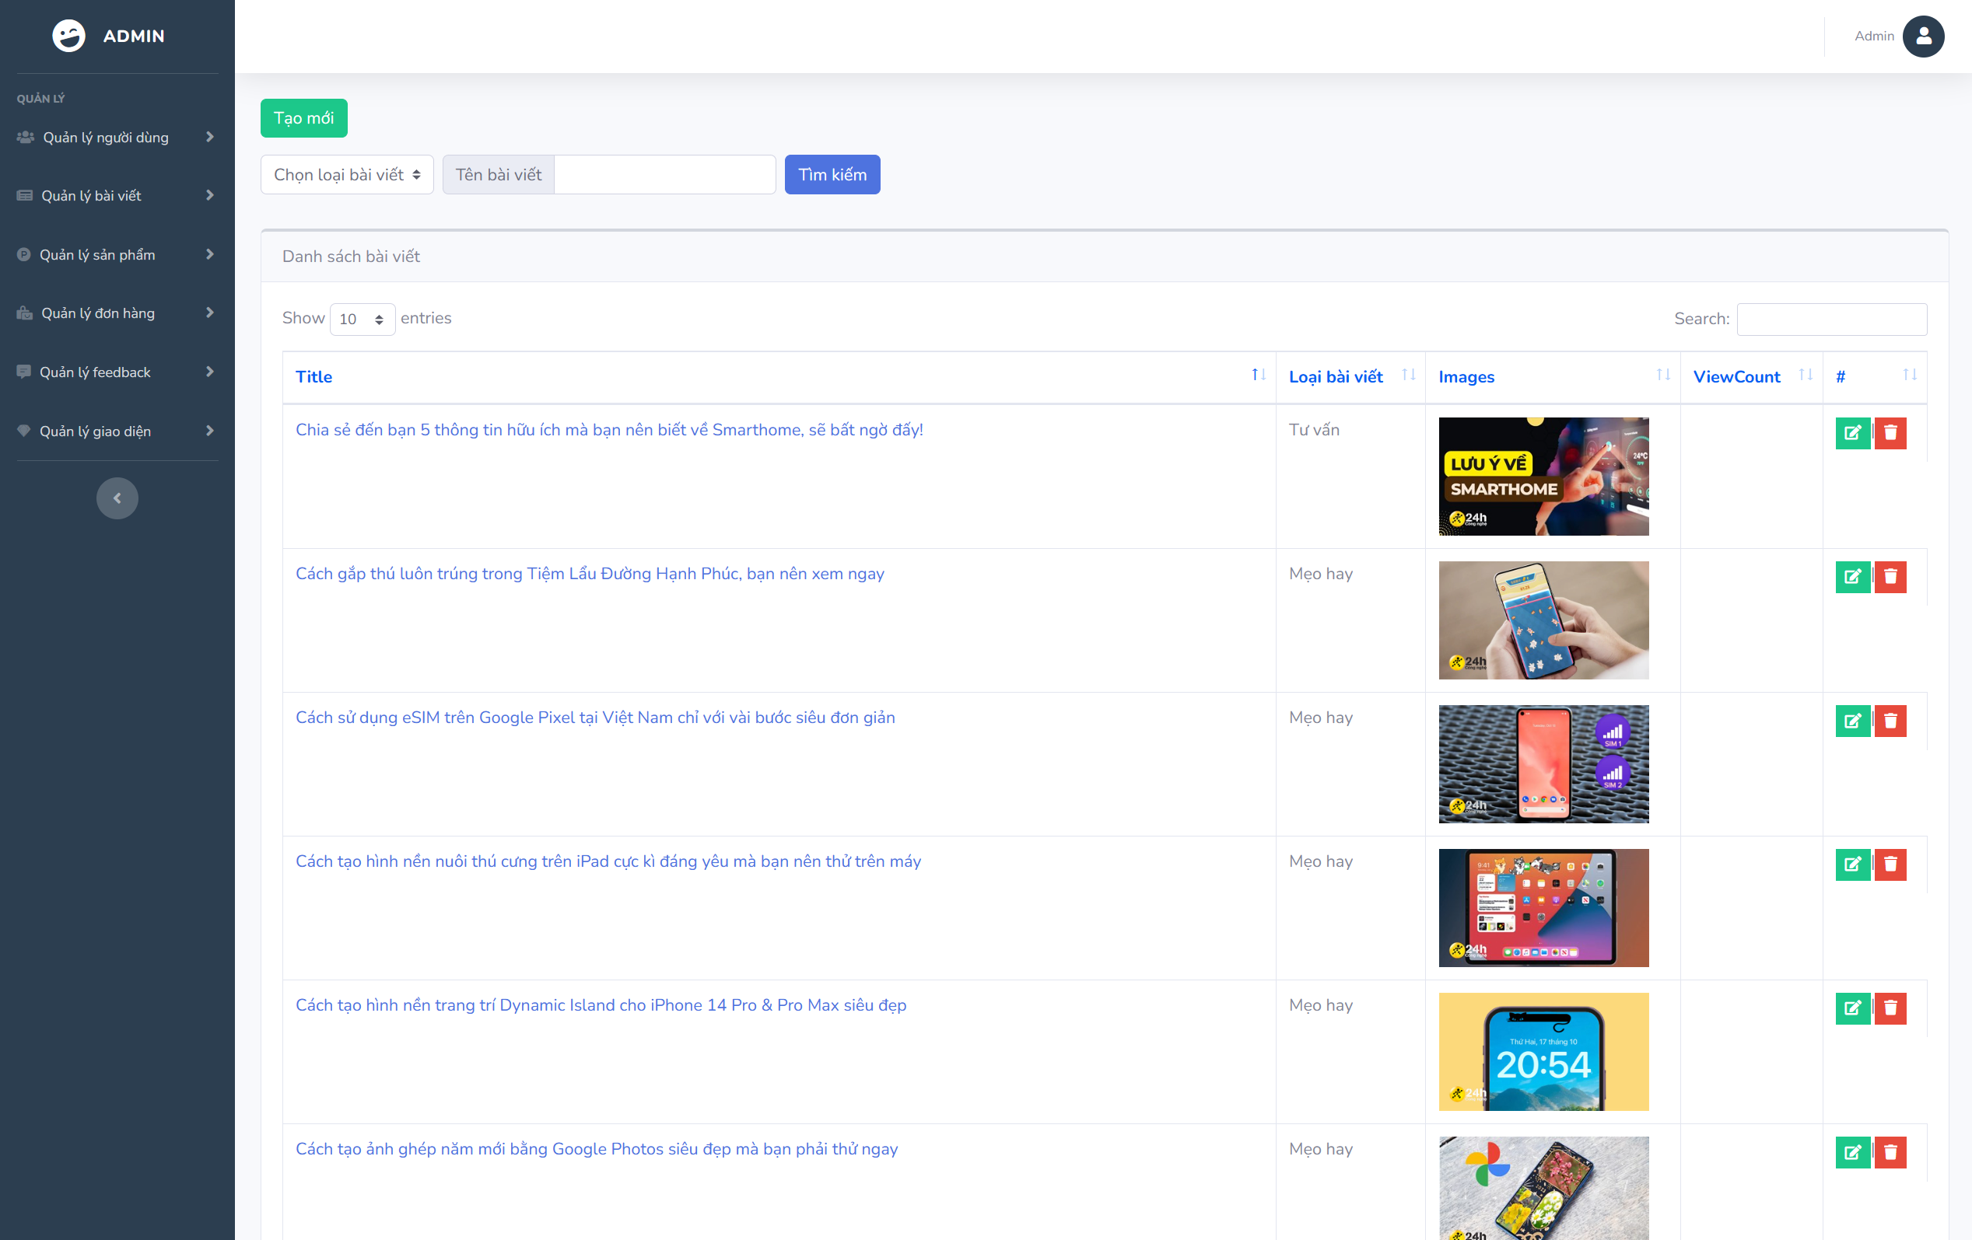

Picture 33: Article management interface

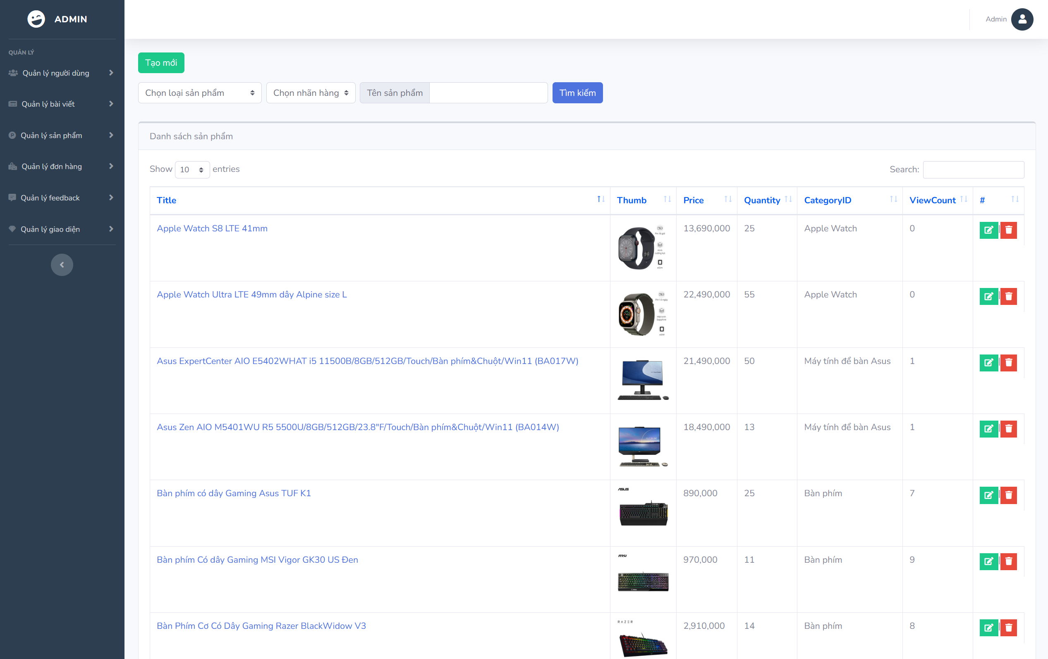

Picture 34: Product management interface

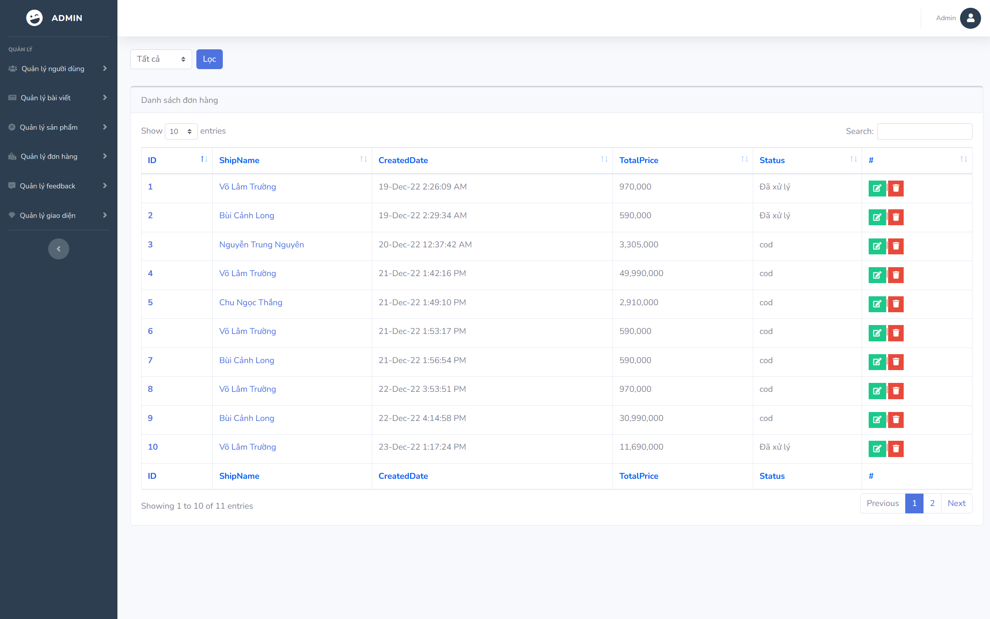

Picture 35: Order management interface

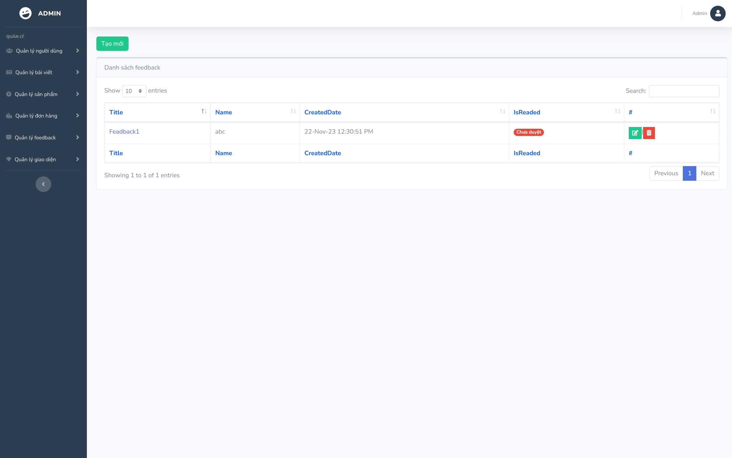

Picture 36: Feedback management interface

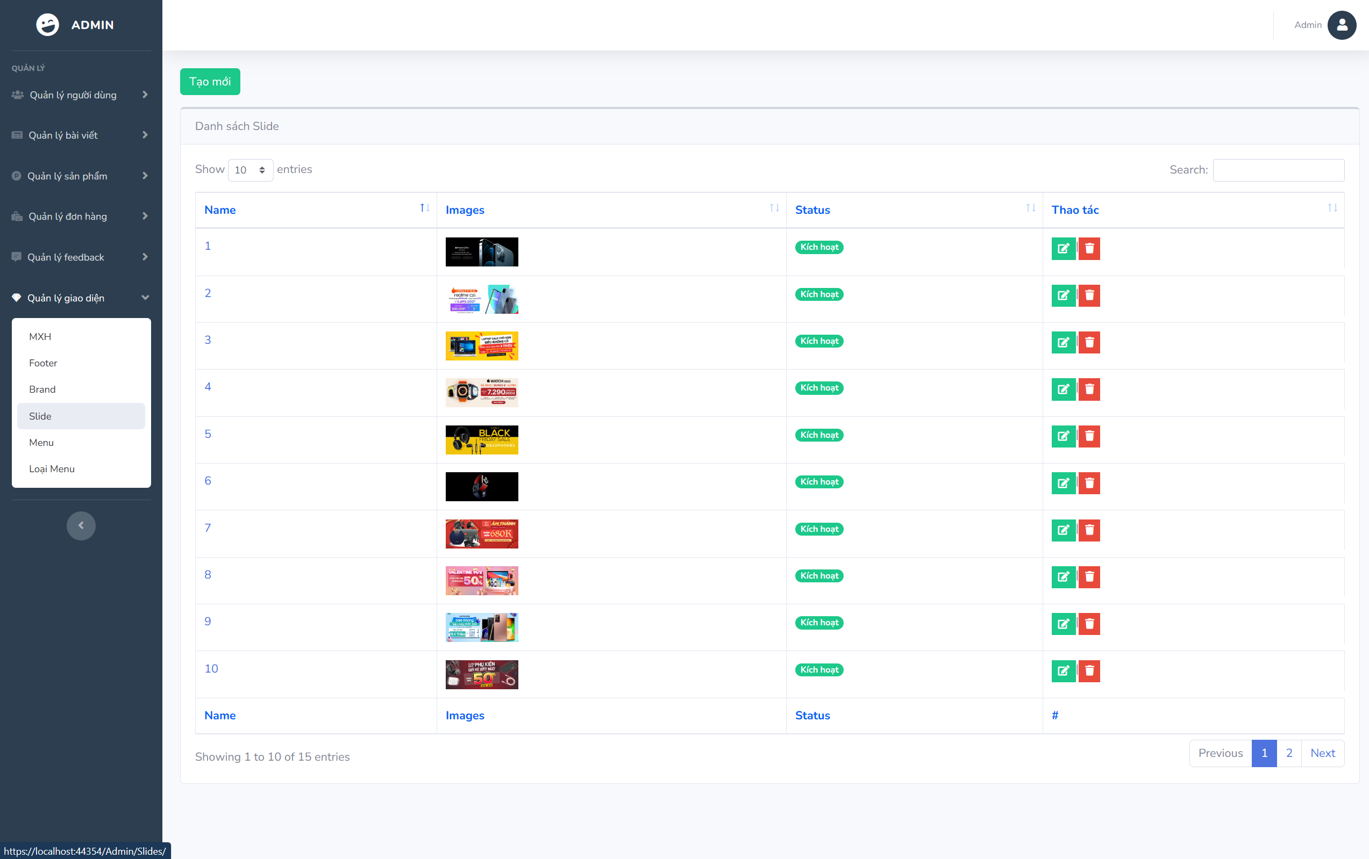

Picture 37: Manage interface components (slides,..)

# CHAPTER 5: CONCLUSION

## 5.1 Project achievement

Websites selling electronics are not too strange to everyone. You just need to stay at home and you can buy everything with one click. Therefore, we have created a website that provides complete information about services and products with a beautiful, easy-to-use graphic interface for customers. We have built 2 sites. One for customers who want to book tickets. And the other one is for administrators, who control and operate the system. Those tasks toke us a lot of time, but it is worth for us. Below this is our system primary functions:

* Purchasing process
* Sign in/Sign up for customer
* Manage Products
* Manage Users
* Manage Interface
* Visualize statistics of revenue based on many criteria.

## 5.2 Limitations

Due to the limited time of the study, the study has the following limitations:

* The user interface and admin are not really perfect.
* Not logged in with facebook, google.
* The interface is not compatible with devices such as mobile and tablet.
* There is no data recovery and backup function yet.

## 5.3 Development direction

In the future, the team will develop and complete the project, specifically as follows:

* Interface design is more aesthetic and reasonable
* Logged in with facebook, google.
* The interface is compatible with devices (Laptop, PC, tablet, mobile).
* Build recovery and backup function.

# CHAPTER 6: SELF ASSESSMENT

|  |  |  |
| --- | --- | --- |
| **Name** | **Bùi Cảnh Long** | |
| **Role** | **Leader** | |
| **Contribution** | **Report** | **Chapter 1:**   * **Introduction**   **Chapter 2:**  **- Interview,**  **- Survey of the organization/ Current organizational situation)**  **Chapter 3:**   * **Use-case Diagram** * **List of use-case** * **Use-case Specification and Activity Diagram, Sequence Diagram, Class Diagram (Sign in, Sign out, Explore product, Recreate password)** * **State Diagram** * **Administrator overview class diagram**   **Chapter 4:**   * **User Interface (Customer interface)** |
| **Demo Project** | **Backend** |
| **Grade** |  | **10/10** |

|  |  |  |
| --- | --- | --- |
| **Name** | **Nguyễn Trung Nguyên** | |
| **Role** | **Member** | |
| **Contribution** | **Report** | **Chapter 1:**   * **Objectives of the project**   **Chapter 2:**  **- Survey of business processes, major activities**  **Chapter 3:**   * **Use-case Diagram** * **Use-case Specification and Activity Diagram, Sequence Diagram, Class Diagram (Sign in (for administrator), User management, Product management, Analysis Revenue)** * **State Diagram** * **Entity class diagram**   **Chapter 4:**   * **Introduction to the implementation environment** |
| **Demo Project** | **Backend** |
| **Grade** |  | **10/10** |

|  |  |  |
| --- | --- | --- |
| **Name** | **Võ Lâm Trường** | |
| **Role** | **Member** | |
| **Contribution** | **Report** | **Chapter 1:**   * **Research problems / Problems of the project**   **Chapter 2:**  **- Software requirements (Functional requirements)**  **Chapter 3:**   * **Use-case Diagram** * **List of actors** * **Use-case Specification and Activity Diagram, Sequence Diagram, Class Diagram (Search product, Manage profile, Product reviews, Choose to buy the product)** * **Customer overview class diagram** * **Mapping to Relational Model diagram from Entity class diagram**   **Chapter 4:**   * **User Interface (Admin interface)**   **Compile and edit reports.** |
| **Demo Project** | **Frontend** |
| **Grade** |  | **10/10** |

|  |  |  |
| --- | --- | --- |
| **Name** | **Chu Ngọc Thắng** | |
| **Role** | **Member** | |
| **Contribution** | **Report** | **Chapter 1:**   * **Scope of project**   **Chapter 2:**  **- Software requirements (Non-functional requirements)**  **Chapter 3:**   * **Use-case Diagram** * **Use-case Specification and Activity Diagram, Sequence Diagram, Class Diagram (Order management, Article management, Manage feedback, Interface management)** * **Class specification**   **Chapter 5:**   * **Project achievement** * **Limitations** * **Development direction** |
| **Demo Project** | **Frontend** |
| **Grade** |  | **10/10** |